MLStocks Final Report

**Team:** MLStocks *(Jarrod Bailey, Samuel Berende, Zehra Siddiqui)* W/ Dr. Cengiz Gunay

**Client:** Dr. Atul Saxena *(GGC Finance Professor)*

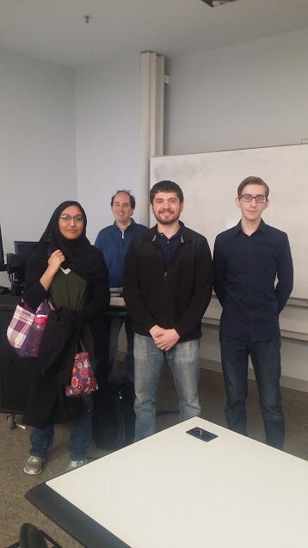 

* Features Implemented:

**The tutorial covers:**

Downloading historical financial data for stocks and indexes.

* + - Sectors: Energy, Information Technology, and Healthcare

Manipulating and formatting this data.

A number of different visualization techniques.

* + - Candlestick Charts
    - Histograms
    - Scatterplots
    - Q-Q Plots

How to analyze the collected data in various ways.

* + - Calculating daily change in value
    - Calculating daily cumulative rate of returns
    - Volatility
    - Correlations
    - Linear Regression

**Sections/Features:**

1: Project Introduction

2: Python Basics

3: Prerequisite Financial Information

4: Numpy Library

5: Pandas Library

6: Plotting

7: Financial Analysis on Historical Stock Data

8: Trading Strategies

9: Preprocessing and Feature Engineering

10: Machine Learning

* Future Iterations:
  + We’ve implemented all client requirements, though we could expand on the machine learning section.
* Known Issues:

**Microsoft Azure Issues:**

On average code execution and performance in general is slower when compared to running it on a local machine.

No automatic installs on required modules. These must be done manually.

Terminal installs don’t place modules in the correct environment.

Installations aren’t as straight forward when compared to doing them on a local machine.

They can oftentimes fix one problem and break another portion of the notebook code.

**Local Machine Issues w/ Anaconda/Jupyter Notebook:**

Modules/libraries not being installed.

Data not being downloaded properly.

* + - Restarting the notebook kernel will fix this.
* Functionality:

Tutorial is segmented into multiple Jupyter Notebook documents that each represent a section of the project.

Notebook documents contain:

* + - Rich text elements
    - Images
    - Results from computations
    - Executable and interactable code

Content is divided into cells in a document.

* + - The user can run/execute these cells and see their output right below the respective cell.
  + *Screenshots of Tutorial run locally and on Azure included on the next two pages:*
* Jupyter Notebook run locally:

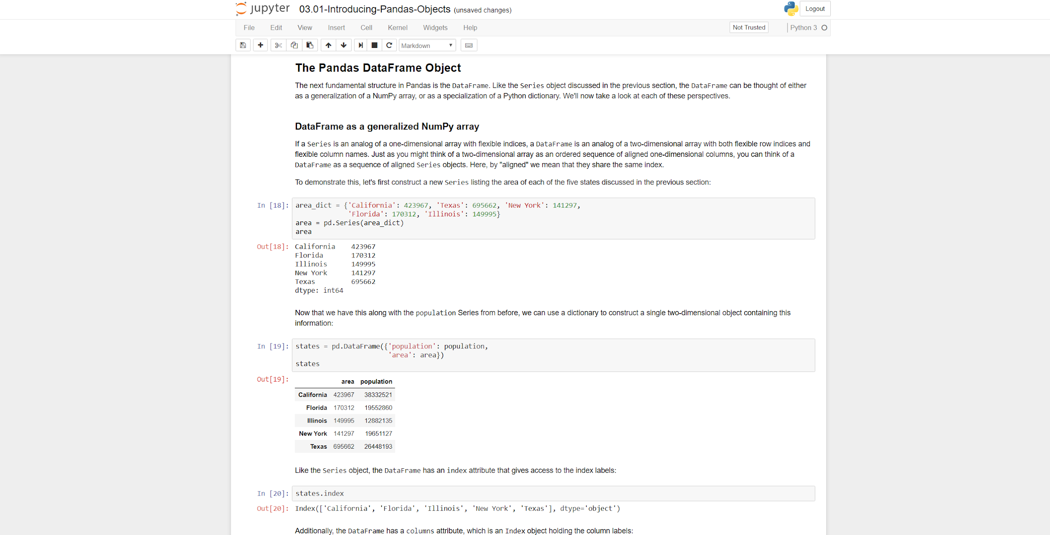

* Jupyter Notebook through Microsoft Azure:

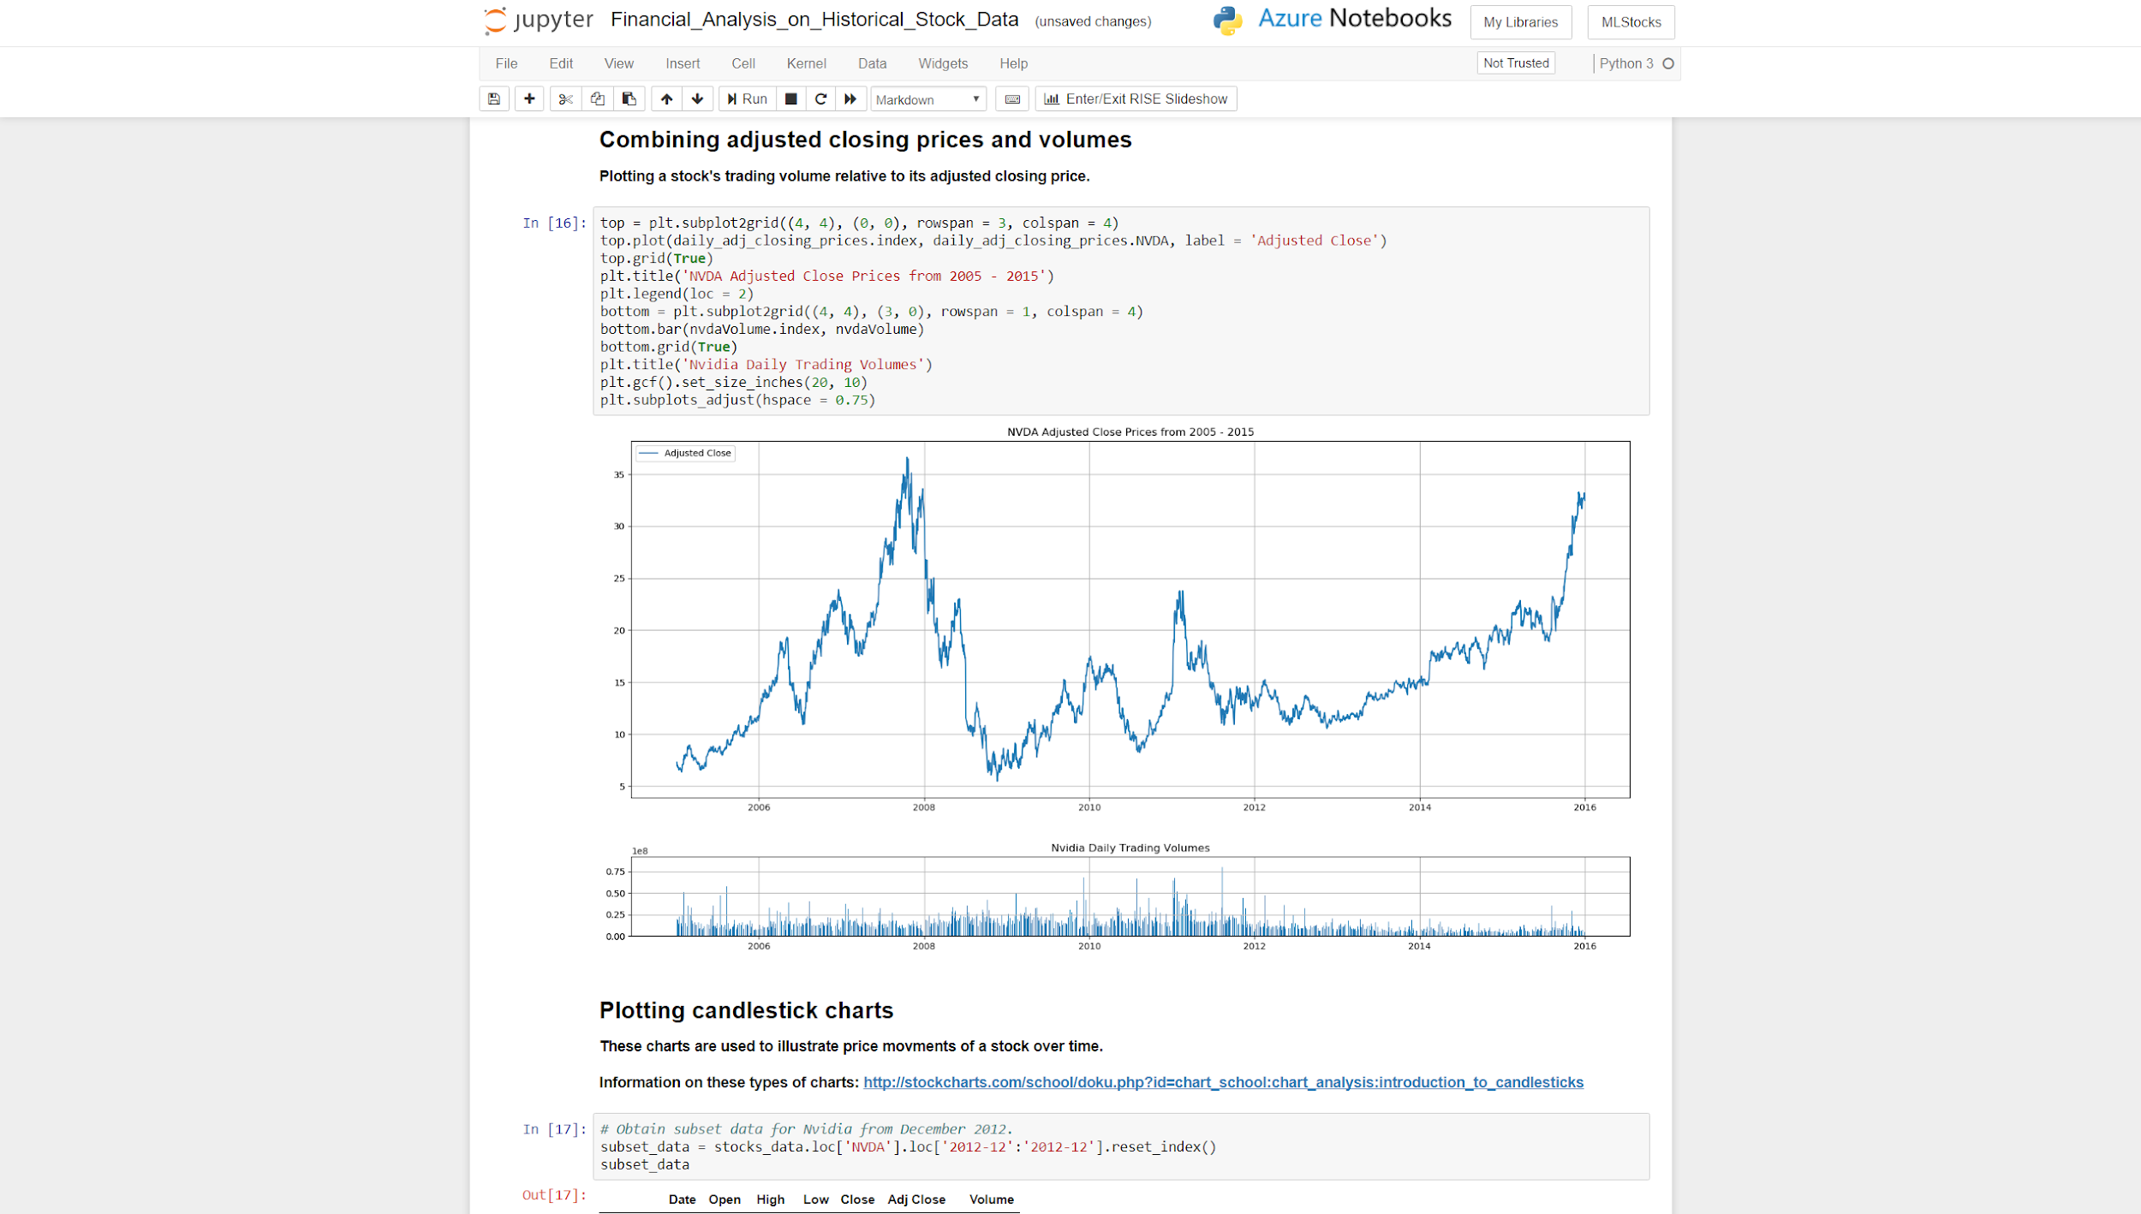

* Project Poster for CREATE:

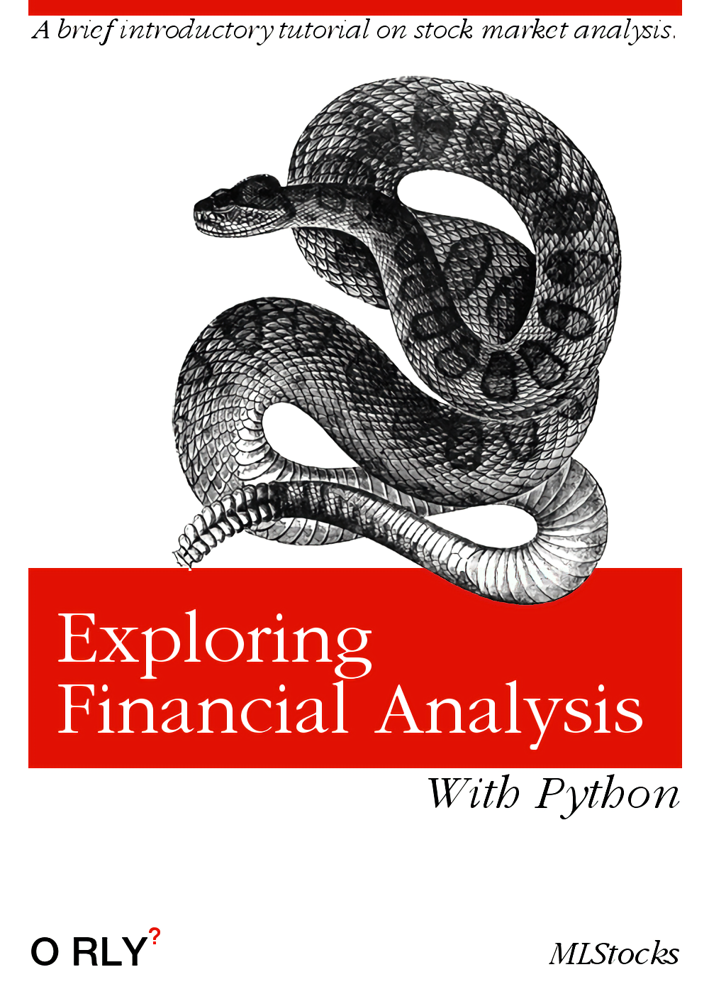

* Screencast Video Demo Link
  + <https://www.youtube.com/watch?v=x5k7kj3faMg&feature=youtu.be>
* Testing Coverage/Methods/Results:
  + Automated Testing & Unit Tests aren’t applicable, because it is a tutorial.
    - Mainly made sure our cells ran correctly
  + Manually tested sections on Azure
  + User Testing happened during CREATE symposium:
    - April 26th, 2018 from 2:00 - 3:00 p.m.
    - *Note: The time stamps on the survey results below are not all within this time period because of issues pulling up the survey. Some of the answers were written down and entered in manually at a later date.*
  + User Testing Results:

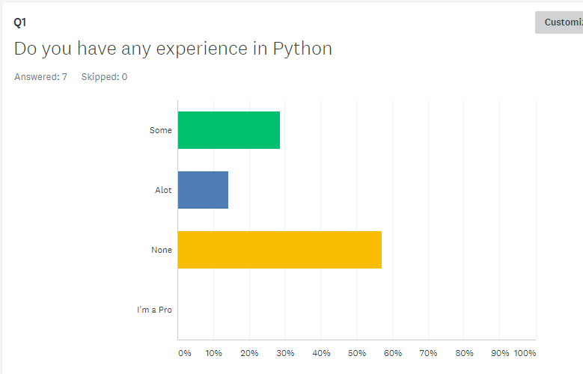

The first question of our survey asked about users current skill level in python. Based off of the results, it seems that most would benefit from the tutorial section that covers some python basics.

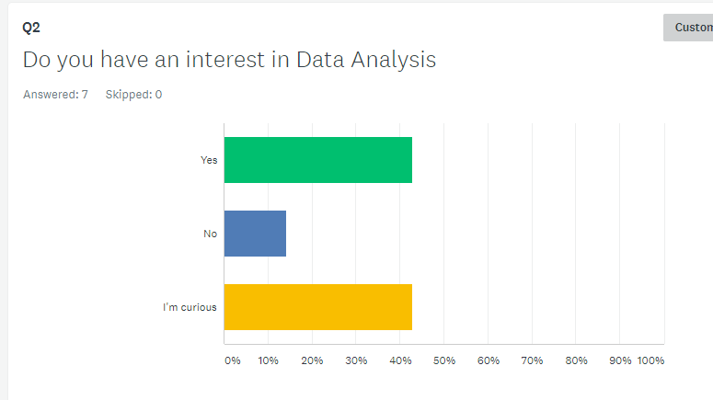

The second question gauged users interest in data analysis. Based off of the results, it seems most would have an interest in going through the tutorial.

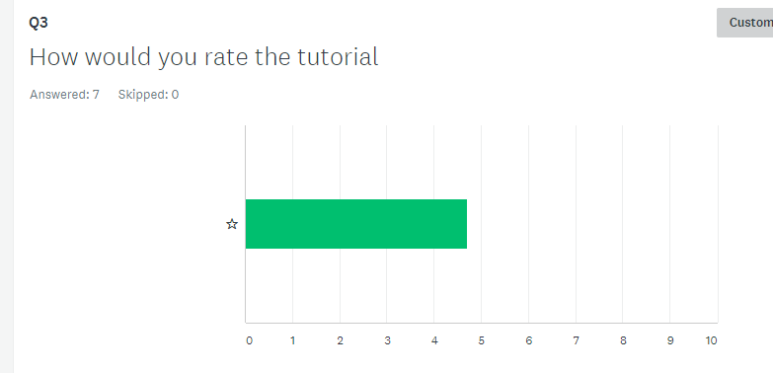

The third question asked users to rate the tutorial. The tutorial was given a high rating.

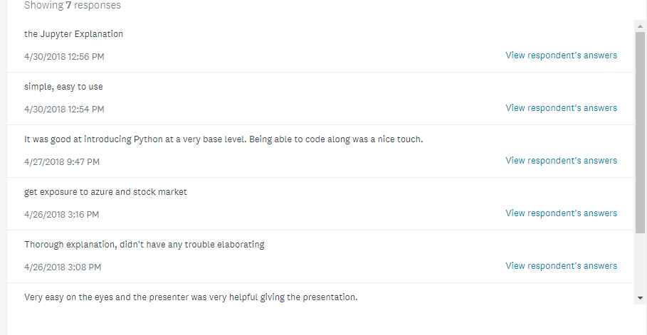

The fourth question asked what users like about the tutorial. The feedback is provided above.

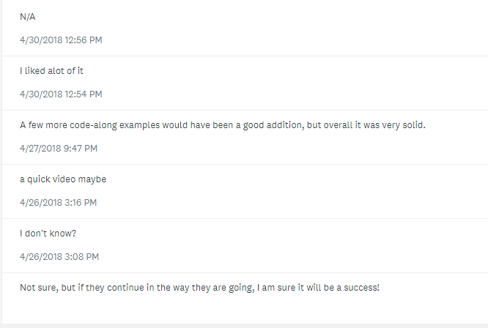

The fifth question asked what users thought could be improved. The feedback is provided above.

* Developer/User Documentation, Installation Instructions, Intellectual Property Agreement, & License (Beerware)
  + Installation: Included in Section 1 & README
  + GitHub: <https://github.com/soft-eng-practicum/MLStocks>
  + Microsoft Azure: <https://notebooks.azure.com/MLStocks/libraries/MLStocks>