Final Report - MatchMakers

**Features**

Fully Implemented Features

* Accepts user information - Cumulative GPA, Science GPA, GRE Scores for Verbal, Quantitative, and Essay, and Healthcare Hours
* Pulls information about the schools from a JSON file
* Allows the user to select a state from a drop down menu and shows a list of Physician Assistant schools in that state
* Allows the user to click on a school from the list
* Compares the user information to the minimum requirements of the school selected
* Calculates the user rating (Poor, Average, Good) and displays to the user

Future Feature Recommendations

* Change the school information to information about the average accepted students; currently, the information is the minimum requirements of the school
* Change the GRE score requirement from a boolean (greRequired) to the required scores for each of the three categories from the schools
* Update calculation to include GRE score requirement
* Limit what the user can enter into the text fields; for example, for cumulative GPA on a 4.0 scale, the user should not be able to enter 10
* Allow the user to pick multiple schools (up to 25) and show the rating for all schools at once
* Change the user rating to show the percentage up chosen schools where the user have a good chance of getting into; show each individual school as well

Example:

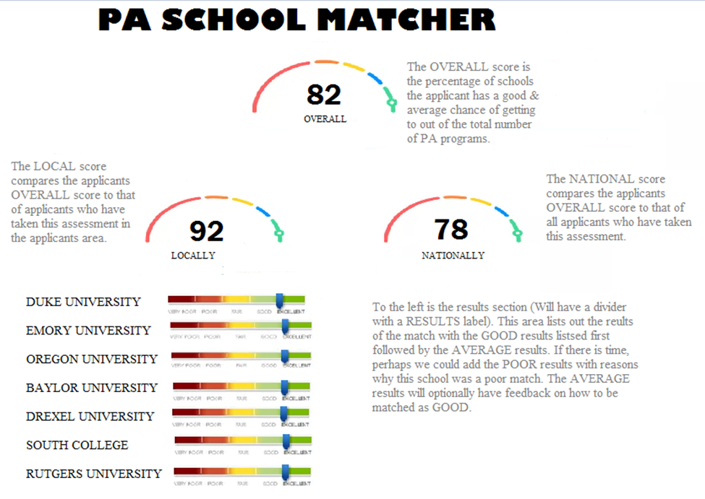

* Fill in the About, Resources, and Contact pages

**Issues**

* State drop down menu goes up instead of down
* On user information page, text boxes are too far away from labels

**Functionality**

[MatchMakers Flyer](https://drive.google.com/file/d/11W1WWJ97BdIuaJG7dd1Kp-UkEhhzJpHO/view?usp=sharing)

* Allows the user to enter their information into text fields

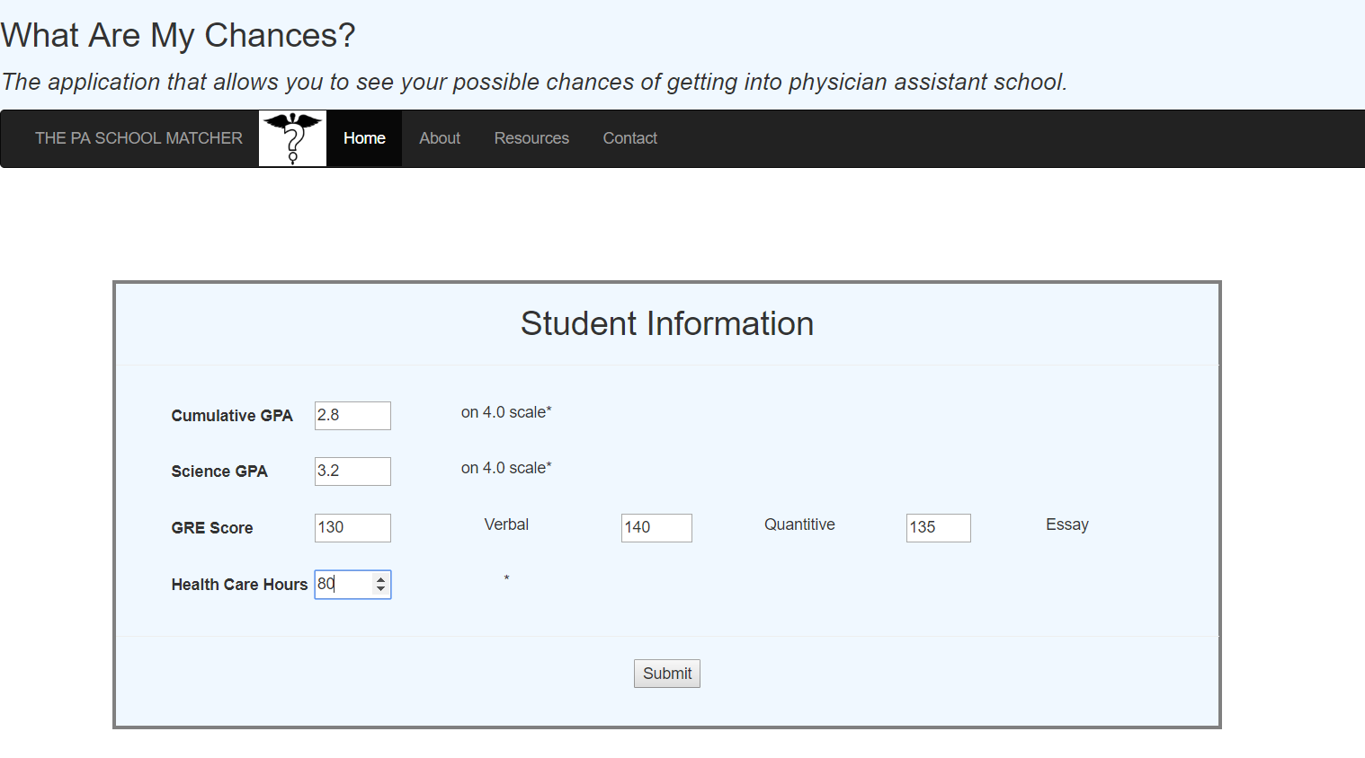

* Allows the user to select a state with a drop down menu

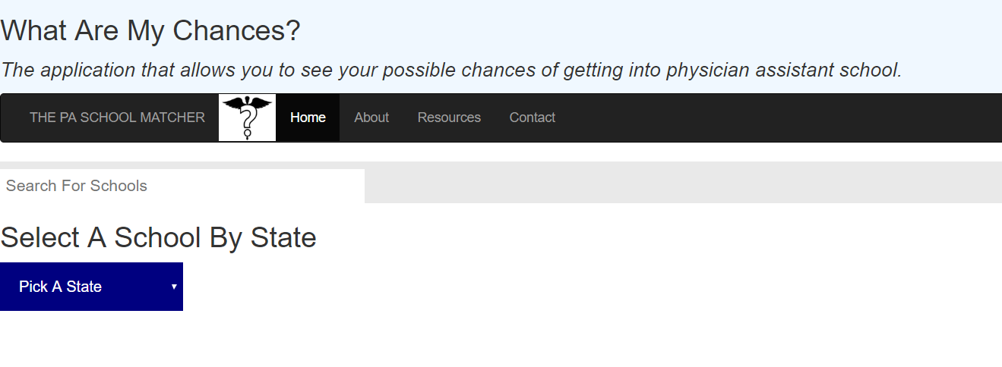

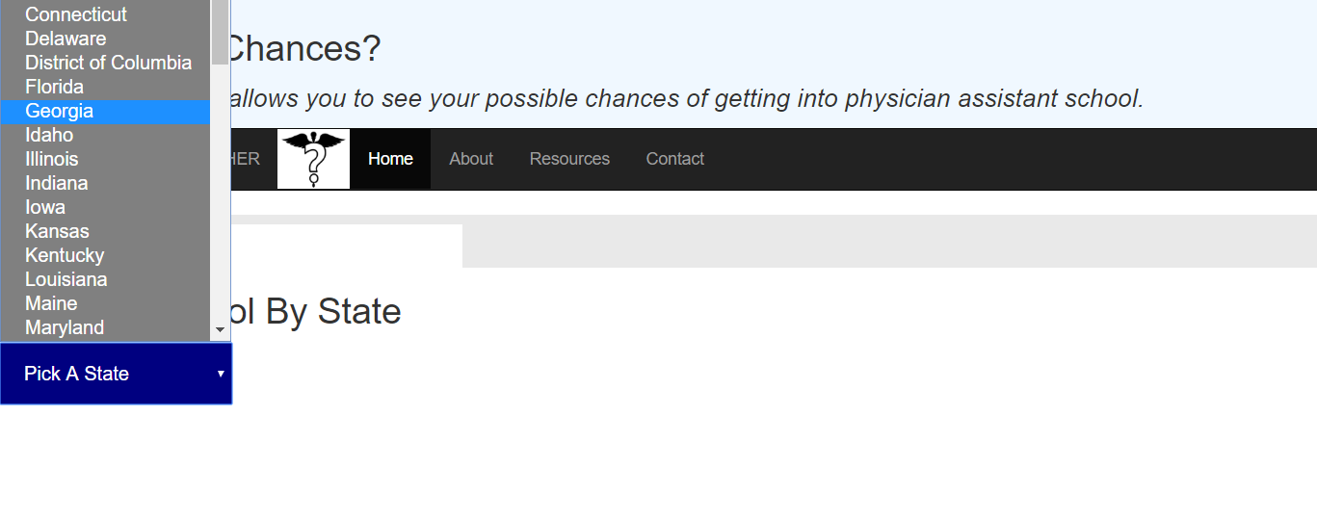

* Allows the user to select a school from a list of schools in that state and returns their chances of being accepted into that school

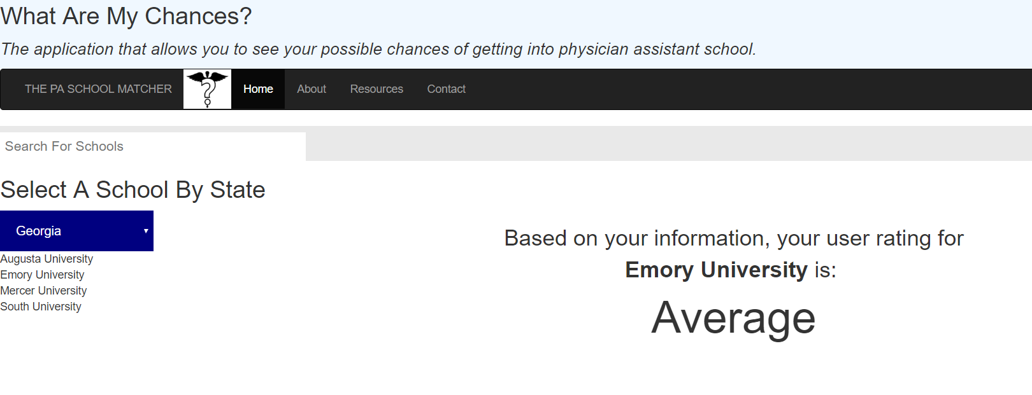

**Screencast**

[Screencast](https://youtu.be/DQcuT6XR8ag)

**Team Members**

* Lauren Marsicano - Lead Programmer, Data Modeler, Documentation Lead
  + Software Development major at GGC. Experienced with Java, JavaScript, HTML/CSS
* Breeona Day - Team Manager, Client Liaison, UI/UX Design, Testing Lead
  + Software Development major at GGC. Experienced with Java, JavaScript, Python and HTML/CSS

**Client**

* Brian M. Palm
  + Physician assistant at Gwinnett Medical Center and Northside Hospital
  + Brian is a Board Certified Chief PA of Emergency Medicine.
  + Member of the AAPA as well as Georgia Association of Physician Assistants.
  + Former adjunct faculty and Admissions Panel member at an accredited PA school.
  + His interest in PA School Prep stems from his passion educating his students and patients on acute illnesses as well as preventative care.

**Testing**

Methods

* Karma Configuration

Coverage/Results

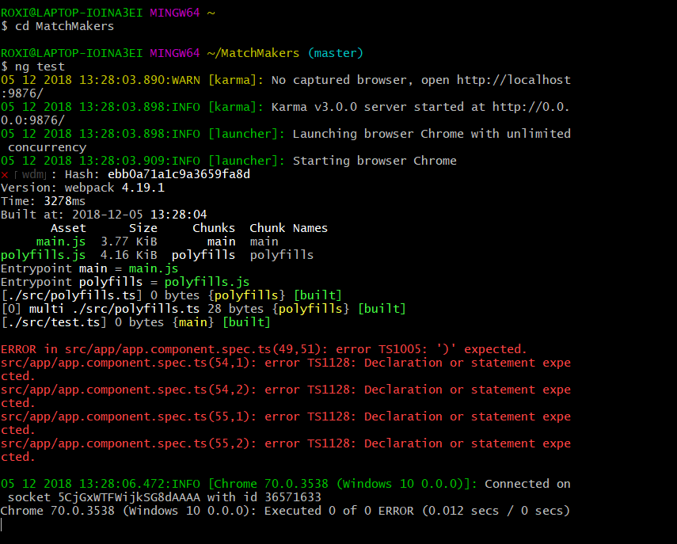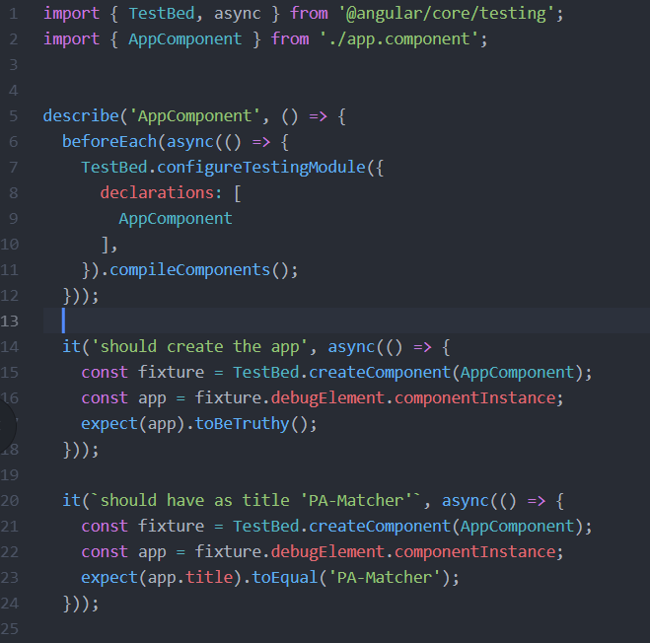

**User Testing Survey Results**

[CREATE Survey Results](https://docs.google.com/spreadsheets/d/1dVhsInClolgOn1hMvQPfXzCYxCDqLKRmIPjHL2cktTg/edit?usp=sharing)

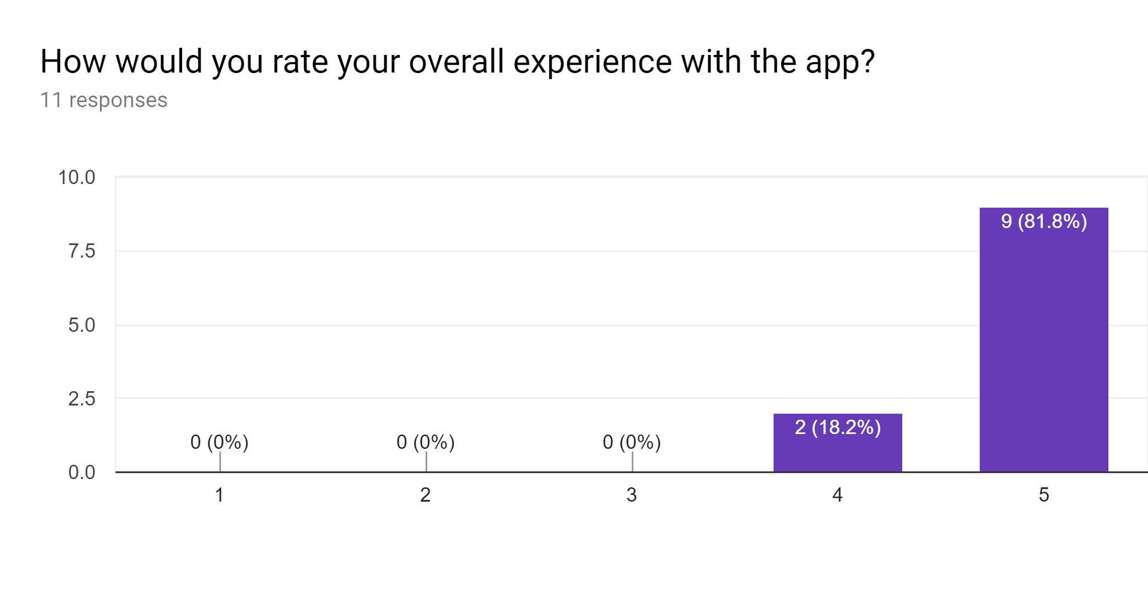

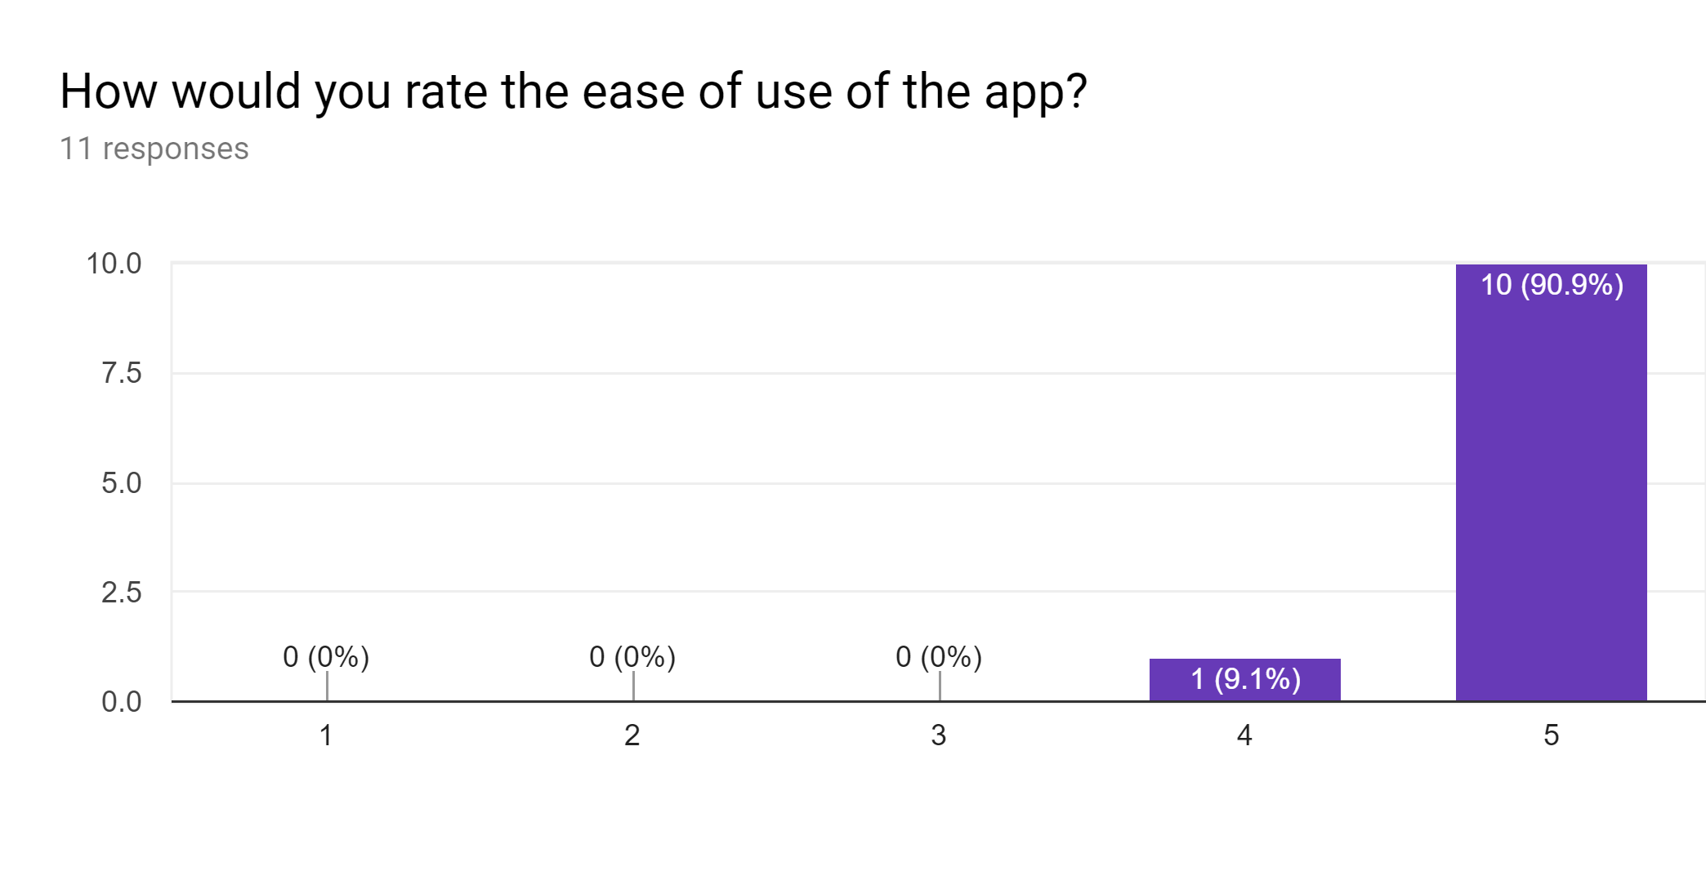

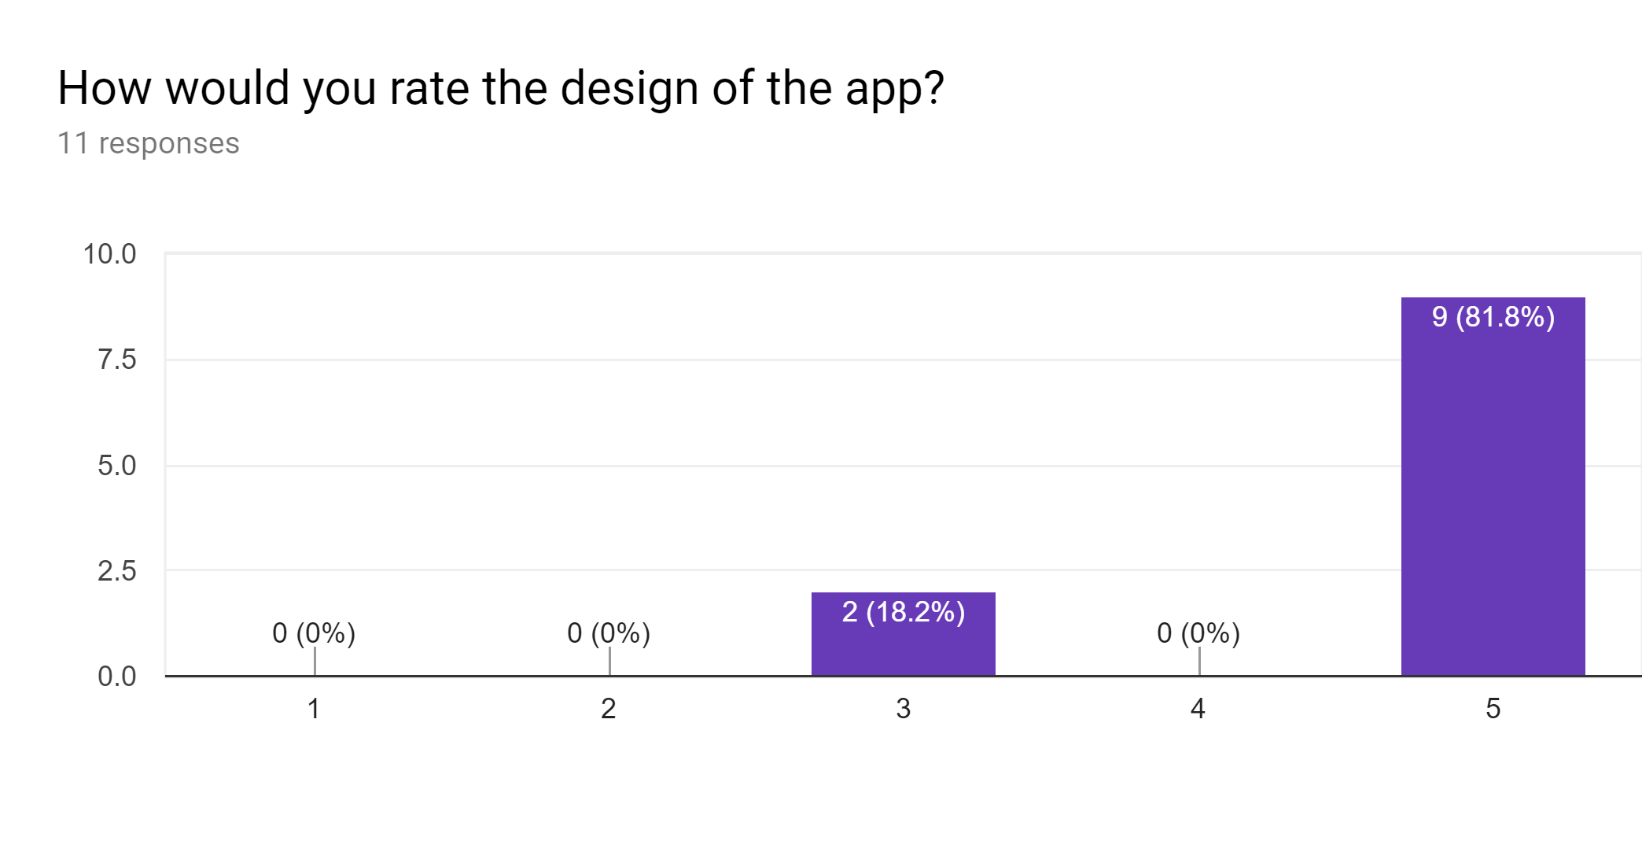

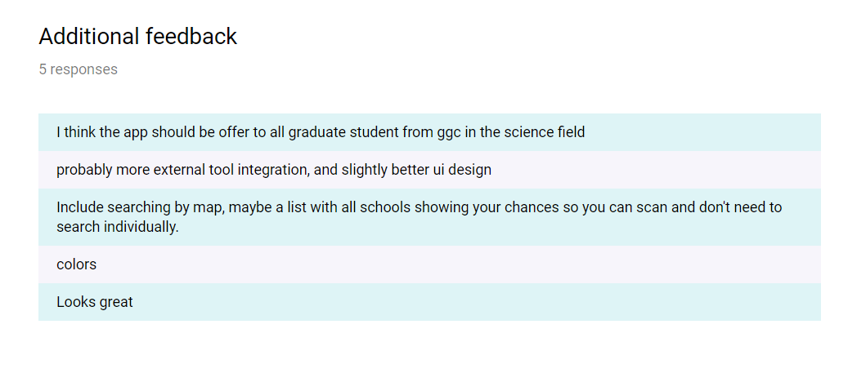

**Installation**

[How to Open the Application](https://docs.google.com/presentation/d/1EepIUPv78ZSCdY6uAzLxTBj5XDFaSQJqZIHlmsUIOv0/edit?usp=sharing)

**Documentation**

* CompoDoc
* <http://127.0.0.1:8080/index.html>
  + Requires running CompoDoc to load documentation
    - Command: npm run compodoc
* Documentation Examples:

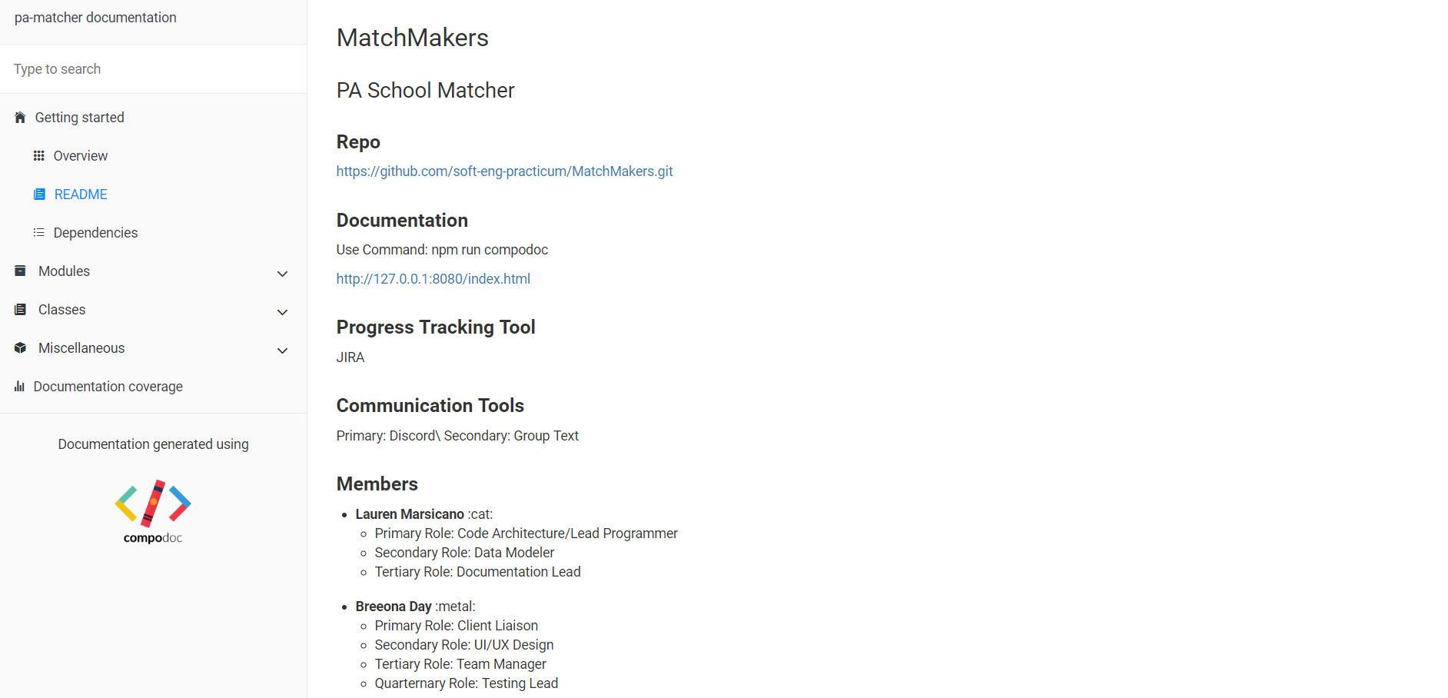

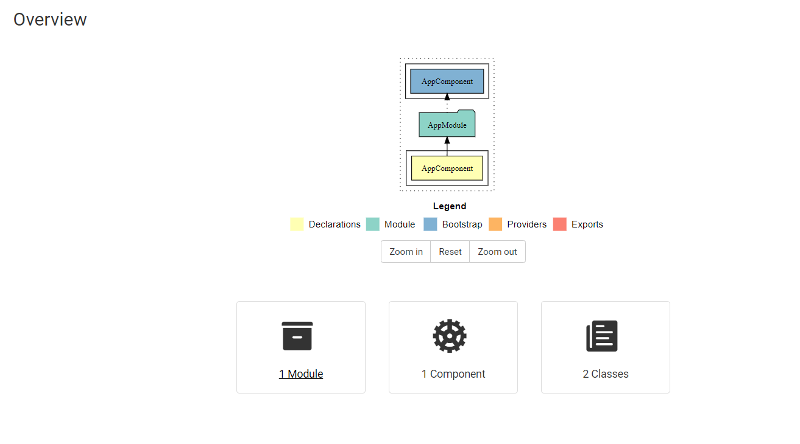

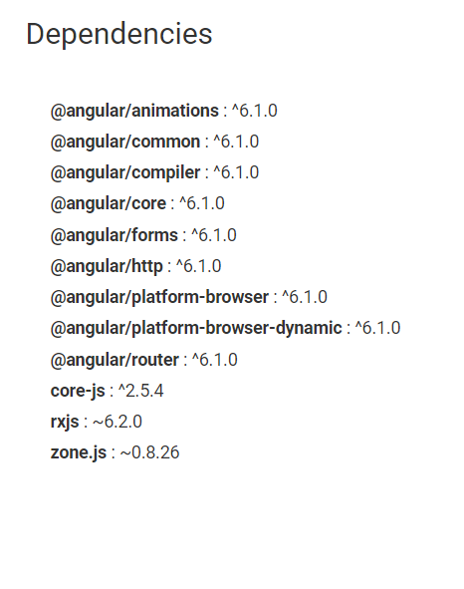

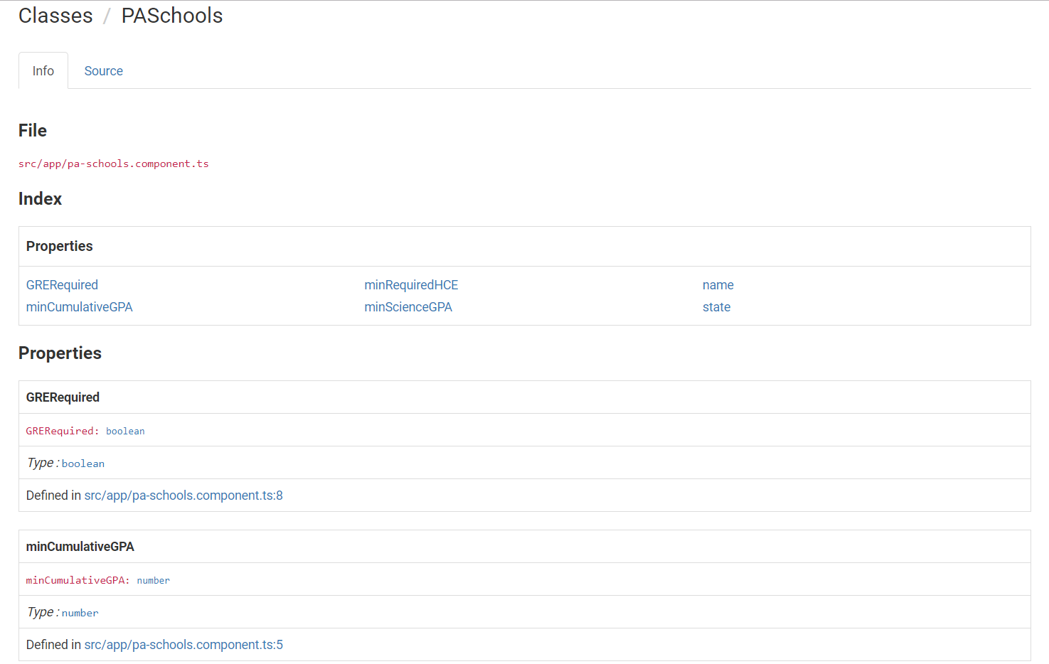

**License**

