Experiment artifacts
These are the materials we used to run our experiment: the app trial (main experiment) and the past-behaviour interviews.
1. Experiment site (Campus Events)
- Live site: https://soft4102-fall2026.github.io/soft4102-fall2026-section2-team-03/prototypes/
- Code: prototypes/ folder in this repository
- Our Lab 06 prototype, updated after feedback and put online with GitHub Pages. It shows upcoming UDST events in one place, with search, filters, event details, seats and registration.
- Each participant gets their own link with a code (for example ?p=S03). When they open the site, the code and the date are saved in the visit log. This is how we can see who comes back and on which days.
- The site says it is a student project and not an official UDST service. It does not send any reminders or notifications.
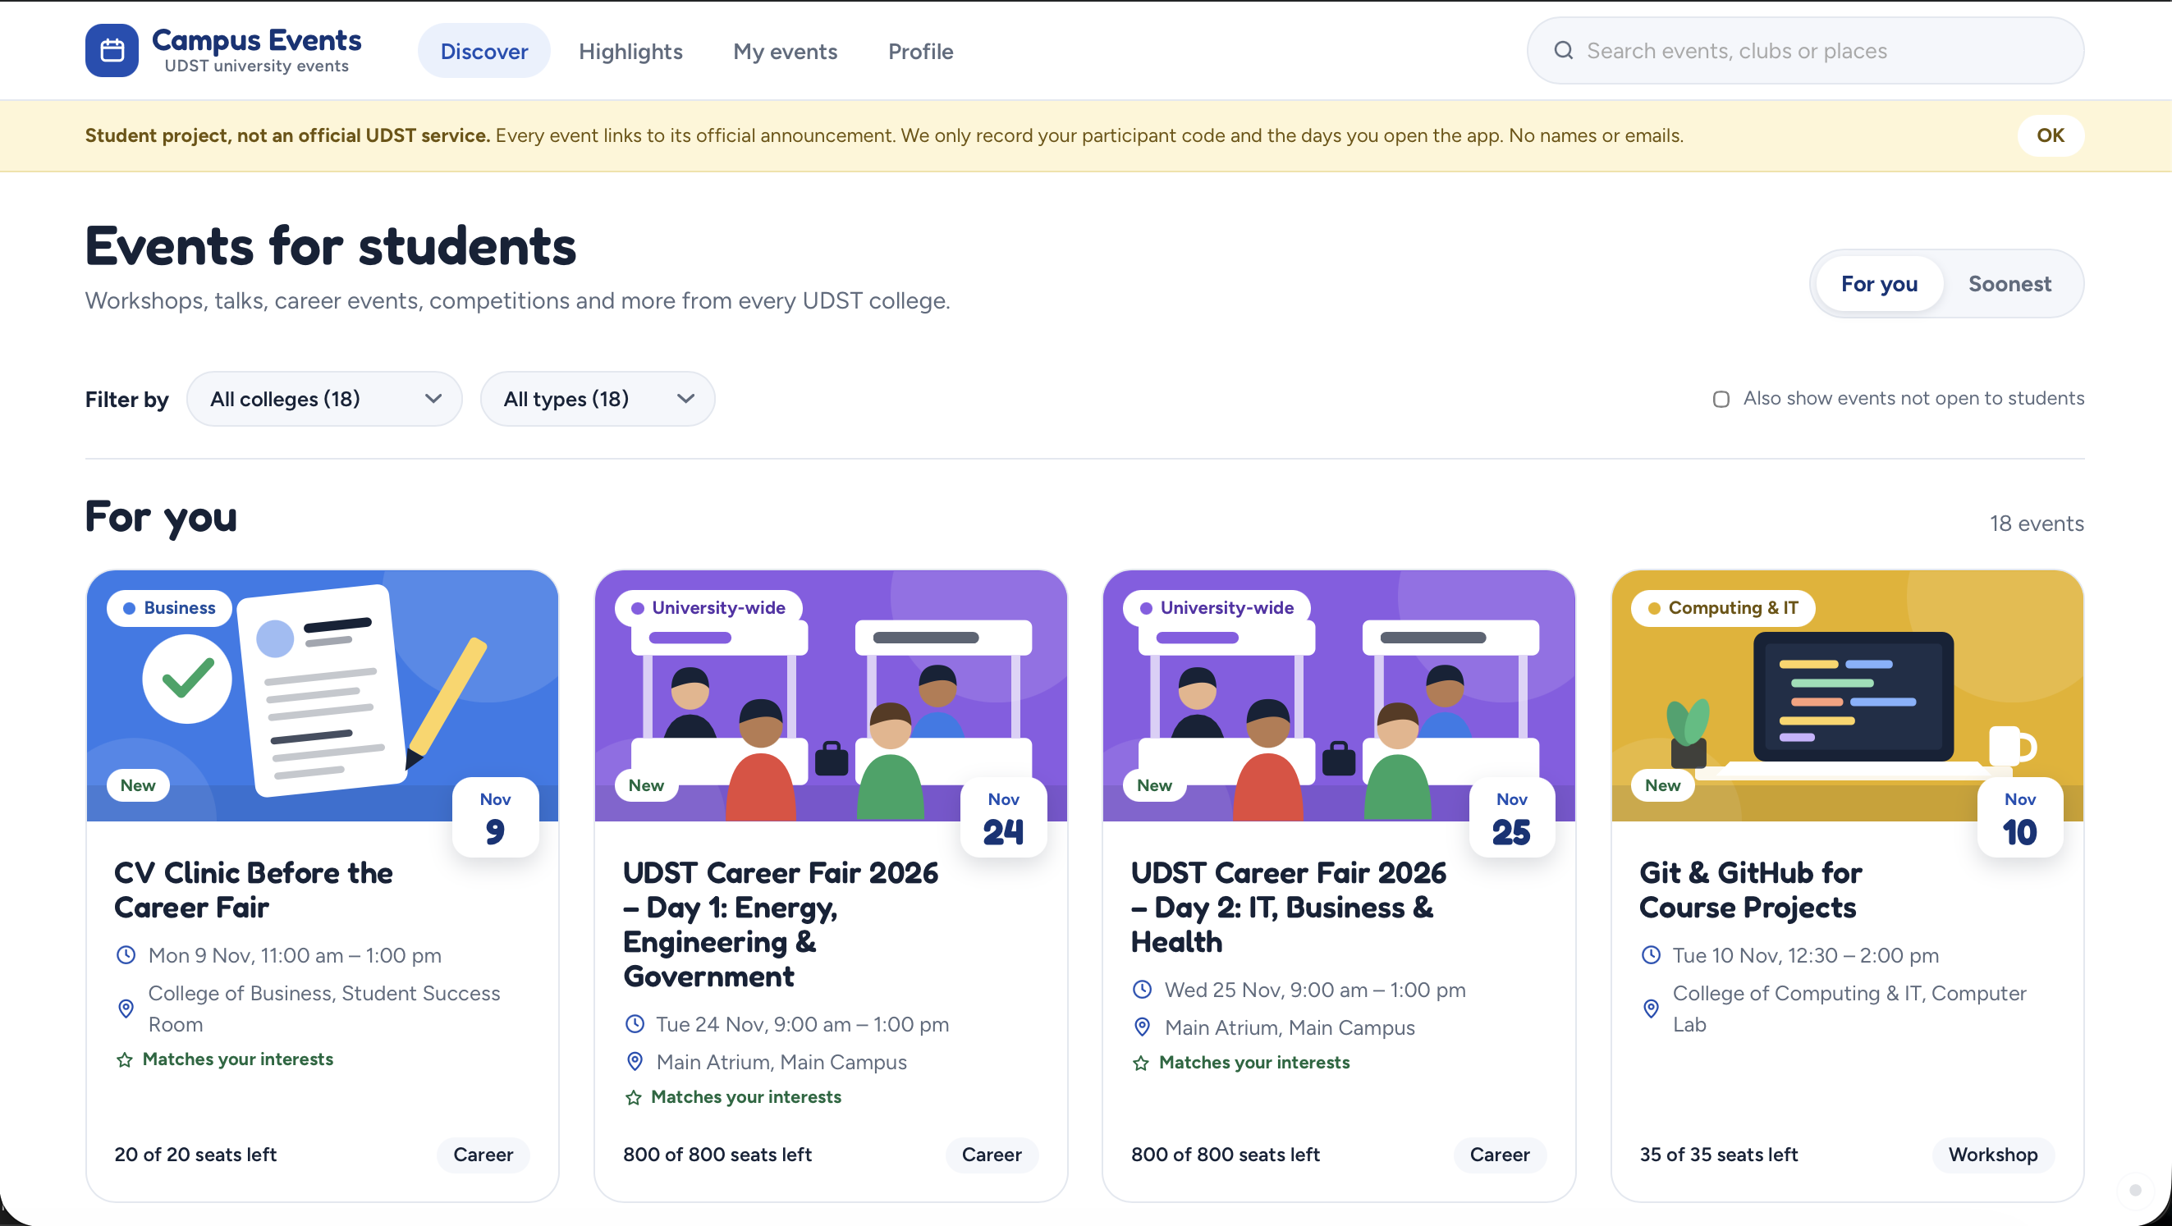
Screenshot 1: the Discover page of the live site
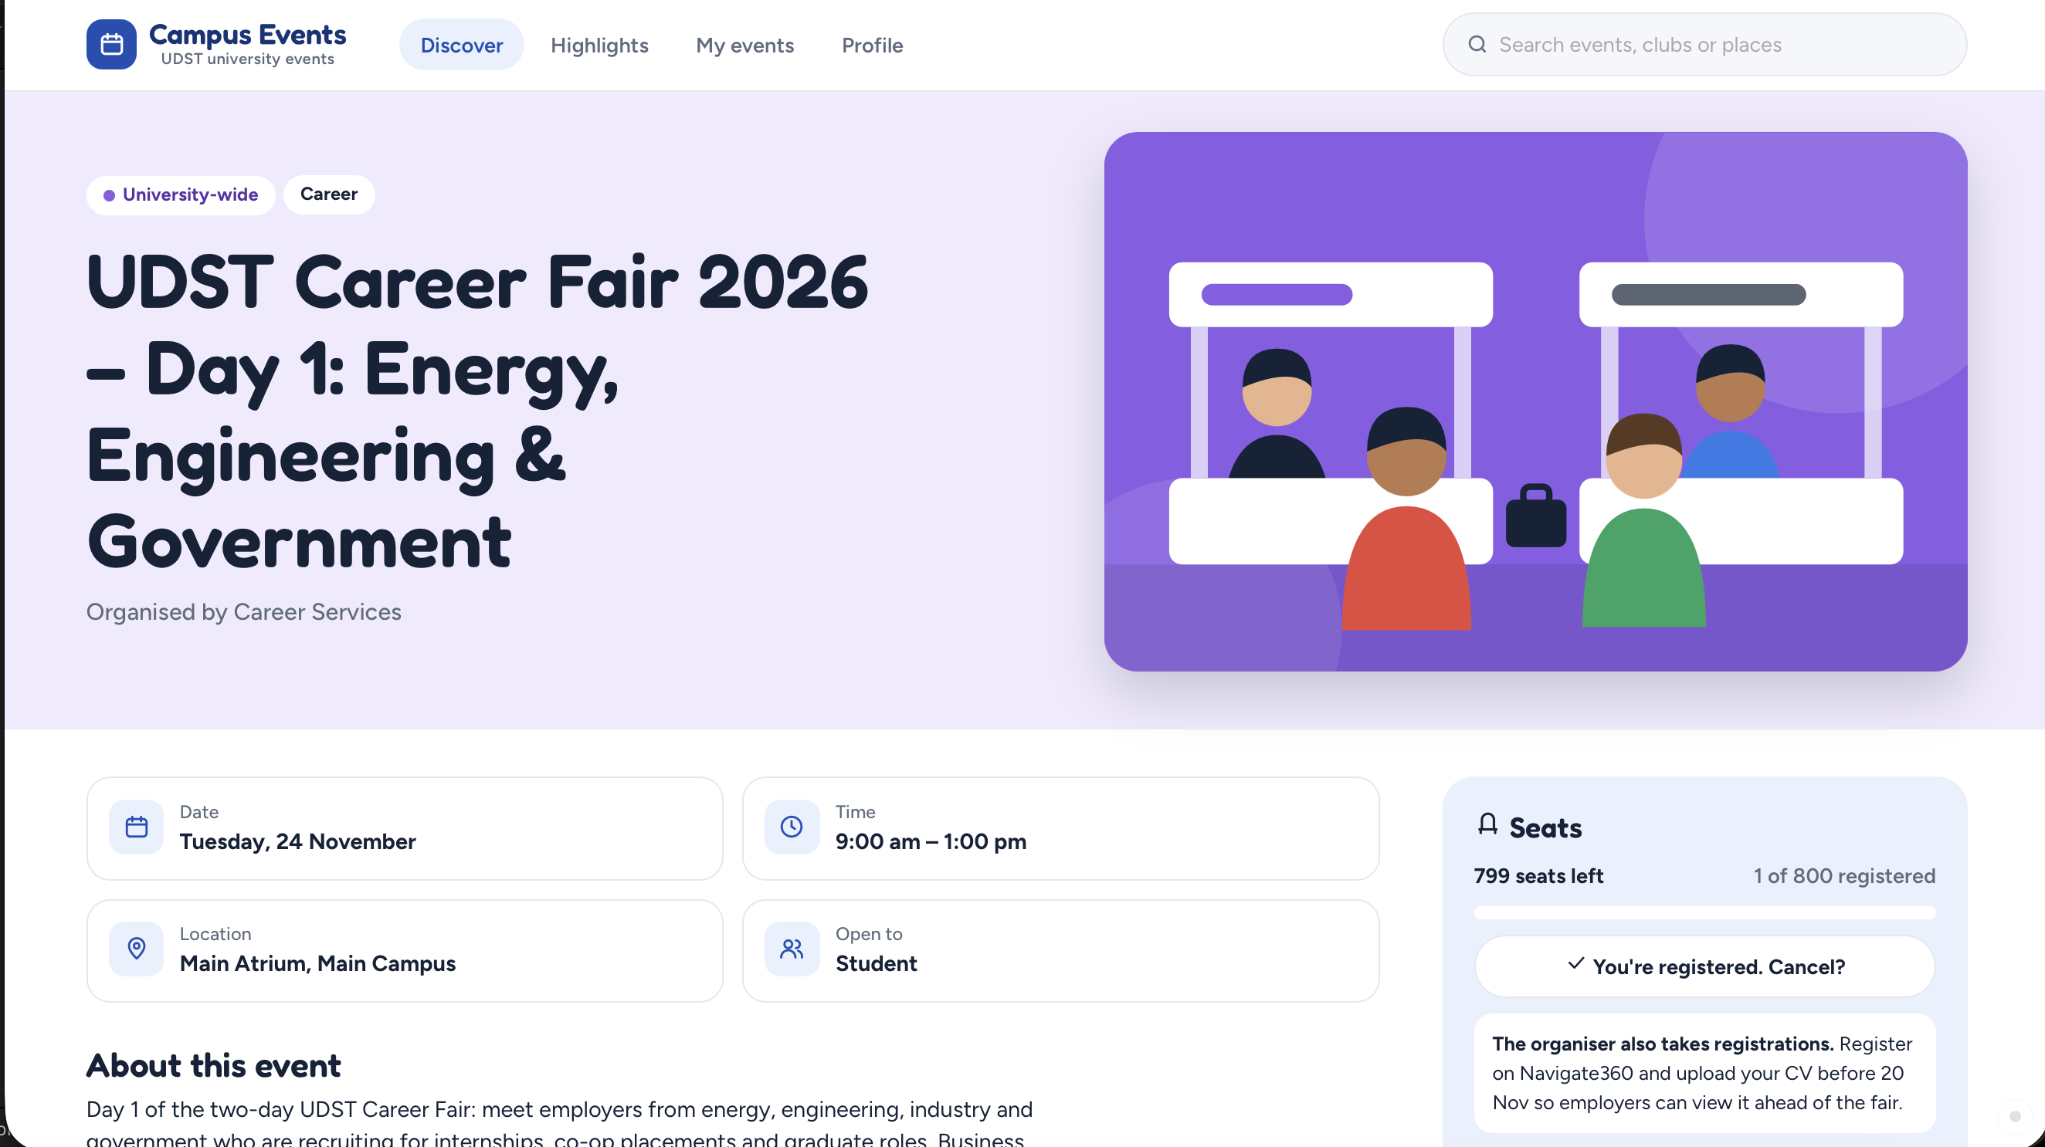
Screenshot 2: an event page with date, location, seats and registration
2. Visit log (Google Sheet)
- Link: https://docs.google.com/spreadsheets/d/1j_DFVVeXT3NT0tn03p-bWqBy-LME4X-LsdrbC9dVzhY/edit?usp=sharing
- The site fills it in automatically. It saves the time, the date (Qatar time), the participant code, a random device ID and what they did (opened the site, opened an event, used a filter, registered).
- No names, emails or locations are saved.
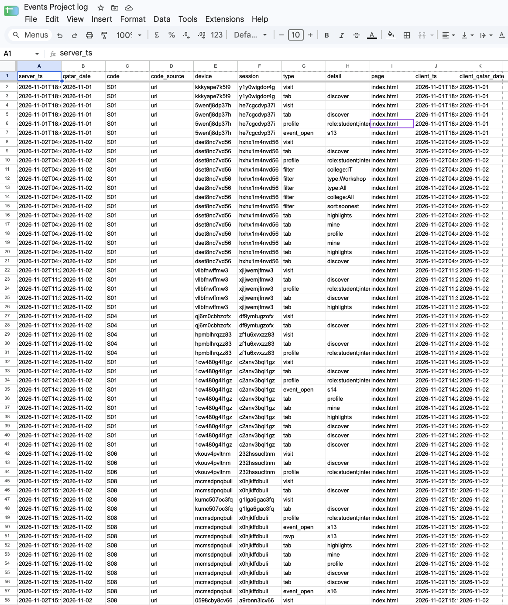
Screenshot 3: the visit log in the Google Sheet
How we count visits:
- One visit = one day per participant code (Qatar time).
- Opening the site many times, or on two devices, on the same day counts as one day.
- S01 is our team test code and is not counted.
- Days 1 and 2 do not count as returns.
- A participant "returned" if they opened the site on 2 or more different days between Day 3 and Day 10.
3. Consent
What we told participants before sending the link:
"This is a SOFT4102 student project at UDST, not an official UDST service. We're testing a website that lists upcoming university events. You'll get a personal link and can use it however you like for about 10 days, then we'll ask you one short question. We only save a code, the days you open the site and what you click, not your name or email. You can stop at any time."
4. Message sent with the link
Everyone got the same message with their own link:
"Hi! Thanks for helping with our course project. Here's your link to Campus Events, a list of upcoming UDST events: [link]. Use it however you like, or not at all. After 10 days I'll ask you one short question. Thanks!"
We don't tell people to "check it often" or "come back", and we don't send reminders after the link.
5. Interview questions
Asked by phone call or text message. We did not mention our app.
1. Event: the last uni event you went to or thought about going to
2. How you heard: where did you first see it? Instagram, Outlook, a friend, a poster...
3. What you checked: what did you look at before deciding, and where?
4. Checking on your own: when was the last time you looked for upcoming uni events yourself, without anyone sending it to you? Last week / last month / more than a month ago / never. Where?
5. Navigate360: have you ever used the events section? When was the last time?
6. Missed events: have you ever missed an event because you found out too late? What happened?
Answers: 04_observations/interviews
6. Tally sheet (return visits)
This tally will be completed after Day 10 (10 November). For now only Days 1 and 2 are filled in from the visit log (Day 1 = 1 Nov, Day 2 = 2 Nov). X = opened the site that day.
Code | D1 | D2 | D3 | D4 | D5 | D6 | D7 | D8 | D9 | D10 | Return days (D3–D10) | Returned?
S02 |  | X |  |  |  |  |  |  |  |  | – | –
S03 |  | X |  |  |  |  |  |  |  |  | – | –
S04 |  | X |  |  |  |  |  |  |  |  | – | –
S05 |  | X |  |  |  |  |  |  |  |  | – | –
S06 |  | X |  |  |  |  |  |  |  |  | – | –
S07 |  | X |  |  |  |  |  |  |  |  | – | –
S08 |  | X |  |  |  |  |  |  |  |  | – | –
S09 |  | X |  |  |  |  |  |  |  |  | – | –

All 8 participants first opened the site on Day 2. Nobody can count as returned yet, because returns are only counted from Day 3.
Result (after Day 10): ___ of 8 returned on 2+ days. Success = 60% or more, failure = 30% or less, anything in between = inconclusive.
7. Final question (after Day 10)
"Think of the last university event you went to or seriously considered. Where did you first hear about it?"
It is the same as the "How you heard" interview question, so we can compare before and after using the app.
8. Privacy
- Participants agreed before taking part and can stop at any time.
- Only codes are saved. The list of who has which code stays with one team member and is deleted after the experiment.
- No reminders, and we did not include our own instructors.

