External Customer App (Web)
Login Screen
Home Screen
• My Appointments (Upcoming, Past - collapsed div)
• C
ancel Appointment
• “New Appointment” button
Booking Flow Screen
• Language selection
• Stepper at top: Select Queue → Select Service → Choose Date → Choose Slot → Additional Info → Confirm.
• Calendar widget with blocked/unblocked days.
• List view of available times once a day is picked.
Staff Dashboard (Web)
• Two-panel layout with left-nav for All/Expired/Queued/Appointments
Details pane with filtered list-view
FCFS Queue View
• Center panel: ordered queue of customers, color-coded by status.
• Action bar: “Serve,” “No-Show,” “Send-Message,” “Reassign-Move.”
Appointment List View
• Tabbed navigation: Yesterday, Today, Tomorrow
• Table with columns: Time, User, Service, Status, Notes.
Calendar View (Appointments Only)
• Month-view (default)
• Navigation to +/- months
Appointment / Customer Details
• Popup or side-slide-panel
Services & Staff Management
• Two-panel layout: left nav for Services, Staff, Roles, Reports.
• Detail pane shows selected option list-view & details
Reporting Dashboard
• KPI cards at top: Avg Wait, Served Today, No-Shows, Bookings.
• Chart area: line graph of queue lengths over past week; pie chart of service distribution.

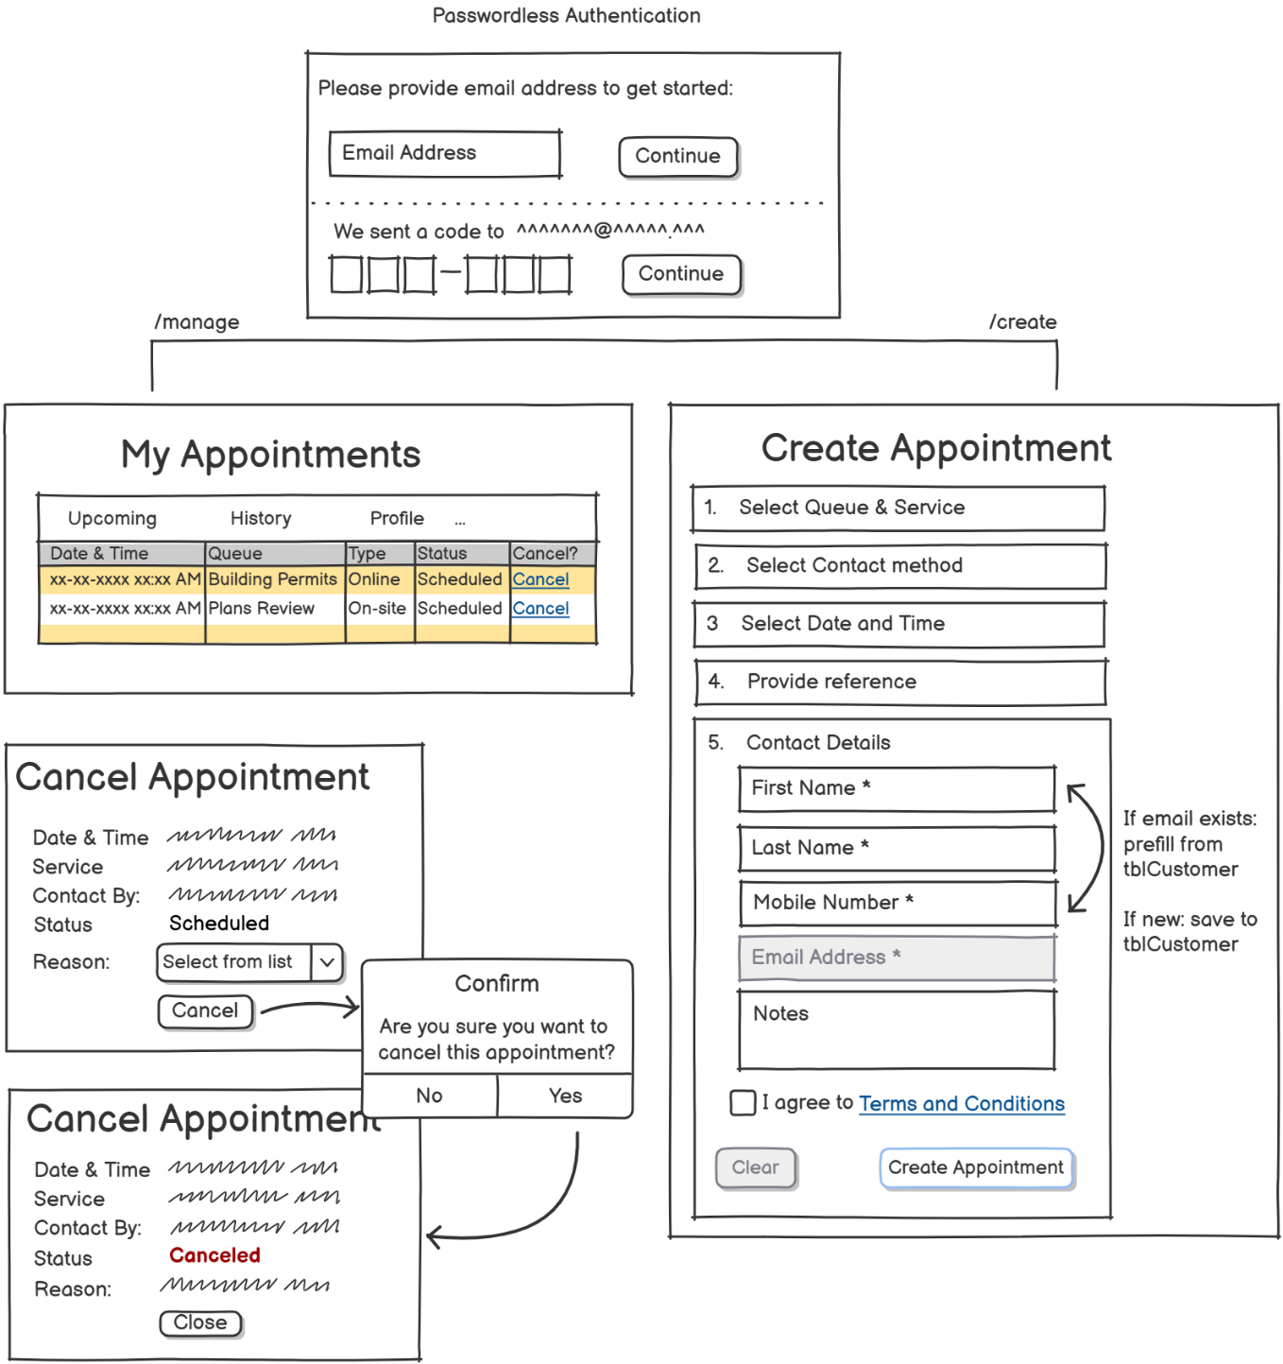

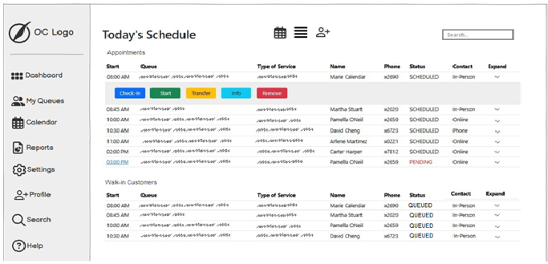

Status Before |  |  |  |  | Status After
Scheduled | Check-in | Start | Transfer | Remove | Arrived
Arrived | Check-in | Start | Transfer | Remove | Servicing
Servicing | Check-in | End | Transfer | Remove | Done
Done | Check-in | Start | Transfer | Remove | Canceled
Canceled | Check-in | Start | Transfer | Re-join | Scheduled
Scheduled | Check-in | Start | Transfer | Remove | Scheduled
update appointment-record with Q2; notify Q2-taker manually; add notes: transferred from Q1 by xxxx
Arrived | Check-in | Start | Transfer | Remove | Arrived
update appointment-record AND service-record with Q2; notify Q2-taker manually; add notes: transferred from Q1 by xxxx
Servicing | Check-in | End | Transfer | Remove | Scheduled
End-svc Q1-servicerecord and add new FCFS record for Q2 and a new FCFS-Q2 service-record
** If "Start" or "Transfer" clicked before "Checkin" - then ask on screen 'Do you want to check-in customer?'
