Appointment Management System
Business Requirement Document

Prepared By: Information Systems and Services
For: PEDS, Orange County, FL
Version: v1.5
Date: 11.03.2025

Approved By: ____________________________ Date: __________________

Table of Contents
1. Introduction 1
1.1 Purpose 1
2. Stakeholder Analysis 1
3. Key Components 2
4. Key Features 2
5. Workflows 3
5.1 Customer Component 3
5.2 Service Provider Component (staff-facing) 5
5.2.1 Transfer Customer 6
5.2.2 Virtual Meeting 7
5.3 Service Configuration Component (staff-admin-facing) 8
5.3.1 Queue Configuration 8
5.3.2 Add new User & assign Queue Permissions: 9
6. Discussion Items 9

1. Introduction
The proposed project is a comprehensive online appointment system designed to maximize convenience for both service providers and customers. This web-based platform offers clients an effortless way to schedule appointments for various services, allowing them to instantly view real-time availability for selected services and dates. Customers can choose between in-person, virtual, or phone appointments with automatic reminders delivered via email and SMS. This solution streamlines booking and enhances customer experience.

1.1 Purpose
The main purpose of this project is to empower users to book 24/7 with online appointment scheduling. It further facilitates all stakeholders accomplishing the following objectives:
- Reliability, Maintainability, Cost-effectiveness, and a User-friendly interface
- Booking the appointments at a convenient time and choice of contact method.
- Proper management of appointments.
- Save time by addressing questions and aiding in a timely manner.

2. Stakeholder Analysis
The proposed system is primarily focused on the following stakeholders / roles.

Customer: It is recommended that this is a registered FastTrack user. If the user is new to the website, they can register themselves for a non-contractor Fasttrack account at: https://fasttrack.ocfl.net/OnlineServices/signupeligibility.aspx by providing basic details such as name, email-id, password etc. Once they log in, they can see the dashboard with overview of profile, permits, inspections, appointments, etc. Under the Appointments option, they can view, manage and book appointment(s) for a range of service offered by the department.
One-time Guest access can be accommodated but with limited functionality.
Service Provider: These are Orange County PEDS staff members, Vertical & Horizontal Permitting Team Members, (front-desk staff, permit analysts, inspectors, plan reviewers, etc.). They can see the upcoming appointments and service the customers in their assigned queue(s). They can initiate the meeting, update status, and access the users’ contact information to send notifications.
System Administrator: The admin is responsible for setting and managing queues & services, availabilities, staff assignments, user profiles & access, and system settings.
Config Administrator: Technical support team/Super-Users with app-level and location-level access.
Report Viewer: Access to canned reports

3. Key Components
- Customer Component
- Service Provider Component
- Service Configuration Component
- Appointment Component
- Reporting Component
- Test Component

4. Key Features
- Ability to schedule Appointments.
- Ability to request appointments for: In-person, Virtual meet and/or Phone call.
- Ability to request multiple appointments for multiple services.
[Limit to a maximum of 3 upcoming meetings; can be scheduled up to 1 month in advance]
- Ability to receive and opt-in/out for SMS notifications, update phone number.
- Ability to manage queues and services completely.
- Ability to transfer customers between queues.
- Ability to track each appointment/visit from check-in to service rendered.
- Ability to collect metrics on usage/volumes, services rendered, returning customers, wait times, etc.
For consideration in next phase:
- Ability to schedule Pre-review meetings.
- Ability to schedule Pre-construction meetings.
- Ability to schedule meetings to discuss Deficiency Comments.

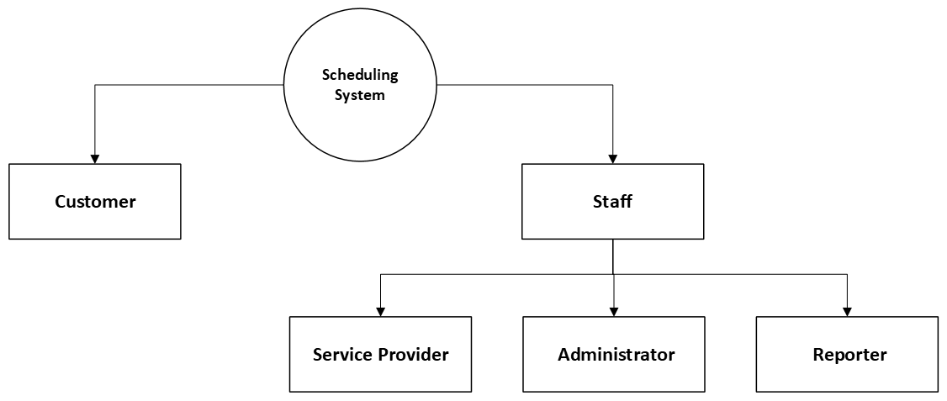

5. Workflows

5.1 Customer Component
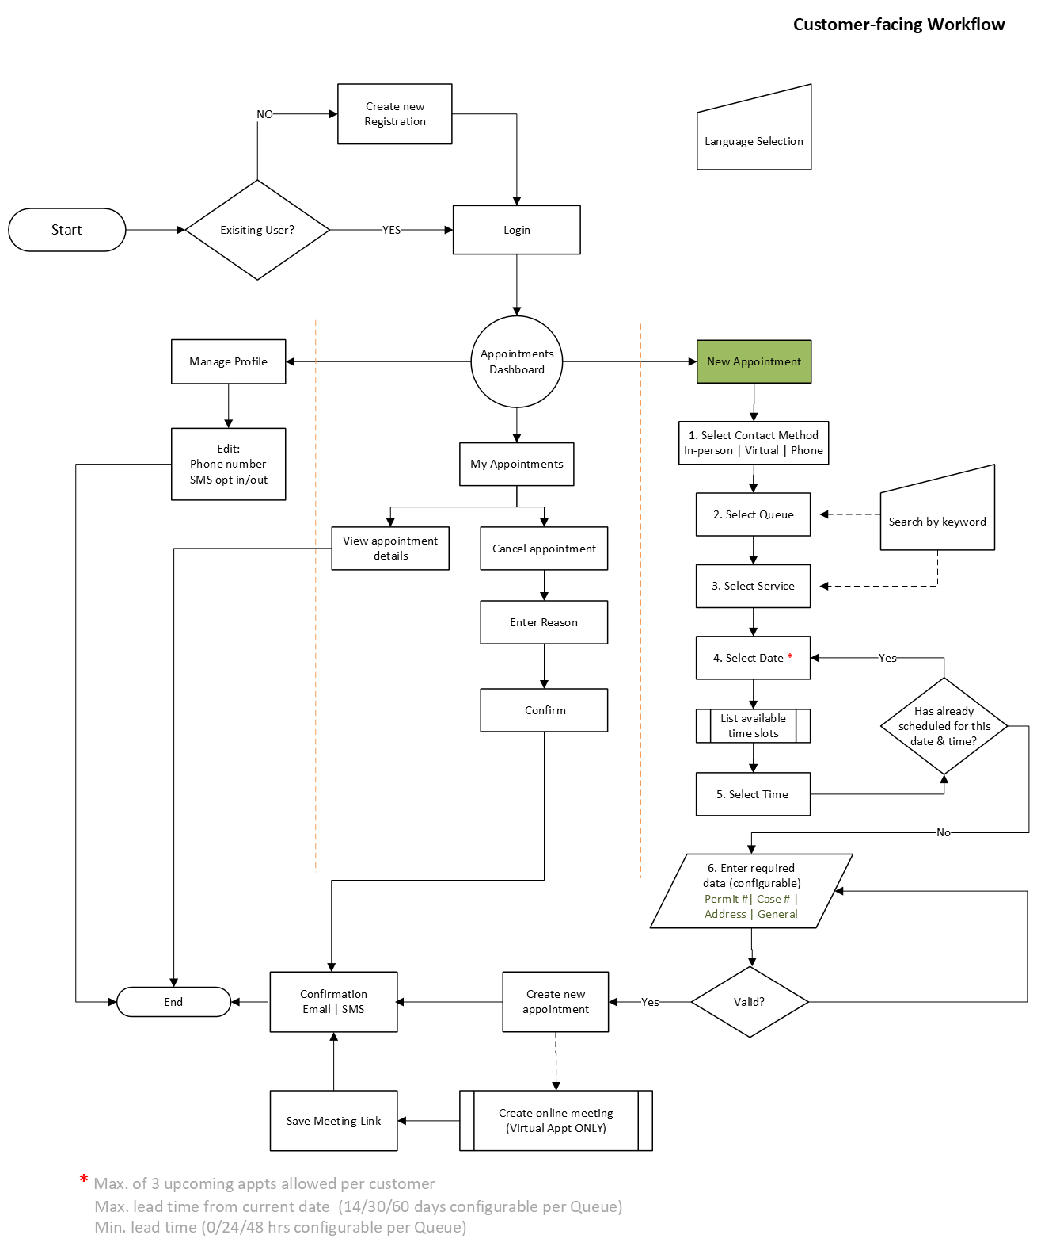
Customer component – Prototype of screens
*11.18.2025 - Display 1st available Date by default {ChristineArrant] Make Phone mandatory [Allen-Zoning]
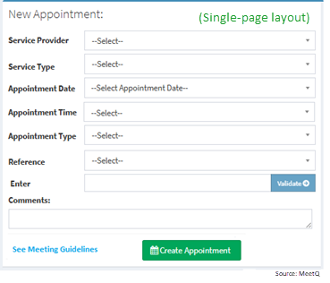
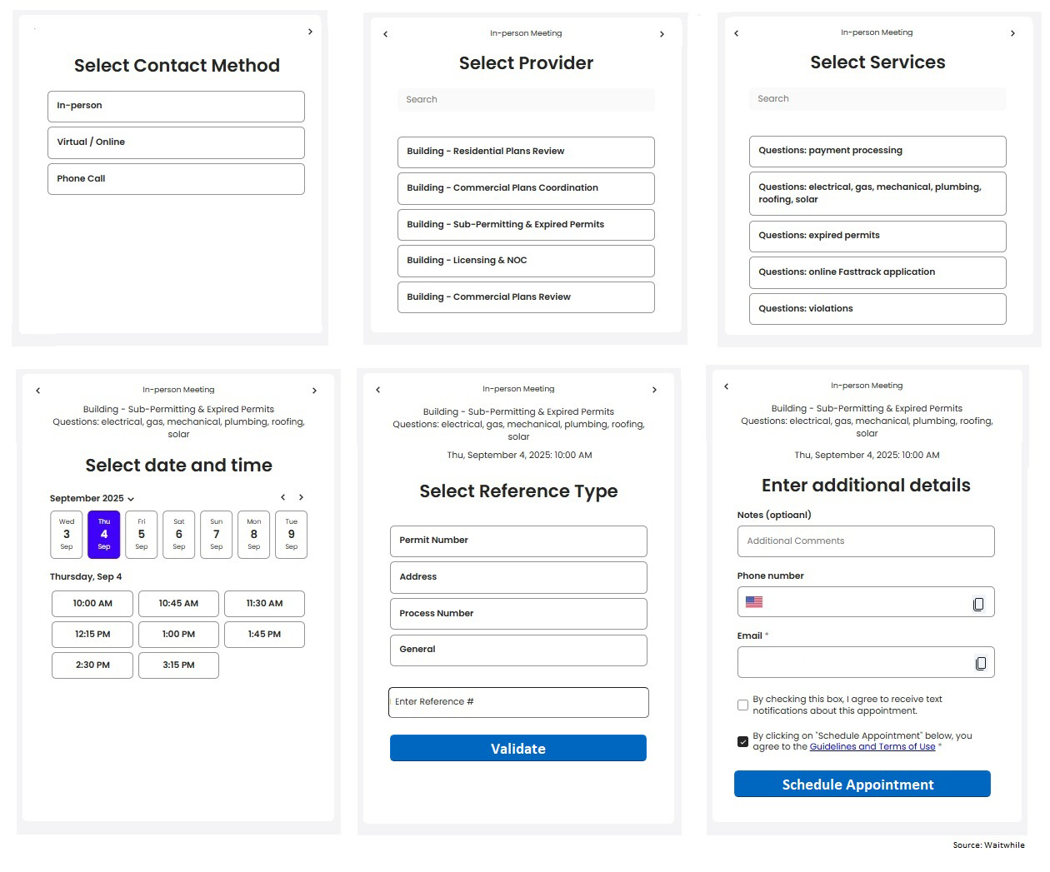
*Restrict scheduling to:
- Max. of 3 upcoming appointments
- Max. Lead Time: Up to 30 days in advance (configurable per Queue)
- Min. Lead time of 48 hrs. (configurable per Queue)

5.2 Service Provider Component
- Views Today’s appointments: List View & Calendar View
- Customer arrives Checks in with Front-Desk staff or self-check-in
- Provider notified (call from front-desk, email notification TBD)
- Provider “Begin Service” to starts meeting with customer
- Provider adds Notes and “End Service" after meeting with customer
- Provider Transfers customer to another queue if additional services are needed

*** All queues & appointments for a given day that are not updated with status will be System-Closed every night at end of that day. (TBD: notify Admin)

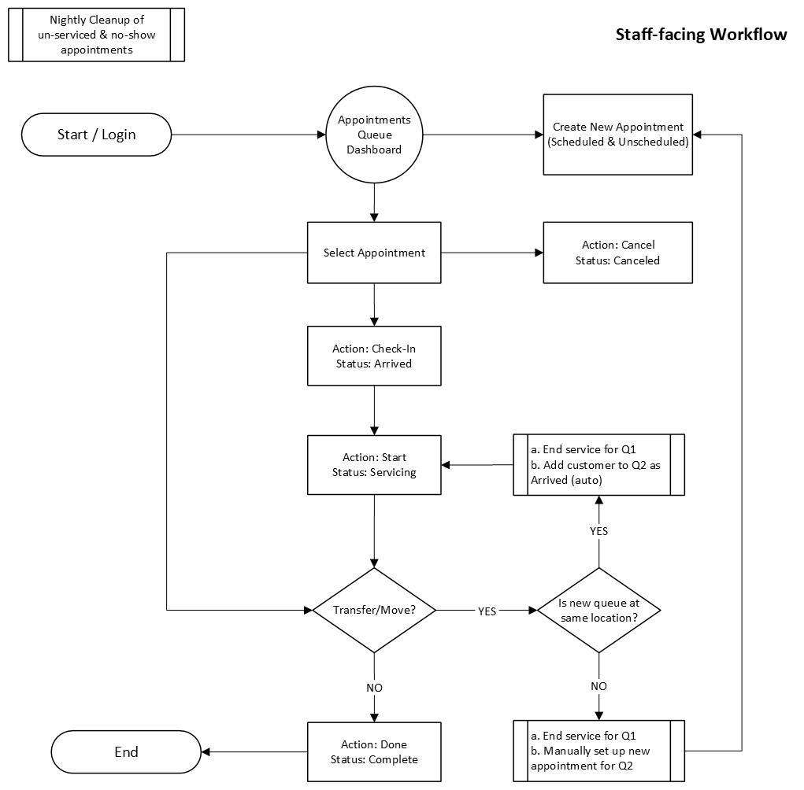

5.2.1 Transfer Customer
If Q2 is at the same location, then transfer customer to the new queue for a same-day first-come first-serve appointment.
- “Transfer” will End Q1 service and add customer to new Q2 service and marked as “Arrived”.
- Q1-ServiceProvider will walk the customer to Front-Desk
- Front-Desk staff will contact new Q2- ServiceProvider to receive the customer.

If Q2 is at a different location, then Q1- ServiceProvider will assist the customer to schedule an appointment for a later date/time for the new Q2 service. This is NOT a transfer, but rather a new appointment for Q2 service.
- End Q1 service and assist the customer with scheduling Q2 appointment (staff-assisted or self-service)

Prototype of Dashboard – 1) List-view of appointments for the queue(s) assigned to the logged-in user
2) Calendar-view and 3) Details-view

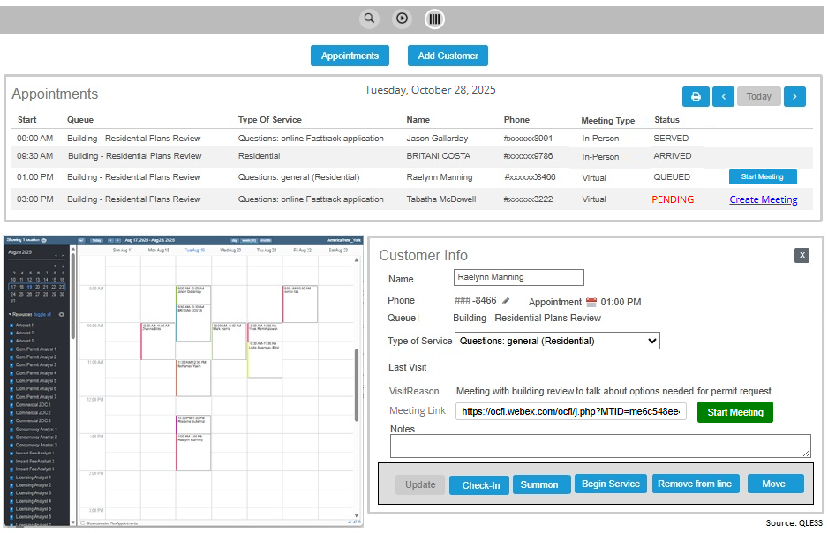

5.2.2 Virtual Meeting
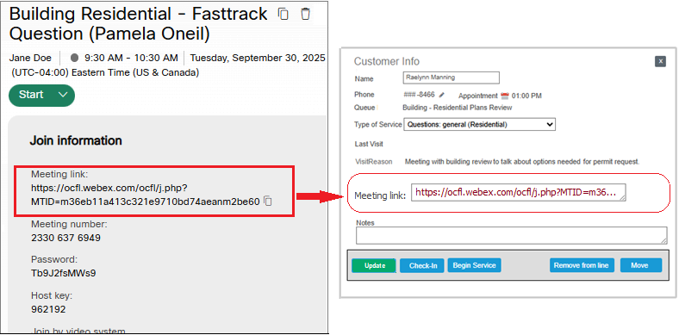
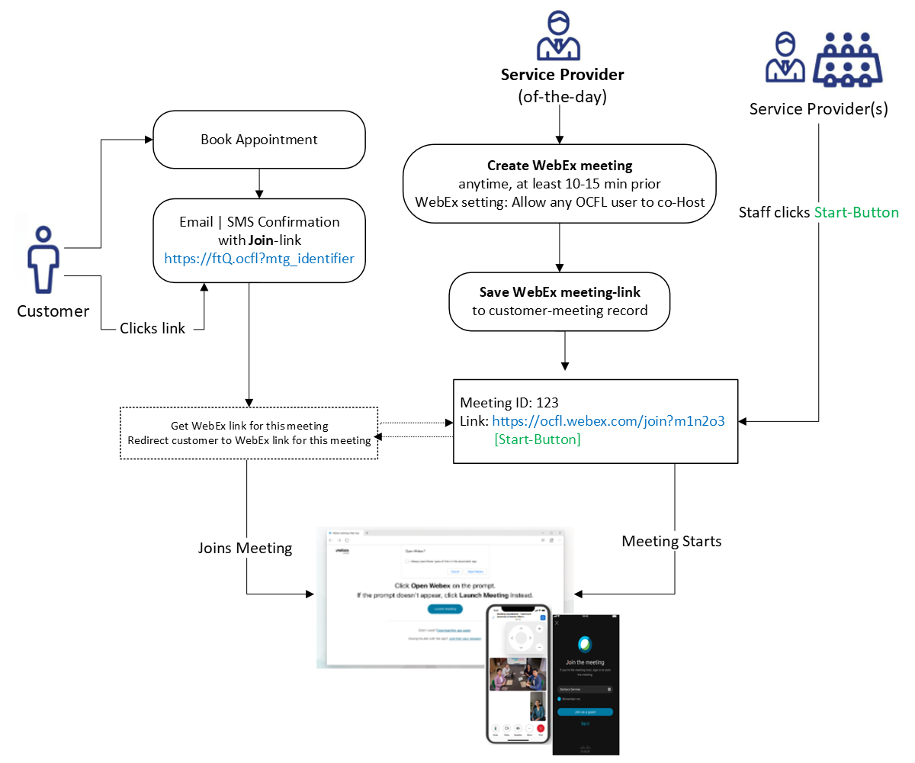

5.3 Service Configuration Component
System Administrators can:
- Set Holiday schedule (automatically import AMANDA’s Holiday schedule)
- Set other predetermined times
- Assign Location start/open times
- Administer Queues (Service Provider) – schedules, docs, guidelines, lead-times for appointments, Reference options (ex.: Permit/Address/Case/General)
- Administer Services (Service Type)
- Assign Roles: Reception | Service Provider | Service Admin | Config Admin | Reporting
- Manage Resources/Users: Name, email, phone, language, role/permissions, location-assigned, queue(s) assigned, service(s)-assigned,

5.3.1 Queue Configuration
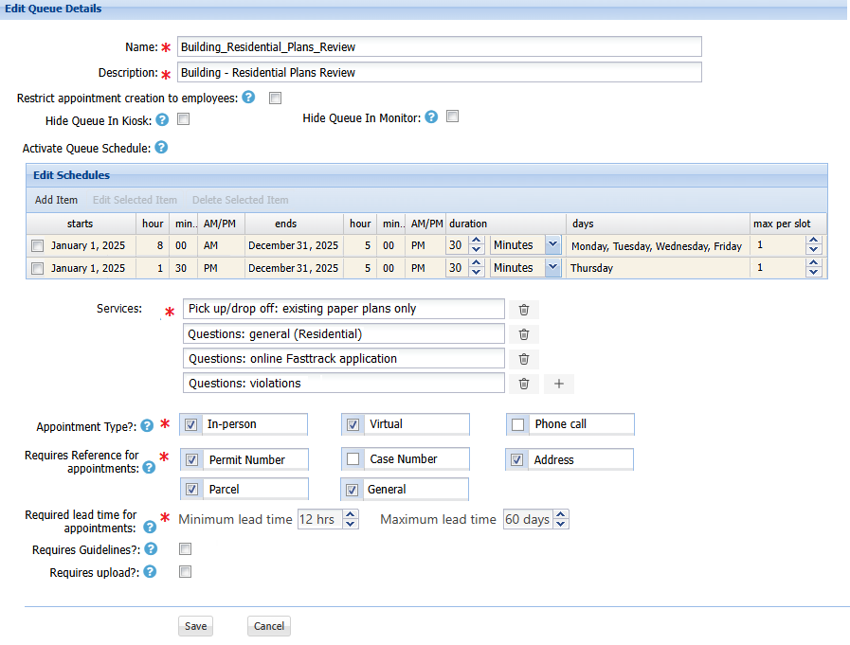
If Needed, Queue can be linked to Dept, Div, Sec, Team or Office

validLocations – validTeams - validQueues – validServices – validAppointmentTypes – validCriterias

5.3.2 Add new User & assign Queue Permissions:

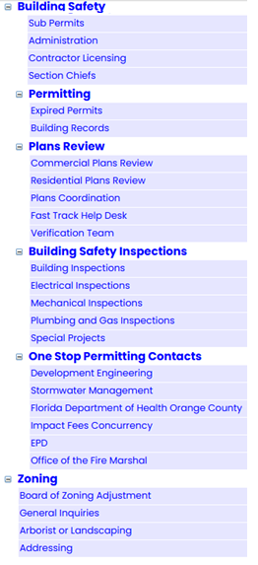
Add new User:
First Name: _____ Last Name: _____ Email: _____ Title: _____
Password: ___ [only for system & test accounts, all others use SSO]
Speaks Spanish?

Is Config Admin? Is System Admin?

Select Location: Building, Zoning, etc.

Select Team: Permitting, Plans Review, Inspections, Licensing, etc.

Select Queues:
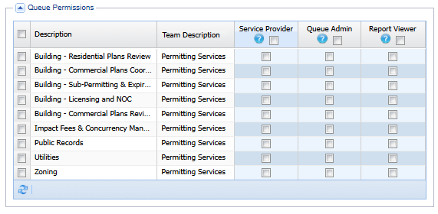

*Note: Selecting a queue automatically grants access to all services in that queue

6. Discussion Items
Identify participating Departments, Divisions, Sections, Units, Groups
Identify Queues for services offered for each participating entity

---- End of document ---

