
USBL Stable Coin Platform
Investor Presentation

Usbl Inc December 2023

Disclaimer
This introduction for informational purposes to help interested parties in making their own assessment with regard to the proposed trade. The data contained does not indicate to be allinclusive. This introduction contains financial figures with regard to certain of Usbl commerce and financial measurements, counting, but not restricted to, USBL in circulation, income, exchange volume, volume loaned, USBL accounts, wage, costs, edge, Seed Contribute closed volume, which are being given for illustrative purposes.
This introduction has been arranged for informational purposes and is confidential. This introduction contains confidential data concerning Usbl’s trade and commerce, but not restricted to, non-public financial data and/or projections. By tolerating this introduction you agree to keep it the data contained confidential and confirm that such data may not be replicated, duplicated or transferred in entirety or in portion.


Our Mission
Enhance financial value exchange that is frictionless to increase global economic prosperity.
Make significantly more open, linked, and interoperable financial system.
Payments are quick, seamless, and almost free.
Decisions about borrowing and lending are made by autonomous software, not by people.
Capital markets are just as international and diverse as other online markets.


The Future of Finances
Rebuilding the global economic system with internet-native technology from the ground up.
Traditional UX, legacy core
Regulated networks.
Separated from developer innovation.
Vulnerable and centralized.
Slow, costly, and complicated.
Electronic money with a closed loop.
Finance on the blockchain based on open networks
Blockchain based technology.
Deployed on the internet, full stack.
Based on open, global networks.
Smart contracts to for programmable money.
Scalable, universal, and effective.
Internet native currency's that effective and fast.


Foundation for Gen 2 Financial Services
Payments Commoditization & Value Storage.
For any type of payment and value exchange, fast and affordable settlement.
Financial inclusion gives support for the unbanked around the world, access to decentralized financial markets, and a way to send money home for cheap.
Electronic products and markets.
Internet-native markets for goods and services are converting digital assets and money in order to expand globally, reduce costs, and develop new business models.
Broad Real-World Asset Tokenization.
Stablecoins serve as native settlement rails for tokenized assets (such as securities, real goods, and digital goods).



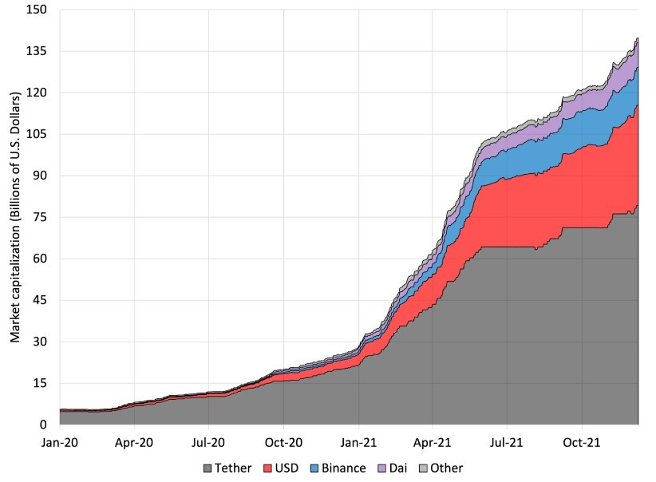
Stablecoins Introduced
The global financial system meets Internet-native currency — Usbl created & operated USBL Coin.
USBL is

A redeemable digital currency that represents a real-world dollar pegged at 1:1 Built on developing public blockchains like Ethereum.
Instantaneous global transfer 24 hours a day, 7 days a week.
Smart contracts enable open, interoperable, and programmability.
Compatible with digital currency rules and regulations.
USBL is not
Replacing the current central bank currency.
Subject to market turbulence in comparison to the matching fiat. Bound by the transferability restrictions associated with traditional fiat currencies
Closed, centralized system.
USBL is a bearer asset and is subject to counterparty risk.

A massive market opportunity expected to play out over decades

Blockchain and crypto entities are forming the basis for a new global financial infrastructure


Usbl operates a platform of internet native financial services The core market infrastructure of USBL
API services provide a comprehensive suite of payments and other services.
Send & Receive on-chain payments free and instant with an easy to use browser interface.
Seamlessly intergate USBL payments, payouts and account functions into custom apps.
Interest on USBL lent into borrowing markets.

CUSTOMERS
Banks & Other Institutions.
Institutional Finances.
Digital Creators.
Ecommerce & Marketplaces.
Blockchain Startups.

Significant Investment achieve Significant Results
Significant team growth in product and engineering.
Investment in technology to support global scaling. Creation of new products, innovation in the fundamental infrastructure of crypto-economic system.

Scaling up in support of new niches and global expansion Investment in broad-based corporate, brand, and product marketing
Accelerating the product vision through the acquisition of identified targets.

Strategic investment fund to encourage business collaborations and wider ecosystem coverage.
Highlights
We are at the beginning stages of digital currency that redefine money, transactions and financial services.
Massive network effect that accelerate adoption.
Serving wide array of customer use-cases.

Attractive economic model that scale, grow and profitable.

Drawbacks
Generated internal estimates, analysis, and forecasts that serve as the foundation for our projections. Our actual operating results could differ considerably and negatively from those anticipated or predicted if these assumptions, assessments, or estimates turn out to be false or wrong.
Cyberattacks and security lapses that affect our systems, or those that affect our clients or other parties, could have a negative effect on our business, operating performance, and financial situation.
In order to give our users access to decentralized finance protocols, currently forming relationships in progress.
Our operating performance for each quarter could vary.

