SSB INDUSTRIES
Stainless Steel Bottle Manufacturing
Manufacturing ERP
User Manual
All portals · for end users and administrators
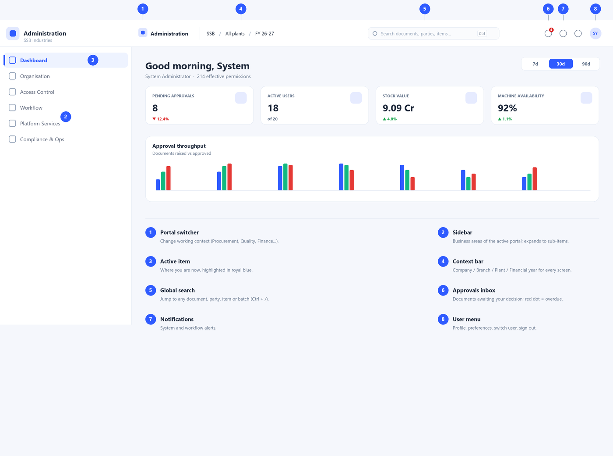

Version 0.1 · August 2026 · Internal use
This manual describes the web application. Screens are represented by annotated diagrams that match the product's layout and design.

Contents

1. Introduction

1.1 What this system is
The SSB Manufacturing ERP is one connected system that runs the business end to end — from buying stainless-steel coil, through production, quality and packing, to dispatch, invoicing and payroll. Instead of separate spreadsheets and disconnected tools, every department works on the same live data, and every document (a purchase order, a production order, an inspection, an invoice) follows the same rules for numbering, approval, and audit.
The application runs in a web browser. It is designed to be calm and consistent: once you learn how one screen behaves — how to search, filter, create, and approve — every other screen in every portal behaves the same way.

1.2 Portals: your working context
The product is divided into portals. A portal is the part of the product a person works in day to day. A storekeeper receiving goods works in the Inventory portal; a buyer works in Procurement; a quality engineer in Quality. You sign in once and can switch portals at any time from the top-left switcher. Portals are a convenience for focus — what you are actually allowed to see and do is always decided by your permissions, not by the portal you are in.
- Core operations: Procurement, Inventory, Production, Quality, Dispatch, Finance.
- Planning & engineering: Product Engineering (BOM/routing) and Production Planning.
- Support & people: Maintenance, HR & Payroll, Master Data.
- Oversight: Analytics & Insights, and Administration.

1.3 Who this manual is for
This manual is written for two audiences and is useful to both. Sections 1–3 and the portal chapters (4–16) are for everyday users — operators, buyers, storekeepers, planners, accountants. Section 17 is for administrators who set up companies, users, roles, masters, workflows and numbering. Appendices give quick reference for statuses, shortcuts and terms.

1.4 How to read the screen diagrams
Because the product is still evolving, the screens in this manual are shown as clean annotated diagrams rather than photographs. They match the real layout, colours and controls, and the numbered markers point to the parts explained in the text beside them. What you see on screen will look the same in structure.

2. Getting started

2.1 Signing in
Open the application URL in your browser. You are asked for your email and password. After you sign in you land on your home dashboard; from there you can switch to any portal your role allows.
- Enter your work email and password.
- Optionally tick “Remember this device” on a trusted personal computer (never on a shared shop-floor terminal).
- Select Login. If your account uses a one-time code, enter it when prompted.
- You arrive at your dashboard. Use the portal switcher (top-left) to move to the area you need.
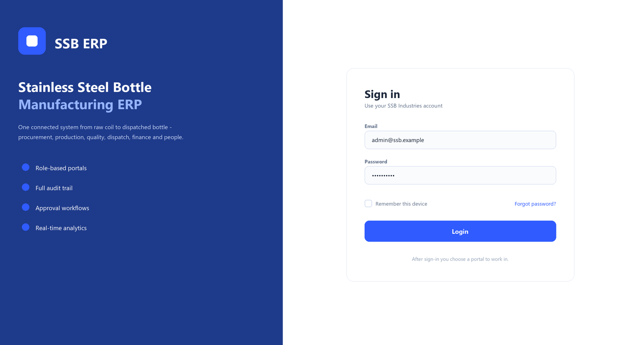
Figure 2.1 — The sign-in screen. After signing in you choose a portal to work in.
Security note: never enter your password into any screen that was reached from an email link you did not expect, and sign out when you leave a shared terminal. The system never asks for your password by email or chat.

2.2 The workspace
Every screen shares the same frame, shown in Figure 2.2. Learn these eight parts once and you can find your way anywhere in the product.

Figure 2.2 — Anatomy of the workspace. The numbered parts are explained below.
- 1 Portal switcher — changes your working context (Procurement, Quality, Finance, and so on).
- 2 Sidebar — the business areas of the current portal. Groups expand to show their screens; only one group opens at a time to keep it calm.
- 3 Active item — where you are now, highlighted in royal blue.
- 4 Context bar — the Company, Branch, Plant and Financial year that every screen is filtered by. Change these to move between sites or periods.
- 5 Global search — jump straight to any document, party, item or batch. Press Ctrl + / from anywhere.
- 6 Approvals inbox — documents waiting for your decision. A red dot means at least one is overdue.
- 7 Notifications — system and workflow alerts.
- 8 User menu — your profile, preferences, switch user, and sign out.

2.3 Finding things quickly
- Global search: press Ctrl + / and start typing a document number, a customer, an item code or a batch.
- Sidebar: click a group to expand it, then a screen. The active screen stays highlighted.
- Context bar: if a screen looks empty, check you are on the right plant and financial year.
- Approvals: the inbox icon is the fastest route to everything waiting on you.

3. Working conventions (the same everywhere)
Screens in the product are built from a small set of repeating patterns. Learn these and every portal becomes familiar.

3.1 List screens
Most screens are lists — of purchase orders, stock items, inspections, employees. They all share the layout in Figure 3.1.
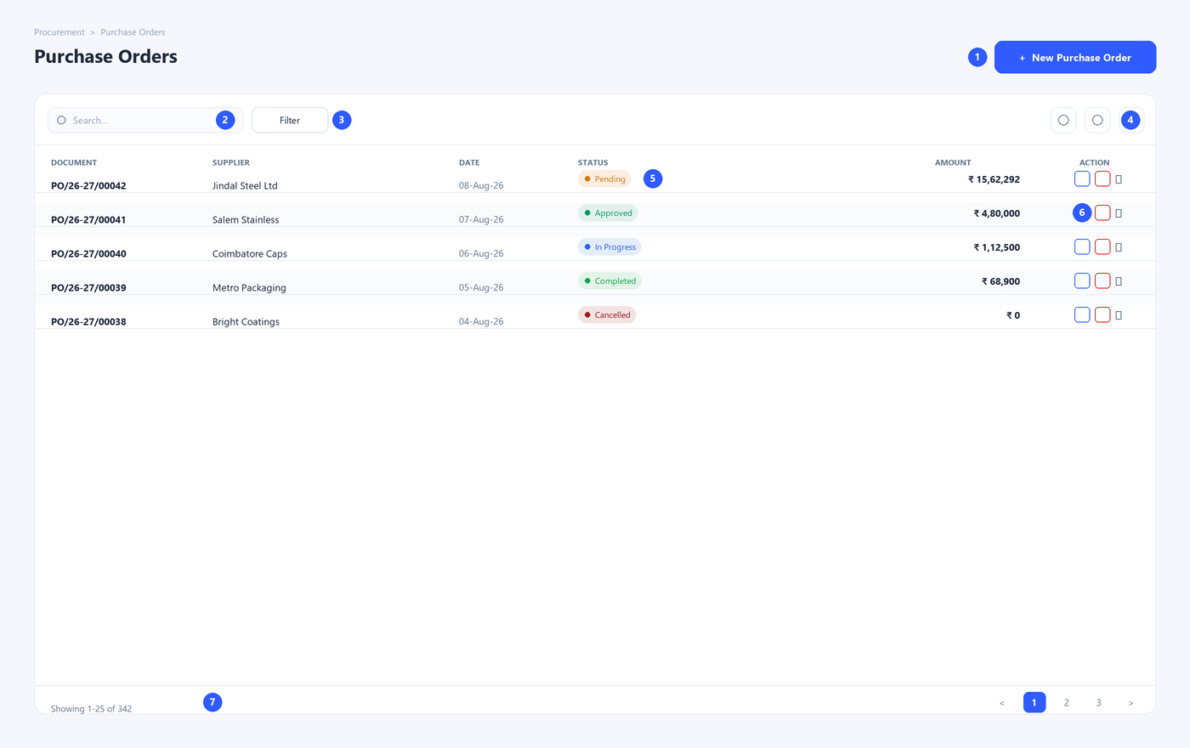
Figure 3.1 — A standard list screen.
- 1 Primary action — the one main thing to do here (for example, New Purchase Order). It is the only filled blue button on the screen.
- 2 Search — type to filter the list instantly.
- 3 Filter — narrow the list by status, date, party and so on. Applied filters show as removable chips.
- 4 Table tools — choose columns, export to Excel / CSV / PDF, and refresh.
- 5 Status — each row shows its status as a coloured badge with a label (never colour alone).
- 6 Row actions — edit and the main action are one click; anything else is under the “⋮” menu.
- 7 Pagination — move between pages; the count shows how many records match.
Tip: select rows with the checkboxes to reveal a bulk-action bar for doing the same thing to many records at once.

3.2 Forms
Creating or editing a document uses a form, organised into clear sections so you are not faced with fifty fields at once.
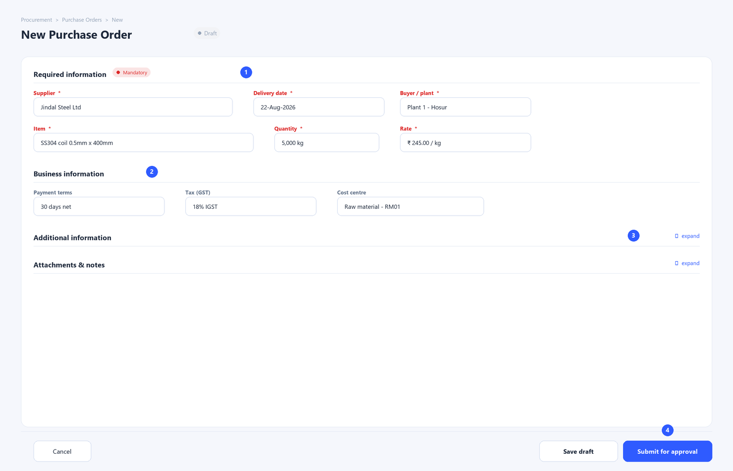
Figure 3.2 — A standard form.
- 1 Required information — the mandatory fields, marked with a red asterisk. Fill these to save.
- 2 Business information — the usual optional-but-important fields (terms, tax, cost centre).
- 3 Additional & Attachments — rarely-needed detail and files are tucked into collapsible sections, opened only when needed.
- 4 Save / Submit — Save keeps a draft; Submit sends it into its approval workflow.

3.3 Status and the document lifecycle
Every transaction document moves through the same set of states, and the same colours mean the same thing across the whole product.
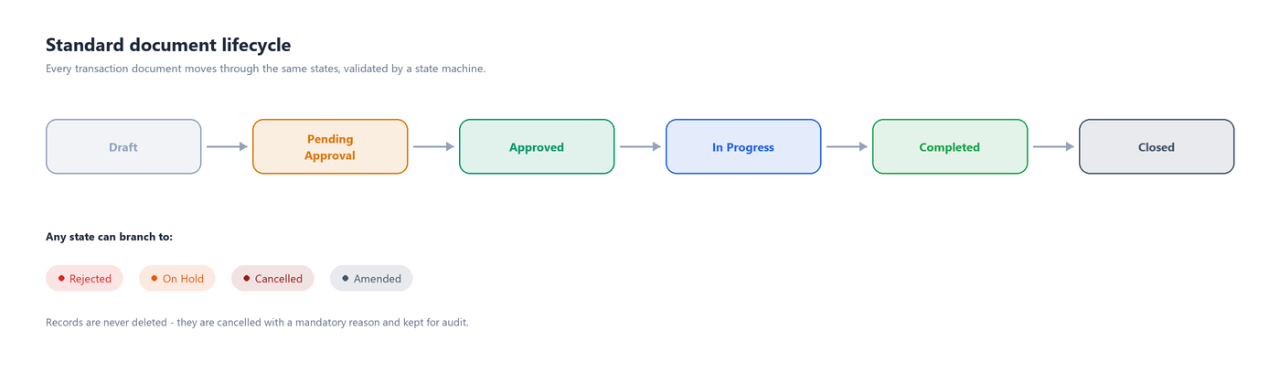
Figure 3.3 — The standard document lifecycle.
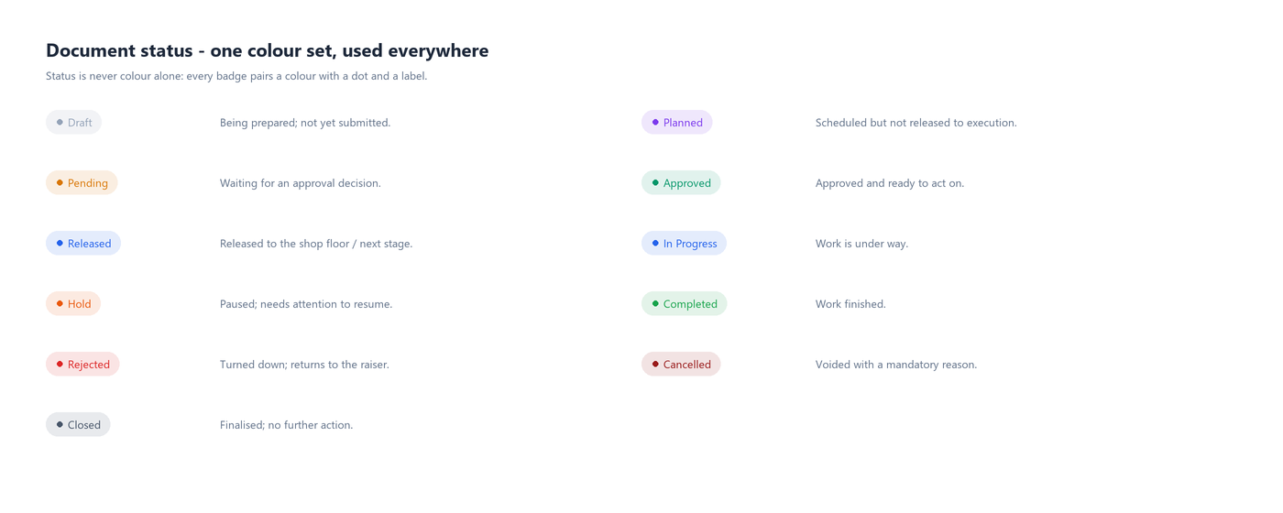
Figure 3.4 — The product-wide status colours.
Records are never deleted. When something must be voided it is cancelled with a mandatory reason, and it stays in the system for audit.

3.4 Approvals
When you submit a document, it goes to the people configured to approve it — often in several levels (for example, a large purchase order may need the buyer, then the manager, then finance). Approvers see it in their Approvals inbox.
- Open the Approvals inbox from the top bar (item 6 in Figure 2.2).
- Select a document to review its details, amounts and any warnings.
- Choose Approve, Reject (with a reason) or put it On hold.
- The document advances to the next level, or becomes Approved when the last level signs off.

3.5 Attachments, notes and audit
- Attachments — every document can carry files (drawings, scanned GRNs, certificates).
- Comments — a remarks thread lets colleagues discuss a document and @mention each other.
- Audit trail — who did what, when, and from where is recorded on every document and cannot be edited.
- Export & print — any list exports to Excel, CSV or PDF; documents print from a configurable template.

3.6 What you can see and do
The system enforces permissions on the server. If you do not have rights to an action, its button simply does not appear — so a storekeeper may see a purchase order but not its rates, and only an approver sees the Approve button. This is why two people can open the same screen and see slightly different controls.

4. Master Data
Master data is the shared foundation every other module relies on: the customers, suppliers, items, machines, tax codes and reference lists that transactions point to. Getting masters right and clean means every downstream document — a PO, a production order, an invoice — is correct by construction.
Primary users: Data-entry teams, department leads who own their masters, and administrators.
Priority: Foundation — set up before transactions, maintained continuously.
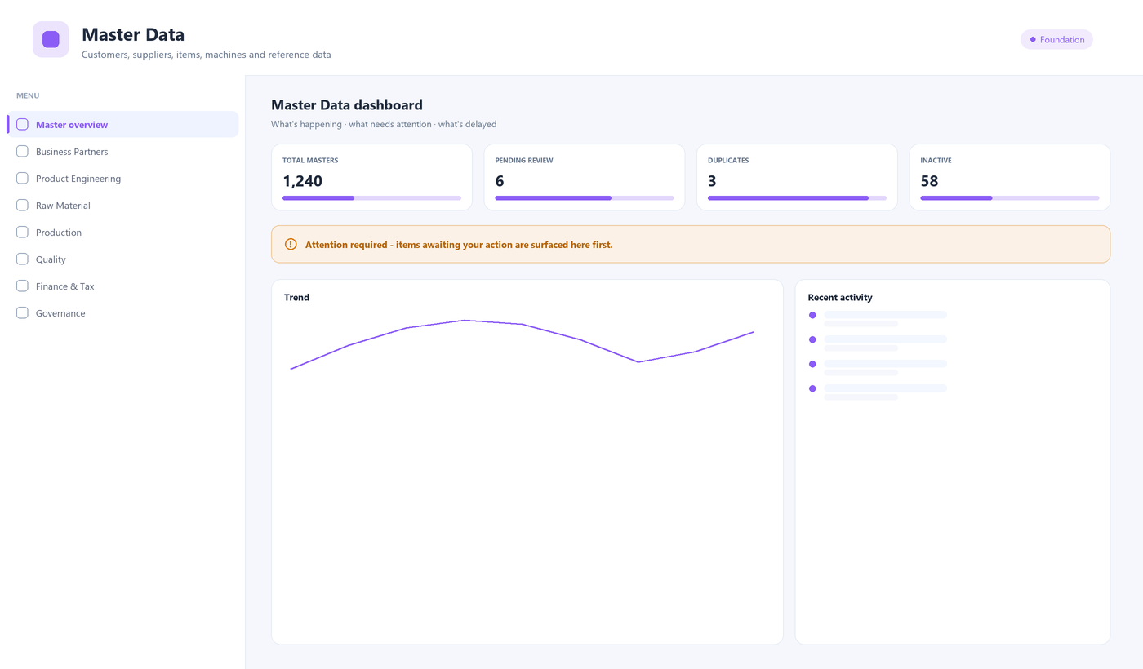
Figure 4.1 — The Master Data portal: menu (left) and dashboard (right).

Menu
Menu area | What it is for
Business Partners | Customers, suppliers, transporters, banks and contacts.
Product Engineering | Items and products, bottle models, capacities, colours, lids and packaging.
Raw Material | Steel grades and thicknesses.
Production | Machines, production lines, shifts and the holiday calendar.
Quality | Inspection parameters and defect types.
Finance & Tax | HSN/SAC codes, tax rates, payment terms, currency and cost centres.
Reference & Geography | Units of measure, reason codes, countries, states, cities.
Governance | Master framework, import/export, duplicate review and audit.

Key tasks
Create a new supplier
- Open Master Data › Business Partners › Suppliers.
- Select New supplier. The code can auto-number or be typed.
- Fill the required fields (name, GSTIN, address); add tax, bank and contact details under the business sections.
- Attach any registration documents, then Save. New masters may need approval before they can be used.
Import masters from Excel
- Open Master Data › Governance › Import & export.
- Download the template for the master you are loading and fill it in.
- Upload the file; review the validation report and fix any flagged rows.
- Confirm the import. Duplicates are held for review rather than created blindly.

Tips
- A master cannot be deactivated while it is used by an open document — the system runs a “where used” check first.
- Use Duplicate review periodically to keep the partner and item lists clean.

5. Procurement
Procurement runs the buying chain in the order the work actually happens: a purchase requisition is raised and approved, a request for quotation goes to suppliers, their quotations are compared, a purchase order is issued and approved, and goods are received against it. Supporting screens (MRP, contracts, imports, ASN, returns, supplier evaluation) stay reachable but out of the main flow.
Primary users: Buyers, purchase managers, and approvers; storekeepers for goods receipt.
Priority: Core (P0) — a critical daily operation.
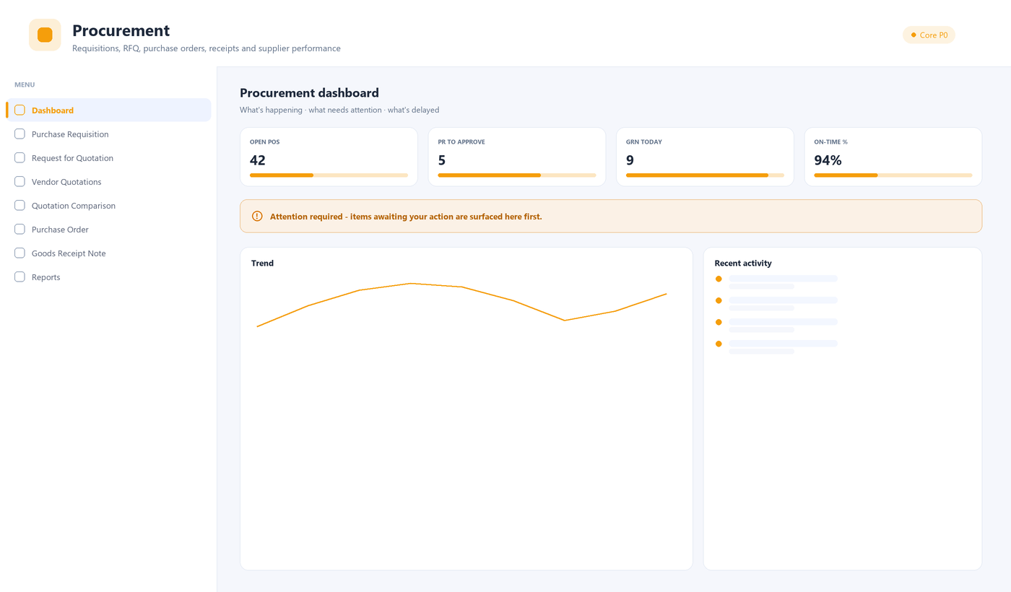
Figure 5.1 — The Procurement portal: menu (left) and dashboard (right).

Menu
Menu area | What it is for
Purchase Requisition | Requests to buy, raised by any department and approved.
Request for Quotation | Send enquiries to shortlisted suppliers.
Vendor Quotations | Capture and store supplier quotations.
Quotation Comparison | Compare quotes side by side to choose a supplier.
Purchase Order | Issue and approve the order to the chosen supplier.
Goods Receipt Note | Record what physically arrived against the PO.
Reports | Spend, supplier performance and procurement analytics.
Settings | Procurement rules and defaults.

Key tasks
Raise and submit a purchase requisition
- Open Procurement › Purchase Requisition and select New requisition.
- Add the items and quantities needed and the required-by date.
- Save as draft to keep working, or Submit for approval when ready.
- Track its status; once approved it can be turned into an RFQ or a PO.
Create a purchase order
- Open Procurement › Purchase Order and select New Purchase Order.
- Choose the supplier; add items, quantities and rates (or pull them from an approved requisition/quotation).
- Check tax and delivery terms, then Submit for approval.
- After approval, send the PO to the supplier from the document actions.
Receive goods (GRN)
- Open Procurement › Goods Receipt Note and select New GRN.
- Pick the purchase order; the expected items are listed.
- Enter received quantities and any short/damaged notes; quality-hold items are flagged for inspection.
- Save to post the receipt — stock updates and the PO shows what is still due.

Tips
- The dashboard surfaces requisitions awaiting your approval and POs due for receipt first.
- Rate warnings (for example, a rate well above the last purchase) appear on the approval screen so approvers can question them.

6. Inventory & Stores
Inventory manages everything physical in the stores: where material is, how much there is, and every movement in and out. Goods are received and put away, issued to production, transferred between locations, counted, valued and traced by batch and serial number.
Primary users: Storekeepers, stores supervisors, and cost/finance for valuation.
Priority: Core (P0) — a critical daily operation.
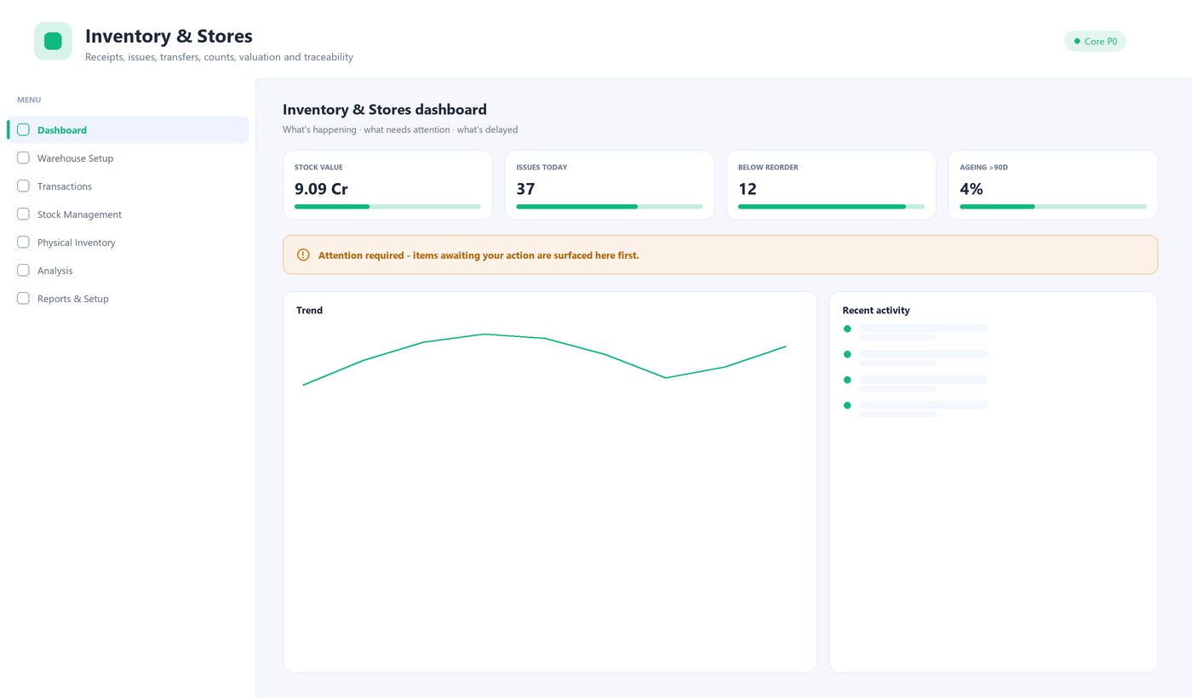
Figure 6.1 — The Inventory & Stores portal: menu (left) and dashboard (right).

Menu
Menu area | What it is for
Warehouse Setup | Warehouses, zones/racks/bins and the bin map.
Transactions | Receipts, put-away, issues, returns, transfers, in-transit, job-work, adjustments and scrap.
Stock Management | Stock enquiry and ledger, reservations, batches, serials, traceability and labels.
Physical Inventory | Cycle counts, physical verification and variance approval.
Analysis | Valuation, ageing, ABC/XYZ, dead-stock and reorder reports.
Reports & Setup | All inventory reports and barcode formats.

Key tasks
Issue material to production
- Open Inventory › Transactions › Goods issue.
- Select the production order or cost centre the material is for.
- Add items and quantities (or scan them); the system checks available stock and reservations.
- Post the issue — stock reduces and the movement is recorded in the ledger.
Run a cycle count
- Open Inventory › Physical Inventory › Cycle count.
- Generate a count sheet for a zone or item class.
- Enter counted quantities; the system shows the variance against book stock.
- Send variances beyond tolerance to Variance approval before stock is adjusted.
Check stock for an item
- Open Inventory › Stock Management › Stock enquiry.
- Search the item; view quantity by warehouse, bin, batch and status (available, reserved, on hold).
- Open the Stock ledger for the full movement history.

Tips
- Items below their reorder level appear on the dashboard and the Reorder report.
- Batch and serial tracking let you trace any bottle back to its coil and forward to its dispatch.

7. Product Engineering
Product Engineering defines what is made and how: the product master, its bill of materials (BOM), the manufacturing routing through work centres, tooling, cost roll-ups and controlled engineering changes. Planning and production both depend on this data being accurate.
Primary users: Design and process engineers; costing for roll-ups.
Priority: Supporting — changes are periodic but high-impact.
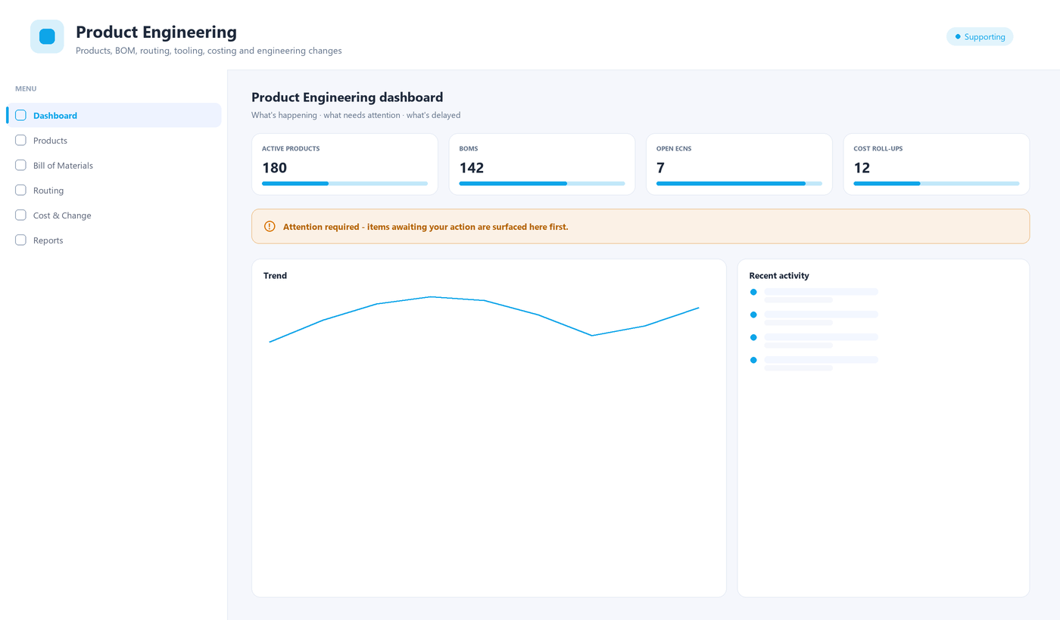
Figure 7.1 — The Product Engineering portal: menu (left) and dashboard (right).

Menu
Menu area | What it is for
Products | The product master and engineering documents.
Bill of Materials | BOM register and a multi-level BOM explorer.
Routing | Manufacturing routing, operations, work centres and tools/dies.
Cost & Change | Cost roll-up and engineering change notes (ECN).
Reports | Engineering reports and audit.

Key tasks
Create a bill of materials
- Open Product Engineering › Bill of Materials › BOM register and select New BOM.
- Choose the parent product and add component items with quantities and scrap allowances.
- Save; use the BOM explorer to check the multi-level structure.
- Submit for approval — an approved BOM is what planning and costing use.
Raise an engineering change
- Open Product Engineering › Cost & Change › Engineering changes.
- Create an ECN describing what changes and why, with effective date.
- Link the affected products/BOMs and attach drawings.
- Submit for approval; on approval the change is versioned with full history.

Tips
- The BOM explorer shows the full component tree, so you can see the impact of a material change before you make it.

8. Production Planning
Planning turns demand into an achievable production plan, built in the order it is reasoned: sales forecast, demand, master production schedule (MPS), material requirements planning (MRP), capacity check, production orders and the schedule board. Reservations and the production calendar sit alongside.
Primary users: Production planners and plant managers.
Priority: Important (P1) — a key operation, usually run to a cycle.
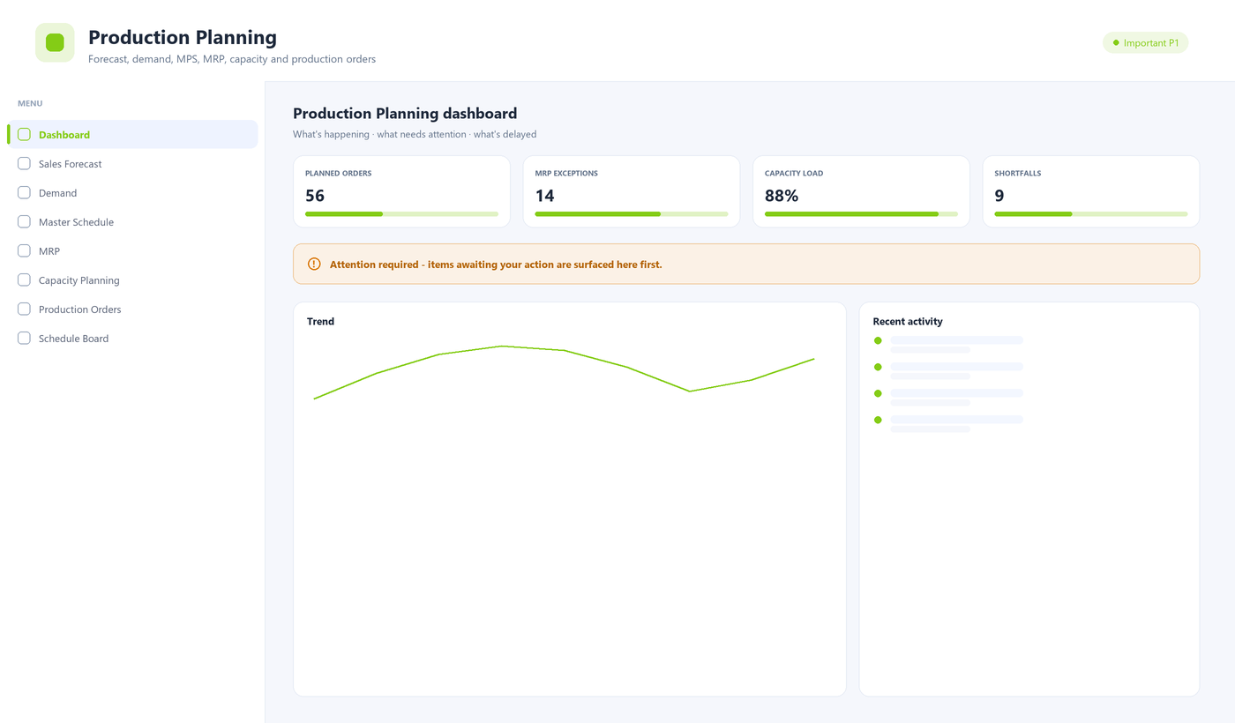
Figure 8.1 — The Production Planning portal: menu (left) and dashboard (right).

Menu
Menu area | What it is for
Sales Forecast / Demand | Expected sales and firm demand that drive the plan.
Master Schedule (MPS) | What to make, in what period, at the finished-goods level.
MRP | Explodes the MPS through BOMs to net material requirements.
Capacity Planning | Checks the plan against work-centre capacity.
Production Orders | Creates the orders the shop floor will execute.
Schedule Board | Sequences and schedules orders across lines.
Reservation / Calendar / Reports | Material reservation, working calendar and plan reports.

Key tasks
Run MRP
- Open Production Planning › MRP.
- Confirm the horizon and the plant, then start the run (large runs return a job you can track).
- Review the exceptions — shortages, reschedules and excess.
- Convert recommended planned orders into production orders or purchase requisitions.
Schedule production orders
- Open Production Planning › Schedule Board.
- Drag orders onto lines and time slots; capacity conflicts are highlighted.
- Release the scheduled orders so the shop floor can execute them.

Tips
- Run MRP after major demand or BOM changes; the dashboard shows the count of open exceptions to clear.

9. Shop Floor Execution
Shop Floor Execution (MES) is where production actually happens and is recorded: production and work orders, operation queues, production entry, work-in-progress, machine status and OEE, downtime, scrap and rework, shifts and labour, and full genealogy for traceability.
Primary users: Operators, line supervisors and production managers.
Priority: Core (P0) — a critical daily operation.
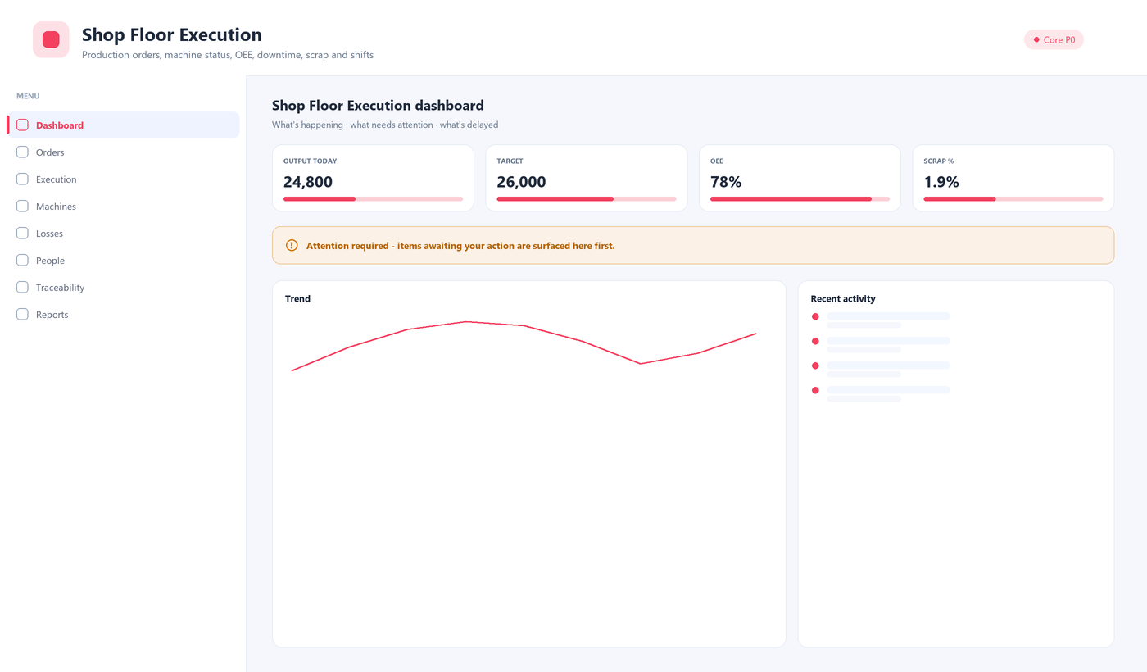
Figure 9.1 — The Shop Floor Execution portal: menu (left) and dashboard (right).

Menu
Menu area | What it is for
Orders | Production orders, work orders and the work-centre queue.
Execution | Production entry, work-in-progress and work instructions.
Machines | Machine status, downtime and OEE.
Losses | Scrap and rework capture.
People | Shift management and labour tracking.
Traceability | Traveller card and production genealogy.
Reports | Production performance reports.

Key tasks
Record production against an order
- Open Shop Floor › Execution › Production entry.
- Select the work order / operation at your work centre (or scan the traveller card).
- Enter good quantity, scrap and rework with reasons, and the time taken.
- Confirm — WIP moves to the next operation and output updates on the dashboard.
Log machine downtime
- Open Shop Floor › Machines › Downtime.
- Select the machine and the downtime reason.
- Enter start and end time; the loss flows into OEE automatically.

Tips
- Shop-floor screens are built for keyboard and touch with large targets, so they work with gloves and without a mouse.
- OEE, scrap % and output-vs-target are on the dashboard so a supervisor sees the shift at a glance.

10. Quality
Quality controls conformance across incoming, in-process and final inspection, and manages what happens when something is wrong: non-conformance reports (NCR), corrective and preventive action (CAPA), gauge calibration, supplier quality and customer complaints.
Primary users: Quality engineers and inspectors; managers for CAPA.
Priority: Core (P0) — a critical daily operation.
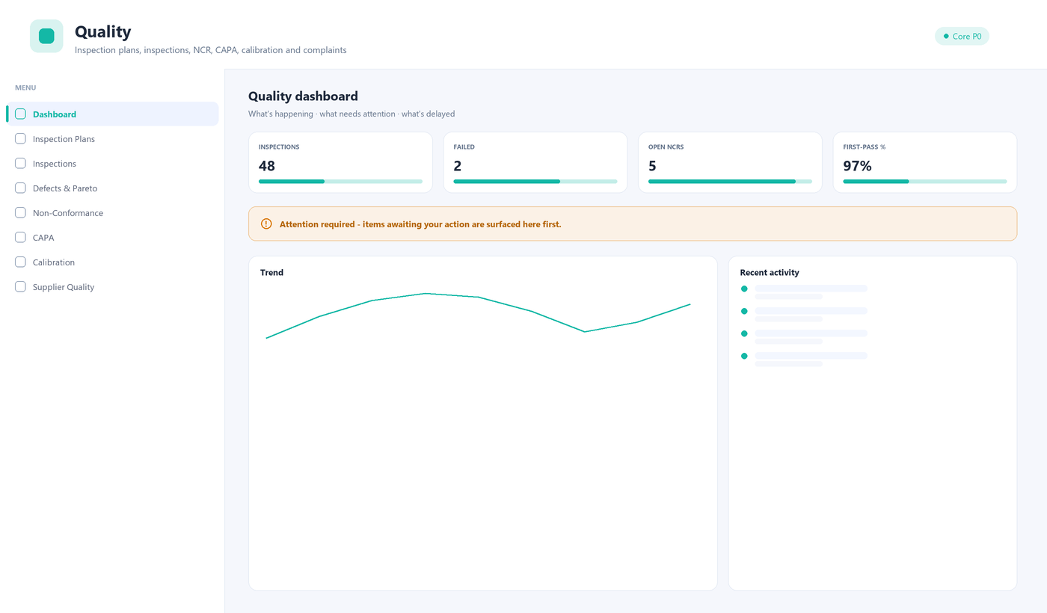
Figure 10.1 — The Quality portal: menu (left) and dashboard (right).

Menu
Menu area | What it is for
Inspection Plans | What to check, how, and against which limits.
Inspections | Record incoming, in-process and final inspection results.
Defects & Pareto | Defect capture and Pareto analysis.
Non-Conformance / CAPA | Raise NCRs and drive corrective/preventive actions.
Calibration | Keep gauges and instruments in calibration.
Supplier Quality / Complaints / Audits | Supplier ratings, customer complaints and audits.
Reports | Quality performance reports.

Key tasks
Record an inspection
- Open Quality › Inspections and select New inspection.
- Choose the source document (a GRN, a production operation, a batch).
- Enter readings against each parameter; the system flags out-of-limit values.
- Record the disposition (accept, reject, rework). Rejects can raise an NCR automatically.
Raise and close an NCR/CAPA
- Open Quality › Non-Conformance and create an NCR describing the problem.
- Assign a root-cause and corrective action owner under CAPA.
- Track actions to completion and verify effectiveness before closing.

Tips
- First-pass yield, failed inspections and open NCRs are on the dashboard.
- Calibration reminders prevent using an out-of-calibration gauge.

11. Plant Maintenance
Plant Maintenance (EAM/CMMS) keeps equipment running: an asset register, preventive maintenance plans, breakdown and work-order handling, condition monitoring, spares, technicians, safety permits, utilities and planned shutdowns.
Primary users: Maintenance engineers, technicians and planners.
Priority: Important (P1).
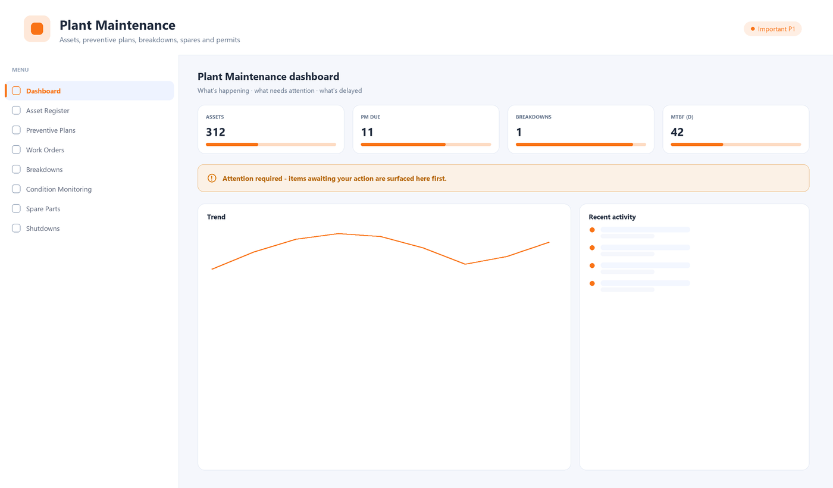
Figure 11.1 — The Plant Maintenance portal: menu (left) and dashboard (right).

Menu
Menu area | What it is for
Asset Register | Every machine and asset with its history.
Preventive Plans | Scheduled maintenance that generates work automatically.
Work Orders / Breakdowns | Planned and reactive maintenance jobs.
Condition Monitoring | Readings that trigger maintenance before failure.
Spare Parts / Technicians | Spares consumption and technician assignment.
Safety Permits / Utilities / Shutdowns | Permits to work, utilities and shutdown planning.
Reports | Reliability and cost reports.

Key tasks
Log a breakdown and raise a work order
- Open Maintenance › Breakdowns and record the machine, time and symptom.
- Raise a work order; assign a technician and the spares expected.
- On completion, record the work done, parts used and downtime.
- The asset history and MTBF update automatically.
Set up a preventive plan
- Open Maintenance › Preventive Plans and create a plan for an asset.
- Define the trigger (calendar or usage) and the task checklist.
- Activate it — work orders are generated automatically when due.

Tips
- Due preventive tasks and open breakdowns are surfaced on the dashboard so nothing is missed.

12. Packing & Dispatch
Packing, Dispatch & Logistics takes finished bottles from packing to the customer: packing orders, cartons and pallets, labels, dispatch planning and pick lists, vehicle loading, shipments and tracking, proof of delivery, returns, freight and exports.
Primary users: Packing and dispatch teams, logistics coordinators.
Priority: Core (P0) — a critical daily operation.
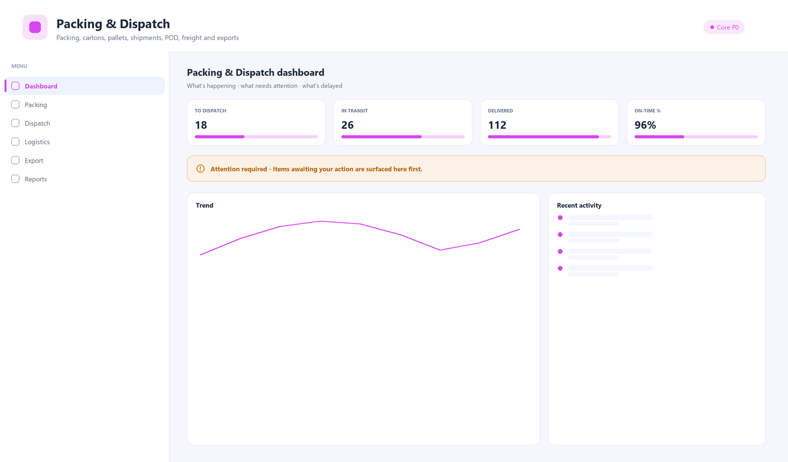
Figure 12.1 — The Packing & Dispatch portal: menu (left) and dashboard (right).

Menu
Menu area | What it is for
Packing | Packing orders, packaging material, cartons, pallets and labels.
Dispatch | Dispatch planning, pick lists, vehicle loading and vehicles.
Logistics | Shipments, tracking, proof of delivery, returns, freight and transporters.
Export | Export shipments and export documents.
Reports | Dispatch and logistics reports.

Key tasks
Create a dispatch / shipment
- Open Packing & Dispatch › Dispatch › Dispatch planning and select the orders to ship.
- Generate pick lists; pick and stage the goods.
- Record vehicle loading, then create the shipment with transporter and vehicle.
- Track the shipment and capture proof of delivery on arrival.
Handle a sales return
- Open Packing & Dispatch › Logistics › Returns.
- Record the returned goods against the original dispatch/invoice with a reason.
- Route returned stock to inspection or back to inventory as appropriate.

Tips
- On-time dispatch % and in-transit shipments are on the dashboard.
- Export documents are grouped separately so export paperwork stays together.

13. Finance & Accounts
Finance is the book of record: the chart of accounts, journals and ledgers, financial statements, receivables and payables, banking, cost and variance, GST/TDS, fixed assets, budgets and period close. Transactions from other modules flow here so the accounts reflect operations.
Primary users: Accountants, finance managers and controllers.
Priority: Core (P0).
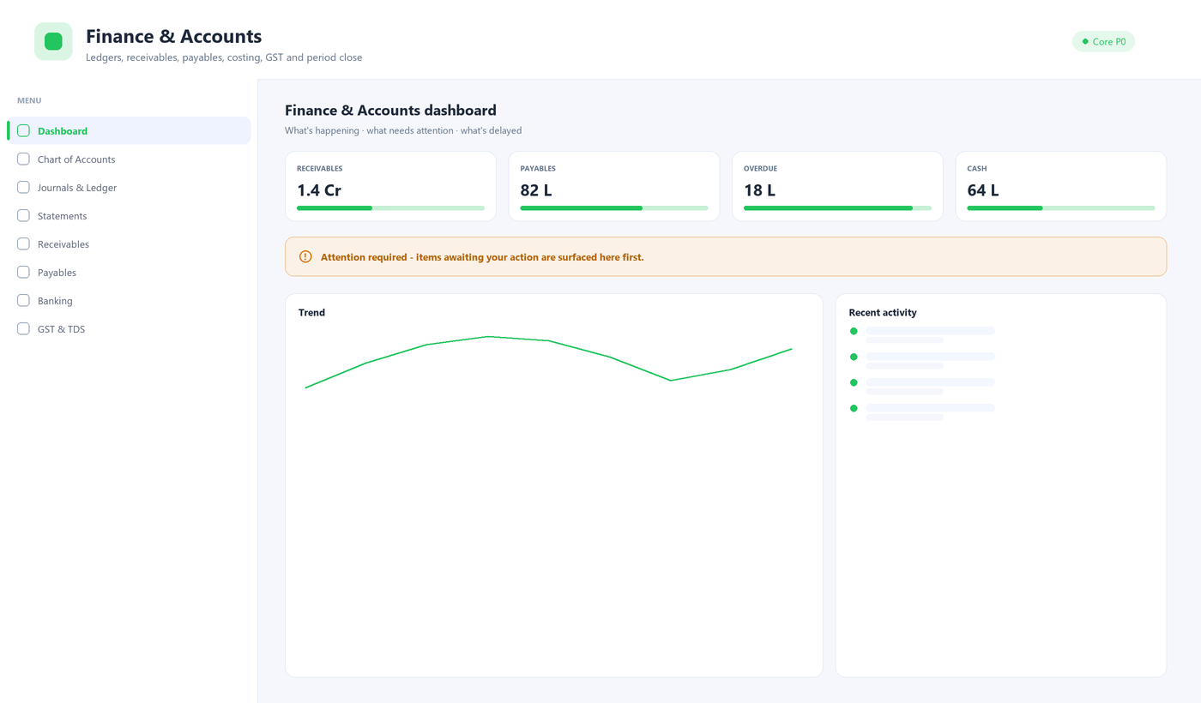
Figure 13.1 — The Finance & Accounts portal: menu (left) and dashboard (right).

Menu
Menu area | What it is for
Chart of Accounts | The account structure everything posts to.
Journals & Ledger | Manual journals and the general ledger.
Statements | Trial balance, P&L and balance sheet.
Receivables / Payables | Customer and supplier balances and ageing.
Banking | Bank accounts and reconciliation.
Cost & Variance | Cost accounting and variance analysis.
GST & TDS / Fixed Assets / Budgets / Period Close | Statutory tax, assets, budgets and closing the period.

Key tasks
Post a manual journal
- Open Finance › Journals & Ledger and select New journal.
- Add balanced debit and credit lines to the right accounts and cost centres.
- Attach support and Submit for approval; on approval it posts to the ledger.
Close a period
- Open Finance › Period Close.
- Work the checklist — reconciliations, accruals, depreciation, tax.
- Lock the period once complete so no further postings can change it.

Tips
- GST and TDS logic is driven by configurable rate masters, so statutory changes do not require code changes.
- Receivables ageing and overdue balances are on the dashboard.

14. HR & Payroll
HR, Payroll & Workforce covers people end to end: employees and org structure, recruitment, attendance and shifts, leave, payroll and payslips, salary structures and statutory returns, production incentives, skills, contractor labour, performance, training and employee self-service.
Primary users: HR and payroll teams; managers for their teams; every employee for self-service.
Priority: Important (P1).
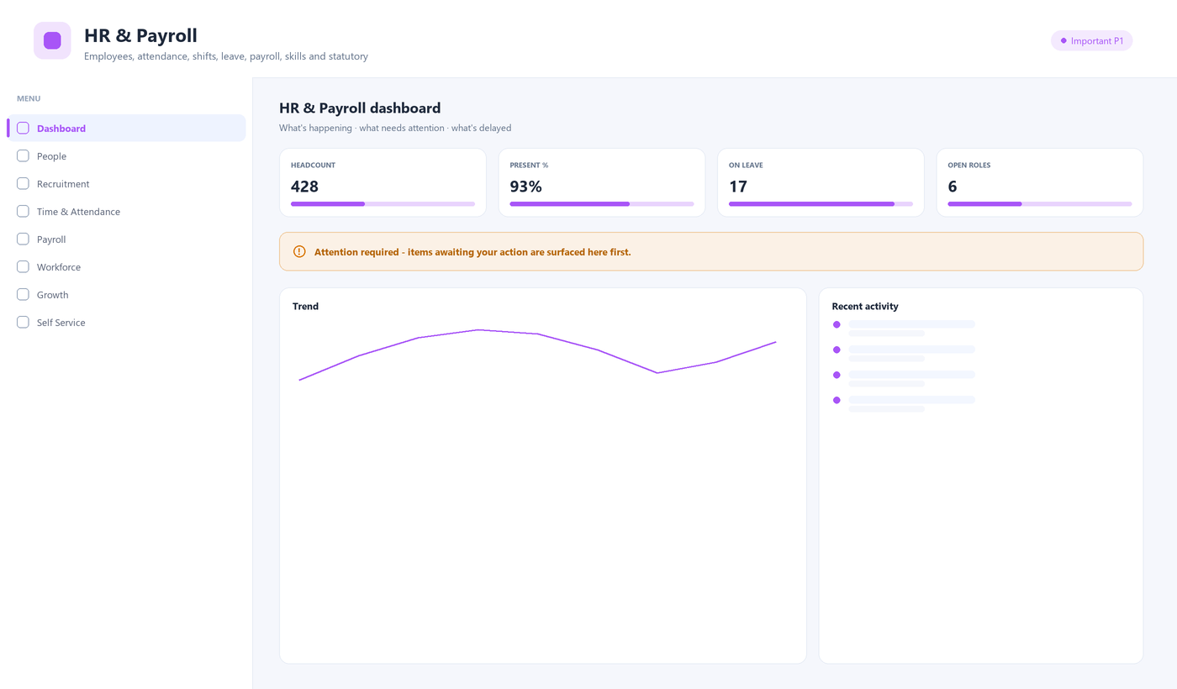
Figure 14.1 — The HR & Payroll portal: menu (left) and dashboard (right).

Menu
Menu area | What it is for
People / Recruitment | Employees, org structure, manpower requisitions and candidates.
Time & Attendance | Attendance, overtime, shifts/roster and leave.
Payroll | Payroll run, payslips, salary structures and statutory compliance.
Workforce | Production incentives, labour cost, skill matrix and contractors.
Growth / Self Service | Performance, training, and each employee's own page and team.
Reports | HR and payroll reports.

Key tasks
Run payroll
- Open HR & Payroll › Payroll › Payroll run for the period.
- Confirm attendance, overtime and leave are captured; run the calculation.
- Review exceptions, then approve; payslips are generated and statutory returns prepared.
Apply for leave (self-service)
- Open HR & Payroll › Self Service › My page.
- Select leave, choose the dates and type, and submit.
- Your manager approves it from their team view.

Tips
- Statutory (PF/ESI, TDS) uses configurable rate masters.
- Attendance %, headcount and open roles are on the dashboard.

15. Analytics & Insights
Analytics & Insights (BI) is the cross-module view: an executive overview, ready-made dashboards, AI insights, per-area analytics, forecasts, a KPI library and scorecards, alerts and a report catalogue, plus the data sources and governance behind them. It reads across modules to answer questions no single portal can.
Primary users: Managers, plant heads and executives; analysts for the KPI library.
Priority: Advanced — for oversight and decision-making.
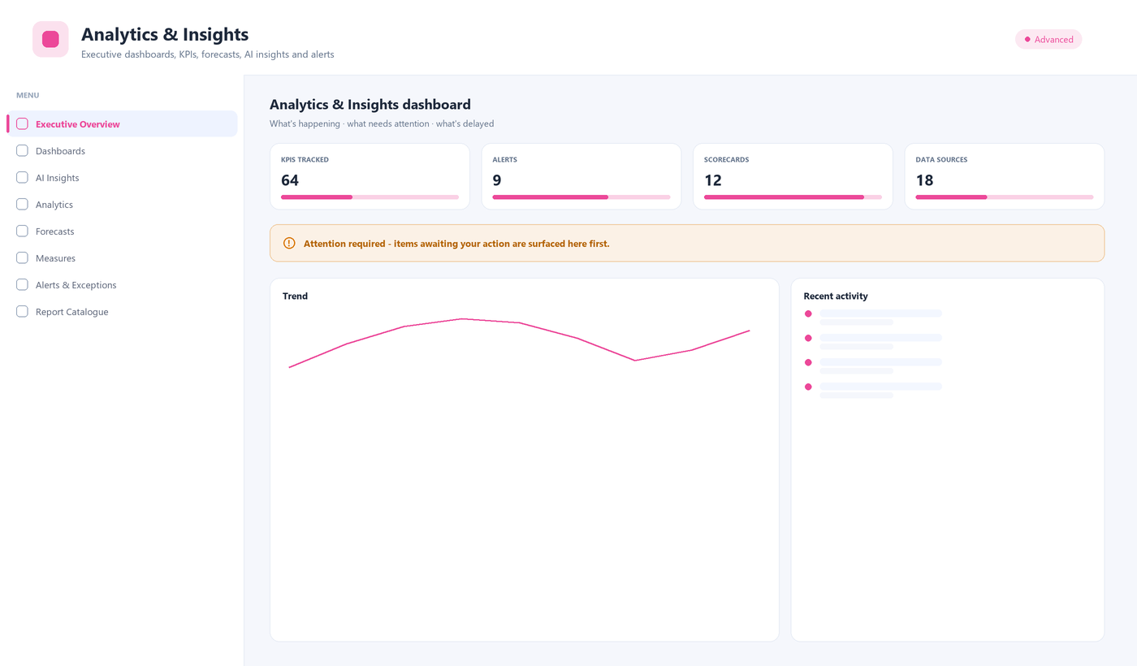
Figure 15.1 — The Analytics & Insights portal: menu (left) and dashboard (right).

Menu
Menu area | What it is for
Executive Overview / Dashboards | The top-level picture and ready-made dashboards.
AI Insights | Automatically surfaced patterns and anomalies.
Analytics | Production, quality, maintenance, procurement, inventory, sales, finance, workforce.
Forecasts / Measures | Forecasts, the KPI library and scorecards.
Alerts & Exceptions | Threshold-based alerts across the business.
Report Catalogue / Data & Governance | All reports, data sources and access/audit.

Key tasks
Read the executive overview
- Open Analytics & Insights › Executive Overview.
- Set the plant, line and period in the filter bar; they follow you across BI screens.
- Drill from a KPI into the underlying area analytics for detail.
Subscribe to an alert
- Open Analytics & Insights › Alerts & Exceptions.
- Choose the measure and threshold that matters to you.
- You are notified when it is breached, without watching a dashboard.

Tips
- Finance and workforce analytics are permission-gated, so sensitive figures are only visible to those allowed.

16. Administration & Setup
Administration is where the system is configured and governed: the organisation structure, users and access control, approval workflows, document numbering, master framework, and compliance/operations tools. This chapter is primarily for administrators.
Primary users: System administrators and IT.
Priority: Setup — configured first, then governed continuously.
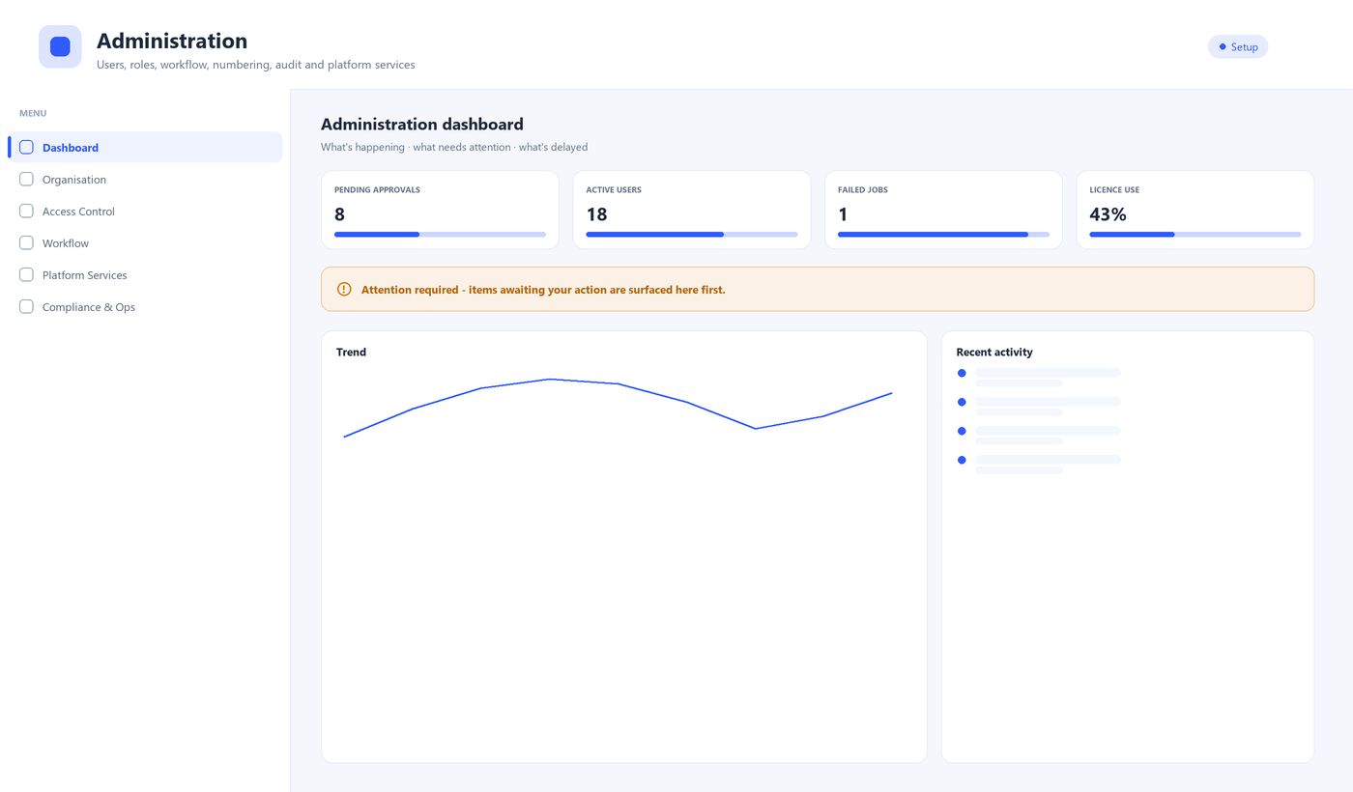
Figure 16.1 — The Administration & Setup portal: menu (left) and dashboard (right).

Menu
Menu area | What it is for
Organisation | Company, branches, plants/lines, warehouses, departments, cost centres, financial year, currency.
Access Control | Users, roles, permission explorer, delegations, sessions, API keys, segregation of duties.
Workflow | Approvals inbox, approval matrix, workflow designer and monitor.
Platform Services | Numbering, notifications, master framework, attachments/DMS, import/export, barcode, reports.
Compliance & Ops | Audit trail, security policy, monitoring, parameters, integrations, jobs, backup, licence.

Key tasks
Add a user and assign a role
- Open Administration › Access Control › Users and select New user.
- Enter the person's details and their company/branch/plant scope.
- Assign one or more roles; the effective permissions preview shows what they will be able to do.
- Save and send the invite. Use the Permission explorer to verify access.
Configure an approval workflow
- Open Administration › Workflow › Approval matrix (or Workflow designer).
- Choose the document type and add approval levels with conditions (for example, by amount).
- Assign approvers or roles to each level and save.
- New documents of that type now route through these levels automatically.
Set up document numbering
- Open Administration › Platform Services › Document numbering.
- Choose the document type and define the format (prefix, financial year, running number).
- Activate it — documents draw their number from here, never from ad-hoc sequences.

Tips
- Roles control action, data scope and even field visibility — so you can let a storekeeper see a PO without its rates.
- The audit trail is append-only; it cannot be edited or deleted, by anyone.

17. Planned portals
Two portals are planned and appear in the switcher as “later” items. They are listed here so you know where that functionality will live.
- Sales & CRM — leads, enquiries, quotations, sales orders and customer service. Until it ships, sales-driven demand is entered through Planning and dispatch is handled in Packing & Dispatch.
- Shop Floor Terminal — a simplified, scan-driven operator screen for line confirmation and material movement, complementing the full Shop Floor Execution portal.

Appendix A. Status reference
The same colours and labels mean the same thing on every screen.
Status | Meaning
Draft | Being prepared; not yet submitted.
Planned | Scheduled but not released to execution.
Pending approval | Waiting for an approval decision.
Approved | Approved and ready to act on.
Released | Released to the shop floor or next stage.
In progress | Work is under way.
On hold | Paused; needs attention to resume.
Completed | Work finished.
Rejected | Turned down; returns to the raiser.
Cancelled | Voided with a mandatory reason (never deleted).
Closed | Finalised; no further action.

Appendix B. Keyboard & efficiency
Action | How
Global search | Ctrl + / from anywhere
Move down / up a list | Arrow keys when the table is focused
Open the focused row | Enter
Select the focused row | Spacebar
Approvals inbox | Inbox icon in the top bar
Export a list | Table tools › Export (Excel / CSV / PDF)
Choose columns | Table tools › Columns
Collapse the sidebar | Collapse control at the sidebar foot

Shop-floor and stores screens are fully keyboard-operable and use large touch targets, so they work with gloves and without a mouse.

Appendix C. Glossary
Term | Meaning
Portal | The working context you sign into (Procurement, Quality, etc.).
Master | Reference data a transaction points to (supplier, item, tax code).
Transaction document | A business record with a lifecycle (PO, GRN, inspection, invoice).
BOM | Bill of materials — the components that make a product.
Routing | The sequence of operations and work centres to make a product.
MPS | Master production schedule — what to make, when, at finished-goods level.
MRP | Material requirements planning — nets demand against stock and BOMs.
GRN | Goods receipt note — records what physically arrived.
NCR / CAPA | Non-conformance report / corrective and preventive action.
OEE | Overall equipment effectiveness — availability × performance × quality.
Workflow | The configured approval path a document follows.
Audit trail | The append-only record of who did what, when and from where.

SSB Industries Private Limited — Manufacturing ERP User Manual. This manual describes the web application and is for internal use.

