1.Environment

-NodeJS Install from Internet

-Get Server IP

This is IP Address of PC on running Backend Server(Node Server).

-Configuration.

If server ip is 192.168.100.180, go to manager directory and open manage.html.

And place serverip=”http://192.168.100.180:4000”.

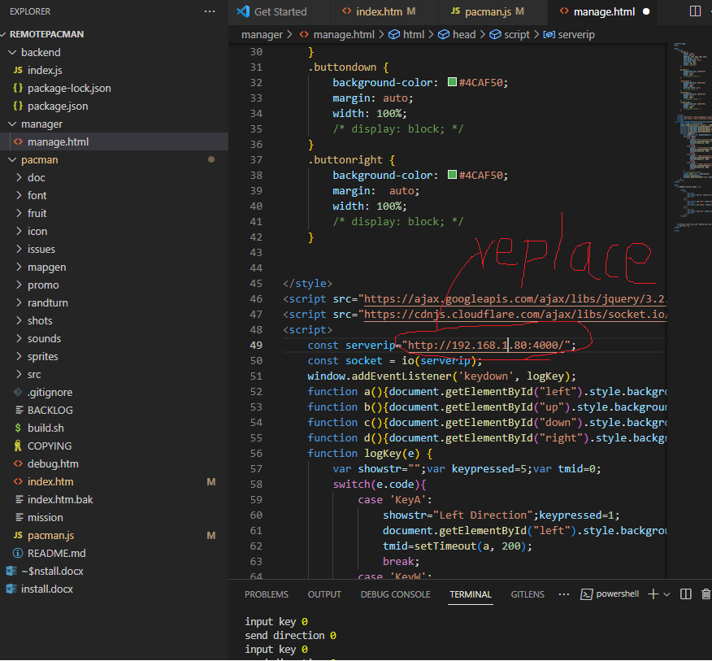

Go to pacman/pacman.js, and place serverip=”http://192.168.100.180:4000”.

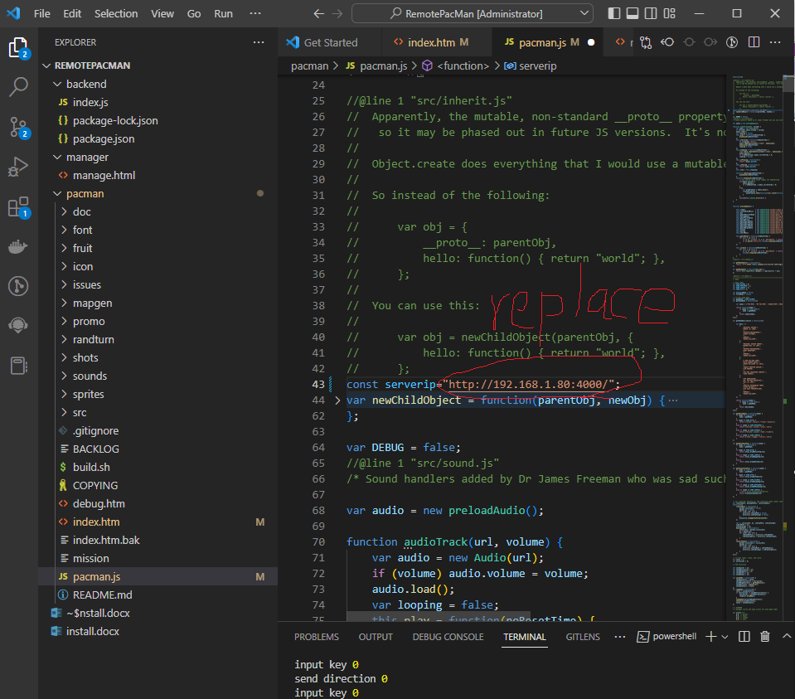

2.Run

1)Controller have to run Backend Server( Node Server).

①Install npm packages.

If controller run Backend Server (Node Server) in this pc at first, controller must walk this step.

But not, you may skip this and go to ②.

Go to backend directory.

Pressing ‘ shift’ key, click right mouse button.

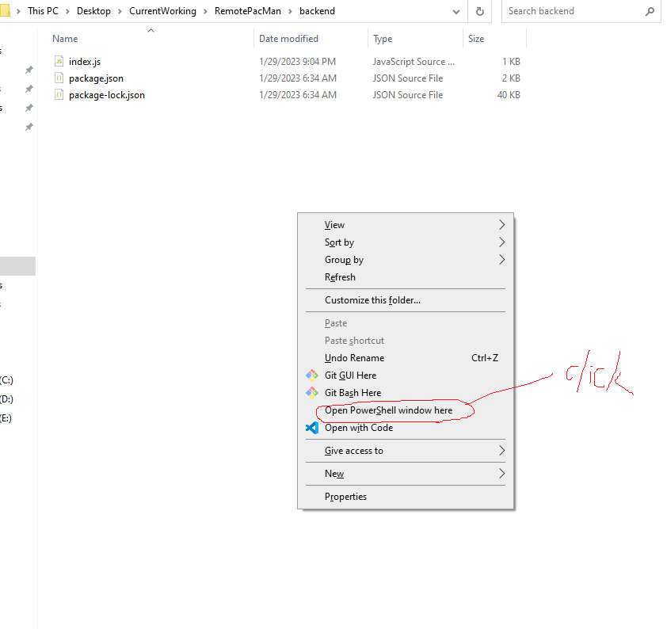

Please type “npm install” and enter.

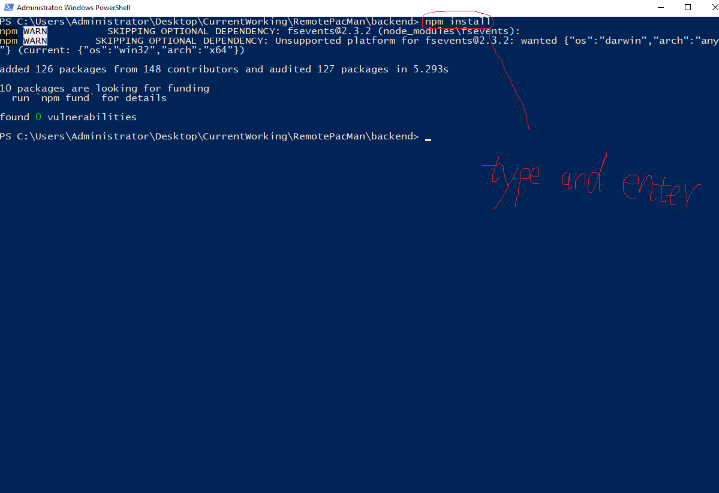

If you pass, you can see node_modules directory in backend directory.

②Run Backend Server( Node Server)

Go to backend directory.

Pressing ‘ shift’ key, click right mouse button.



Please type “npm start” and enter.

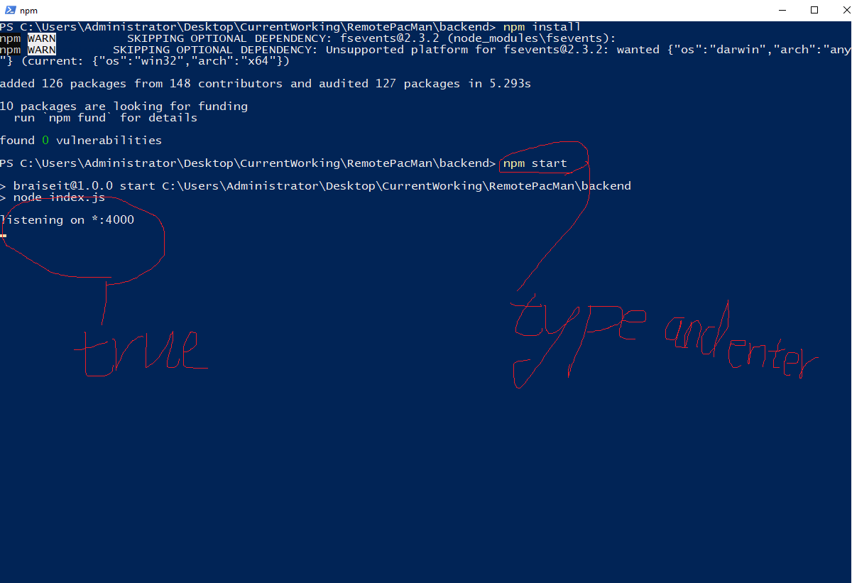

2)User can run pacman at any place on internet.

If user is going to run program, open pacman directory and run index.html through web browser.

3))Controller can run manage at any place on internet.

If controller is going to run program, open manager directory and run manage.html through web browser.

And press a,s d,w button.It will work well.

Thank you for your contact me.