Let’s clarify your proposal:

First , i am going to tell you about your proposals.

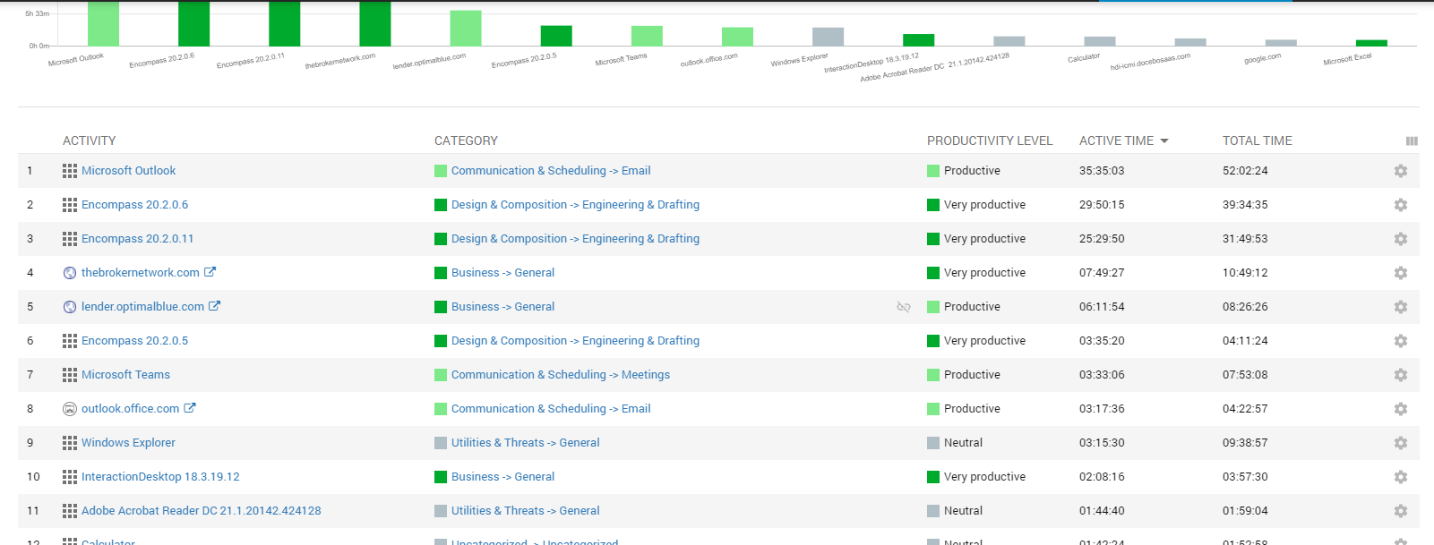

As discussed earlier,according to order of uncat.csv file, I have to sort Activity fields.

And about Category field, if selected item is fited Parent_name and Category_name, our case are right.

But if selected item is fited Parent_name and not Category_name, our case are Parent_name-General. Right?

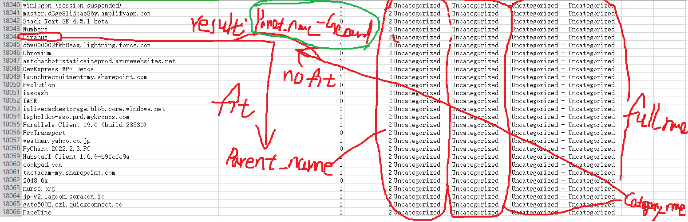

If our is right, I have to own apikey.

Because I sorted our out.csv according to if selected item is not fited two condition(Parent_name and Category_name), i placed it to uncategorized field.

That is concurrently under the two conditions. So I have to own apikey, If selected item is fitted Parent_name but not full_name, placed it to Parent_name-General.