|  |  |
| --- | --- |
| **C:\Users\Workstation\Desktop\Capture.JPGC:\Users\Workstation\Desktop\Capture.JPGC:\Users\Workstation\Desktop\Capture.JPGC:\Users\Workstation\Desktop\Capture.JPGProcess delete a project**  1 log in with or without fb  2 go to “all my projects”  3 click “edit”, go down the page and click “delete project”  4 enter your password  5 if forgotten click forgot your password  6 email is sent to you (the one you gave on FB or the one you signed up with on BB)  7 click "reset it here" in the email received  now 2 processes:  -8 if you were logged in when you clicked "reset it here" in the email  9 create your new pass  10 you need to log out and resign in with or without fb  11 then do again steps 2 and 3 and this time enter your new password set on 9  -8 If you were logged out when you clicked "reset it here" in the email,  9/create your new pass  10/log in with or without fb  11/delete your project | **Process delete your account**  1 log in with or without fb  2 go to your profile/edit profile  3 click delete account in account tab  4 enter your password  **NOT WORKING ANYMORE**   * **Worked back OK**     5 if forgotten click forgot your password  6 email is sent to you (the one you gave on FB or the one you signed up with on BB)  7 click "reset it here" in the email received  When user was logged out when he clicked on "reset it here" in the email, process is working fine, like on the left. But (to do: 1)when user is logged in on bb when he clicks on "reset it here", user is not directed to step 9, this process is not working, can you please solve it?  **->When user has forgottent their password they need to regain new password, in the case they logged in the our system, this mean that they do not their password. I think the process is right.No because when they are logged in and they forgot their password, users cannot reset their password.PLEASE SEE VIDEO BELOW (CLICK DROPBOX LINK) OR 1ST DIAGRAM I SENT YOU LAST WEEK.**[**https://www.dropbox.com/s/wj4hafq6stwv2v9/delete%20account%20not%20working%20when%20user%20has%20forgotten%20his%20password.avi**](https://www.dropbox.com/s/wj4hafq6stwv2v9/delete%20account%20not%20working%20when%20user%20has%20forgotten%20his%20password.avi)  After User deletes his account, User cannot sign in again neither using fb nor using sign in form (error message appears telling him to “contact Admin to reactivate his account”, this is ok.). But (to do 2) there is no way for Admin to reactivate this deleted account, which can be an issue if User closed his account without deleting his pledge.can you please solve it?  **-->OKCould not be checked-> Why? Pls follow according to the following video example http://screencast.com/t/CgOKMCuT** RECOVER FUNCTION LOOKS GREAT I WILL TEST AGAIN WHEN OTHER TODOS ARE DONEOK THANK YOUSUPER☺ |

**I/If creator wants to cancel/delete his project**

Before submitting a project to Admin:If creator wants to delete his project, he can do it by going to “edit project” and clicking “delete project”)

The following section only talks about the process involved **after** Admin has approved a project.

**A/During funding: this means after Admin has approved the project using Admin panel, so at this time project is live**

**1/during project funding:**

**a/**Creator makes a request to BB Admin down homepage in “contact us” section.

This request does not appear in Admin panel where it should (it’s ok) but an email is sent to Admin that appears on [boostbloomarmenia@gmail.com](mailto:boostbloomarmenia@gmail.com)(info sectionof this Gmail account)(ok). Thanks to this email, Admin knows that user wants tho cancel his project.

**b/** After reading the email,Admin goes to AdminPanel “project section” and cancels the project “by hand”:

**-**this removes the project from recommended section of BB but leaves it in other sections as a thumbnail without showing “canceled“(OK)

**-**“canceled” only appears in the profile of the creator and in the profile of the backer in the created and backed project tab respectively(OK)

**-** when user clicks on the title of the canceled project, this “cancelled page”appears: OK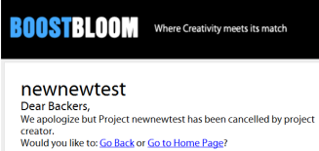

**c/**If pledges were made:

- After Admin cancels project from Admin panel,Backers’ pledges should be cancelledbut are not!

So todo3: Can you make sure the pledge is cancelled as it works now in II/B/1/b?

In addition when Backer clicks on “manage my pledge” (he is directed to “manage my pledge after creator cancelled.jpg” page), which is wrong. Backer should be directed to “cancelled pledge page.jpg” like in II/B/1/b. Can you please fix thistoo.

**🡪 OK**

**-**Backers receive a notification email telling them Creator has canceled his project (to do 4: this notification email exists in “project_cancellation_to_backer.ctp” but process is not working, can you fix this?)**see comments at the endOK**

-to do 5: add a notification in activity (on top of homescreen of backer)saying that “Backed project has been cancelled” like in activity.jpg**I didn’t see this one work are you sure it works? I mean the notification in activity on top of homepage?**

**🡪 OK**

**-**Creators are notified by email that their project was exceptionally cancelled by Admin and that such behavior is not recommended (to do 6: can you please add such a process) **see comments at the end**

**OK**

**d/**If no pledges were made:

(1a and 1b still necessary and like before Creators are notified by email that their project was exceptionally cancelled by Admin and that such behavior is not recommended (same to do as right above, to do 6)

**2/After unsuccessful funding:**Creator cannot cancel his project. Creator is still able to send a “cancel request” (to hide the failure of his project???) to Admin via “contact us “butAdmin should not cancel because then the project appears as cancelled and leads to “cancelled page” instead of being visible and appearing as “unsuccessful”.**(OK)**

**3/After successful funding**

**a/**Before sending rewards:

-Impossible to cancel project, and Creator has received the money on funding day and therefore is responsible and must send its rewards after sending his survey to Backers.

-Creator is still able to send a “cancel request” to Admin via “contact us “butAdmin should never cancel such a project (Admin can check the funding is still on by reading “end date” in Admin page before canceling)

**b/**After sending rewards:impossible to cancel project (not relevant), same as in “sending reward” bullet 2 in 3/a.

**\*) Questions**

1. **What is the diffrence between “cancel” and “delete” project”?no difference**
2. **In the section, we are talking about “creator cancels his project” but in the describes admin is who do this (cancle project)??Admin does this on admin panel after creator asks hin to cancl/delete his project**
3. **Could you pls explain more about Creator’s role and Backer’s role.?**

**- As I understand:**

**- in the our system have three object : “Creator”, “Backer” and “Admin”, right?? YES**

**- “Admin” is who manage full system, and the highest powers.yes**

**- “Creator” is who create his projectyes**

**- “Backer” is who create pledges and each of the projects will have many pledges.yes**

**- or an account will have 2 roles : Creator and Backer?Yes, a user can be a backer and a creator**

**II/Account closing and pledge canceling**

**Intro: A word on how Backer cancels his pledge**

**1/during project funding**

**a/**Backer goes on top of home page and clicks manage pledge (where he can cancel or update his pledge.)

Update pledge redirects to PayPal/Cancel pledge is automatic

**b/**Canceling or updating is notified by email to backer and creator.**OK**

**c/**Canceling and updating is possible until when? To do 7: can we allow cancelling only until 48 hours before the end?**OK let’s forget this one**

* **You mean** : we will wait 48 hours after backer clicks on cancel his pledge, if over 48hours the system will automaticlly cancel his pledge?

**No I meant if backer for example pledged on 15th of December, and if project ends on 30th december, maybe we could allow user to cancel pledge only until 28th of December. If too complicated don’t do it. I want you to focus on the rest. This is optional.**

**2/After unsuccessful funding:**Backer cannot cancel his pledge but Backer was not debited on funding day anyway. So not relevant.

**3/After successful funding**: Backer is charged on funding day so he cannot cancel his pledge anymore.

**A/Backer closes his account:**

**1/During project funding**

**a/** If User did not pledge

**-**Usercan close his account without effect

**-**He will receive an email notification (user_account_deleted.ctp: ok). This is a closing account message sent to any user closing his account, Backer and Creator) warning them they remain responsible for their pledge unless they canceled it.

**b/** If User pledged

**-**Backer’s pledge is not canceled: a notification email (same as before) is sent to backer warning him he stays responsible for his pledge unless he canceled it.

***But****: if backer deleted his account without canceling his pledge, he cannot cancel it afterwards because he does not have access to his account anymore. That’s why Admin needs this reactivate function to reactivate deleted account (to do2).*(note to Admin: Admin cannot cancel a pledge)

**2/After unsuccessful funding:**Backer can close account without any effect on anything, because pledges are automatically canceled. To do 7.1: check that is is working. **It seems to be working but please check it works**

**Yes, I have just checked it againSo it means the pledges are automatically cancelled properly? It works? Sorry I insist but this is important.**

**3/After successful funding:**Backer is charged on funding day so he cannot cancel his pledge anymore. If he deletes his account after being charged, can he still receive the survey*? (Not typical process: why would he delete his account after a successful project he backed? And anyway he still receives the email notification message telling him he is still responsible for his pledge when he closed his account)*

**B/Creator closes his account** (in profile: delete account and page 1 process)

*Same email as above is sent to Creator: user_account_deleted.ctp*

**1/During project funding(please see comments in projects.docx)-> Yes, Please check this video (pls ignore the sounds because it so noisy from my colleagues ☺ )** [**http://www.screencast.com/users/NguyenHoang/folders/Jing/media/20bab9f5-5f2a-4988-b66d-dc4402815890**](http://www.screencast.com/users/NguyenHoang/folders/Jing/media/20bab9f5-5f2a-4988-b66d-dc4402815890)**this is to do 8 please check todo8.docx**

***a/***If no pledges were made:

**-**same effect as when Admin cancels a project after receiving a request:

closing account removes the project from recommended section of BB but leaves it in other sections as a thumbnail without showing “canceled “

**-**“canceled” only appears in the profile of the creator and in the profile of the backer in the created and backed project tab respectively (OK)

**-** when user clicks on the title of the canceled project, “cancelled page” appears (ok)

***b/***If pledges were made

***-****Backer can see his pledges were cancelled when he clicks on Manage my pledge (ok):*

- 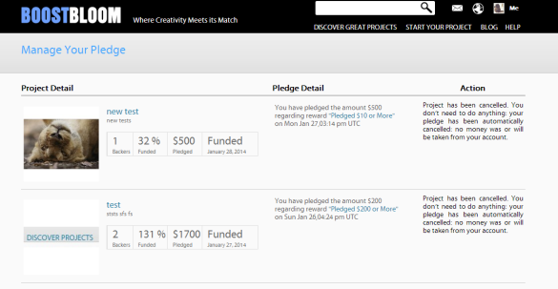

**-**Backers receive a notification email telling them Creator has canceled his project (to do 4 again, like in I/A/1/c, but this time sending the email “project_cancellation_to_backer.ctp” to backers when account is closed**Pending**

**-**to do 5 again, like in I/A/1/c: add a notification in activity (on top of home screen of backer) saying that “Backed project has been cancelled”**Pending**

*When a creator delete his account then are his projects available in the site?? Or we will remove all his project?*

*It depends when creator deletes his account, during funding, or after funding. Please see below my explanations if it is still not clear I will explain again. For the moment I didn’t have time to do a diagram, I am travaling back tonight. All is written down here, please let me know if it still not clear after you read again below.. To do 8 is when creator closes his account* ***AFTER unsuccessful funding****. We do not want the project to appear as canceled. We want it to appear as unsuccessful but still visible. To do 9: If account is closed* ***after successful funding****, we want it to appear as successful.*

**2/After unsuccessful funding I will test tomorrow after 2 projects are ending, one succesful other unsuccessfulsee todo8-9.docx**

**-**Creator can close account because he did not receive any money on funding day (pledges were automatically cancelled)

**-**Creator receives the same notification email as above

**-**Project appears as “cancelled”: This is an issue. To do 8: can we make the project appear as unsuccessful(so still visible and not displaying “cancelled page”) when account is closed after the project is not funded? If not, some Creators will close their account because they do not want their failed project to appear and website will be empty.

**🡪 OK: there is a mistake here:It is written unsuccessful even while project is funding please fix. Should be written Launched!**

**->Where did you check site (live or stage)?ON STAGE, please see diagram we sent for you yesterday it is more clear**

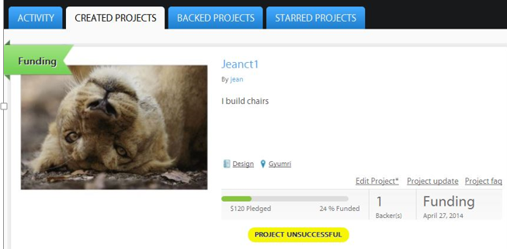

**3/After successful fundingI will test tomorrow after 2 projects are ending, one succesful other unsuccessful**

**a/**Before sending rewards:

**-**Possible to close account but Creator has received the money on funding day and therefore is responsible and must send its rewards after sending the survey.

**-**Project appears as “cancelled”: to do 9 : same issue as before: if account is closed after project is successfully funded (note for Admin: this is less likely to happen than closing an account after a non-successfully funded project) please make the project appear as successful, for same reason as above(risk of empty website)

* **OKCould not be checked yet**

**b/**After sending rewards: Possible but project stays online and appears as“cancelled”: to do: same to do as to do 9

To make things clearer only a project cancelled while funding would appear as cancelled.

* **OKCould not be checked yet**

**Emails and messaging**

**When project is successfully funded**

Project creators

-no email is sent telling creator that his project was successful, inviting him to send a survey, and telling him his account will be credited

To do 10:Can you create this email process? I checked and the previous coders didn't create one...

**-> Done** **Could not be checked yet**

Project backers

-No email is sent telling backers the project was successful, therefore that their account was debited of their pledge amountand telling them that they should receive a survey.

To do 11: Can you create this email process? I checked once more and the previouscodersdidn't create one...

**-> Done** **Could not be checked yet**

To do 12 In addition to the email can we add a notification on top of home screen in activity tabfor backer and creator telling them “Project successfully funded” like here? (activity.jpg)

**-> Done** **Could not be checked yet**

**When project is NOT successfully funded**

Project creators

-no email is sent telling creator that his project was NOT successful

To do 13: Can you create the email process? Nothing from the previous coders...

**-> Done** **Could not be checked yet**

Project backers

To do 14: a notification email exists here project_unsuccess_backer.ctp but process is not working, can you please solve it?

**-> Done** **Could not be checked yet**

To do 15 In addition to this can we add a notification on top of home screen for backer and owner telling them “Project not successfully funded” like here? (activity.jpg)

**-> Done** **Could not be checked yet**

**About the survey**

Backers do not receive the survey set here (rewardsurvey.jpg)

To do 16: Can you please solve it?

**-> Please tell me how can I go to this page (rewardsurvey.jpg)i**

**Here:**

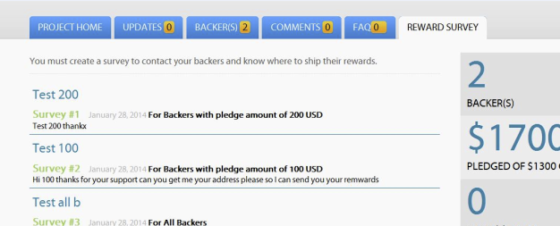

**When the project is successful, a new tab appears on project page of the creator**

**Here he writes a message that all bakers should receive by email depending on the amount of the money they gave for the project. This is the survey. This survey exists but the backers do not receive it. This is todo 16**

* **I tested many time but don’t see the new tab appear**

**This tab appears only after funding is OVER**

* **Done. Pls check it**

Creators do not receive the list of the emails of the backers set here: send__email_list.ctp

To do 17: The process exists but is faulty can you please solve it?

**-> I saw this action in function process_payment_by_project app/controlers/file crons_controller.php, but I don't know when we call this process? Can you tell me when the process is happened?**

**When project is successful, creator should receive the emails of the backers. This is to do 17**

* **Donewill check tomorrow after project is successful**

To do 18: In addition to the email can we add a notification like before on top of home screen telling backers to check their email for the survey just sent by creators?

**-> Will do immediately after I finish the to do 16**

**-> Done. Pls check it**

**Project ending in less than 48 hours:**

To do 19**:**Ending soon email notification not working (ending_soon_notification.ctp) can you solve the process?

**-> Done** **Could not be checked yetI never received this one is it working?**

***Sumup of todos:***

-Todo1and2 and Todo3: OK

-Admin clicks "cancel project" in project section of Admin Panel:

Todo4 and todo6 OK, todo5 please confirm if working I could not see it work

**->OK**

-Creator closes his account DURING funding

Todo4 not done: **OK**

Todo5 not done: **OK**

Todo6 ok

-Todo7.1: please confirm again that pledges are canceled

-Creator closes his account after UNSUCCESSFUL funding

Todo8 not done (see docx todo8-9) : **OK**

-Creator closes his account AFTER SUCCESSFUL FUNDING

Todo 9 not done (see docx todo8-9): **OK**

Todo 10-11-12-16-17-18: I have a project that finishes in 10 hours I will see if I receive the email and the notification on top of page. Please check if it is done because I always have to wait for a project to end to be able to check. This takes time. Thank you Duong ☺

Todo13-14-15: I have never received notifications or emails please check it works I am creating another project ending tomorrow to check.

Todo19: I couldn’t check this one, you can show me process by video if you want that will save time. Thanks ☺

***New skype issue***

Issue1:

I checked again and the name of backers does NOT appear at the end of the funding.

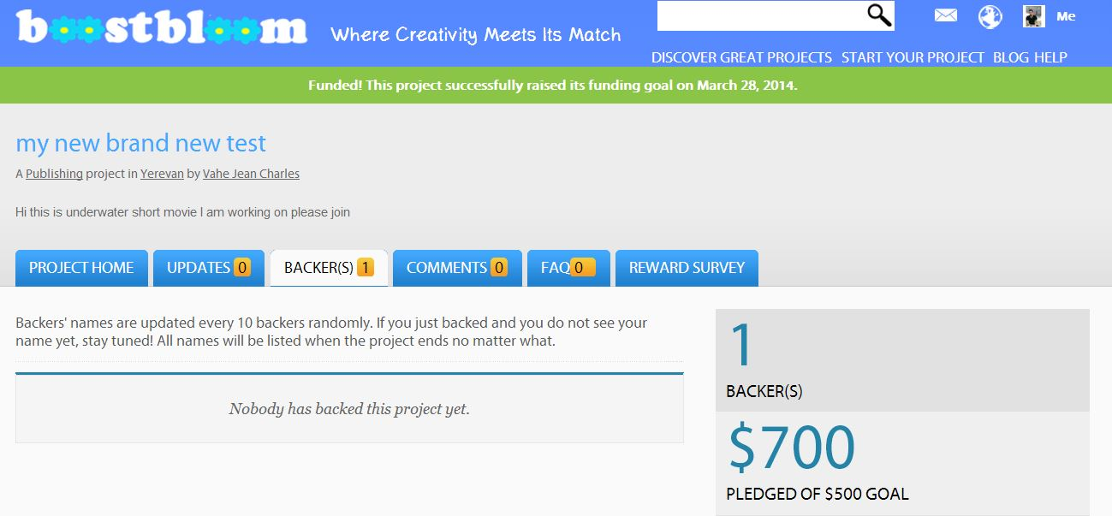

Check this it is on live server:

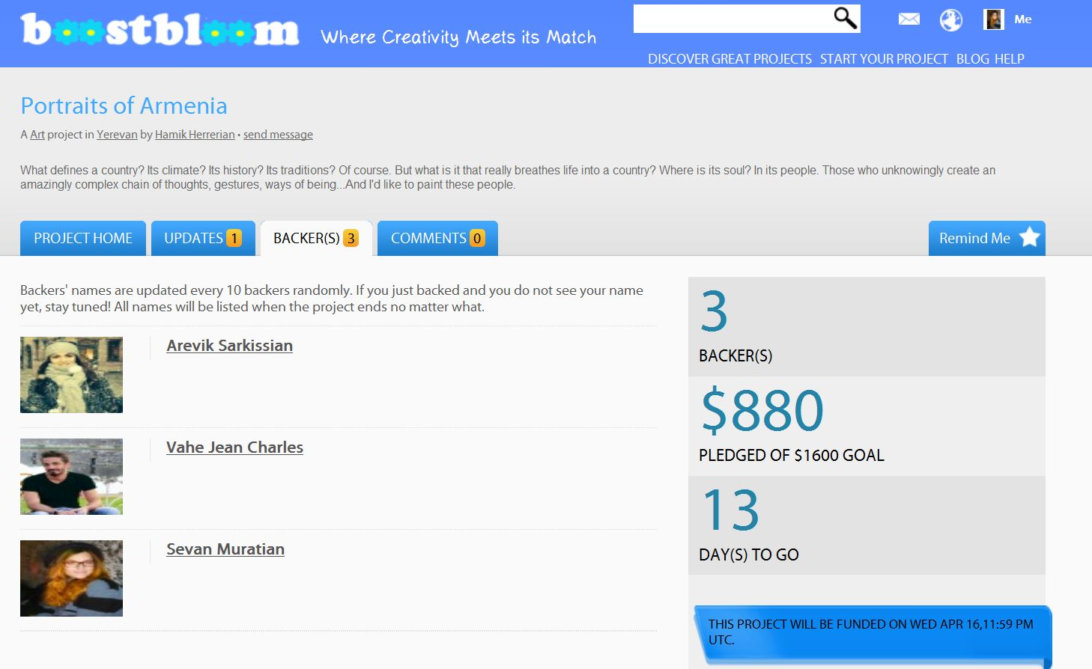

Issue2: video I sent you before. This issue is not your fault. I will pay extra for it.