Creator closes his account DURING funding

Backer’s tab Before Creator closes his account: OK

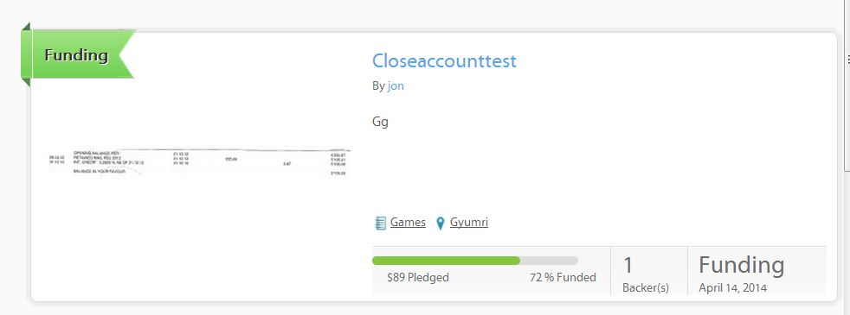

Backer’s tab After Creator closes his account: NOT OK

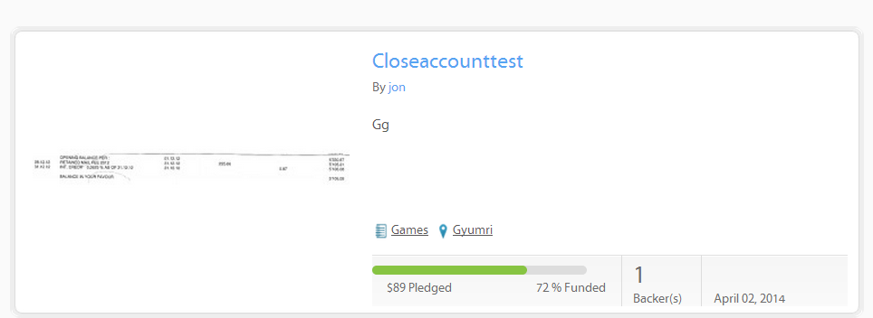

It should be:

