**Account is open and project is unsuccessful (todo8)**

Tigran created project Armenian Tourism App, his Created Projects Tab is like this: **OK**

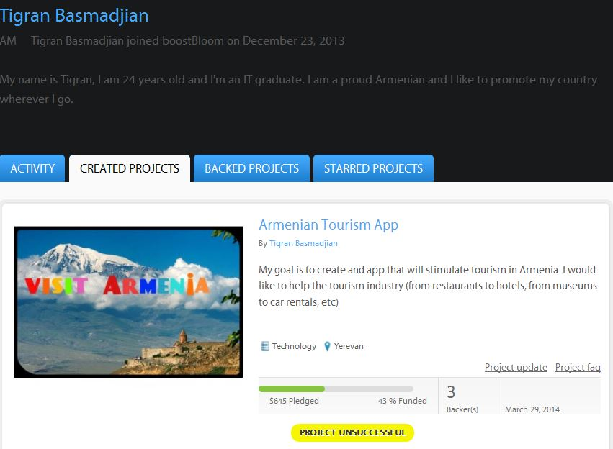

Backer’s (jcfermandjian) backed project tab: **NOT OK**

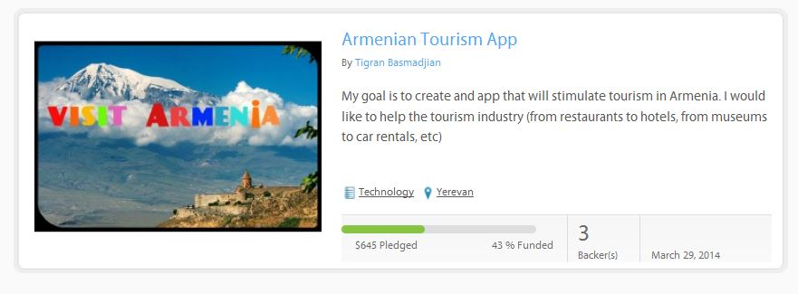

**It should be:**

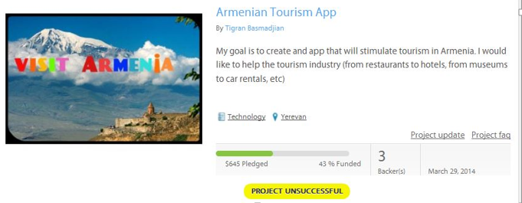

**Account is closed and project is unsuccessful(todo8)**

Backer’s (jcfermandjian) backed project tab NOT OK

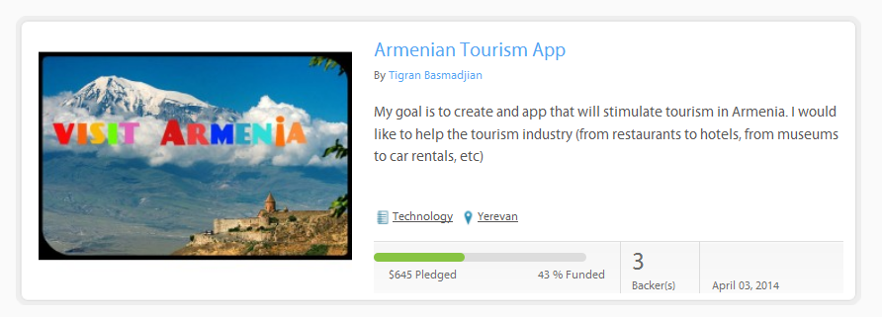

It should be (same as before)



Now there is this issue when project is successful (todo9)

