**I. User**

1. “tour has calender data and available stocks of each day”

you want a calendar like this <http://screencast.com/t/TkBmsyz39P> in tour details page, right? Available stock of each date will be manged by vendor. Right?

Answer:

No, marked red indicates “public holiday, Saturday and Sunday”, available slots, we’d like to display as below

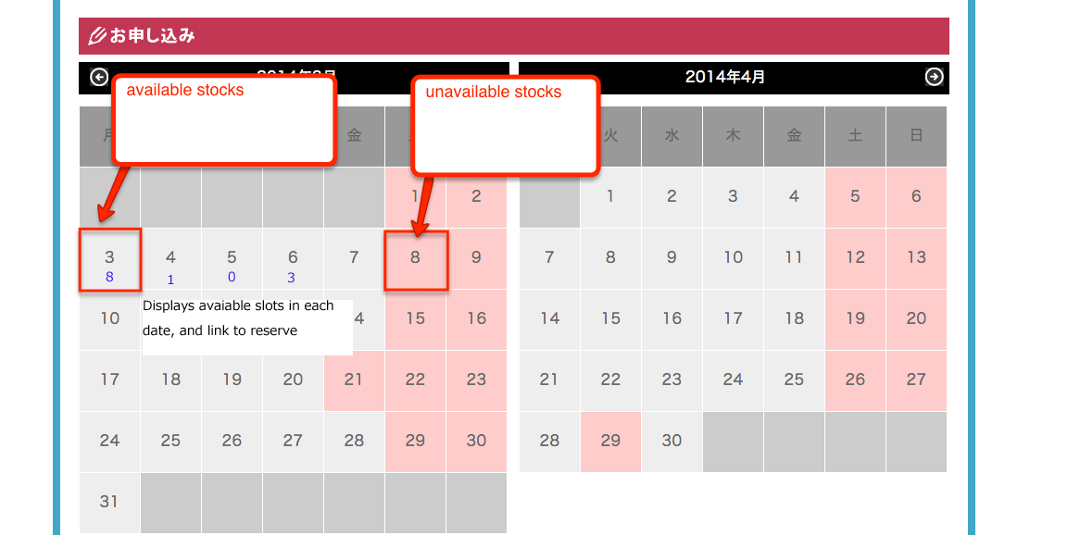

1. “Display details of reservation for confirmation”

* in the my page ( or dashboard of each user) will has a section which to show details of reservation which this user was reversed them before. But I do not understand “ for confirmation” phrase.
* Just to confirm tours reserved and experienced, history function and for example, you reserved some tours in 3 months, you want to check what you reserved before joining it several days earlier, right? So as to remind users.

3. “rate tours joined” .

-> Please explain more this?

Record tours experienced and rate/review tours such as Single Star or Five Star and comment it.

4. “Map serch enhancement”

-> Please explain more this?

For current function, when user filters by area, such as Danang, user can view listing tours. However we’d like to display such as below

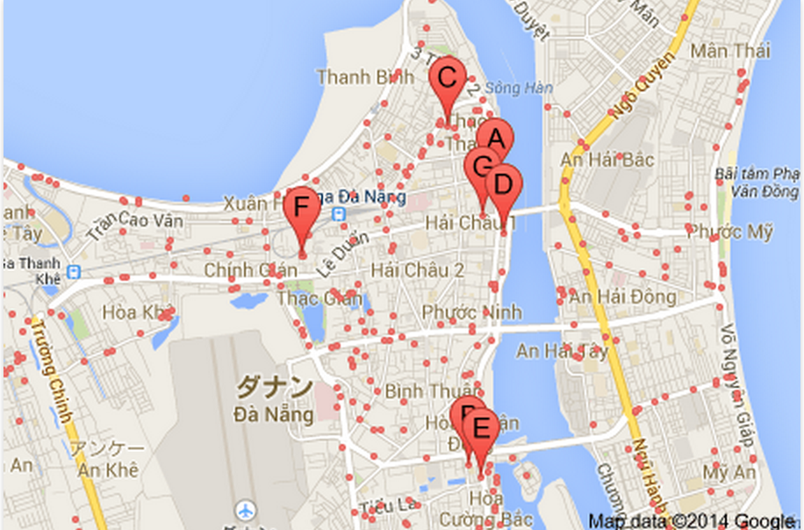

clicked each pin then display tour information on the same page(AJAX)

**II Admin**

5. “Salese management by each vendor( all/yearly/monthly/weekly/daily)”

* when a user reserve a tour, we will make a order ( you mean: sale ) and in this requiment you want to manage these orders, right?
* Yes, count reservations, sum of fees by total/monthly/weekly etc..

6. Could you please give me a example or more details about anaylytics and report ??

As mentioned above, we’d like to display tours reservation data as following filter

* by tours
* by date
* by Vendor
* by agent
* etc..

We’d like to decide which data is needed…

**III Additions**

1. We will continue working on old design ? Did you make any change?

We’d like you to continue on source I sent, I changed much like

* ssl ( admin page/ contact page)
* map search
* preview function
* document upload function
* etc..

So I’d like you to assume the work estimation including investigation of current source.