FreeEsVclComponents

1. Add “Source” folder to library path

(Tools->Options->Delphi Options->Library->Library path):

**For “Selected platform”: “32-bit Windows” and “64-bit Windows”**

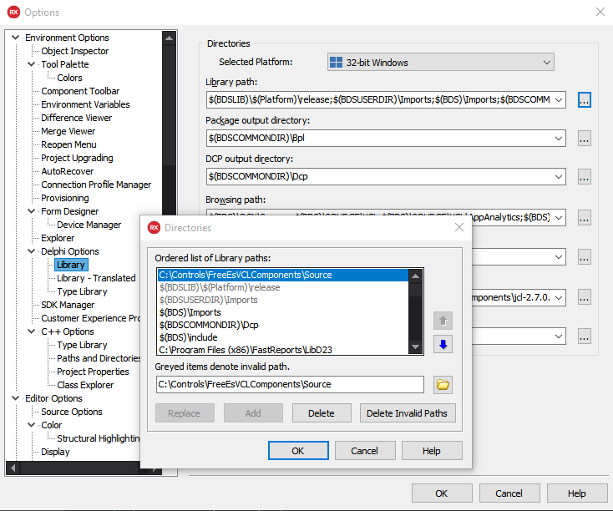

1. Open Project Group “ErrorSoftGroup”:

If you have plan to install the components to multiple versions of Delphi on computer(multiple installation),

then start the "Packages\PackagesGenerator.exe" and choose appropriate generated project files.

1. Click “Build All”:

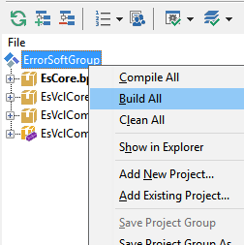

1. Select “EsVclComponentsDesign” and Click “Install”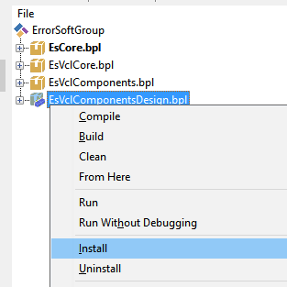
2. Done!