# C:\sources\components\GitHubVersion\FreeEsVclComponents\Logos\Logo.png

# errorsoft VCL components v4.0

# Release notes

This is big release free open source library **errorsoft VCL components**.

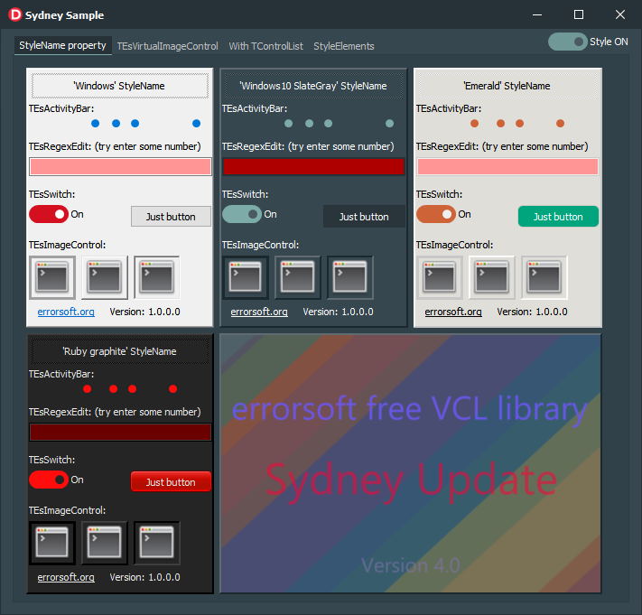

## What’s new?

### New components

Two new components for Delphi 10.4 Sydney: **TEsVirtualImage, TEsVirtualImageControl.**

These components are similar to TEsImage and TEsImageControl but with support for TimageCollection.

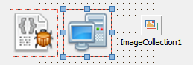

TEsVirtualImage and TEsVirtualImageControl provide additional capabilities such as:

* Adjustable opacity
* Configurable pixel interpolation mode
* New stretch modes
* Ability to set a frame with style
* Ability to set background color
* Border support
* And of course - TEsVirtualImageControl doesn't flicker

**The best way to explore this feature is to look at the "Sydney Sample":**

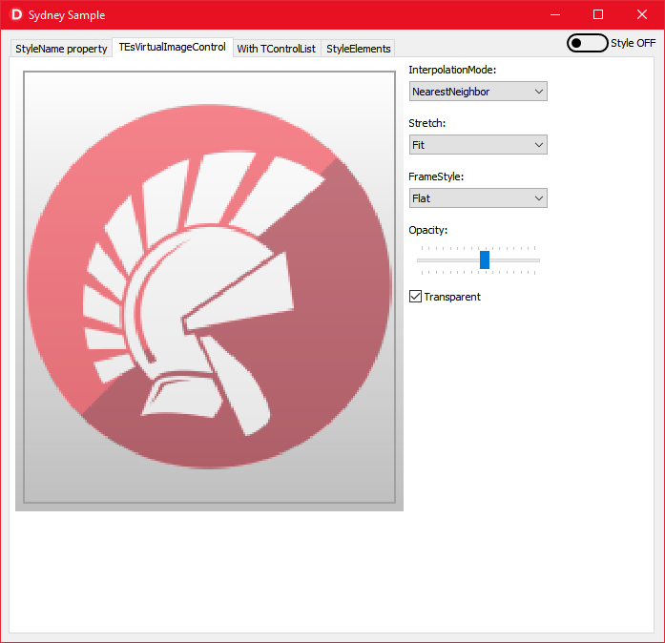

### Rewrited ES.BaseControls.pas

This module had a long history and support for XP and Delphi 7. This resulted in a bit of confusing code and a lot of IFDEFs, and the module was really hard to support. Starting with this release, the minimum supported version of Windows is Windows 7, as well as Delphi XE2.

The end of support for XP allowed for many optimizations, as well as many rendering enhancements:

* Faster DWM buffering is now used by default.
* The code has been cleaned up and some documentation has appeared.
* Improved style support.
* And more…

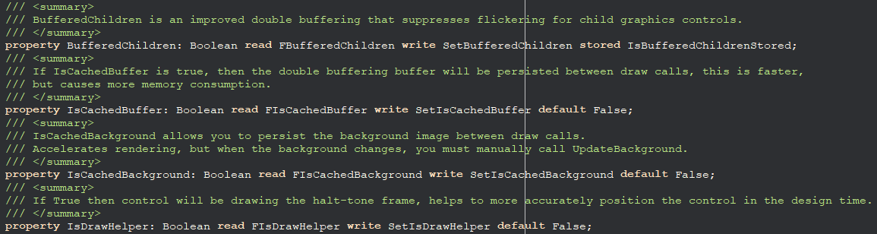

### Full support individual control styling

In Delphi 10.4 added support for setting different styles for different controls using the StyleName property.

Full support for this feature has been added to the library, all components support individual styling.

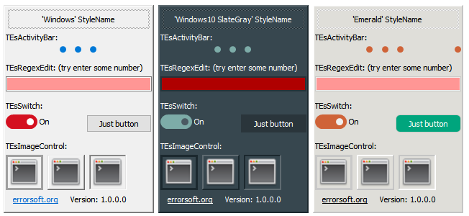

### TVirtualImageList support

All components supporting TImageList received support for the ImageName property.

Yes - you can use TEsImage to display icons from TVirtualImageList / TVirtualImageList to TСontrolList.

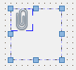

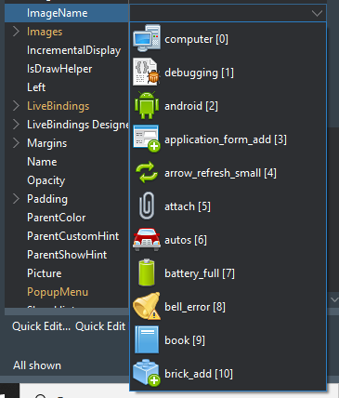

### Improved TEsPanel

TEsPanel now supports Caption when CaptionVisible is activated.

Disabled by default, because usually no need an Caption.

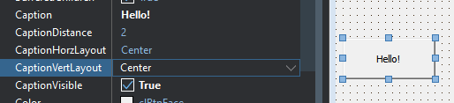

### Other improvements

* Work on quality
* Cleaning up the code
* Improved support for styles
* Fixes for HiDPI
* Removing multiple IFDEFs and their associated code
* TEsImage now also supports custom frameTEsImage now also supports custom frame
* Improving Samples

# What's next?

I recommend watching the Sydney Update example for new features. It is located in the examples folder, but is not part of the project group so that users of previous Delphi versions have no problems. You can open it manually.

