# C:\sources\components\GitHubVersion\FreeEsVclComponents\Logos\Logo.png

# errorsoft VCL components v3.0

# Release notes

This is big release free open source library **errorsoft VCL components**.

## What’s new?

* Four new components: **TEsPaintBox, TEsLinkLabel, TEsVersionLabel, TEsPanel**
* Some code refactoring.
* **HiDPI** support for **Delphi/C++Builder Berlin** and higher versions.
* Rename **BufferedChildrens** to **BufferedChildren**, **ParentBufferedChildrens** to **ParentBufferedChildren**. (Need renaming these properties in your code, but in **DFM** files will converting automatically)
* Improvements
* Fixing draw selection bug on Designder
* Now **BufferedChildren** is **True** by defalut in **TEsLayout/TEsPanel/TEsImageLayout**
* New functions, please see further
* New record TFileVersion for to find out the version of the file or application

## Review new components:

**TEsLinkLabel** – Clickable link, opens a link on the Internet or local.

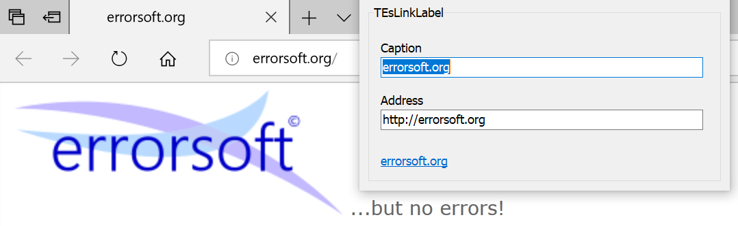

*See: Labels sample*

**TEsLinkLabel** – Display current version of application.

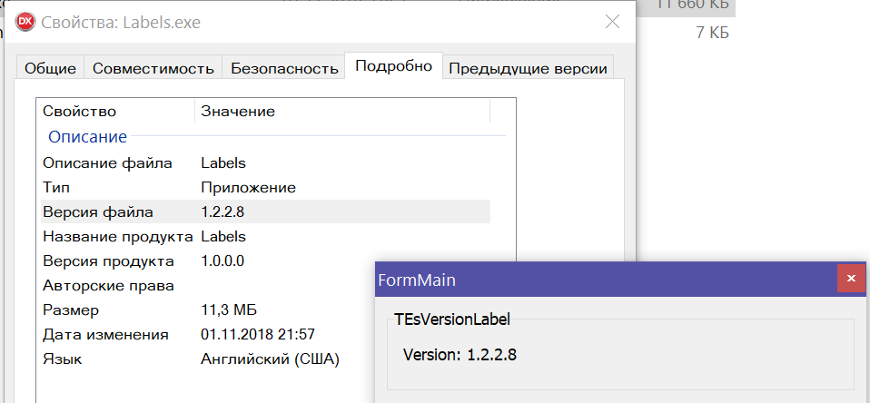

*See: Labels sample*

**TEsPaintBox** – Flicker free PaintBox. It’s very nice replacement for TPaintBox.

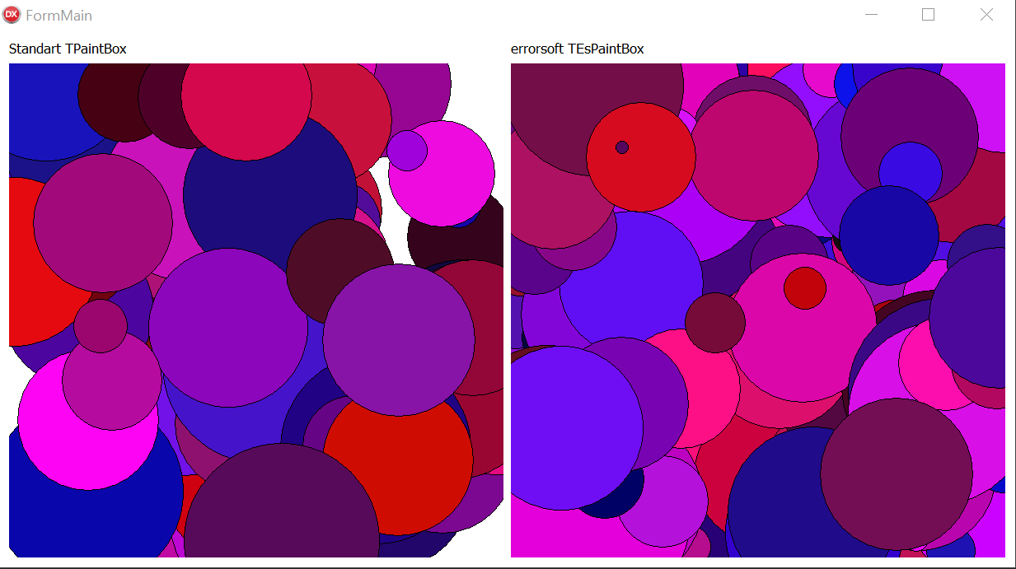

*See: PaintBox sample*

**TEsPanel** – Flicker free Panel. It’s very nice replacement for TPanel, also this support new frame styles.

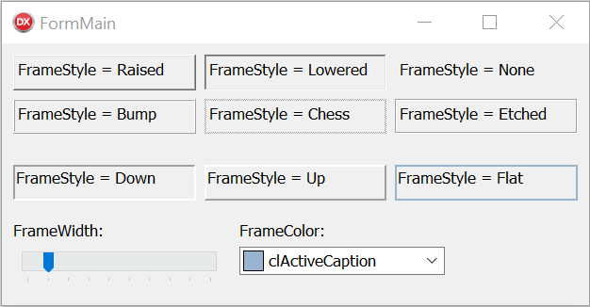

*See: Panel sample*

## Improvements:

Now, TEsNinePatchImage, TEsImageLayout, TEsImageStaticText, TEsImageLabel draws corners in design time.

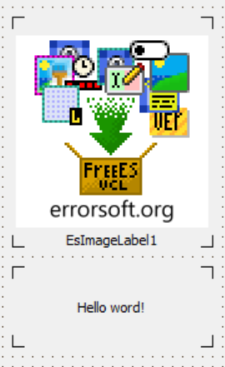

Adding new functions to **ES.ExGraphics**:

**procedure DrawCorners(R: TRect; Width: Integer);** - Draw corners on canvas.

**function HighlightColor(Color: TColor; Value: Integer): TColor;** - Highlightcolor, use relative value (-255…255).

**procedure DrawHalftoneBitmap(Canvas: TCanvas; X, Y: Integer; Bitmap: TBitmap; Value: Byte; Color: TColor = clBlack);** - Draw half-tone bitmap on canvas.

**procedure HalftoneBitmap(Bitmap: TBitmap; Value: Byte; Color: TColor = clBlack);** - Halftone bitmap.

Some improvements for support **AlphaSkins** library.