**LAB:NO:05**

**OBJECT:** **TO BECOME FAMILIAR WITH RMI OBJECT SERIALIZATION.**

**CLASS TASK:** **create a program in which server sharing an object via RMI and a client calling the shared instance.**

**Program: Interface.java:**

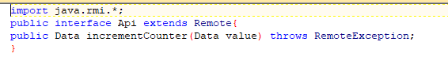

**RemoteObjectClass.java:**

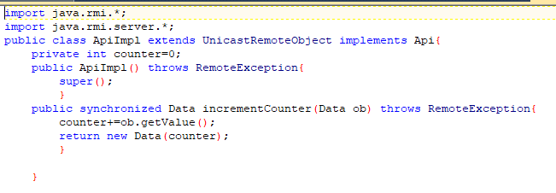

**Serializable class:**

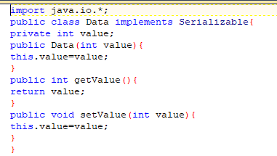

**Server.java:**

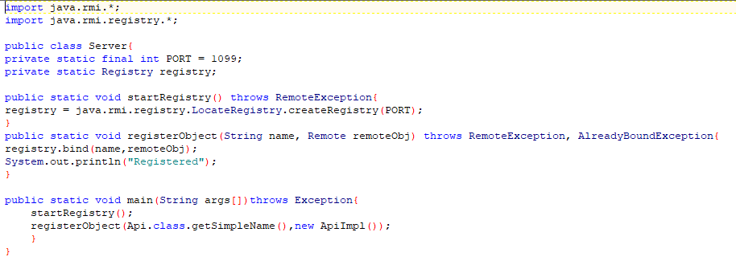

**Client.java:**

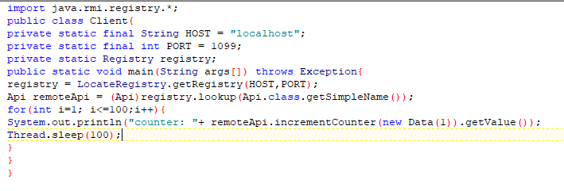

**Output:**

**First compile all classes:**

**Create stub and skeleton of RemoteObjectClass.**

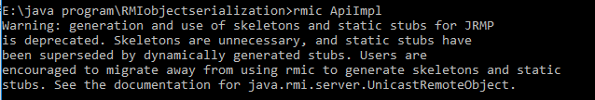

**Start server and Register Server RemoteObject**



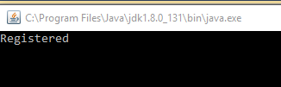

**And then run client class**

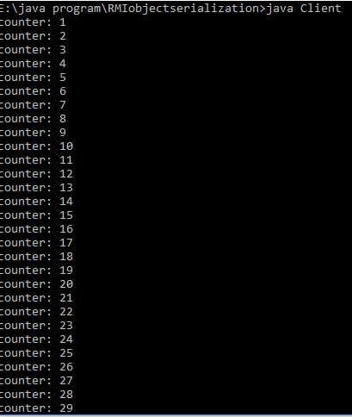

**TASK: Develop any simple application to demonstrate object passing in RMI. (Expl: Make a class of your own and use its objects as arguments and return types for RMI).**

**Program: Interface.java:**

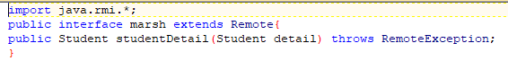

**RemoteObjectClass.java:**

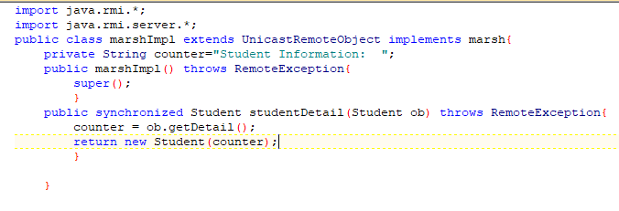

**Serializable class:**

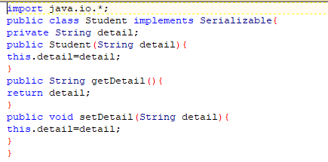

**Server.java:**

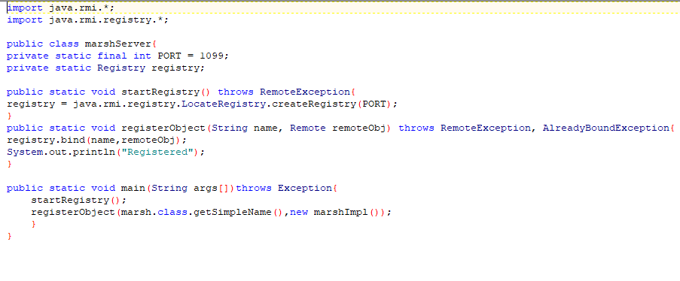

**Client.java:**

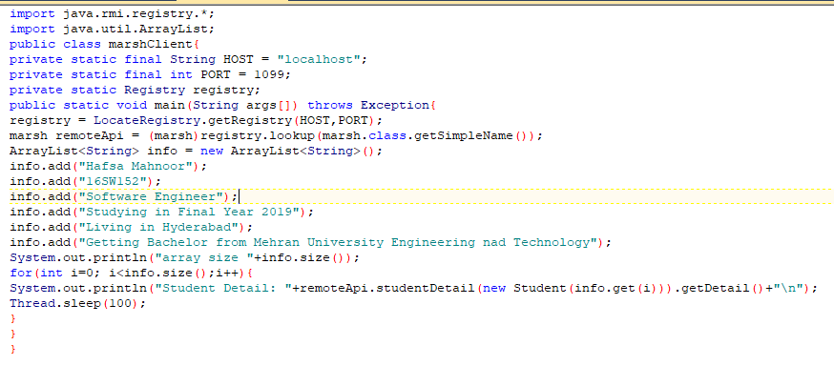

**First compile all classes:**

**Create stub and skeleton of RemoteObjectClass**

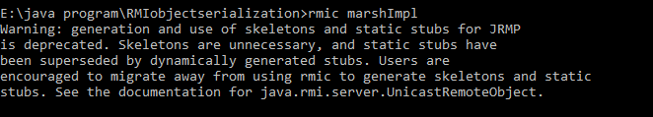

**Start server and Register Server RemoteObject**



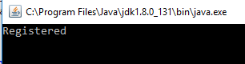

**And then run client class**

