**LAB:NO:06**

**OBJECT: TO GET FAMILIAR WITH CODE OF “RMI-IIOP”.**

**CLASS TASK: HelloWorld Application using IIOP.**

**Program: Interface.java:**

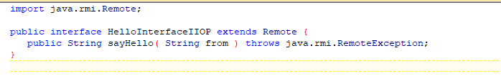

**RemoteObjectClass.java:**

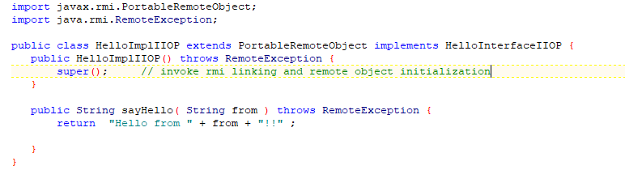

**Server.java:**

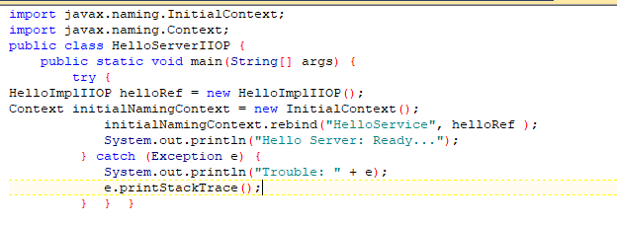

**Client.java:**

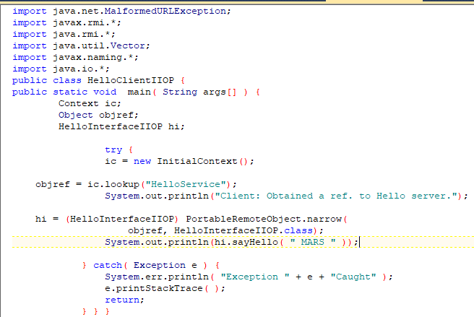

**Output:**

**First compile all classes:**

**Create stub and ties of RemoteObjectClass**



**Register Server RemoteObject**



**Start server**



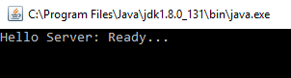

**And then run client class**



**TASK: Create RMI IIOP application in which take a sentence at runtime on the client application and let the server return its reverse.  
E.g. input could be: subject is distributed computing   
output should be: computing distributed is subject.**

**Program: Interface.java:**

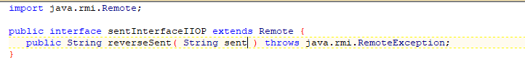

**RemoteObjectClass.java:**

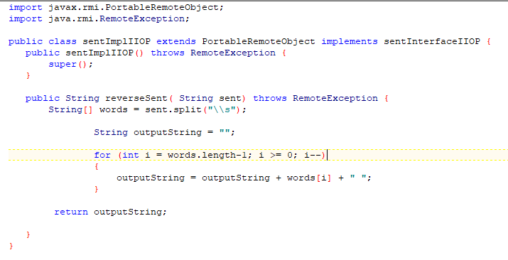

**Server.java:**

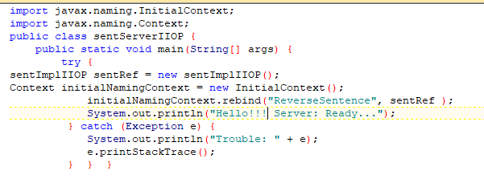

**Client.java:**

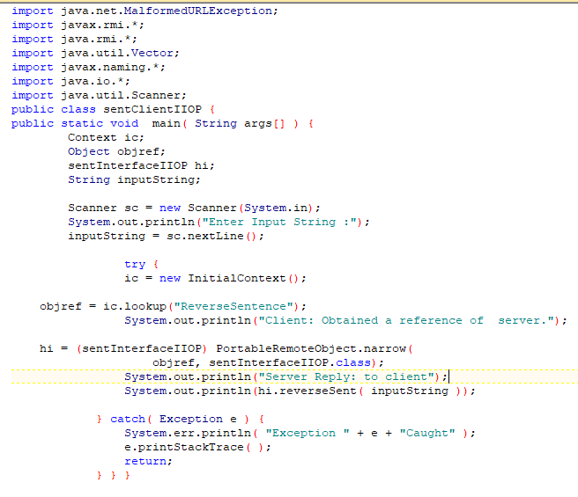

**Output:**

**First compile all classes:**

**Create stub and ties of RemoteObjectClass**



**Register Server RemoteObject**



**Start server**



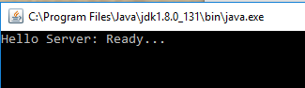

**And then run client class**

