**LAB:NO:07**

**Object: TO UNDERSTAND MULTITHREADING.**

* **Write the same code for matrix multiplication and divide the code into ten threads. Also note the timestamp at the start and end of the program. Give your conclusion.**

**Matrix Multiplication using Traditional Method:**

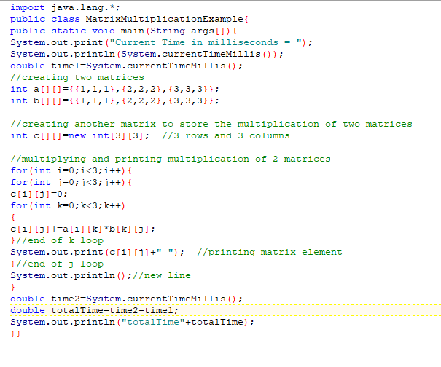

**Output:**

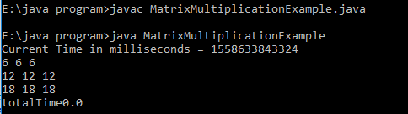

**Matrix Multiplication using Thread:**

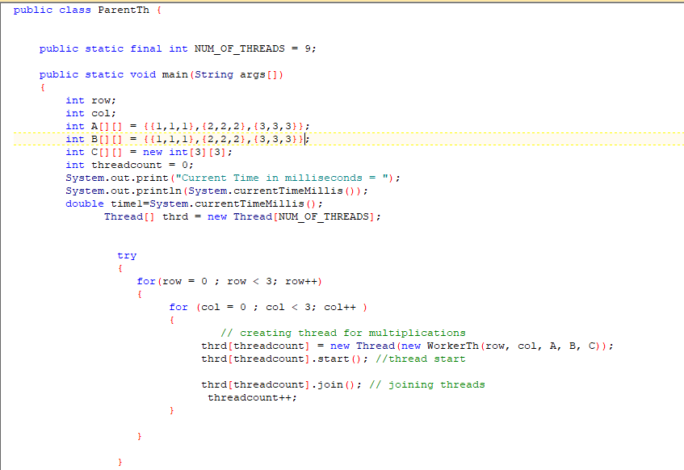

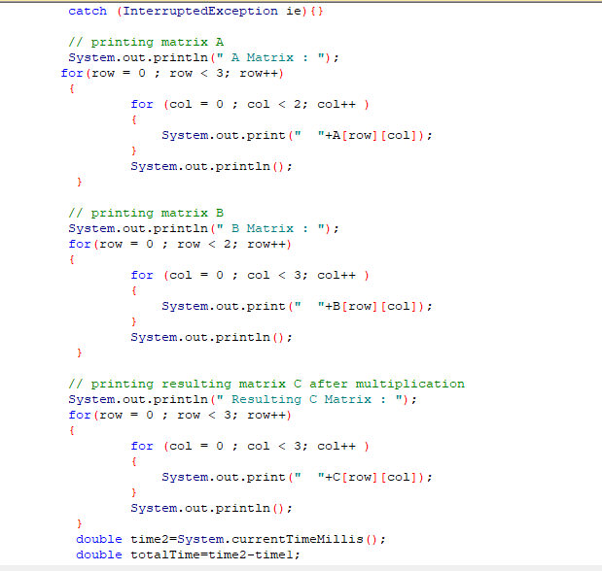

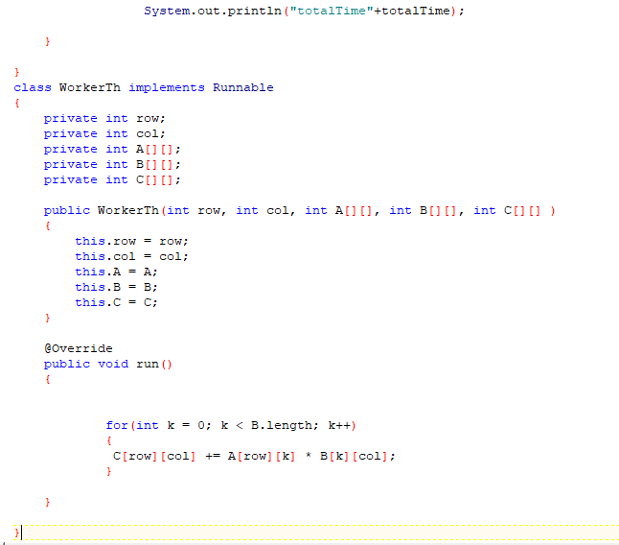

**Output:**

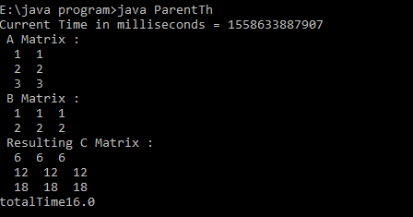

**Conclusion: time taken to calculate the matrix multiplication using threads is more than the traditional one.**