

大标题

文件修改记录
文件版本 | 日期 | 作者 | 修改描述
1.0 | 2026-3-19 | 阮俊寒 | 初始版本

目录
大标题 3
1. 一级章节标题 3
2. 一级章节标题 3
2.1. 二级标题 3
3. 参考文献 5

大标题
- 一级章节标题
正文。
- 一级章节标题
  - 二级标题
    - 三级标题

四级标题
正文
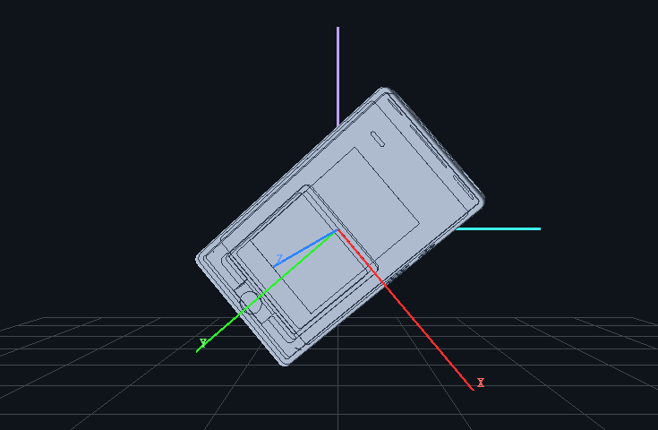
图 1：图片题注

方案来源 | 任务/状态类别 | 传感器布置 | 核心特征与方法概括 | 与 iT30 适配度
Dikkema (2023) | Walking, Standing, Sitting, Semi-lying, Supine 等8类 | 双加速度计(胸+腿) | 基于重力方向角 θ/ψ/φ + SMA，规则阈值表分类 | 中 (双传感器)
Nazarahari (2018) | Daily postures + Walking modalities | 单三轴加速度计  (胸) | 通过躯干倾角与重力变化检测 walking | 高
Vähä-Ypyä (2018) | Lying,Sitting, Standing | 单三轴加速度计  (髋) | APE核心指标，通过 ROC 建立分类基线 | 高
Vähä-Ypyä (2024) | Standing, Sitting, Reclining, Lying | 单三轴加速度计  (髋) | APE+Walking参考筛选 | 最高 (阈值源)
Rauen (2018) | Semi-side-lying 的体位变化检测 | 上躯干/大腿 | 0.25 Hz 低通获取倾角 + SMA 小波峰值监测 | 较高
Yoon (2015) | 多种卧姿细分 (Lateral, Prone 等) | 贴片式 IMU | 提取三轴姿态分布特征区分卧姿 | 中 (侧重卧姿)
表格样式
- 参考文献
[1] Vähä-Ypyä H et al.. Measurement of Sedentary Behavior—The Outcomes of the Angle for Posture Estimation Method. Sensors. 2024; 24(7):2241
[2] Dikkema et al.. Identification and Quantification of Activities Common to Intensive Care Patients; Development and Validation of a Dual-Accelerometer-Based Algorithm. Sensors. 2023; 23(3):1720
[3] Nazarahari R, Rouhani H. Detection of daily postures and walking modalities using a single chest-mounted tri-axial accelerometer. Medical Engineering & Physics. 2018; 57:75-81
[4] Rauen K et al.. Accelerometric Trunk Sensors to Detect Changes of Body Positions in Immobile Patients. Sensors. 2018; 18(10):3272
[5] Vähä-Ypyä H et al.. Reliable recognition of lying, sitting, and standing with a hip-worn accelerometer. Scandinavian Journal of Medicine & Science in Sports. 2018; 28(3):1092-1102
[6] Yoon SW et al.. Estimation of sleep posture using a patch-type accelerometer based device. 2015 37th Annual International Conference of the IEEE Engineering in Medicine and Biology Society (EMBC). 2015
[7] Madgwick S. O. H.．An efficient orientation filter for inertial and inertial / magnetic sensor arrays[A]．2010．

