Create a MVC3 Project from Template:

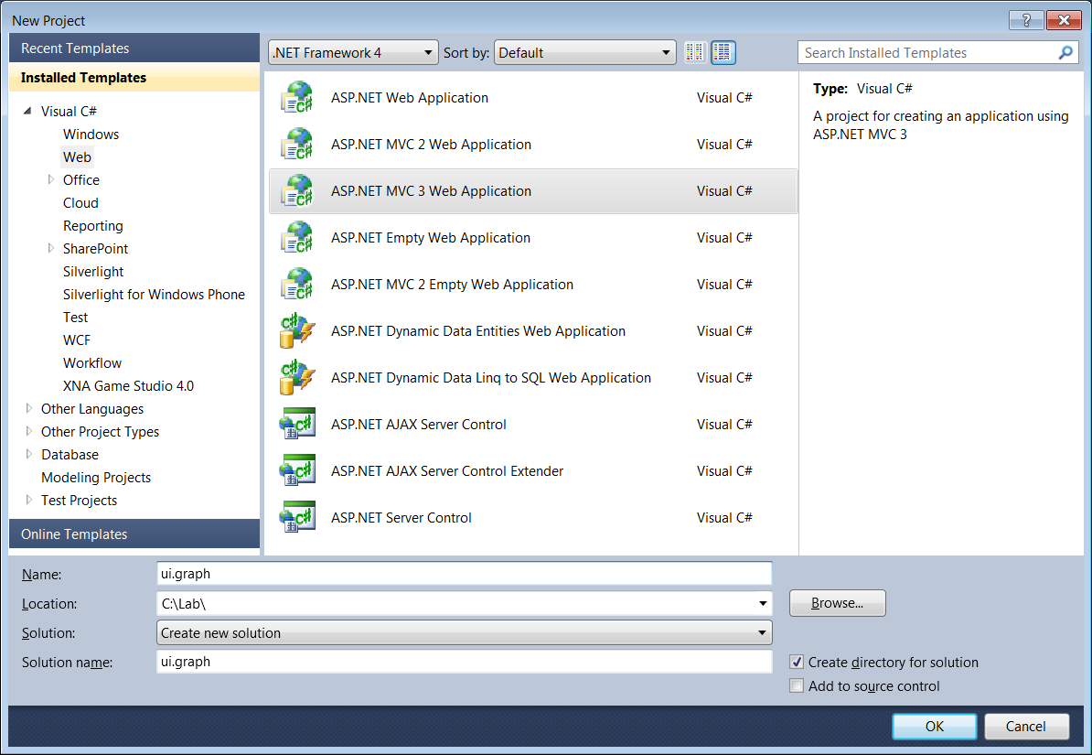

It will create default web application:

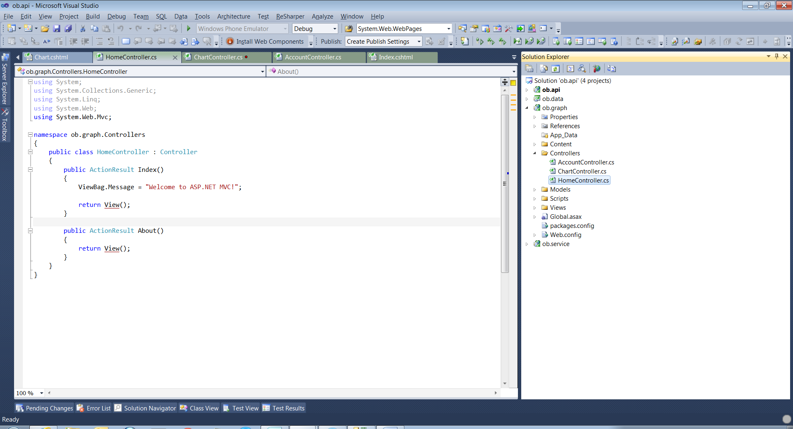

The Reference to Data Visualization

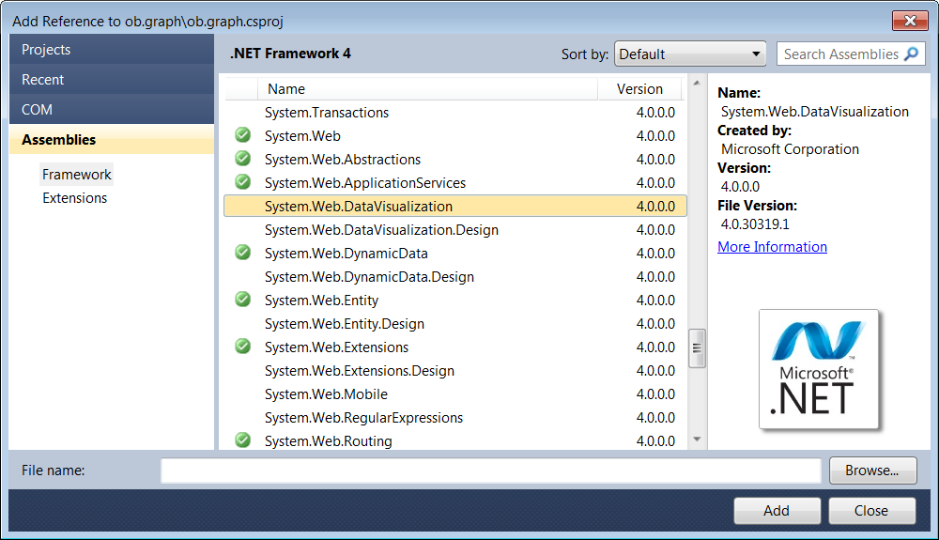

The added reference is here

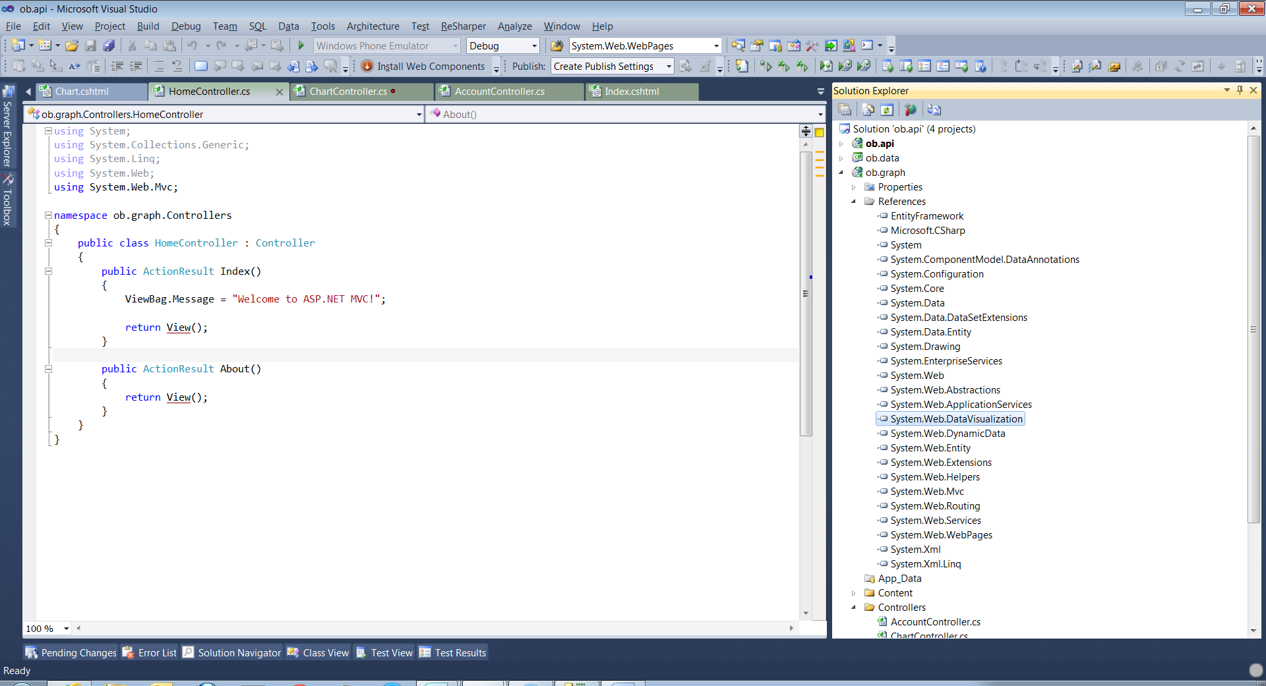

The add a controller

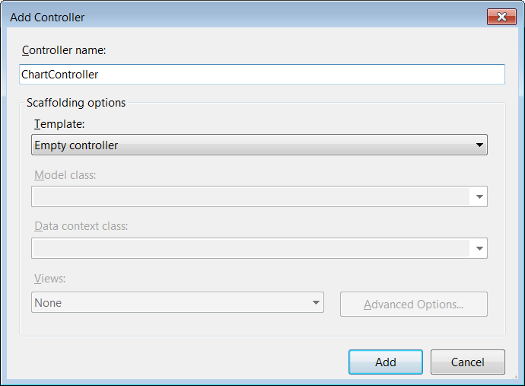

Add these following Code **Graph** Action in **Chart**Controller.cs

|  |
| --- |
| public ActionResult Graph(string id, double? width, double? height)          {              string title = "Data for Parameter " + id;              // Get the Data by ID...              double[] yValues = { 10, 27.5, 7, 12, 45.5 };              string[] xNames = { "Visitor", "Added To Cart", "Entered Billing", "Created PaymentMethod", "Completed Purchase" };              return File(GetChart(title,width, height, xNames, yValues), "image/png");          } |

And Actual rendering by a private method

|  |
| --- |
| private byte[] GetChart(string title, double? width, double? height, string[] xNames, double[] yValues)          {              var reportData = new List<string>();              byte[] data = new byte[256];              Chart chart = new Chart();              chart.Width = new Unit(width.Value);              chart.Height = new Unit(height.Value);              chart.Titles.Add(title);              Series pieSeries = new Series();              pieSeries.ChartType = SeriesChartType.Pie;              pieSeries.Points.DataBindXY(xNames, yValues);              pieSeries.Points[4]["Exploded"] = "True";              chart.Series.Add(pieSeries);              chart.ChartAreas.Add("basic");      chart.ChartAreas[0].Area3DStyle  = new ChartArea3DStyle()  { Enable3D=true};              MemoryStream ms = new MemoryStream();              chart.SaveImage(ms);              data = ms.GetBuffer();              return data;          } |

Then the View Part, add the jquery plugin

|  |
| --- |
| <script src="../Scripts/jquery.graph.js" type="text/javascript"></script>  <h2>Chart</h2>    <div id="spchart">      <p>          Parameter Width =   <input type="text" value="600" id="p1"/> px      </p>      <p>          Parameter Height =   <input type="text" value="400" id="p2"/> px      </p>      <p>     <input type="button" id="b1" value="Render Chart"/>      </p>      <script src="../Scripts/jquery.graph.js" type="text/javascript"></script>      <script type="text/javascript">            $('#b1').click(function (p) {              var p1 = $('#p1').val();              var p2 = $('#p2').val();              var url = "/Chart/Graph/Customer--Name?width=" + p1 + "&height=" + p2;              $('#chart').graph("pie", { url: url });          });      </script>  </div>    <div id="chart">    </div> |

Then the client part of Html  where jquery plug in is called.

|  |
| --- |
| <script type="text/javascript">            $('#b1').click(function (p) {              var p1 = $('#p1').val();              var p2 = $('#p2').val();              var url = "/Chart/Graph/Customer--Name?width=" + p1 + "&height=" + p2;              $('#chart').graph("pie", { url: url });          });      </script> |

Putting it altogether

|  |
| --- |
| @{      ViewBag.Title = "Chart";  }    <h2>Chart</h2>    <div id="spchart">      <p>          Parameter Width =   <input type="text" value="600" id="p1"/> px      </p>      <p>          Parameter Height =   <input type="text" value="400" id="p2"/> px      </p>      <p>     <input type="button" id="b1" value="Render Chart"/>      </p>      <script src="../Scripts/jquery.graph.js" type="text/javascript"></script>      <script type="text/javascript">            $('#b1').click(function (p) {              var p1 = $('#p1').val();              var p2 = $('#p2').val();              var url = "/Chart/Graph/Customer--Name?width=" + p1 + "&height=" + p2;              $('#chart').graph("pie", { url: url });          });      </script>  </div>    <div id="chart">    </div> |

That’s it. Go and add a link to Graph page. Preferably with **_Layout.cshtml** page

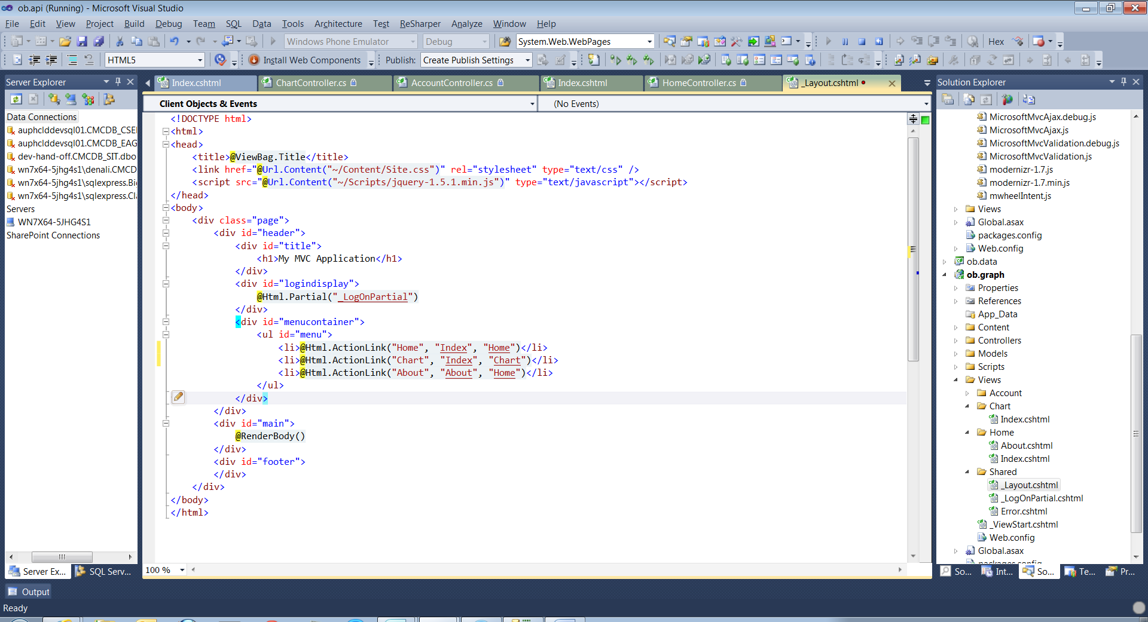

Browse the site.

Here is the Graph!!

