
TRUCK NO :
OD14Z2212

22

YASUJA ENTERPRISES PVT. LTD.

(DRIVER REGISTRATION FORM)

DRIVER CODE :

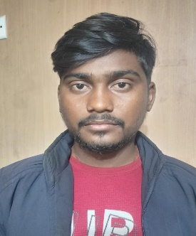
DRIVER BANE : RAVI KUMAR
DATE OF JOINING : 02/12/2024
OPENING HSD : 26.LTR
CONTACT NO : 6201474897
REFERENCE : ( DRIVER MITHILESH )

DOCUMENT DETAILS
UP3320160012299
JHJJJJCCCJH58522155CGCCCGGGGGGFHHHHHH
DL NO : ADHAR NO :
5672 2337 4535

BANK ACCOUNT DETAILS –

A/C NO | IFSC CODE | A/C HOLDER NAME
2648001700179595 | PUNB0264800 | BINDA DEVI

PERSONAL DETAILS
RAMESH MISTRI

BINDA DEVI

FATHER’S NAME :
SPOUSE NAME :

DATE OF BIRTH : BLOOD GROUP -
01/01/1998
O +

FAMILY CONTACT NO :
7870871476

AT/PO- SARSOT, PS-HARIHARGANJ, DIST- PALAMU, JHARKHAND
PIN- 822113

ADDRESS :

BANESWAR MAHANTA

SIGNATURE OF AUTHORITY SIGNATURE OF DRIVER

