Step 1: Remove the 8 screws of the bottom cover. Then remove the bottom cover

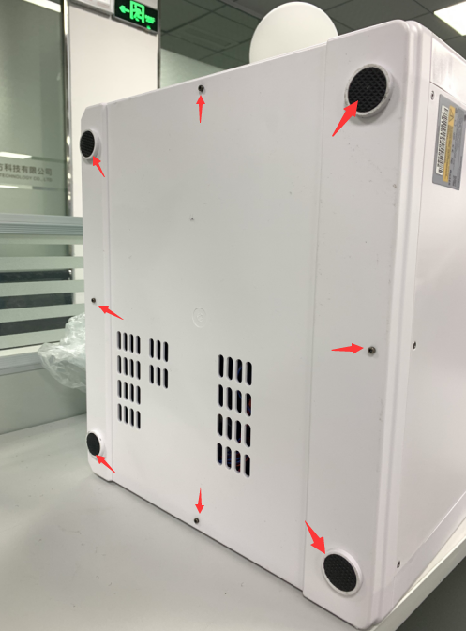

Step 2: Remove the 8 screws of the back cover. Then remove the back cover

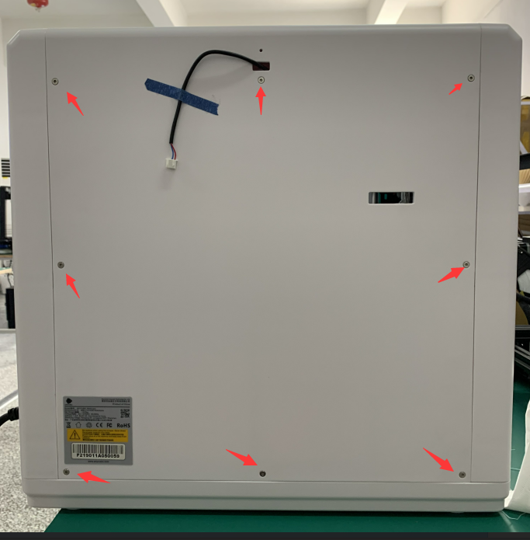

Step 3: Remove the 4 screws at the bottom of the right side cover

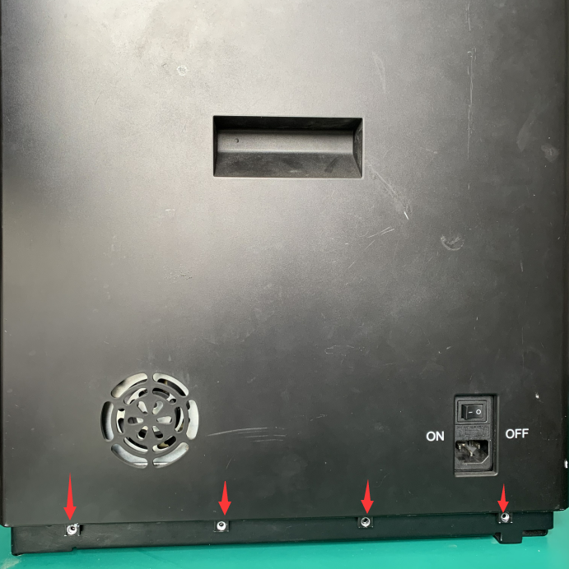

Step 4: Remove the right side cover. Don't be brute force. If you can't take it, you can pry the circlip from the inside of the machine.Use the same method to remove the left side cover.

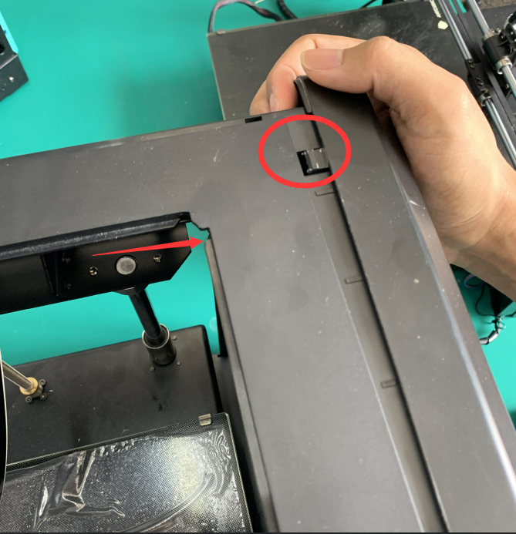

Step 5: Unscrew these 2 screws and replace the buckle

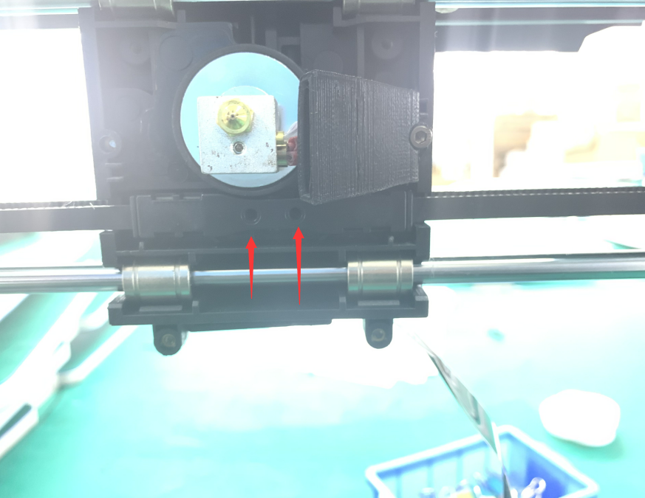

Step 6:If the sync wheel falls out during installation, please pay attention to its installation location.

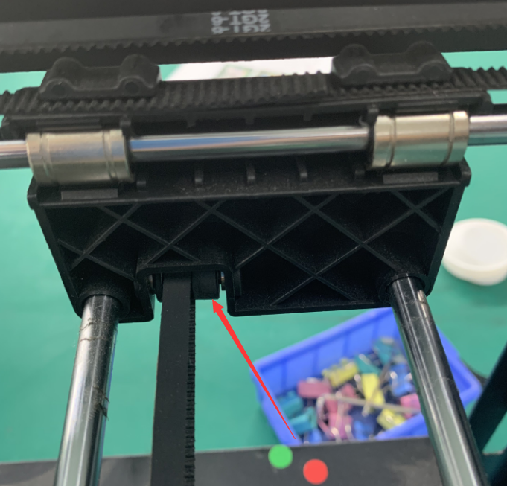

Step 7: Loosen the 4 screws and tighten the X-axis motor to the left side of the printer, then tighten the screws immediately. Fixed motor.

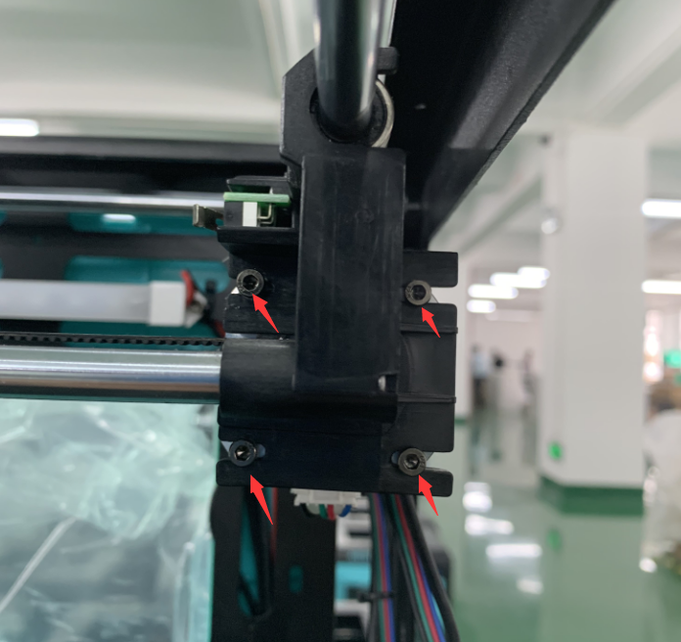

Step 8, attach the buckle of the belt to the bottom of the print head and fix it with screws

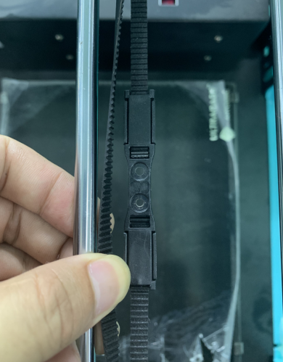

Step 9, install the printer's cases back