How to replace the touch screen of a 4MAX-PRO printer

Step 1: Remove the 8 screws of the bottom cover. Then remove the bottom cover

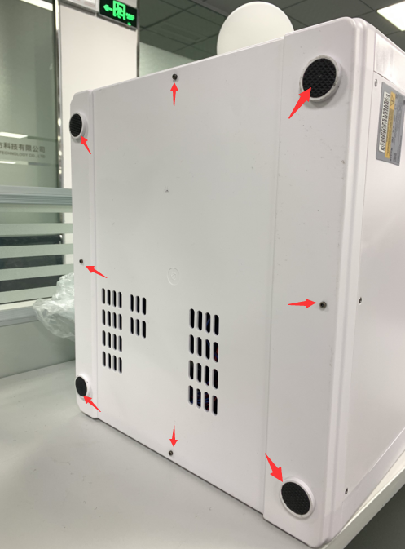

Step 2: Remove the 8 screws of the back cover. Then remove the back cover

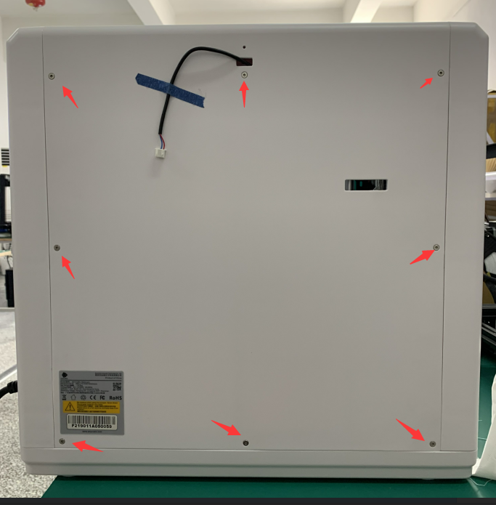

Step 3: Remove the 4 screws at the bottom of the right side cover

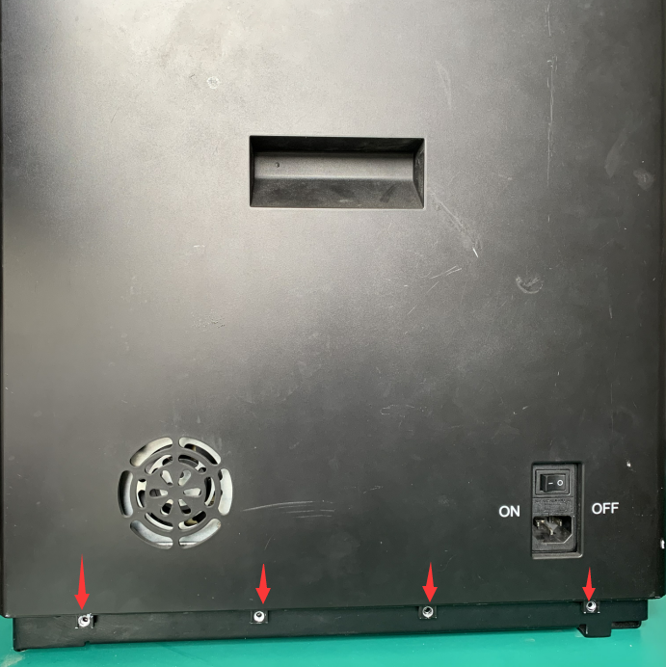

Step 4: Remove the right side cover. Don't be brute force. If you can't take it, you can pry the circlip from the inside of the machine.Use the same method to remove the left side cover.

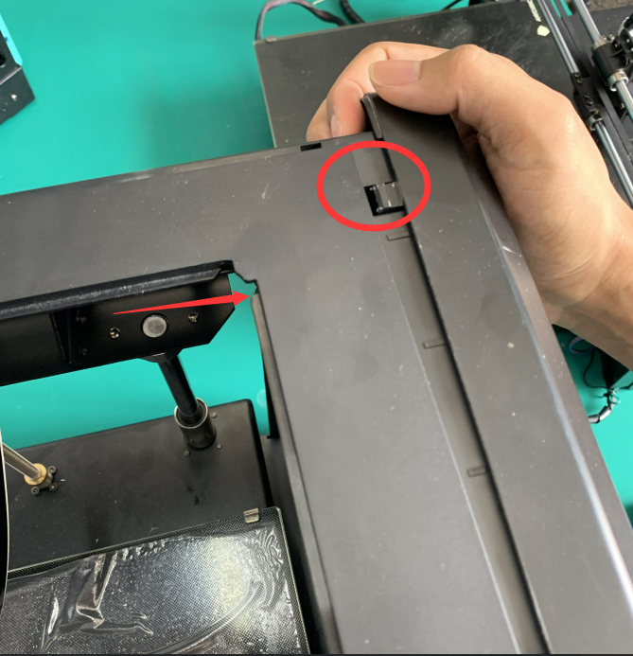

Step 5: Remove the 9 screws on the left, right and back of the top cover.

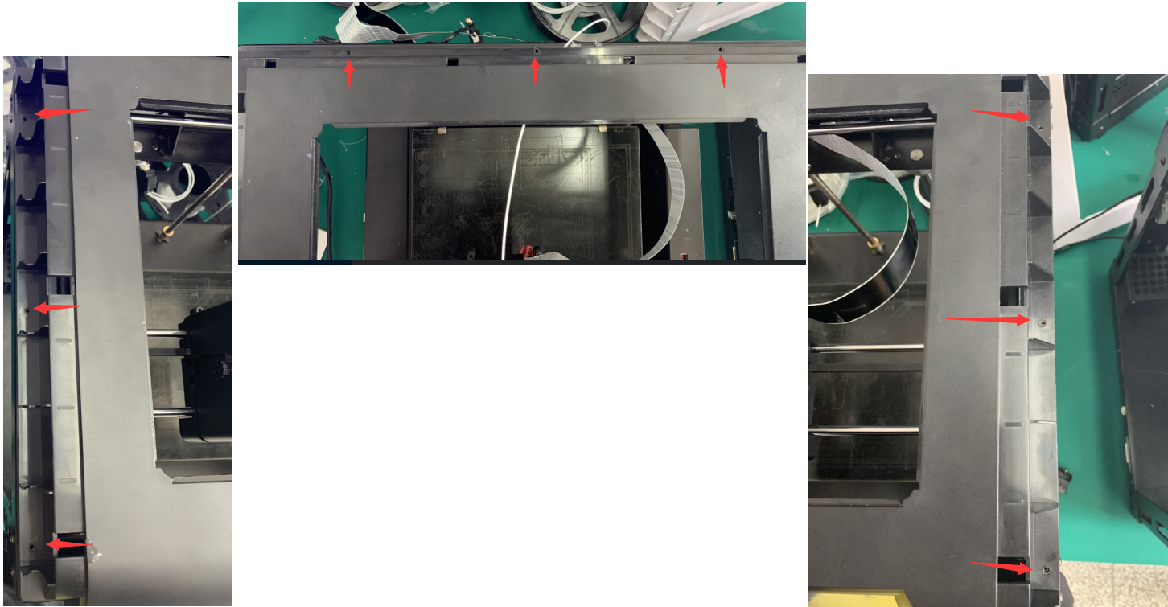

Step 6:Remove the top cover. And replace the touch screen.

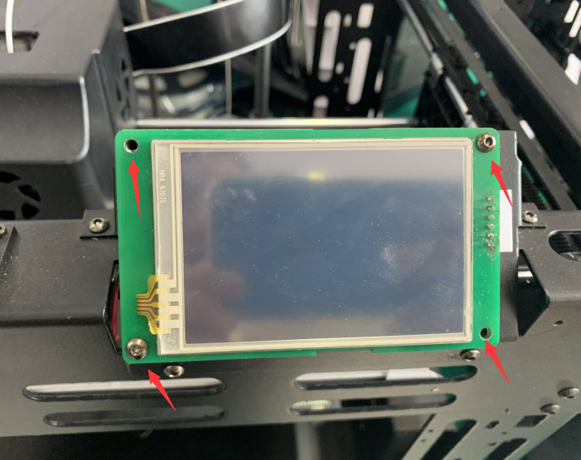

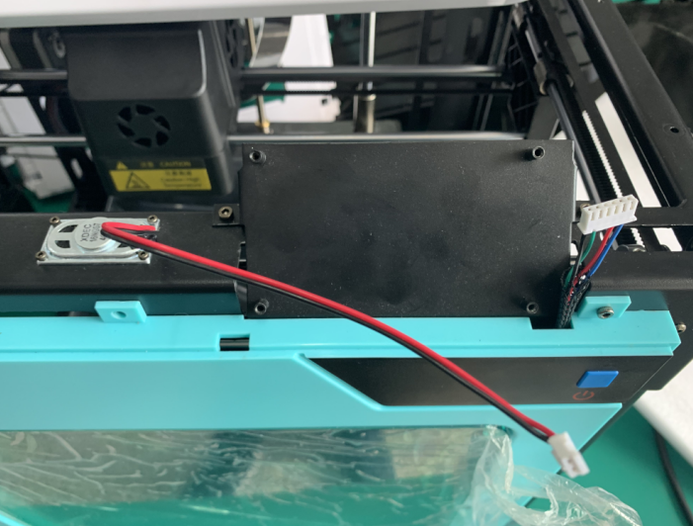

Step 7: Please install all the covers back.