**1. 다운로드 & 압축해제**

<http://alexgorbatchev.com/SyntaxHighlighter/download/>

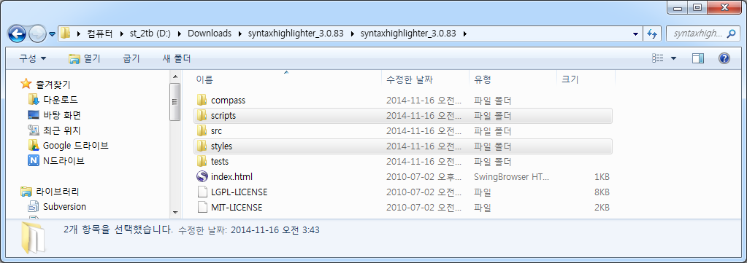

**2. 티스토리 관리자 – HTML/CSS 편집 : SyntaxHighlighter - 파일 업로드**

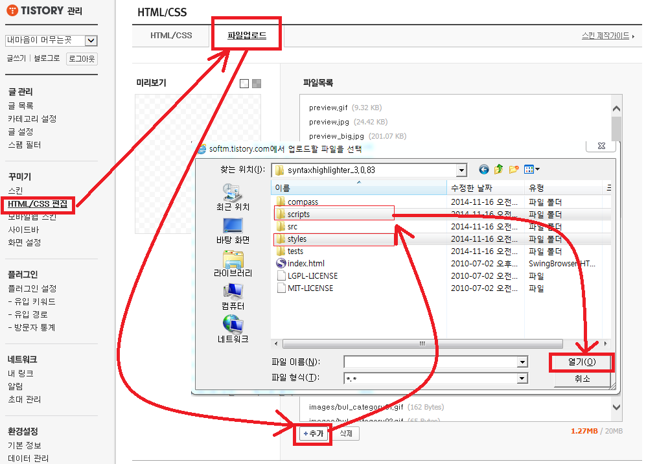

* **디렉토리를 선택면 안됩니다.**

**Script, styles 디렉토리의 파일 전체를 한번씩 선택해서 “열기”해주세요.**

**3. html에 SyntaxHighlighter 적용**

**티스토리 관리자 – HTML/CSS 편집 – HTML/CSS(탭)**

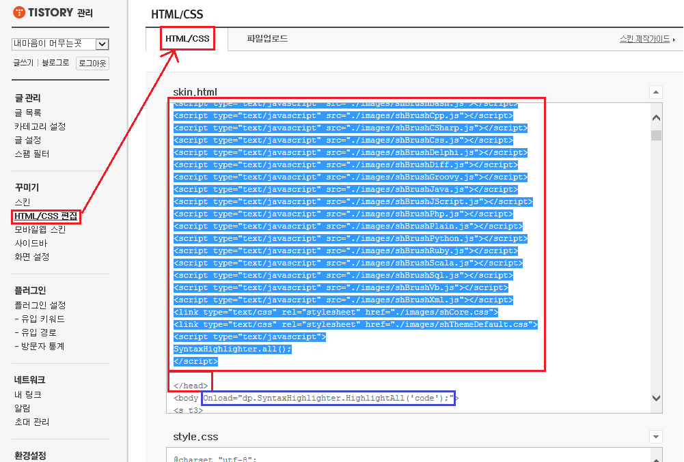

2

1

* **복사할 코드**

|  |
| --- |
| <script type="text/javascript" src="./images/shCore.js"></script>  <script type="text/javascript" src="./images/shLegacy.js"></script>  <script type="text/javascript" src="./images/shBrushBash.js"></script>  <script type="text/javascript" src="./images/shBrushCpp.js"></script>  <script type="text/javascript" src="./images/shBrushCSharp.js"></script>  <script type="text/javascript" src="./images/shBrushCss.js"></script>  <script type="text/javascript" src="./images/shBrushDelphi.js"></script>  <script type="text/javascript" src="./images/shBrushDiff.js"></script>  <script type="text/javascript" src="./images/shBrushGroovy.js"></script>  <script type="text/javascript" src="./images/shBrushJava.js"></script>  <script type="text/javascript" src="./images/shBrushJScript.js"></script>  <script type="text/javascript" src="./images/shBrushPhp.js"></script>  <script type="text/javascript" src="./images/shBrushPlain.js"></script>  <script type="text/javascript" src="./images/shBrushPython.js"></script>  <script type="text/javascript" src="./images/shBrushRuby.js"></script>  <script type="text/javascript" src="./images/shBrushScala.js"></script>  <script type="text/javascript" src="./images/shBrushSql.js"></script>  <script type="text/javascript" src="./images/shBrushVb.js"></script>  <script type="text/javascript" src="./images/shBrushXml.js"></script>  <link type="text/css" rel="stylesheet" href="./images/shCore.css">  <link type="text/css" rel="stylesheet" href="./images/shThemeDefault.css">  <script type="text/javascript">  SyntaxHighlighter.all();  </script> |

1. **</head>태그를 찾는다.**
2. **위쪽에 코드를 삽입한다.**
3. **<body> 🡪 <body Onload="dp.SyntaxHighlighter.HighlightAll('code');"> 변경.**

**4. Syntax Highlighter 적용**

[**http://alexgorbatchev.com/SyntaxHighlighter/manual/installation.html**](http://alexgorbatchev.com/SyntaxHighlighter/manual/installation.html)

**- 티스토리 에디터에서 html을 선택하고 직접 코드를 입력해서 적용합니다.**

<textarea name="code" class="**brush:js;**">

var a = 1;

alert(a);

</textarea>

**★ brush: 이후에 사용할 언어를 지정하면된다.**

**※ 사용가능 언어 목록.**

|  |  |  |
| --- | --- | --- |
| Brush name | Brush aliases | File name |
| [ActionScript3](http://alexgorbatchev.com/SyntaxHighlighter/manual/brushes/actionscript3.html) | as3, actionscript3 | shBrushAS3.js |
| [Bash/shell](http://alexgorbatchev.com/SyntaxHighlighter/manual/brushes/bash.html) | bash, shell | shBrushBash.js |
| [ColdFusion](http://alexgorbatchev.com/SyntaxHighlighter/manual/brushes/coldfusion.html) | cf, coldfusion | shBrushColdFusion.js |
| [C#](http://alexgorbatchev.com/SyntaxHighlighter/manual/brushes/csharp.html) | c-sharp, csharp | shBrushCSharp.js |
| [C++](http://alexgorbatchev.com/SyntaxHighlighter/manual/brushes/cpp.html) | cpp, c | shBrushCpp.js |
| [CSS](http://alexgorbatchev.com/SyntaxHighlighter/manual/brushes/css.html) | css | shBrushCss.js |
| [Delphi](http://alexgorbatchev.com/SyntaxHighlighter/manual/brushes/delphi.html) | delphi, pas, pascal | shBrushDelphi.js |
| [Diff](http://alexgorbatchev.com/SyntaxHighlighter/manual/brushes/diff.html) | diff, patch | shBrushDiff.js |
| [Erlang](http://alexgorbatchev.com/SyntaxHighlighter/manual/brushes/erlang.html) | erl, erlang | shBrushErlang.js |
| [Groovy](http://alexgorbatchev.com/SyntaxHighlighter/manual/brushes/groovy.html) | groovy | shBrushGroovy.js |
| [JavaScript](http://alexgorbatchev.com/SyntaxHighlighter/manual/brushes/javascript.html) | js, jscript, javascript | shBrushJScript.js |
| [Java](http://alexgorbatchev.com/SyntaxHighlighter/manual/brushes/java.html) | java | shBrushJava.js |
| [JavaFX](http://alexgorbatchev.com/SyntaxHighlighter/manual/brushes/javafx.html) | jfx, javafx | shBrushJavaFX.js |
| [Perl](http://alexgorbatchev.com/SyntaxHighlighter/manual/brushes/perl.html) | perl, pl | shBrushPerl.js |
| [PHP](http://alexgorbatchev.com/SyntaxHighlighter/manual/brushes/php.html) | php | shBrushPhp.js |
| [Plain Text](http://alexgorbatchev.com/SyntaxHighlighter/manual/brushes/plain.html) | plain, text | shBrushPlain.js |
| [PowerShell](http://alexgorbatchev.com/SyntaxHighlighter/manual/brushes/powershell.html) | ps, powershell | shBrushPowerShell.js |
| [Python](http://alexgorbatchev.com/SyntaxHighlighter/manual/brushes/python.html) | py, python | shBrushPython.js |
| [Ruby](http://alexgorbatchev.com/SyntaxHighlighter/manual/brushes/ruby.html) | rails, ror, ruby | shBrushRuby.js |
| [Scala](http://alexgorbatchev.com/SyntaxHighlighter/manual/brushes/scala.html) | scala | shBrushScala.js |
| [SQL](http://alexgorbatchev.com/SyntaxHighlighter/manual/brushes/sql.html) | sql | shBrushSql.js |
| [Visual Basic](http://alexgorbatchev.com/SyntaxHighlighter/manual/brushes/vb.html) | vb, vbnet | shBrushVb.js |
| [XML](http://alexgorbatchev.com/SyntaxHighlighter/manual/brushes/xml.html) | xml, xhtml, xslt, html, xhtml | shBrushXml.js |