**1.** [**https://highlightjs.org/**](https://highlightjs.org/) **접속**

**■ “Get version 8.4” 클릭**

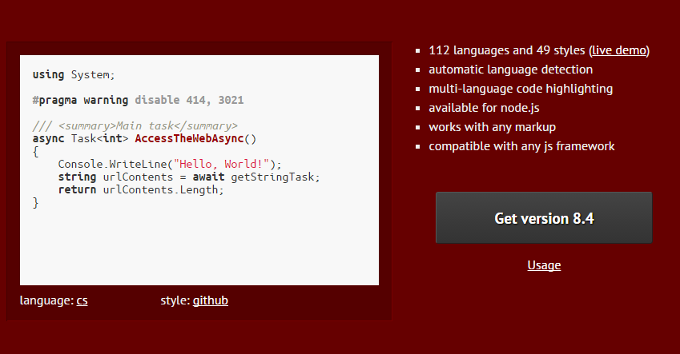

**2. highlight js 링크 복사**

<link rel="stylesheet" href="//cdnjs.cloudflare.com/ajax/libs/highlight.js/8.4/styles/**default.min.css**">

<script src="//cdnjs.cloudflare.com/ajax/libs/highlight.js/8.4/highlight.min.js"></script>

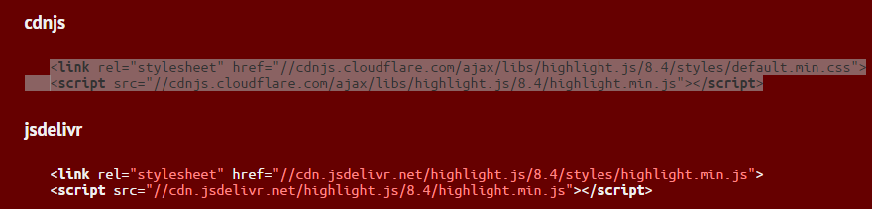

**■** css변경( <https://highlightjs.org/static/demo/> )

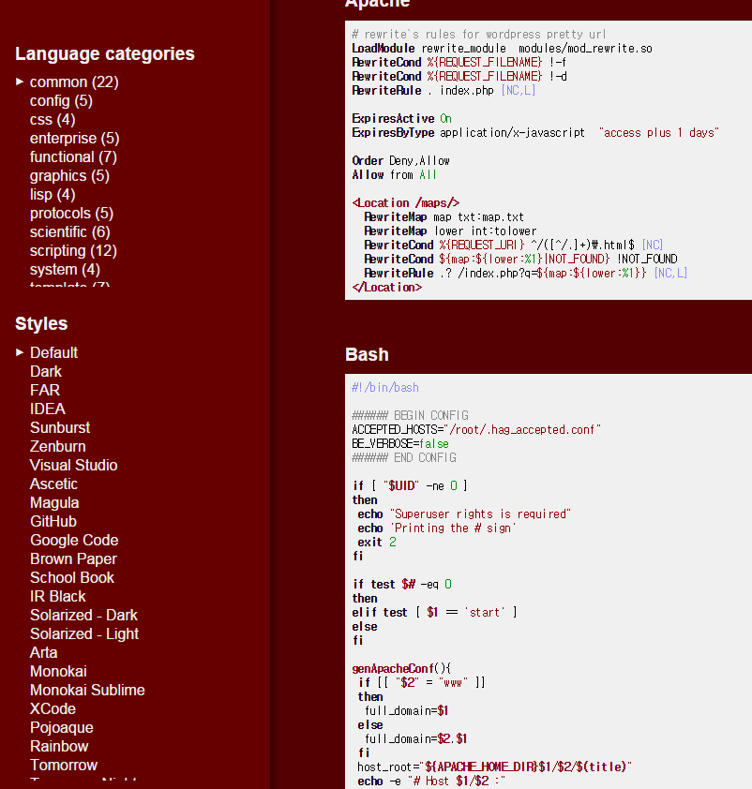

스타일을 Dark로 변경한다면

default.min.css 🡪 dark.min.css

를 변경

**3. 초기화 스크립트 복사**

**첫화면에서** [Usage](https://highlightjs.org/usage/) 클릭 🡪 사용방법 <https://highlightjs.org/usage/>

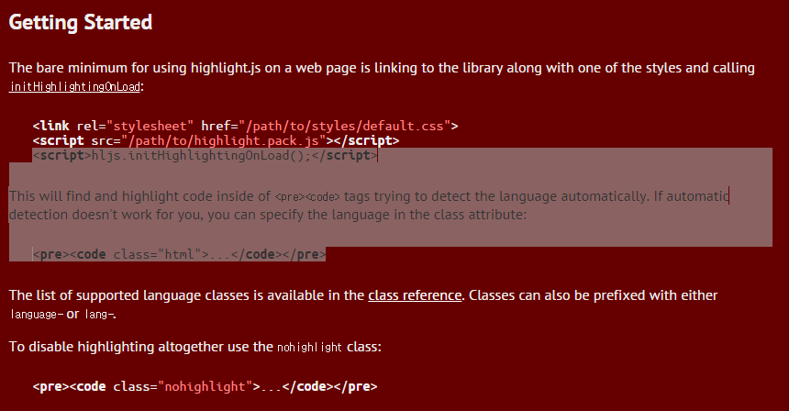

<script>hljs.initHighlightingOnLoad();</script>

**4. 적용**

<link rel="stylesheet" href=" https://cdnjs.cloudflare.com/ajax/libs/highlight.js/8.4/styles/**dark.min.css**">

<script src="https://cdnjs.cloudflare.com/ajax/libs/highlight.js/8.4/highlight.min.js"></script>

<script>hljs.initHighlightingOnLoad();</script>

<pre><code class="java">

package net.softm.test;

import java.util.Random;

public class RandomTest {

public static void main(String[] args) throws Exception {

exec();

}

public static String exec() {

String rtn = "";

Random randomGenerator = new Random();

return rtn;

}

}

</code></pre>