1. Data Cleanup and feature engineering for the timeseries ARIMA model

[Continuning right after talking about the data cleanup for the ML models]

For the the timeseries analysis and forecasting, we implemented some aditional cleanup steps. Initialy we are interested to answer the question [ INSERT QUESTION No], so we removed all other features and kept the timestamps for each entry. By aggregating the timestamps of each row for a set period, we engineered a new feature, as hourly, daily, weekly, monthly reported crimes counter.

2. Exploration for the timeseries ARIMA model
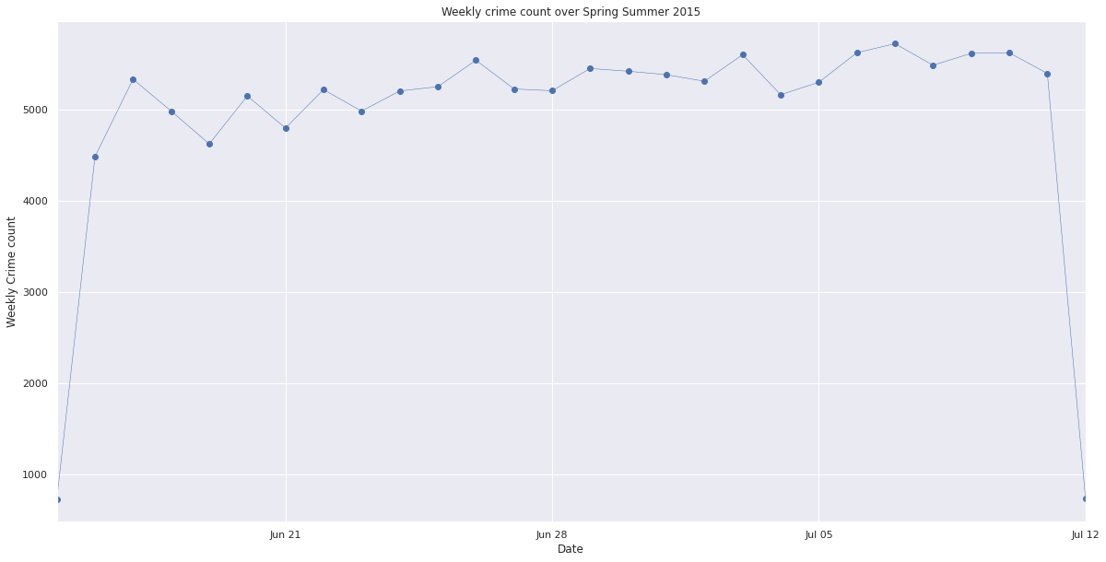
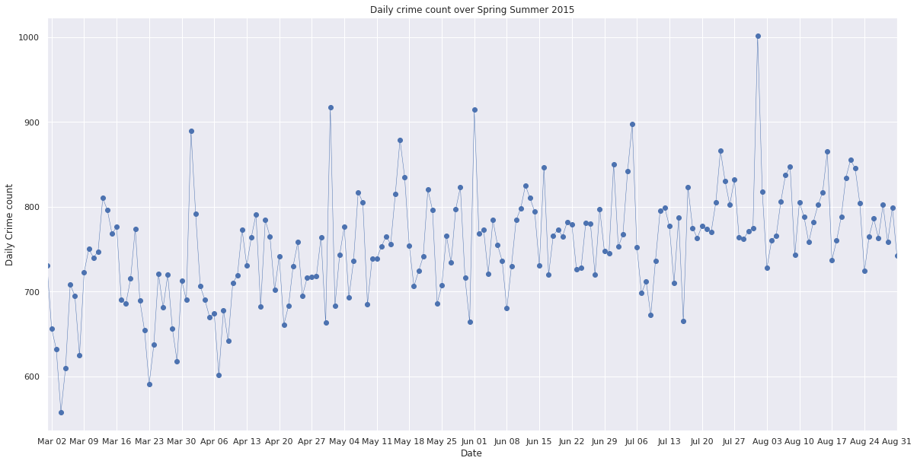
In image [INSERT IMAGE no] one can see the daily and weekly crime count for the peak months of Spring and Summer 2016. It is noticeable that there are outliers on the 1st day of each month. We are not sure if that is a systematic error, or an actual occurence so this poses an interesting problem. We worked around this problem, by choosing a weekly forecasting period, this way we spread the outlier values of the 1st day over the whole 1st week of the month.

3. Splitting the set in training, validation and testing sets (Decision Tree and ARIMA models)

In order to train our models, tune their hyperparameters and test the result on unseen data we split the cleaned dataset in 3 sub sets. We split the data in chronological order, where the training set is chronologically first, the validation set comes next and the test data is the last. The reason for this is that our questions are trying to get answers about unknown future values – extrapolation. So we want to train and evaluate our models in a chronological order, by learning on previous data and forecasting future uknown data. For the timeseries ARIMA model, we split the data in 75% train/validation and 25% test data, and further split the train/validation in 75% train and 25% validation. For the rest of the machine learning models, we split the data in 60% training, 20% validation and 20% testing. [cell 62 in ak_implementation, cells 16 & 19 in timeseries notebook]

Timeseries Dataset:
Size of Training set : (147)
Size of Validation set : (49)
Size of Test set : (65)
Machine Learning Dataset:
Size of Training set X: (24147, 2)
Size of Training set Y: (24147,)
Size of Validation set X: (8049, 2)
Size of Validation set Y: (8049,)
Size of Testing set X: (8049, 2)
Size of Testing set Y: (8049,)

4. Implementation and Parameter tuning for ARIMA

We chose to include a classical forecasting model for timeseries, as these models are known in may cases to perform better and needing less data, as observed by Parmezan et al. [Ref 3] We opted for the Autoregresssive Integrated Moving Average (ARIMA) model due to the observed trend in the dataset [ref to where we show the trend images]. The ARIMA model is a common choice for this type of datasets, we cite similar work from Al Balamesh et al and Eymen et al. [Ref 1, Ref 2] The ARIMA model is expecting monodimentional periodic series of data with a trend and three hyperparameters. The hyperparameters are initialising the three different aspects of the model, p for autoregression, d integration and q for the moving average. We used the Grid Search method as described by LaValle et al, [Ref 4] and executed walk-forward train/validation steps for each combination of the selected hyperparameter values [cell 20 in timeseries notebook]. We used the Mean Square Error in order to evaluate and compare the predictions of each hyperparameter set [cell 16 timeseries notebook].

5. Findings for ARIMA

The results of the Grid Search method for selecting hyperparemeter values resulted to an ARIMA(4, 0, 0) with Mean Square Error of 136179 for the train/validation sets and 84182 for the test set. This means that according to our research a simple Auto Regressive model with a lag order of 4 is enough, as values of 0 for the Integration and Moving Average are disabling these last two models. In the following figure [INSERT FIGURE no] we see the results of the tuned model on the test data, and the actual observations.

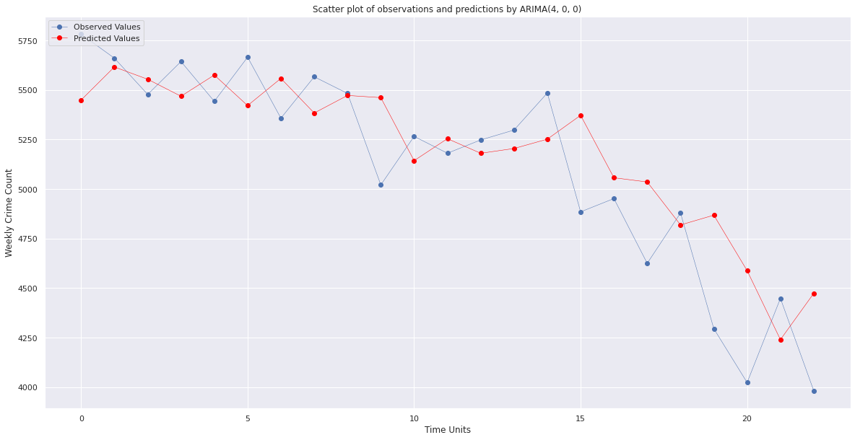
REFERENCES:

1. Al Balasmeh, O., Babbar, R. & Karmaker, T. Trend analysis and ARIMA modeling for forecasting precipitation pattern in Wadi Shueib catchment area in Jordan. Arab J Geosci 12, 27 (2019). https://doi.org/10.1007/s12517-018-4205-z
2. Eymen, A., Köylü, Ü. Seasonal trend analysis and ARIMA modeling of relative humidity and wind speed time series around Yamula Dam. Meteorol Atmos Phys 131, 601–612 (2019). https://doi.org/10.1007/s00703-018-0591-8
3. Parmezan, Antonio & Alves de Souza, Vinícius & Batista, Gustavo. (2019). Evaluation of statistical and machine learning models for time series prediction: Identifying the state-of-the-art and the best conditions for the use of each model. Information Sciences. 10.1016/j.ins.2019.01.076.
@article{article,
author = {Parmezan, Antonio and Alves de Souza, Vinícius and Batista, Gustavo},
year = {2019},
month = {01},
pages = {},
title = {Evaluation of statistical and machine learning models for time series prediction: Identifying the state-of-the-art and the best conditions for the use of each model},
journal = {Information Sciences},
doi = {10.1016/j.ins.2019.01.076}
}
4. LaValle, S.M., Branicky, M.S. & Lindemann, S.R., 2004. On the relationship between classical grid search and probabilistic roadmaps. The International Journal of Robotics Research, 23(7–8), pp.673–692.
@article{lavalle2004relationship,
title={On the relationship between classical grid search and probabilistic roadmaps},
author={LaValle, Steven M and Branicky, Michael S and Lindemann, Stephen R},
journal={The International Journal of Robotics Research},
volume={23},
number={7-8},
pages={673--692},
year={2004},
publisher={SAGE Publications}
}

