PDS – Import and Persistence Update – Assembly Contest Deployment Guide

Revision History
Author | Revision Number | Date
KennyAlive | 1.0 | 10.31.2013

Introduction 3
New Concept 3
Cassini profile 3
1. Organization of Submission 4
2. Application Setup 4
2.1. Configuration files 4
2.2. Build Scripts Setup 6
3. Database Setup 6
3.1 Schema update information 7
4. Deployment Instructions 7
5. Starting 7
6. Verification 7
6.1 SBN profile verification 14
7. Resource Contact List 14

Introduction
The import and persistence application is developed to parse PDS datasets information and store it into the relational database. A heavy data such as images is not stored into the database directly. Database is mostly used to store various dataset relationship, meta-information and textual data (text documents and tables).

The PDS dataset organization is described by the PDS Standards Reference. It is available here:
http://pds.nasa.gov/tools/standards-reference.shtml

New Concept
The ‘red’ requirement of this contest is do not break existing functionality. The original codebase was developed for SBN datasets. In this contest Cassini datasets (subset of them) should be processed. Although dataset organization is described by a single specification (see above) in the real world there could be deviations from the standard (for example, due to historical reasons) or some additions.

In order to support datasets produced by different departments/organizations and with varying level of standard compliance a profile concept is introduced.

The profile encapsulates configuration and functionality to provide behavior that is not described by the standard, so it is not implemented in the main processing pipeline.

From implementation side, profile is a Java class which provides dataset family specific configuration and functionality. The dataset family specific features are implemented in the profile and the main processing code remains unchanged. Only minor changes should be made to the main code in order to activate some profile functionality when necessary.

Processing profile is specified in application configuration and at runtime the configured profile become active. The main processing code checks if a particular profile is active and triggers profile logic when necessary. It looks like a condition followed by the method call.

Profile classes do not implement some kind of ‘Profile’ interface. Each profile encapsulates features unique only to some dataset family. If some common behavior is needed consider to put it into the main processing code.

Two profiles are defined: SBN profile and Cassini profile. SBN profile is empty at the moment and is provided because of the importance of SBN datasets for this project. It should be extended when some SBN specific functionality will be requested. The main effort of this submission is to implement Cassini profile. It supports processing of the supplemental tables that are defined outside of the main dataset.

Cassini profile
The Cassini profile provides two core features: 1) flexible configuration of supplemental tables, 2) supplemental tables processing.

1)
This submission works with the datasets produced by Cassini ISS (Imaging Science Subsystem) instrument. Profile configuration allows you to specify additional instruments.

Each instrument can have the list of associated supplemental table. For this contest 4 supplemental tables are associated with ISS instrument (4 supplemental tables are provided for each dataset).

Additional supplemental table types could be specified and assigned to instruments. It’s possible to associate additional semantics with each supplemental table if additional code processing is required for such table. For example, in the provided datasets 3 tables (saturn, ring, moon) are described as data tables. So they are marked with REGULAR_TABLE semantics. But inventory table is different since it’s not presented as PDS table product and for this table separate semantics is introduced- INVENTORY_TABLE.

2)
Both regular tables (saturn, moon but not ring) and inventory table provide observation information. This information provides the list of targets (i.e. planets, moons, comets, etc.) that were observable by the given instrument and were registered in some product (image). In other words, it’s the list of objects that you can see on particular image.

This submission updates database schema to store observation information. This information is sourced from both inventory and regular tables.

The regular tables information (saturn, moon and ring tables) is stored in corresponding database tables configured in cassini-profile.properties file.

For additional details about database schema update please refer to section 3.1.

1. Organization of Submission

The submission follows directory structure provided below:

import_and_persistence
This directory replicates the import and persistence application distribution structure and includes only updated and new files.
This submission is based on the revision 229227 of import and persistence application:
https://coder.topcoder.com/tcs/clients/ntl-pds/assets/assembly/pds_projects/import_and_persistence

2. Application Setup

The application is expected to be deployed to the following environment:

JDK 1.6
MySQL 5.5
Apache Ant 1.8.2

2.1. Configuration files

config/application.properties – application main configuration file
Property | Description
jdbc.driverClassName | MySQL jdbc driver class
jdbc.url | MySQL jdbc connection URL
jdbc.username | The username of the MySQL user
jdbc.password | The password of the corresponding user
jdbc.mysql | Specifies mysql client executable. Used by reset-db target.
dataSetProcessor.cacheDirectory | The directory to store dataset caches.
dataSetProcessor.dataSetArchives | Specifies the file that contains information about datasets. Each line of this file should contain a path to the directory that contains datasets. Each such directory is scanned by the processor to find all datasets it contains.
dataSetProcessor.startDataSet | The dataset to start processing from. Can be empty string to start from the first dataset. The ‘list’ utility can be used to get ordered list of all datasets.
dataSetProcessor.endDataSet | The dataset to stop processing after it. Can be empty string to process all datasets from the start one to the last one. The ‘list’ utility can be used to get ordered list of all datasets.
dataSetProcessor.asciiFileTypes | The file types that should have their content read. Anything else is referenced directly by using file path.
dataSetProcessor.ignoredSoftwareTypes | The file types that should be ignored when processing the software folder. The exe, bat, jar, dll extensions are some examples.
dataSetProcessor.utilityName | The utility that will be used when running ‘ant utility’ command. For example, ‘list’ utility can be specified to list all datasets that will be selected for processing according to above parameters.
conversionPersistence.defaultTargetType | Some datasets do not provide information about target type of the particular target. This property specifies default target type in case when dataset does not provide this information.
conversionPersistence.tempFileDirectory | Where to create temporary files.
profile.type (NEW) | Specifies dataset processing profile. The following values are supported: sbn, cassini
profile.configuration (NEW) | Specifies configuration file for the selected profile

config/cassini-profile.properties (NEW) – configuration for Cassini processing profile
profile.supplementalTablesDirectory | Specifies directory which contains subdirectories with supplemental tables for each dataset. Subdirectories should be named after corresponding dataset directories.
<instrument_name>.<table_type>.label | The property of this form specifies label file name (or pattern) for instrument with <instrument_name> name and for supplementary table with <table_type> type.  For instrument configuration refer to cassini-instruments.list. For table types configuration refer to cassini-table-types.list
<instrument_name>.<table_type>.dbName | Specifies database table name to store regular table’s data

profile.supplementalTablesDirectory – is required property. All other properties are optional but for Cassini ISS datasets we specify 4 supplemental table for ISS instrument.

config/cassini-instruments.list (NEW) – specifies available instruments
Each row of this file specifies the name of the one of the Cassini’s instruments. For Cassini ISS datasets only ‘iss’ instrument is specified.

config/cassini-table-types.list (NEW) – specifies the list of table types
Each row starts with table type name following by optional space separated list of semantics associated with this table type. Some semantics have special meaning and defines how the table will be treated by the code.

config/sbn-profile.properties (NEW) – configuration for SBN processing profile. At the moment SBN profile does not require additional configuration (since original code base were developed for SBN datasets). It will be used when SBN-specific functionality that should not affect other profiles is added.

test_files/dataset_archives_cassini.list (NEW) – specifies the list of directories that contain Cassini datasets.

test_files/ignoredTableFileTypes.list – contains the list of file types that should not be processed as tables in case some label references table object in such file.

2.2. Build Scripts Setup
The build.xml ant build script provides the following targets:

Target name | Description
clean | Deletes build files
services_jar | Creates pds_services.jar that is used by web_service and front_end projects
run_cache | Runs the cache processor. The cache processor will create caches for datasets specified in application.properties file.
run_dictionary | Runs DataDictionaryCommandLine command line utility. It is used to store dictionary information into database.
run_processing | Runs DataSetProcessingCommandLine command line utility. It is used to persist datasets specified in application.properties. The database should have tables created and dictionary imported before running this command (just run ‘ant reset-db’ to prepare database).
run_validation | Validates the datasets. Checks that parser can parse them successfully.
utility | Runs the utility. The utility name should be specified via dataSetProcessor.utilityName in application.properties file.
reset-db | Drops existing nasa_pds database, then creates new nasa_pds database with pds tables and dictionary data.
compile_test | Compiles the unit tests
test | Run the unit tests

3. Database Setup
1. Update mysql server configuration file (my.ini on Windows, my.cnf on Linux):
Add the max_allowed_packet=32M property to [mysqld] section. Restart MySQL server.

NOTE: the following steps should be done after application is deployed as per section 4.

2. Ensure that JDBC configuration from application.properties is updated for your environment.

3. Run ant reset-db from project root.

3.1 Schema update information
The existing table definitions were not modified.

The new tables to store observation information:
cassini_instrument – defines Cassini instrument.
cassini_observation – defines single observation (i.e. an act of creating some product, like an image).
cassini_observation_product – specifies which product was produced by particular observation.
cassini_instrument_observation – specifies observation which was accomplished by the given instrument.
cassini_observation_target – which target was visible for the given observation

These new tables to store data from corresponding regular tables:
cassini_bool_summary
cassini_ring_summary

4. Deployment Instructions

Checkout the codebase (the below URL is wrapped due to page size)
svn co https://coder.topcoder.com/tcs/clients/ntl-pds/assets/assembly/pds_projects/import_and_persistence -r 229227

Override codebase with import_and_persistence folder from submission.

Now when application is deployed setup JDBC properties and initialize database as per section 3.

5. Starting
Ensure that MySQL server is running.

6. Verification

This section demonstrates dataset processing using COISS_2001 dataset. Multiple datasets processing is also supported and will be demonstrated in the last steps.

At first download COISS_2001 dataset. (after that you can also download COISS_2002, COISS_2040 which will be used to demonstrate multiple datasets import).

I used wget tool on Windows. Command line to download COISS_2001 (line is wrapped):

wget.exe -r -np --cut-dirs=2 -R index.html* http://pds-challenge.seti.org/volumes/COISS_2xxx/COISS_2001/

Use similar command to download supplemental tables.

Update application.properties:

dataSetProcessor.cacheDirectory – should point to an empty directory.
Example: dataSetProcessor.cacheDirectory=a:/pds_data/cache/cassini

conversionPersistence.tempFileDirectory – on Windows should be an empty string:
conversionPersistence.tempFileDirectory=

profile.type and profile.configuration are set to use Cassini profile

Update test_files/dataset_archives_cassini.list:
This file should contain single line which specifies directory which contains datasets.
For verification steps this directory should contains COISS_2001 dataset.

For example, on my machine I have the following in this file:
a:/pds_data/cassini/full_datasets

So, COISS_2001 dataset has this location: a:/pds_data/cassini/full_datasets/ COISS_2001

Update cassini-profile.properties:
profile.supplementalTablesDirectory specifies directory which stores supplemental table for each dataset.

For example, on my machine I have the following:
profile.supplementalTablesDirectory=a:/pds_data/cassini/supplemental_tables

and supplemental tables for COISS_2001 are located here:
a:/pds_data/cassini/supplemental_tables/COISS_2001

ISS supplemental table properties are already set to correct filename patterns, no changes are required.

- Run: ant reset-db
- Run: ant run_cache
- Run: ant run_processing

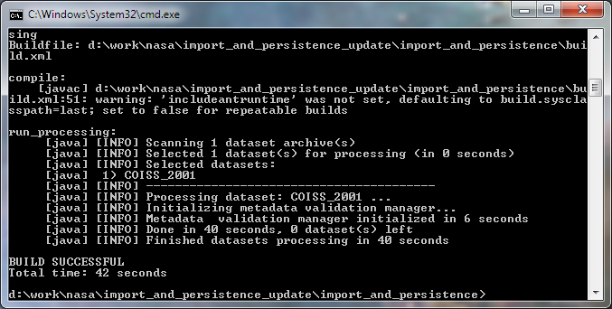
You should see the message that dataset was processed.

Now we will examine updated database. I used MySQL Workbench.

Here are the new tables to store observation information. All Cassini related tables have ‘cassini_’ prefix.

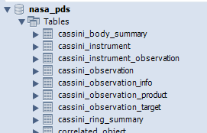

The data for moon, ring and saturn summary tables is stored in these database tables:
cassini_body_summary (for moon and saturn data), cassini_ring_summary (for ring data).

Let’s check observation tables.

Cassini instruments table stores single instrument: ISS.
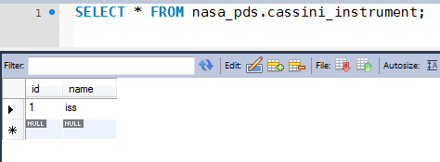

Since provided datasets use only ISS instrument then all observations are associated with it:
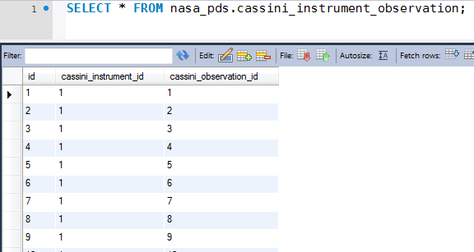

The list of observations:
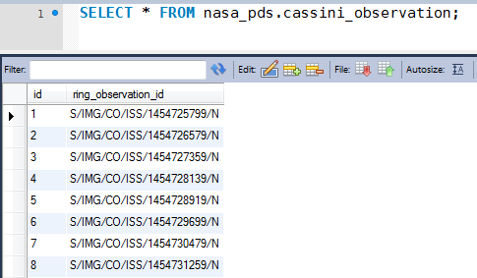

Each observation is associated with single product:
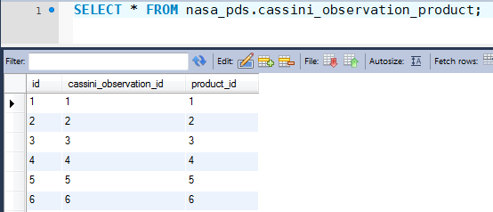

In our case the products are just images:
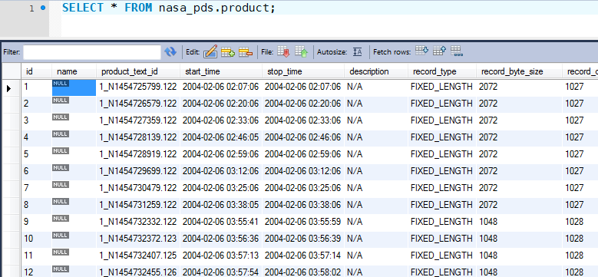

You can check that it’s really images but using product_file table, which shows that product id=1 is associated with data_file id=3 and data_file=3 is an image:

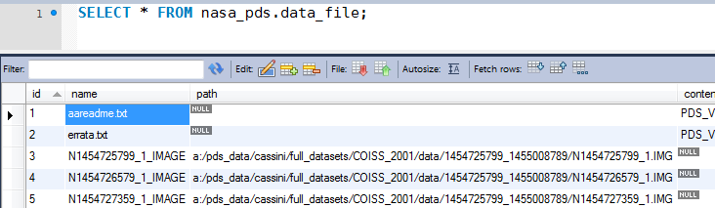
And the most interesting information: targets associated with each observation.

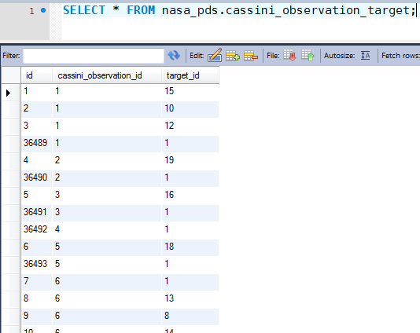

Here you can see that for observation id=1 we have 4 targets: id=15, id=10, id=12, id=1.

And the first 3 targets were added at the same time (during processing of inventory table) but the 4th target was added later during processing of saturn table.

You can refer to `target` table to check that target with id=15 it’s RHEAD, id=10 it’s HELENE, id=12 it’s TELESTO and the target that was added later (during saturn table processing) with id=1 it’s SATURN.

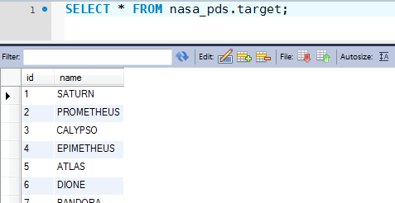

NOTE: as you can see ‘cassini_xxx’ tables do not mention ‘Volume ID’ which is available in some tables (inventory table, for example). It’s because VolumeID is associated with dataset, dataset is associated with product, so we can get VolumeID if we know product id).

I used COISS_2001, COISS_2002, COISS_2040 to demonstrate multiple datasets import.

Just copy these datasets to the same folder where COISS_2001 already located. Do the same for supplemental tables.

Remove generated content from cache directory.

Run: ant reset-db, ant run_cache, ant run_processing

Here are 3 datasets in the database:
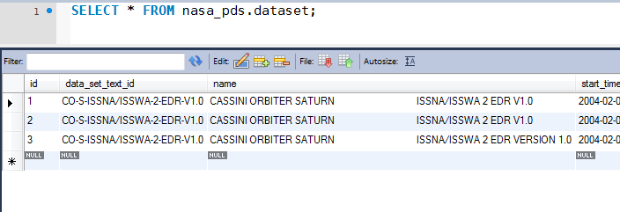

And more observations are registered (for single dataset it was ~ 3000):

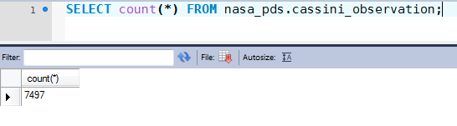

In the existing code base unit tests are provided for JDBC Dictionary import service and for JDBC Metadata validation manager service. These services were not modified in this contest so no new unit tests were provided (according to forum, support only existing functionality).

But existing unit tests were update and can be run successfully.

Run: ant test

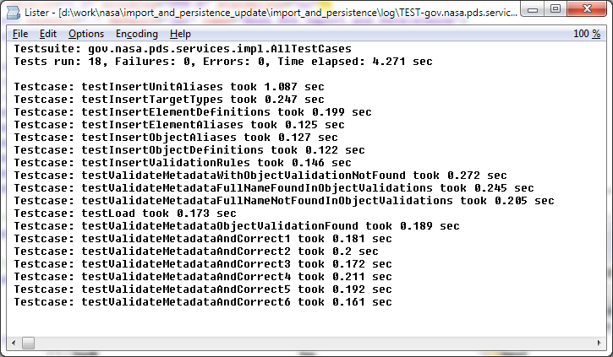

6.1 SBN profile verification

In order to test SBN datasets processing make the following changes in application.properties.

Configure SBN profile:
profile.type=sbn
profile.configuration=sbn-profile.properties

Configure test SBN datasets:
dataSetProcessor.dataSetArchives=test_files/dataset_archives_test.list

The other properties should not be changed.

Then run: ant reset-db, ant clean, ant run_cache, ant run_processing.

7. Resource Contact List

Name | Resource Email
KennyAlive

