PDS API Update Module Architecture Design Specification
Author | Revision Number | Date
Architect | 1.0

PDS API Update Module Architecture Design Specification 1
Application Design Specification 3
1. Design 3
1.1 Work Flow Description 3
1.2 Component Requirements 4
1.2.1 TopCoder Software Catalog Components 4
1.2.2 Custom Software Components 4
1.2.3 Third Party Components 4
1.3 Application Management 4
1.3.1 Transaction 4
1.3.2 Threading 4
1.3.3 Configuration 5
1.3.4 Persistence 5
1.3.5 Logging 5
1.3.6 Exception Handling 5
1.3.7 Internationalization 5
1.3.8 Auditing 5
1.3.9 Authentication 5
1.3.10 Authorization 5
1.3.11 Validation 5
1.3.12 Performance 5
1.3.13 Scalability 5
1.4 Deployment Constraints 5
1.4.1 Technology overview 5
1.4.2 Operation System(s) 6
1.5 Interfaces Classes Overview 6
1.6 Changes to Existing System 6
2. User Interface 6
3. Included Documentation 6
3.1 Architecture Documentation 6
4. Future Enhancements 6

Application Design Specification

Design
The purpose of this project is to develop an application that will utilize Hadoop-MapReduce to perform image processing that transforms the raw images taken by Lunar Reconnaissance Orbiter (LRO) to geo-referenced and ‘mosaicked’ images that can be displayed on the LMMP (www.lmmp.nasa.gov) as rich visualization layers which are highly valuable for future mission planning and development.

This project will update existing PDS API for new LRO data.

Work Flow Description
This module defines the following assembly:
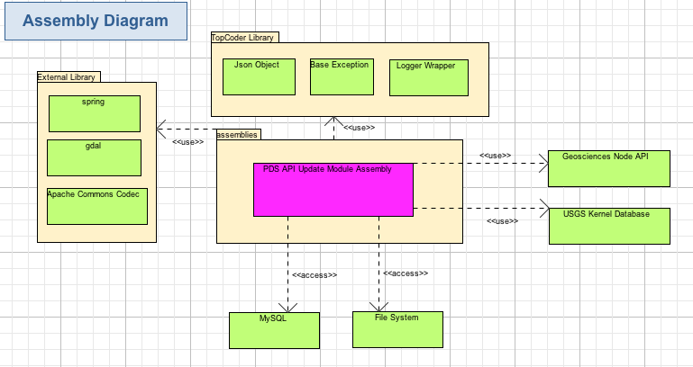

The PDS API Update Module Assembly will implement following tasks:.
- Update entities in gov.nasa.pds.entities package
- Update DataSetService and its implementation, update ConversionPersistence and its implementations.
- Implement LROCImportProcessor, KernelImportProcessor and command line utilities for them in package gov.nasa.pds.commandline. in "PDS API Changes and Application Class Diagram".

Component Requirements

TopCoder Software Catalog Components
- Base Exception 2.0
- Logging Wrapper 2.0
- JSON Object 1.0

Existing Catalog Components
None.

Custom Software Components

New Custom Components
None.

New Assemblies
- PDS API Update Module Assembly 1.0
The PDS API Update Assembly implements the whole architecture.

Third Party Components
- Spring 3.0.5 http://projects.spring.io/spring-framework/
- Gdal 1.11.0 (http://download.osgeo.org/gdal/1.11.0/ )
- Apache Commons Codec 1.9 (http://commons.apache.org/proper/commons-codec/ )

Application Management

Transaction
The services will use Spring to manage their transactions. All modifying methods should provide transactional control.

Threading
The entities are mutable and not thread safe, but they are not expected to be used concurrently.
The services are thread safe after initialization because they are immutable, and database will ensure thread safety of concurrent persistence operations.
The command line tools are run by single thread, so they have no thread safety issue.

Configuration
All service implementations will use setter injection for configuration with the use of Spring.

Persistence
The kernel importing service will store plain program in the local file system. The LRO importing service will write the formatted image data to file system as well as save the LRO data in the database with JDBC and Spring.

Logging
The services will log activity and exceptions using the Logging Wrapper in this component.

It will log errors at Error level, and method entry/exit information at DEBUG level.

It will log errors at Error level, potentially harmful situations at WARN level, and method entry/exit, input/output information at DEBUG level.

Specifically, logging will be performed as follows, if logging is turned on.

- Method entrance and exit will be logged with DEBUG level.
  - Entrance format: [Entering method {className.methodName}]
  - Exit format: [Exiting method {className.methodName}]. Only do this if there are no exceptions.
- Method request and response parameters will be logged with DEBUG level
  - Format for request parameters: [Input parameters[{request_parameter_name_1}:{ request_parameter_value_1}, {request_parameter_name_2}:{ request_parameter_value_2}, etc.)]]
  - Format for the response: [Output parameter {response_value}]. Only do this if there are no exceptions and the return value is not void.
  - If a request or response parameter is complex, and if it comes from this component, use its toJSONString () method. If that is not implemented (such as for list parameters then print its value using the same kind of name:value notation as above.
- All exceptions will be logged at ERROR level, and automatically log inner exceptions as well.
  - Format: Simply log the text of exception: [Error in method {className.methodName}: Details {error details}]
  - The stack trace of the error and a meaningful message.

In general, the order of the logging in a method should be as follows:

    - Method entry
    - Log method entry
    - Log method input parameters
    - If error occurs, log it and skip to step 7
    - Log method exit
    - If not void, log method output value
    - Method exit

Exception Handling
This is an update of existing PDS project, the architecture reuse the existing exception handling of original PDS project.

Internationalization
Internationalization does not need to be handled in this module.

Auditing
None.

Authentication
None.

Authorization
None.

Validation
None

Performance
JDBC batch update operations may be used to improve performance.

Scalability
No scalability requirement is needed for this application.

Deployment Constraints
The system will interact with external Geosciences Node API and USGS Kernel database.
There are additionally 2 command line utilities that are used to run import of images for LROC mission and kernel programs to the local file system. They are expected to be run separately

Technology overview
- Java 1.6
- Spring 3.0.5 http://projects.spring.io/spring-framework/
- Gdal 1.11.0 (http://download.osgeo.org/gdal/1.11.0/ )

Operation System(s)
- Linux (rsync tools should be pre-installed as per http://isis.astrogeology.usgs.gov/documents/InstallGuide/index.html)

Interfaces Classes Overview
See the TCUML file.

Changes to Existing System
This architecture will update existing PDS API for new LRO data.

User Interface
There are 2 command line utilities that are used to run import of images for LROC mission and kernel programs to the local file system.

Included Documentation

Architecture Documentation
- Assembly Diagram
- Sequence Diagrams
- Application Design Specification
- Assembly Specifications

Future Enhancements
None.

