NASA PDS Web Service 1.0 Deployment Guide

Revision History
Author | Revision Number | Date
KennyAlive | 1.0 | 02.29.2012
KennyAlive | 1.1 | 03.11.2013

1. Project organization 2
2. Application Setup 3
2.1. Build Scripts Setup 3
2.2. Application configuration 3
2.3. paths_mapping configuration 3
3. Database Setup 4
4. Deployment Instructions 4
5. Verification 4
6. Resource Contact List 5

1. Project organization
The project has the following directory structure:

.settings
Eclipse project's settings

config
This directory is for project's configuration files.

doc
Contains this document: NASA_PDS_Web_Service_Deployment_Guide.doc

lib
Contains project’s dependencies.

The dependency from the accompanied project import_and_persistence:
- pds_services.jar

The following TopCoder's generic components are used:
- Base Exception 2.0 Used for base classes of exceptions
- Logging Wrapper 2.0 Used for logging operations in all business methods.
- JSON Object 1.0 Used for serializing entity values for logging.
- Logging Wrapper dependencies

The following third party dependencies are used:
- Spring 3.0.5
- Apache CXF 2.5.2 (These binaries are not included in the lib folder but are referenced by the build.xml ant build script).
- Log4j 1.2.16
- Mysql Connector 5.0.8
- Spring dependencies

src
Contains java source code for Service Endpoint Interface (SEI) and its implementation. Also it contains generated by CXF framework code.

WebContent
Contains Java EE Web application resources:
- META-INF directory with generated manifest.
- WEB-INF directory web application descriptor (web.xml) and web service's spring configuration (beans.xml).
- wsdl directory contains web service's WSDL file and accompanied schema.

.project, .classpath
This is the eclipse project files.

build.xml
Ant build script. Used to build nasa_pds_ws.war war file. Defines 'war' target. The web application should be deployed to Java EE application server (tomcat 6 was used during development).

2. Application Setup
The following technologies are used by this assembly:
- J2SE 1.6
- MySQL 5.5: http://www.mysql.com/
- Apache CXF 2.5.2 http://cxf.apache.org/

The lib folder provides all the necessary dependencies to build this web application except CXF runtime. The CXF runtime is referenced via ' cxf.home' property defined in build.xml which should be updated to match local environment.

The Ant build tool is used to run build.xml targets.

2.1. Build Scripts Setup
Build.xml has the following tasks
Task | Description
war | Builds web service application and creates nasa_pds_ws.war
compile | Compiles the code in src directory.

2.2. Application configuration
The application configuration parameters are defined in config/application.properties file.

Property | Sample | Description
jdbc.driverClassName | com.mysql.jdbc.Driver | JDBC driver class
jdbc.url | jdbc:mysql://localhost:3306/nasa_pds | JDBC url
jdbc.username | Root | The database user name
jdbc.password | Root | The password

2.3. paths_mapping configuration
config/paths_mapping configuration file is used to map paths that are stored in db to local paths.

If datasets were imported into database on the same machine where web service is running then this file should be empty. If web service is running on the different machine then the paths should be mapped.

For example, the test 11_datasets.sql mysql dump was created on my developer machine. The datasets are stored in a:/pds_data/new_datasets folder. Now let’s assume that web service is running on the different machine and the same datasets are stored on this path: d:/data/PDS/new_datasets

For the above example we need to add the following pair of lines to the paths_mapping file:
a:/pds_data/new_datasets
d:/data/PDS/new_datasets
You can add multiple pairs of dataset_path/local_path lines to paths_mapping file.

The web service uses this mapping to convert the paths that are retrieved from the database (data_file table) to the local paths. Given the local path the web service could send the file content to the client if the client makes corresponding request.

3. Database Setup
Before deploying web application to Java EE application server you should prepare MySQL database by creating nasa_pds database and populating it with pds data. For 'how to' instructions please read the deployment guide of the accompanied project import_and_persistence.

4. Deployment Instructions
1. Update config/paths_mapping as explained in section 2.3.

2. Run ‘ant war’ to generate nasa_pds_ws.war file.

3. Java EE Web service application deployment.
The app was developed to work in tomcat 6 application server. Copy nasa_pds_ws.war file to webapps directory from the tomcat's root directory.

4. Running application.
Start tomcat 6 web server. For this run the following command
[on windows]: tomcat_installation_dir/bin/startup.bat
[on linux]: tomcat_installation_dir/bin/startup.sh

5. Verification
Go to this url: http://localhost:8080/nasa_pds_ws/services/PlanetaryDataSystemPort?wsdl
(update tomcat ip/port if needed)
The web service's WSDL should appear in the browser window. If it's not the case that something is wrong with deployment.

Use SoapUI application to send requests to the web service. Check that responses are as expected.

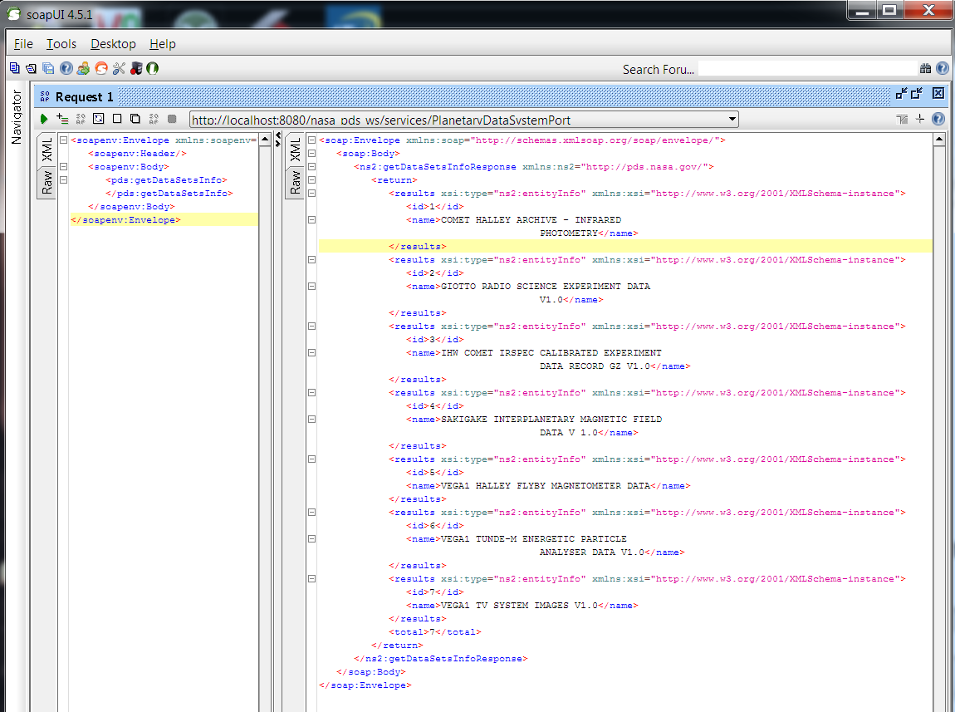

In order to use web service programmatically using java language, refer to the accompanied project web_service_example_client.

In order to use web service from javascript, refer to web_service_javascript. In the demos folder there are various web service usage scenario. And in the doc folder there is useful documentation that is worth to read even you are not going to use javascript, since it explain some important PDS API concepts.

6. Resource Contact List
Name | Resource Email
KennyAlive

