Week – 1
Task 1: Create an IAM User and Attach Policies
Steps:
- Login into AWS console as root user
- Search “IAM” in search bar
- Click “IAM users” in left panel
- Click “Create User” and input user name(“TestIAMUser”)
- Tick “Provide user access to the AWS Management Console “ radio button
- Choose custom password and input the password
- Choose “Attach policy directly”

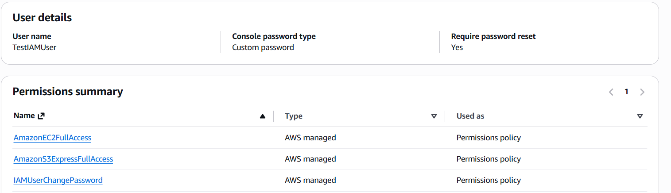
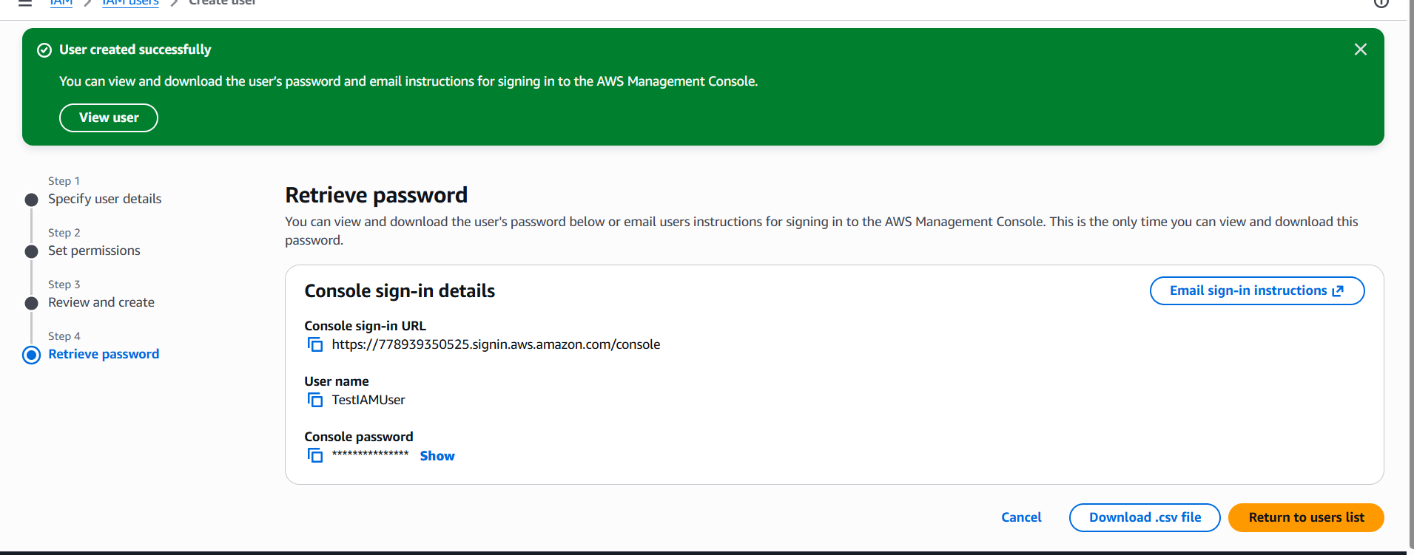
- Click “Download .csv file” to see the password and user account details
- Click “Return user list”

- Click “Policies” and click “Create Policy”
- Choose “RDS, S3 & EC2” services and input policy name “TestIAMuserpolicy”
- Click “Create”
- Choose created policy and click “Actions” and choose “Attach”
- Then choose IAM user “Test IAMuser” and click “Attach Policy”
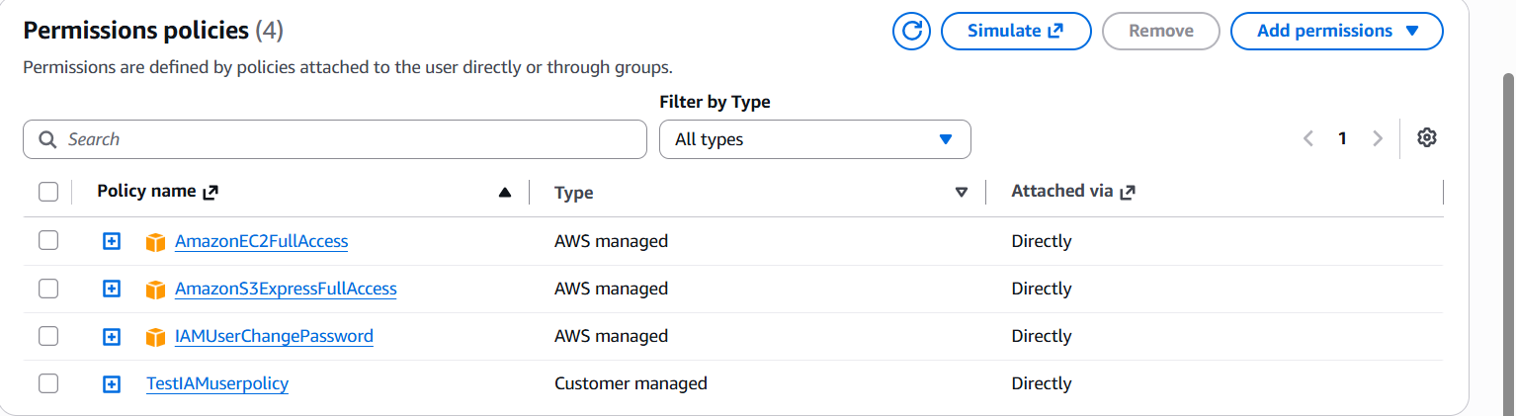

Task 2: Create an IAM Group and Attach Policies
- Click “IAM user groups”
- Click “Create Group” and choose “AmazonECSFull_access”
- Click “user group” and group created
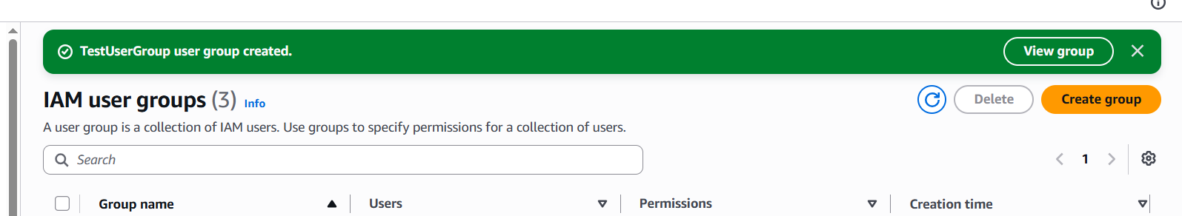
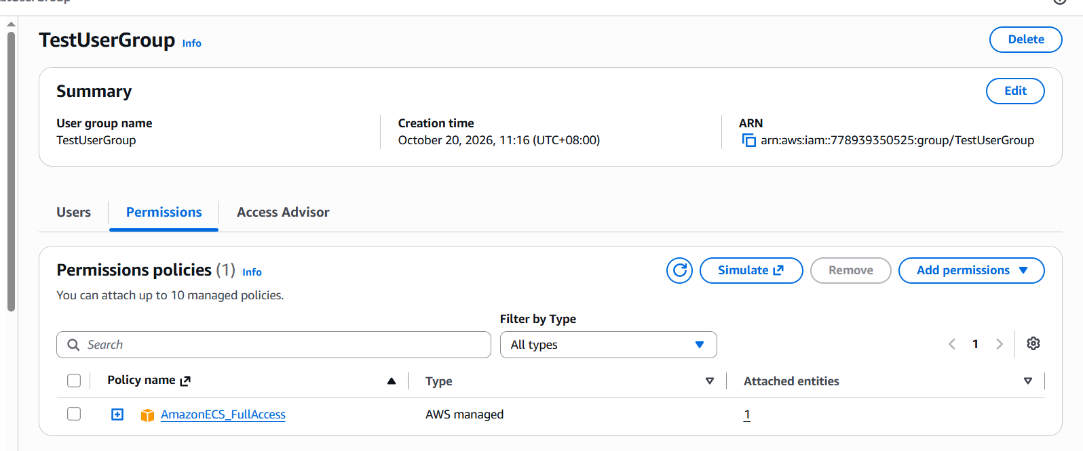
- Choose “users” tab
- In next page, able to see created IAM users
- Select respective user and click “Add users”
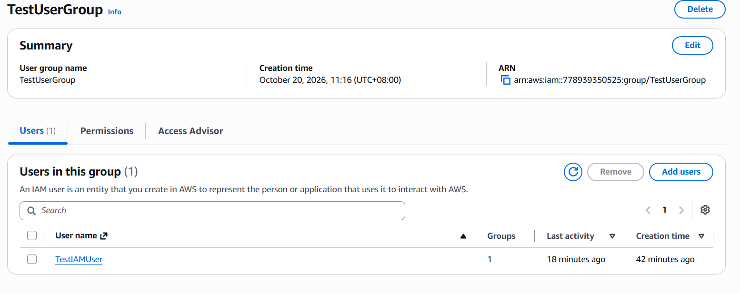

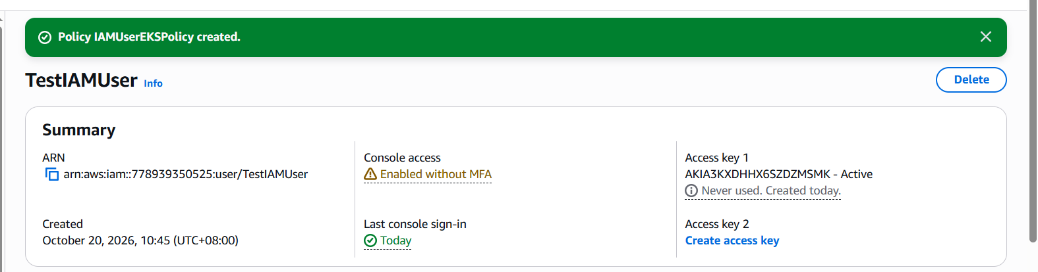

- Able to view EKS configuration page

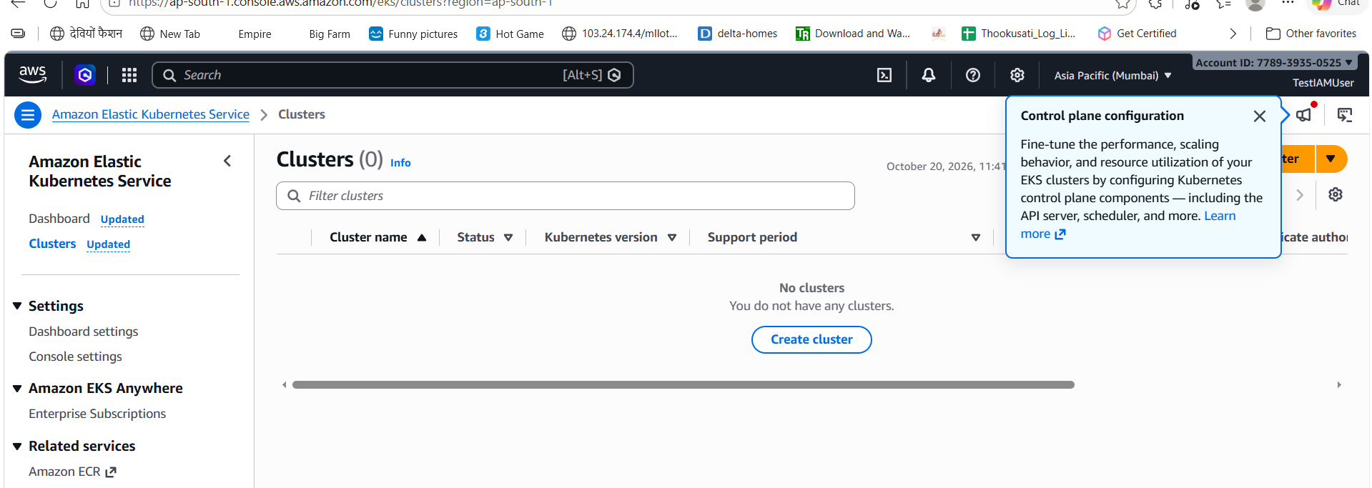
Task 3: Create custom IAM policy
- Click “policies” on left panel
- Click “Create Policy” button
- Choose “SNS” service & select “All SNS actions”
- Choose “All” resource
- Give the policy name and click “Create policy”
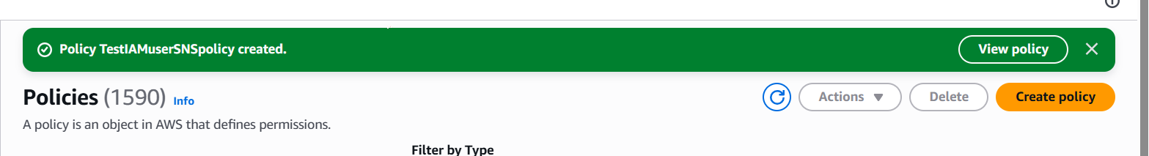
- Attach the newly created “SNS” policy to custom IAM user
- Then login into aws console by IAM user and able to view SNS page
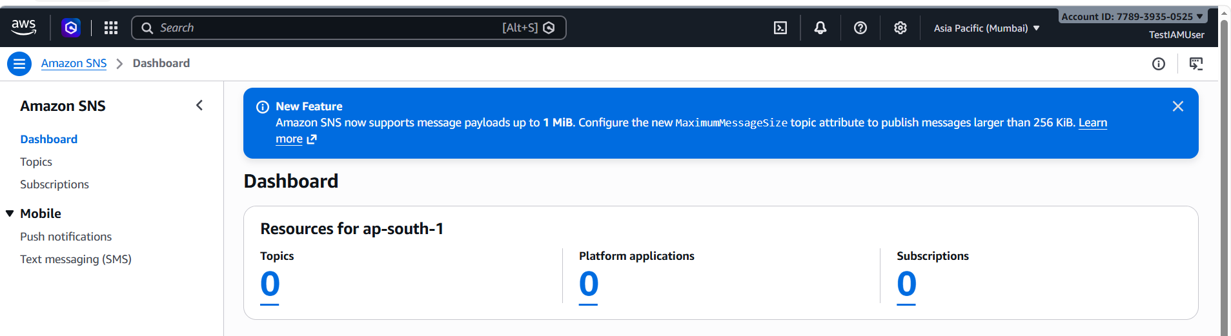

Task 4: Create an IAM Role and Attach Policies
- Click “Roles” on left panel
- Click “Create Role” on right side corner
- Select AWS services EC2, RDS & SNS
- Click “next” & input role name “TestIAMRole”
- Click “Create Role”
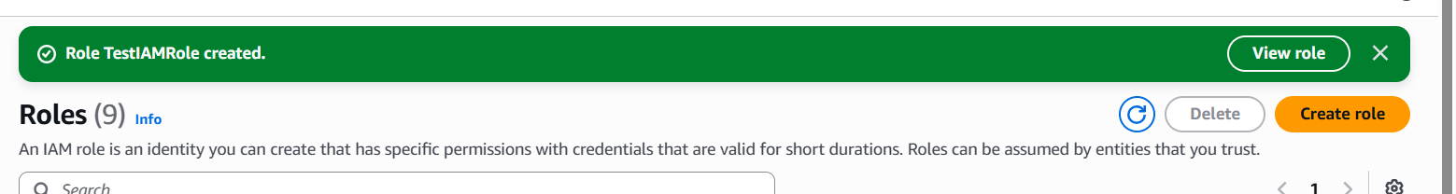

Task 5: Set Up AWS CLI on Your Machine and Access Your AWS Account

