Operator Console Redesign
Sidebar navigation, tabular tenant data, and a real dashboard — client feedback, addressed directly.
Why this changes, and what doesn't.
The client's feedback on the Operator Console is fair: the current top-nav + card-grid layout was carried over from the patient-facing MediGo screens, which suits a hospital's clinical staff but reads as consumer software for an internal tool managing dozens of tenants at once. This redesign is SCOPED TO THE OPERATOR CONSOLE ONLY. The clinic staff app and patient portal are unaffected — they keep their existing card/pill language, which the client has not objected to.

Proposed Layout
Sidebar navigation replaces the top nav bar, grouped by function (Overview, Tenants, Platform, System). A real dashboard becomes the operator's landing view instead of a bare tenant list — KPI tiles, a trend chart, and the tenant list rendered as a sortable, scannable table rather than a grid of cards. This is the same pattern used by Stripe, Retool, and most serious admin tools — it scales to hundreds of tenants in a way cards do not.

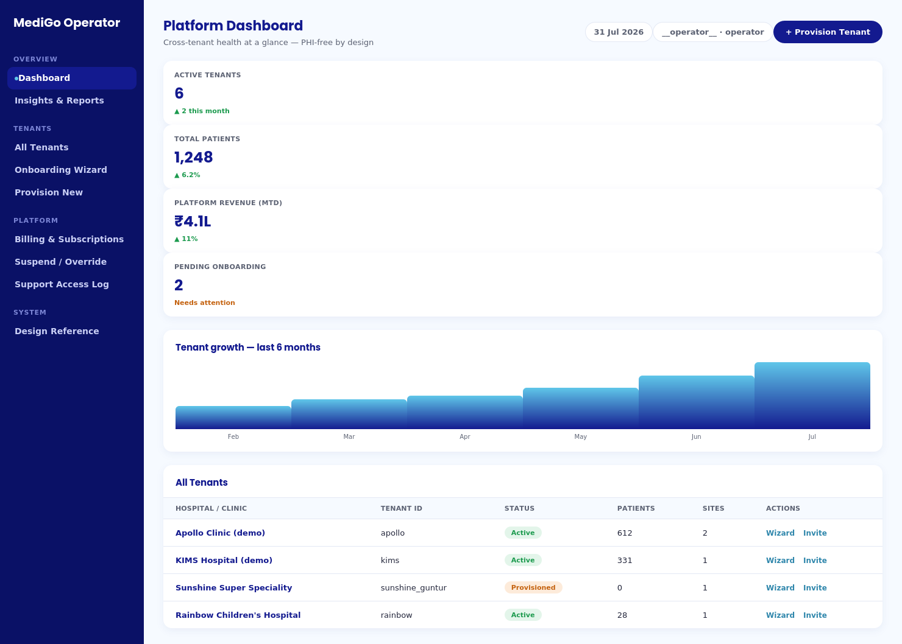
Proposed Operator Console — sidebar nav, KPI dashboard, growth chart, tabular tenant list

What Changes, Specifically
Element | Today | Proposed
Navigation | Top bar: Tenants Management · Onboarding Wizard · Platform Billing & Ops · Design | Left sidebar, grouped: Overview (Dashboard, Insights) · Tenants (All, Onboarding, Provision) · Platform (Billing, Suspend/Override, Support Log) · System (Design Reference)
Landing view | Tenants Management (a list of cards) | Dashboard — KPI tiles + trend chart + tenant table below
Tenant list | One card per tenant, grid layout | One row per tenant in a sortable/filterable table — scales far better past ~10 tenants
Insights | None — no cross-tenant view exists today | New Insights & Reports section: tenant growth trend, revenue trend, onboarding funnel (how many tenants are stuck at which stage)
Design tokens | MediGo tokens (unchanged) | Same tokens — indigo, Baloo2/Poppins-style display font, semantic accents. This is a layout change, not a new color direction.

Implementation Tickets

Structure
- OC-01 — Sidebar shell component: grouped nav sections, active-state highlighting, replaces the current top nav for the Operator Console only (clinic app and portal nav are untouched).
- OC-02 — New Dashboard landing route: KPI tiles (active tenants, total patients across platform, MTD revenue, pending onboarding count) sourced from existing/extended metrics endpoints.
- OC-03 — Tenant growth trend chart: simple bar/line chart, tenant count over the last 6 months. Backend: confirm whether a metrics endpoint already supports a time series, or add one.

Tenant list → table
- OC-04 — Replace the tenant card grid with a data table: columns for hospital name, tenant ID, status, patient count, site count, and row actions (Wizard, Invite Staff, existing offboard delete action retained).
- OC-05 — Add sort and filter to the table (by status, by name) — this is the main scalability win over cards and should not be skipped.

Insights section (new)
- OC-06 — Onboarding funnel view: how many tenants are at each lifecycle stage (provisioned / configuring / migration / readiness / active) — directly useful for spotting stuck onboardings, which the client has specifically cared about ("complete onboarding ASAP").
- OC-07 — Revenue trend (subscription invoicing, aggregate only — still PHI-free, still no per-tenant clinical data).

Cleanup while in this code
- OC-08 — Test-tenant hygiene, round 2: the screenshot that prompted this redesign shows 't_b'/'Tenant B' and two differently-ID'd tenants both named 'KIMS Andhra Onboarding Hospital' still present. The earlier teardown-fixture fix likely only covers pytest-created tenants, not ones created manually through the UI during testing/demos. Add a simple manual cleanup pass now, and consider a lightweight 'synthetic/demo' flag on test tenants so they're filterable out of the new table view by default.

Sequencing
This does not need to block or wait on the staging deployment track — different surface, no shared dependency. Suggest: OC-01/02/04 first (sidebar + dashboard shell + table, the core of what the client asked for), OC-05 next (sort/filter, cheap and high-value), OC-06/07 (insights) after, OC-08 (hygiene) whenever convenient but before the next client demo.

Definition of Done
# | Check
1 | Sidebar navigation live on the Operator Console, grouped as specified; clinic app and patient portal navigation unchanged.
2 | Dashboard is the operator's landing view with real (not placeholder) KPI numbers and the growth chart.
3 | Tenant list renders as a sortable/filterable table; card grid removed.
4 | Insights section exists with at least the onboarding funnel view.
5 | Tenant list is free of leftover test/demo debris, or such tenants are clearly filterable/labeled.
6 | Screenshot of the real running console — not a mockup — attached to the PR for review, same standard as every other UI change in this project.

This is a real, contained scope of work — a layout and information-architecture change on one console, using components and tokens that already exist. It should not require new visual language or another client round-trip on colors; it directly answers what was asked.

