Protective effect of Nigella sativa extract on paracetamol-induced hepatotoxicity in rats
Manuscript ID: PJPS-2025-0101
Authors: Imran Hussain, Sana Qureshi, Tariq Mehmood
Department of Pharmacology, Demo Institute of Pharmaceutical Sciences, Lahore, Pakistan
Corresponding author: imran.hussain.demo@gmail.com

Abstract
This study examined the hepatoprotective activity of Nigella sativa seed extract in rats given paracetamol. Serum enzymes and liver histology were examined and the extract reduced the rise of liver enzymes in a dose-dependent manner.

Introduction
Liver injury caused by paracetamol overdose remains a leading cause of acute liver failure, and herbal products are widely used in Pakistan for hepatic protection. Nigella sativa seed extract has shown antioxidant and anti-inflammatory activity in several experimental models (Ahmad et al., 2013; Hewlings and Kalman, 2017). The present work evaluated whether a standardised seed extract protects the liver of rats exposed to a toxic dose of paracetamol.

Materials and Methods
Male Wistar rats (n = 48, 180-220 g) were divided into six groups of 8 animals. The extract was given at 100 and 200 mg/kg for seven days. The study was approved by the Institutional Animal Ethics Committee (approval no. DIPS/IAEC/2025/17). Chemicals were purchased from Sigma-Aldrich.

Results
The extract lowered serum ALT and AST in a dose-dependent manner (Figure 1, Figure 2).
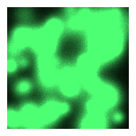
Figure 1. Liver sections, control group.
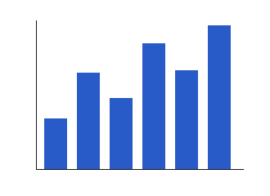
Figure 2. Serum ALT in the experimental groups.

Discussion
The protective effect agrees with earlier reports (Ahmad et al., 2013).

References
Ahmad A, Husain A, Mujeeb M, Khan SA, Najmi AK, Siddique NA, Damanhouri ZA and Anwar F (2013). A review on therapeutic potential of Nigella sativa: A miracle herb. Asian Pac J Trop Biomed, 3(5): 337-352.
Hewlings SJ and Kalman DS (2017). Curcumin: A review of its effects on human health. Foods, 6(10): 92.

