Hepatoprotective effect of Nigella sativa seed extract against paracetamol-induced liver injury in rats: molecular docking and machine-learning prediction
Manuscript ID: PJPS-2026-0412
Authors: Imran Hussain, Sana Qureshi, Bilal Ahmed, Kamran Raza
Department of Pharmacology, Demo Institute of Pharmaceutical Sciences, Lahore, Pakistan
Department of Mechanical Engineering, Sample University of Technology, Karachi, Pakistan
Corresponding author: bilal.ahmed.demo@gmail.com, imran.hussain.demo@yahoo.com

Abstract
This study examined the hepatoprotective activity of Nigella sativa seed extract in rats given paracetamol. Serum enzymes and liver histology were examined and the extract reduced the rise of liver enzymes in a dose-dependent manner. Network pharmacology, molecular docking, hub genes and KEGG/GO enrichment analysis identified the likely targets. A counterfeit consciousness model was used to predict activity.

Introduction
Liver injury caused by paracetamol overdose remains a leading cause of acute liver failure, and herbal products are widely used in Pakistan for hepatic protection. Nigella sativa seed extract has shown antioxidant and anti-inflammatory activity in several experimental models (Ahmad et al., 2013; Hewlings and Kalman, 2017). The present work evaluated whether a standardised seed extract protects the liver of rats exposed to a toxic dose of paracetamol.
Curcumin and silymarin act through similar pathways (Hewlings and Kalman, 2017; Rehman et al., 2022). Combined use gave synergistic protection (Farooqi et al., 2021), and an earlier trial reported comparable effects (Ali et al., 2020). Autism and hepatic outcomes have also been debated (Wakefield et al., 1998).

Materials and Methods
Rats were divided into groups and treated with the extract. HEp-2 cells were used to test cytotoxicity. Reagents and kits were used according to the instructions. A profound learning model, an irregular woodland classifier and a bolster vector machine were trained on the docking scores; data mining of the targets used the STRING database.
As an AI language model, I cannot provide the exact catalogue numbers, but the following sections describe a typical protocol. Certainly! Here is a revised version of the statistical section.

Results
The extract lowered serum ALT and AST in a dose-dependent manner. Liver sections of the control and treated groups are shown in Figure 1, the protein expression in Figure 2, and the effect on serum markers in Figure 3. Histology of the treated liver is shown in Figure 4 and the gross appearance in Figure 5.
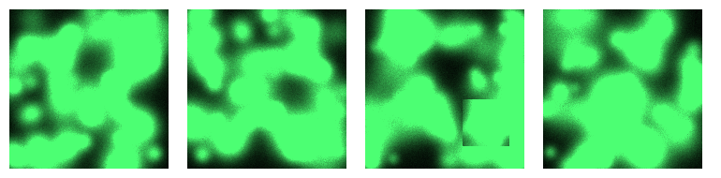
Figure 1. Liver sections of the control and treated groups.
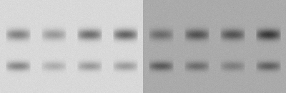
Figure 2. Western blot of Nrf2 in liver tissue.
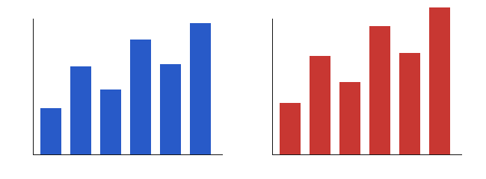
Figure 3. Serum ALT (left) and AST (right) in the experimental groups.

Figure 4. Histology of the treated liver (H&E).
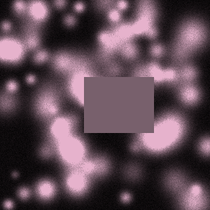
Figure 5. Gross appearance of the liver.

Discussion
The protective effect agrees with the earlier work (Ahmad et al., 2013; Iqbal et al., 2020). I hope this helps.

References
Ahmad A, Husain A, Mujeeb M, Khan SA, Najmi AK, Siddique NA, Damanhouri ZA and Anwar F (2013). A review on therapeutic potential of Nigella sativa: A miracle herb. Asian Pac J Trop Biomed, 3(5): 337-352.
Hewlings SJ and Kalman DS (2017). Curcumin: A review of its effects on human health. Foods, 6(10): 92.
Hewlings SJ and Kalman DS (2019). Curcumin: A review of its effects on human health. Foods, 6(10): 92.
Wakefield AJ, Murch SH, Anthony A, Linnell J, Casson DM, Malik M, Berelowitz M, Dhillon AP, Thomson MA, Harvey P, Valentine A, Davies SE and Walker-Smith JA (1998). Ileal-lymphoid-nodular hyperplasia, non-specific colitis, and pervasive developmental disorder in children. Lancet, 351(9103): 637-641.
Rehman S, Qureshi T and Mirza FJ (2022). Nano-engineered phytosomal curcumin attenuates paracetamol hepatotoxicity through Nrf2 up-regulation in Wistar rats. J Adv Hepatic Pharmacol, 14(3): 211-226.
Farooqi HM, Zafar N and Baig MA (2021). Synergistic hepatoprotective activity of Nigella sativa and silymarin: a randomised multicentre trial. Int J Phytother Res, 9(2): 45-58.
Iqbal M, Shah SA and Rauf A (2020). Herbal hepatoprotectants in South Asia: an overview. Pak J Pharm Sci, 33(4): 1801-1812.

