2.4 Communication Layer
The communication layer enables real-time data exchange between the Raspberry Pi and the visualization platform. The system uses the MQTT (Message Queuing Telemetry Transport) protocol due to its lightweight design and suitability for IoT applications.
In this architecture, the Raspberry Pi acts as an MQTT publisher, sending sensor data to a locally hosted MQTT broker (Mosquitto). The broker manages message distribution and forwards the published data to subscribed clients.
Each MQTT message is formatted in JSON and includes key information such as the flame detection status, sensor value, and timestamp. Using a local broker allows the system to operate fully offline while maintaining reliable communication between components.
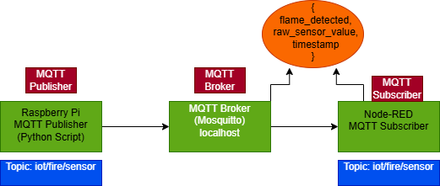
Figure 2. MQTT-based communication model illustrating the interaction between the Raspberry Pi publisher, the Mosquitto broker, and the Node-RED subscriber.

2.5 Visualization Layer
The visualization layer is implemented using Node-RED, which functions as the MQTT subscriber and dashboard platform. Node-RED subscribes to the MQTT topic published by the Raspberry Pi and processes incoming JSON messages in real time.
The processed data is displayed on a web-based dashboard that includes graphical elements such as charts and status indicators. These elements allow users to monitor flame sensor readings and fire detection status through a standard web browser without requiring custom frontend development.
The detailed Node-RED flow configuration and dashboard design are presented in Section 5.

