5 MQTT Communication and Node-RED Setup
This section describes the communication infrastructure of the system and the configuration of the Node-RED platform used for data subscription and visualization. The objective of this section is to explain how sensor data is transmitted from the Raspberry Pi to the dashboard using the MQTT protocol.

5.1 MQTT Broker Configuration
The system uses the MQTT protocol to enable lightweight and reliable communication between the Raspberry Pi and the visualization platform. A Mosquitto MQTT broker is installed and configured locally on the Raspberry Pi.
Running the broker locally allows the entire system to operate without internet connectivity, which is essential for offline demonstrations and laboratory testing. The broker listens on the default MQTT port and handles message distribution between the publisher and subscribed clients.
The Raspberry Pi publishes sensor data to a predefined MQTT topic at a fixed interval. Using a single topic simplifies subscription management and ensures consistent data flow throughout the system.
- Broker: Mosquitto (local)
- Port: 1883
- Topic: iot/fire/sensor
The MQTT communication model used in the system was previously illustrated in Section 2.

5.2 Node-RED Subscriber and Flow Design
Node-RED is used as the MQTT subscriber and dashboard platform. It runs locally on the Raspberry Pi and subscribes to the MQTT topic published by the Python application.
The Node-RED flow consists of the following main components:
- An MQTT In node configured to subscribe to the topic iot/fire/sensor
- A Function node used to parse incoming JSON messages
- Dashboard nodes used to visualize sensor values and detection status
Incoming MQTT messages are processed in real time and forwarded to the appropriate dashboard widgets. This flow-based approach allows rapid development and easy modification of the visualization logic without changing the publisher code.
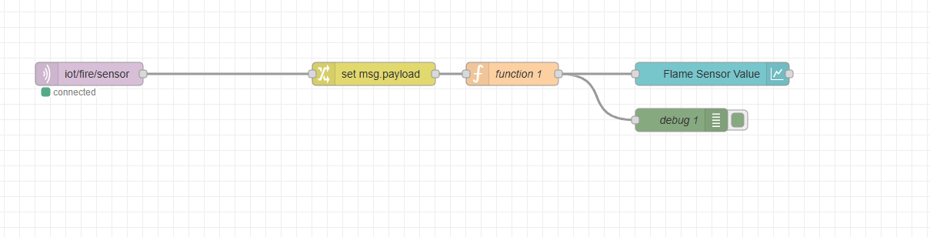
Figure 5. Node-RED flow used to subscribe to the MQTT topic, process incoming JSON messages, and forward data to the dashboard visualization.

5.3 Dashboard Configuration
The Node-RED dashboard provides a web-based user interface for monitoring the fire detection system. It displays real-time sensor data using graphical and textual elements.
The dashboard includes:
- A line chart showing flame sensor values over time
- A status indicator representing the fire detection state
The dashboard automatically updates as new MQTT messages are received. This allows users to observe system behavior in real time using a standard web browser.
Dashboard visualization results are analyzed and discussed in Section 7.

