**Software Requirements Specification**

Version 1.0

<<Annotated Version>>

May 11, 2021

Dentist clinic automation system

Alaa Alkhalil

Reham Alomar

Heba Raddah

Nermin Garoug

**Table of contents**

**1.0.Introduction**

1.1.Purpose

1.2.Scop of project

1.3.Glossary

**2.0.Overall description**

2.1.System environment

2.2.Functional requirements specification

2.2.1.Doctor/Secretary Use Case

Use Case: make session

2.3.User Characteristics

2.4.Non-Functional Requirements

**3.0.Requirements Specification**

3.1.External Interface Requirements

3.2.Functional Requirements

3.3.Detailed Non-Functional Requirements

**1.0.Introduction**

1.1.purpose

The purpose of this document is to present a detailed description of desktop app of dentist clinic .It will explain the purpose and features of the system, the interfaces of the system, what the system will do, the constraints under which it must operate and how the system will react to external stimuli. This document is intended for both the stakeholders and the developers of the system and will be proposed to the dentist clinic.

A dental clinic is a medical facility that a lot of people go through: employees and

clients. After engaging in the automation of management and accounting processes in it, this automation must be implemented in a comprehensive manner. It should apply to both individuals and clients of dental services.

1.2.Scope of Project

This software system will be a simple system whose mission is to assist the dentist in organizing and facilitating his work in order to shorten the time as it was created to make the accounting and management of the dental clinic easier and faster and meets all needs while maintaining easy of understanding and use.

This app offers automation of patient databases,

It creates a monitoring system for their tasks, and forms an appropriate and understandable system for monitoring the quality of task performance for both dentist and secretary. The clear automated control system increases the motivation of the dentists to do a good job. In the field of automation related to working with clients, the clinic automation software also organizes data for all the topics that the dental clinic is working on

The primary mission of any dentistry is to provide patients with high-quality dental services. Therefore, it is very important to organize work in a medical institution so that doctors and all medical staff spend most of their work time working with clients, on dental treatment. However, in practice, doctors and nurses often have to fill out a large number of documents, prepare reports, and do other bureaucratic work. This distracts from the main thing: from the sick! So the task of any dental clinic and its leaders, if they want the clinic to thrive, is to organize work so that doctors engage in treatment, not fill out paperwork.

1.3 Glossary

|  |  |
| --- | --- |
| Dentist: | The person responsible for organizing the clinic’s affairs, examining patients, and giving them appointments for review. Communicate with the warehouse and request materials  Pay all the bills involved |
| The bills : | Money to be paid to pay warehouse accounts or money paid by the patient as a result of an examination |
| session : | An appointment set by the doctor  During which dental treatment is followed |
| Store : | The location of the large quantities of medicines and supplies for the dentist's clinic |
| Material: | Dental materials  Or the materials used in the manufacture of work requirements |

***1.4. References***

***1.5. Overview of Document***

The next chapter, the Overall Description section, of this document gives an overview of the functionality of the product. It describes the informal requirements and is used to establish a context for the technical requirements specification in the next chapter.

The third chapter, Requirements Specification section, of this document is written primarily for the developers and describes in technical terms the details of the functionality of the product.

Both sections of the document describe the same software product in its entirety, but are intended for different Dentists and thus use different language.

**2.0.Overall Description**

2.1.System environment

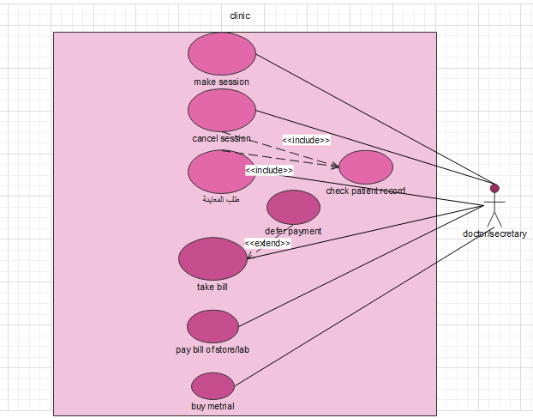

The section will give an overview of the whole system. The system has one actor. The Doctor\Secretary that interacts via an interface with warehouse manager and laboratory.

2.2.Functional Requirements

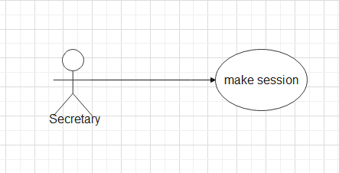

**Brief Description:**

The Secretary recording the patient's appointment if it is for the first time to receive the patient's card by taking the necessary information about him and transferring him to the doctor at the scheduled time.

**Initial Step-By-Step Description**:

Before this use case can be initiated, the Secretary/Dentist has already opened the application.

1. If the patient has come to the clinic is the first time, the secretary by pressing a ( new card ) for the patient and then booking the session date.
2. If the patient already exists, the secretary is adjusting on the patient card and booking the session date.

2.3.User characteristics

The doctor is expected to handle with the computer well.

The secretary is expected to handle with the computer well and to be able to coordinate and organize tasks in the correct manner.

2.4.Non-Functional Requirements

* Availability
* Easy to handle
* Consider the link between the responsibilities of the doctor and the secretary.

**3.0. Requirements Specification**

***3.1 External Interface Requirements***

The only link to an external system is the link to the Dental store/lab Database to verify the membership of store. The Dental store/lab Database fields of interest to the clinic application Systems are Dental store/lab's name, Dental store/lab's (ID) number, and Dental store/lab’s location.

***3.2 Functional Requirements***

The Logical Structure of the Data is contained in Section 3.3.1

3.2.1 Make session

|  |  |
| --- | --- |
| Make Session | **Use Case Name** |
| Section 2.2.2, make session  SDD, Section 7.2 | **XRef** |
| The doctor/secretary | **Trigger** |
| The doctor/secretary should to open the application | **Precondition** |
| 1. after open the application and the doctor/secretary press on the bottom “make session” for add a new patent  2. the doctor/secretary insert the details and information about the patent  3. the system check the correctly of inserts and show wrong if any filed empty or false  4. the system add the patient to the database | **Basic Path** |
| If was any wrong in the database the system show error | **Alternative Paths** |
| The patient has been added to the database. | **Postcondition** |
| The doctor may abandon the operation at any time | **Exception Paths** |
| The patent information includes name, age, sex | **Other** |

3.2.2 Cancel Session

|  |  |
| --- | --- |
| Cancel Session | **Use Case Name** |
| Section 2.2.3, Cancel session  SDD, Section 7.3 | **XRef** |
| doctor/secretary | **Trigger** |
| The doctor/secretary should to login to the application | **Precondition** |
| 1. after open the application the doctor/secretary press on the bottom “cancel session” for delete the patent  2. the doctor/secretary insert the details and information about the patient for delete  3.the system delete the patient from the database | **Basic Path** |
| If was any wrong in the database the system show error | **Alternative Paths** |
| The patent has been deleted from the database. | **Postcondition** |
| The doctor may abandon the operation at any time | **Exception Paths** |

3.2.3 reviewer Order

|  |  |
| --- | --- |
| Reviewer order | **Use Case Name** |
| Section 2.2.4, reviewer order  SDD, Section 7.4 | **XRef** |
| doctor/secretary | **Trigger** |
| the doctor/secretary should to open the application and entered the patient data | **Precondition** |
| 1. after open and insert the information about the patent  2. the doctor/secretary press on the bottom “reviewer order”  3.the system check the correctly of inserts and show wrong if any filed empty or false | **Basic Path** |
| If was any wrong in the database the system show error | **Alternative Paths** |
| The patient has been ordered from the database | **Postcondition** |
| The doctor may abandon the operation at any time | **Exception Paths** |

3.2.4 Take Bill

|  |  |
| --- | --- |
| Take Bill | **Use Case Name** |
| Section 2.2.5 take bill  SDD, Section 7.5 | **XRef** |
| doctor/secretary | **Trigger** |
| the doctor/secretary should to open the application and entered the patient data | **Precondition** |
| 1. after open the application and insert the information about the patient  2. the doctor/secretary press on the bottom “take bill”  3.the system check the correctly of inserts and show wrong if any filed empty or false  4.the system bring the patient data  5.now the doctor/secretary can know the amount owned by the patent | **Basic Path** |
| If was any wrong in the database the system show error | **Alternative Paths** |
| The doctor may abandon the operation at any time | **Exception Paths** |

3.2.5 Pay Bill of store/lab dental

|  |  |
| --- | --- |
| Pay Bill of store/lab | **Use Case Name** |
| Section 2.2.6 pay bill of store/lab  SDD, Section 7.6 | **XRef** |
| doctor/secretary | **Trigger** |
| the doctor/secretary should to open the application and entered the store or lab data | **Precondition** |
| 1. after open the application and insert the information about the store or lab  2. the doctor/secretary press on the bottom “pay bill of store or lab”  3.the system check the correctly of inserts and show wrong if any filed empty or false  4.the system bring the store or lab data  5.now the doctor/secretary can know the amount owned by him and pay it  6. the system update the store or lab database | **Basic Path** |
| If was any wrong in the database the system show error | **Alternative Paths** |
| The doctor may abandon the operation at any time | **Exception Paths** |
| The store or lab information includes name, number, address, email | **Other** |

3.2.6 Buy Materials

|  |  |
| --- | --- |
| Buy materials | **Use Case Name** |
| Section 2.2.7 buy materials  SDD, Section 7.7 | **XRef** |
| doctor/secretary | **Trigger** |
| the doctor/secretary should to login to the application and entered the materials data | **Precondition** |
| 1. after open the application the doctor insert the information about the materials  2. the doctor/secretary press on the bottom “buy materials”  3.the system check the correctly of inserts and show wrong if any filed empty or false  4.now the doctor can know the amount of materials and buy his need  5.the system update the materials database | **Basic Path** |
| If was any wrong in the database the system show error | **Alternative Paths** |
| The doctor may abandon the operation at any time | **Exception Paths** |
| The materials information includes  name, number, amount, price | **Other** |

***3.3 Detailed Non-Functional Requirements***

3.3.1 Logical Structure of the Data

The logical structure of the data to be stored in the patent and stores database is given below

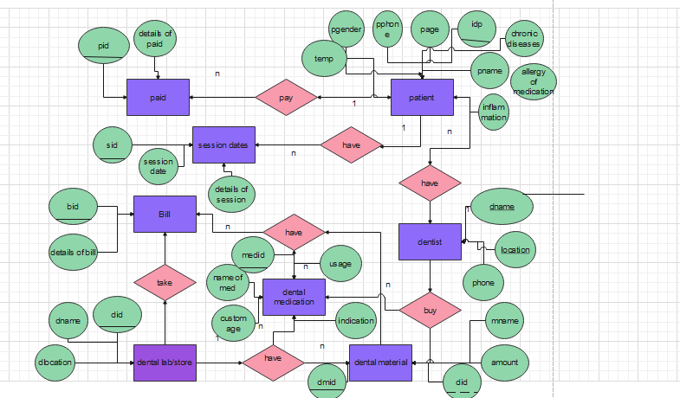

**Figure 4 - Logical Structure of the clinic data**

The data descriptions of each of these data entities is as follows:

|  |  |  |  |  |  |  |
| --- | --- | --- | --- | --- | --- | --- |
| **Comment** | |  |  |  | | --- | --- | --- | |  |  | **Description** | | **Type** | **Data Item** |
|  | Name of principle patient | Text | **Name** |
| Used as key in patient Database | ID number of patients | Integer | **Id** |
| Used to call with patient | Mobile number of patients | Integer | **Phone** |
| The doctor needs to know patient temperature, now he can decide if he can manipulate patient or not | Temperature of patient | Boolean | **Temp** |
| The doctor needs to know patient gender, to know if she is female or not | Gender of patient | Text | **Gender** |
| The doctor needs to know patient age, so if was elderly the doctor should to be careful | Age of patient | Integer | **Age** |

Doctor Data Entity:

|  |  |  |  |  |  |  |
| --- | --- | --- | --- | --- | --- | --- |
| **Comment** | |  |  |  | | --- | --- | --- | |  |  | **Description** | | **Type** | **Data Item** |
|  | Name of principle doctor | Text | **Name** |
| Used by patient to know where the clinic | Clinic address of doctor | Text | **Location** |
| Used to call with doctor by patient | Mobile number of doctor or clinic | Integer | **Phone** |

Store /Lab dental Data Entity:

|  |  |  |  |  |  |  |
| --- | --- | --- | --- | --- | --- | --- |
| **Comment** | |  |  |  | | --- | --- | --- | |  |  | **Description** | | **Type** | **Data Item** |
|  | Name of principle store/lab | Text | **Name** |
| Used as key in store/lab dental database | ID number of store/lab dental | Integer | **Id** |
| Used to know where the store/lab by the doctor | Address of store/lab dental | Text | **Location** |

Material Data Entity:

|  |  |  |  |  |  |  |
| --- | --- | --- | --- | --- | --- | --- |
| **Comment** | |  |  |  | | --- | --- | --- | |  |  | **Description** | | **Type** | **Data Item** |
|  | Name of principle material | Text | **Name** |
| Used as key in material database | ID number of materials | Integer | **Id** |
| The kind and the price of all material amount | Amount of material, the doctor needs it | Text | **Amount** |

3.3.2 Non-Functional Requirements

the system is available for the doctor and secretary within the specified working hours between 9 am and 4 pm, Easy to handle and understand in a simple way, without complications, Consider the link between the responsibilities of the doctor and the secretary.