Defect Summary:
User should be able to simulate the experiment after creating circuit for NAND gate.
Defect Description:
In the VLSI Experiment 2, when we click on the "Experiment" link on Virtual Experiment page, and create circuit for NAND gate, the simulation should be successful. "The circuit is not complete, Please Complete it and try again." message is displayed.

Actual Result:
1."The circuit is not complete, Please Complete it and try again." message is displayed.

Environment :
OS: Ubuntu
Browsers: Firefox,Chrome
Bandwidth : 100Mbps
Hardware Configuration:4GBRAM,
Processor:i3

Screenshot:

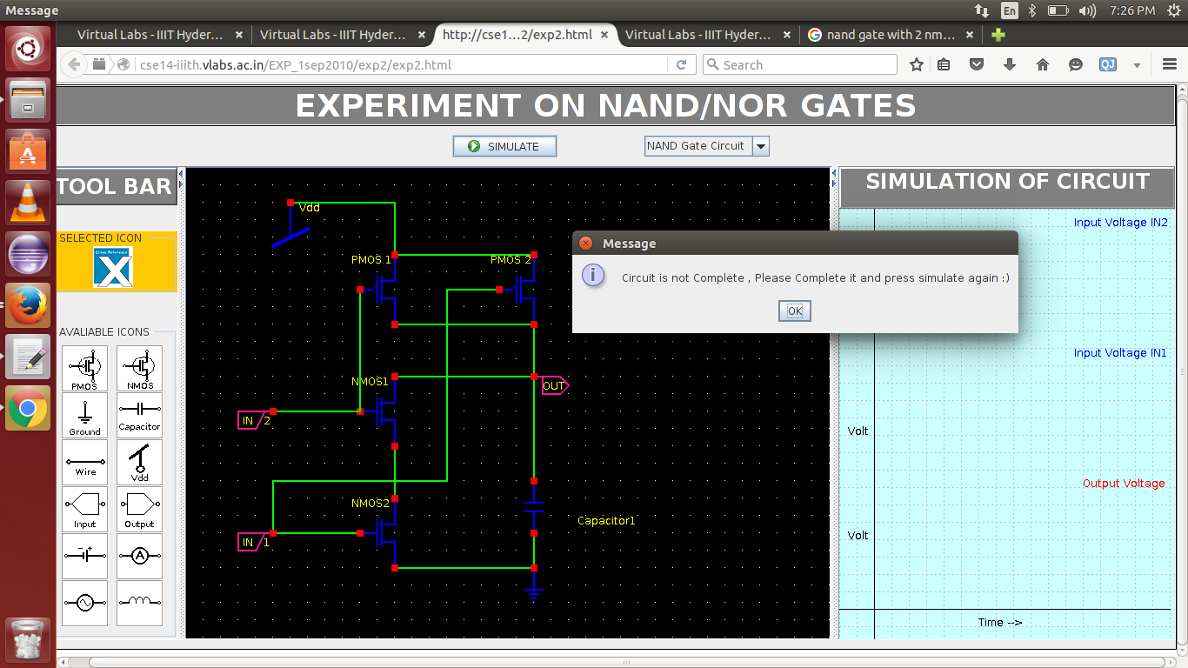

Code Defects

There are many unnecessary comment blocks in the code. Comments like
“
// add(txtArea, "center");
// String prHtml = this.getParameter("fileToRead");
// if (prHtml != null) fileToRead = new String(prHtml);
”
are not needed in the code and only make the code dirty

Moreover, the code is not modular. There are only 2-3 functions in the entire class. There are some empty catch statements that might result to improper error handling.

