Defect Summary:
Images are not displyed on Quiz page.
Defect Description:
In the VLSI Experiment 2, when we click on the "Quiz" link Quiz page should be opened and Content should be present with no distortions and Junk characters.

Actual Result:
Images are not displyed on Quiz page

Environment :
OS: Ubuntu
Browsers: Firefox,Chrome
Bandwidth : 100Mbps
Hardware Configuration:4GBRAM,
Processor:i3

Screenshot:
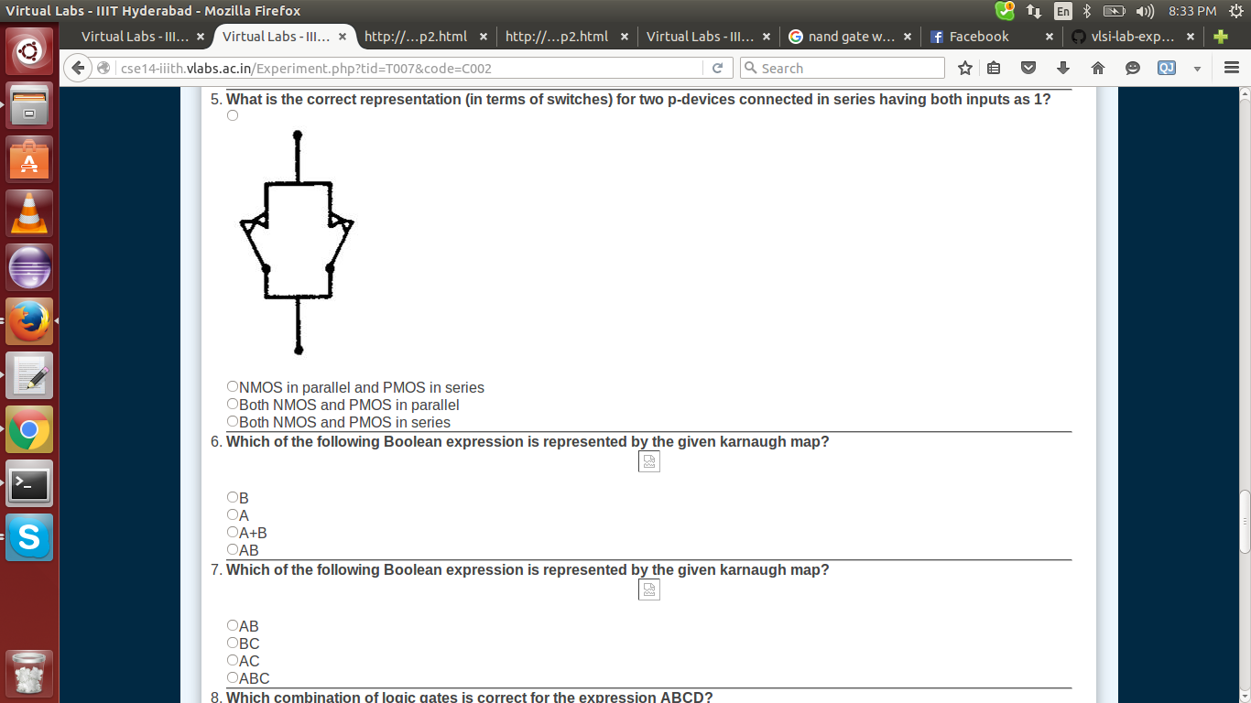
Code Defects

There are many catch statements that are empty resulting into improper error handling. Moreover the experiment is not working in all the laptops as some java plugin is required to run it. The code is too long, also because of the undeleted comments. There are some functions in exp2.java too that are pretty long and need to be further modularised.

