**Practical 1**

//Index.js

import React from 'react';

import ReactDOM from 'react-dom/client';

import './index.css';

import App from './App';

import reportWebVitals from './reportWebVitals';

const root = ReactDOM.createRoot(document.getElementById('root'));

root.render(

  <React.StrictMode>

   <h1>Hello 221107056</h1>

  </React.StrictMode>

);

// If you want to start measuring performance in your app, pass a function

// to log results (for example: reportWebVitals(console.log))

// or send to an analytics endpoint. Learn more: https://bit.ly/CRA-vitals

reportWebVitals();

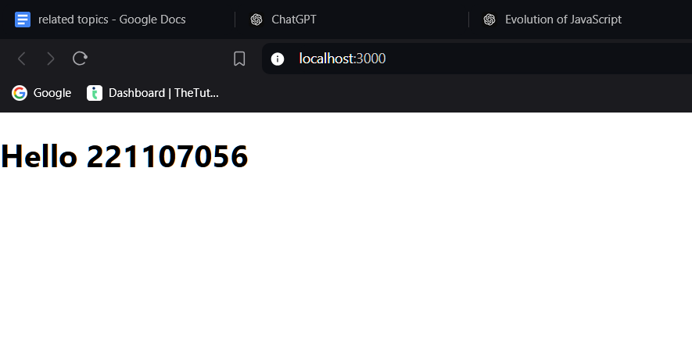

**Practical 2**

**Program with jsx :**

//index.js

import React from 'react';

import ReactDOM from 'react-dom/client';

import './index.css';

import App from './App';

import reportWebVitals from './reportWebVitals';

const myElement = <h1>221107056 with jsx !</h1>;

const root = ReactDOM.createRoot(document.getElementById('root'));

root.render(myElement);

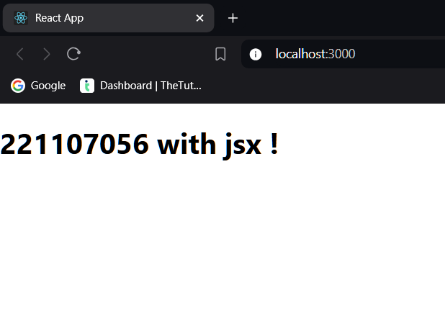

**Program without jsx :**

//index.js

import React from 'react';

import ReactDOM from 'react-dom/client';

const myElement = React.createElement("h1", null, '221107056 without jsx !');

const root = ReactDOM.createRoot(document.getElementById("root"));

root.render(myElement);

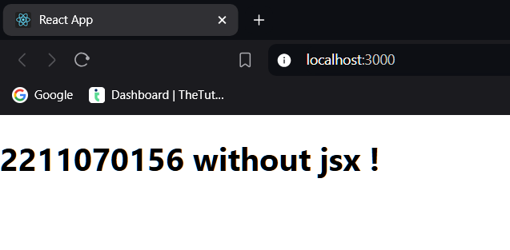

**Program with components :**

//Index.js

import React from 'react';

import ReactDOM from 'react-dom';

import Heading from '/Heading';

ReactDOM.render(

<>

<Heading>[HeadingS]</Heading>

<p>PATIL NIRANJAN RAVINDRA</p>

<ol>

<li>Mobile No. : - 91234xxxxx</li>

<li>Email ID : - niranjan.p@example.com</li>

<li>Address :- Near Patel Nagar, Shirpur</li>

</ol>

</>,

document.getElementById("root")

);

//Heading.jsx

import React from 'react';

function Heading

return <h1>My PRN is 221107056</h1>;

}

export default Heading;|

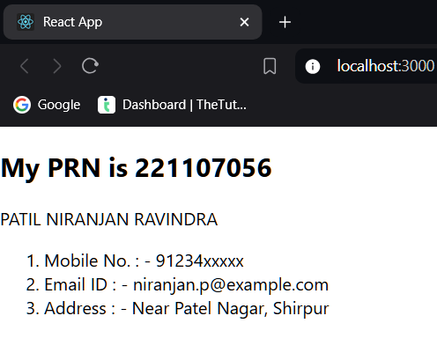

**Program with props :**

//index.js

import React from 'react';

import ReactDOM from 'react-dom';

function RCPIT(props) {

return <h1>I am {props.name}! Student of RCPIT.</h1>;

}

const myElement = <RCPIT name="NIRANJAN" />;

const root = ReactDOM.createRoot(document.getElementById('root'));

root.render(myElement);

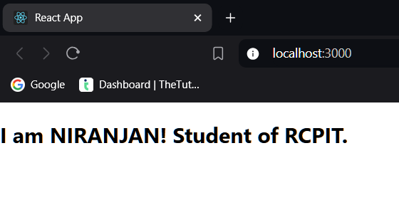

**Program with usestate :**

//UState.js

import React, { useState } from 'react';

function UState() {

const [count, setCount] = useState(0);

return (

<div>

<h1>{count}</h1>

<button onClick={() => setCount(count + 1)}>Update</button>

</div>

);

}

export default UState;

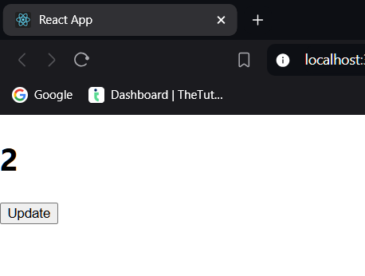

**Practical 3**

**Forms:**

//Forms1.jsx

import React, { useState } from 'react';

import ReactDOM from 'react-dom';

import './App.css';

export default function Forms1() {

const [name, setName] = useState('');

const [gender, setGender] = useState('Male');

const [phoneNumber, setPhoneNumber] = useState('');

const handleSubmit = (event) => {

event.preventDefault();

alert(`Hello ${name}, you are submitting the form`);

};

return (

<div className="formevent">

<h1>2 Batch React Form</h1>

<form onSubmit={handleSubmit}>

<label>Name: </label>

<input type="text" value={name} onChange={(e) => setName(e.target.value)} /><br/><br/>

<label>Gender: </label>

<select value={gender} onChange={(e) => setGender(e.target.value)}>

<option value="Male">Male</option>

<option value="Female">Female</option>

</select><br/><br/>

<label>Phone Number: </label>

<input type="text" value={phoneNumber} onChange={(e) => setPhoneNumber(e.target.value)} /><br/><br/>

<input type="submit" />

</form>

</div>

);

}

ReactDOM.render(<Forms1 />, document.getElementById('root'));

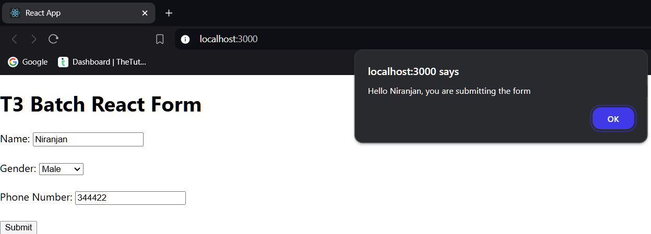

**Keys :**

//Students.jsx

import React from 'react';

function Students() {

const students = ["Aakash", "Virat", "Rohit", "Sachin"];

return (

<div>

{students.map((std) => <h1 key={std}>{std}</h1>)}

</div>

);

}

export default Students;

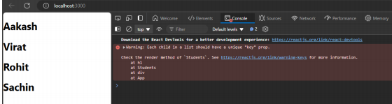

import React from 'react';

function Students() {

const students = ["Aakash", "Virat", "Rohit", "Sachin"];

let studentNames = students.map((std, index) => <li key={index}>{std}</li>);

return (

<div>

<ul>

{studentNames}

</ul>

</div>

);

}

export default Students;

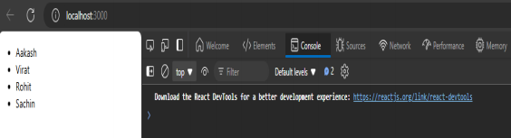

**Refs :**

// HookuseRef.jsx

import React, { useEffect, useRef } from 'react';

function HookuseRef() {

const newRef = useRef();

const handleHeading = () => {

newRef.current.style.color = 'red';

};

useEffect(() => {

console.log(newRef); // This logs the newRef to the console when the component is mounted

}, []); // Empty dependency array to ensure this runs once on mount

return (

<div>

<h1 ref={newRef}>Hello 221107056</h1>

<button onClick={handleHeading}>Submit</button>

</div>

);

}

export default HookuseRef;

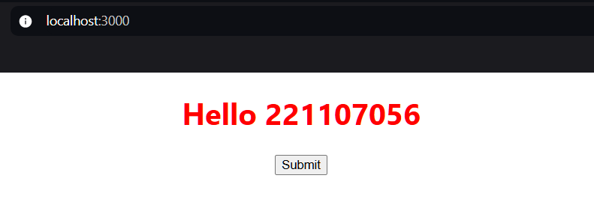

**React Routers :**

import Home from './Home';

import Contact from './Contact';

import About from './About';

import './App.css';

import { BrowserRouter, Route, Routes } from "react-router-dom";

function App() {

return (

<BrowserRouter>

<Routes>

<Route path="/" element={<Home />} />

<Route path="/about" element={<About />} />

<Route path="/contact" element={<Contact />} />

</Routes>

</BrowserRouter>

);

}

export default App;

//Home.jsx

import React from 'react';

import { NavLink } from 'react-router-dom';

const Home = () => {

return (

<>

<header>

<nav>

<ul>

<li><NavLink to="/">Home</NavLink></li>

<li><NavLink to="/about">About</NavLink></li>

<li><NavLink to="/contact">Contact</NavLink></li>

</ul>

</nav>

</header>

</>

);

};

export default Home;

// About.jsx

import React from 'react';

import { NavLink } from 'react-router-dom';

const About = () => {

return (

<>

<header>

<nav>

<ul>

<li><NavLink to="/">Home</NavLink></li>

<li><NavLink to="/about">About</NavLink></li>

<li><NavLink to="/contact">Contact</NavLink></li>

</ul>

</nav>

</header>

</>

);

};

export default About;

//Contacts.jsx

import React from 'react';

import { NavLink } from 'react-router-dom';

const Contact = () => {

return (

<>

<header>

<nav>

<ul>

<li><NavLink to="/">Home</NavLink></li>

<li><NavLink to="/about">About</NavLink></li>

<li><NavLink to="/contact">Contact</NavLink></li>

</ul>

</nav>

</header>

</>

);

};

export default Contact;

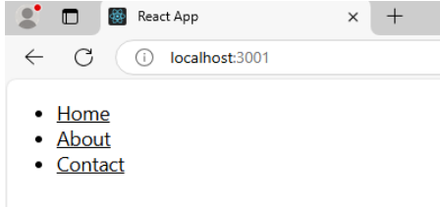

**Practical 4**

1. **Conditional rendering If statement :**

// App.js

import React from 'react';

import Component1 from './Component1';

import Component2 from './Component2';

function App() {

const name = 'someCondition'; // Set your condition here

if (name === 'condition1') { // Replace 'condition1' with your actual condition

return <Component1 />;

} else {

return <Component2 />;

}

}

export default App;

//Component1.jsx

import React from 'react';

function Component1() {

return (

<div>

<h1>Name: PATIL NIRANJAN RAVINDRA<br />

PRN: 221107056

</h1>

</div>

);

}

export default Component1;

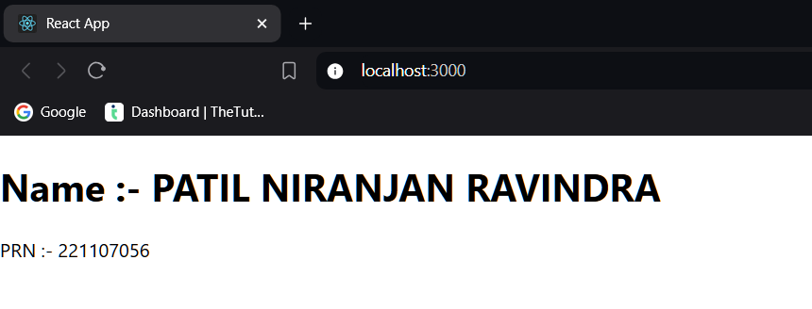

import React from 'react';

import Component1 from './Component1';

import Component2 from './Component2';

function App() {

const name = "Niranjan!";

if (name === "Om") {

return <Component1 />;

} else {

return <Component2 />;

}

}

export default App;

// Component2.jsx

import React from 'react';

function Component2() {

return (

<div>

<h1>Hi User!</h1>

</div>

);

}

export default Component2;

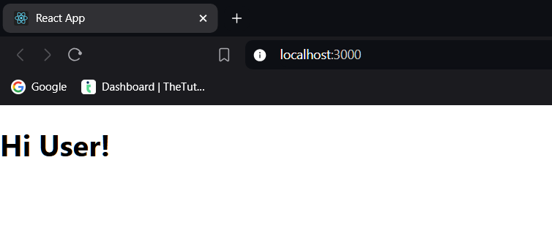

1. **Using Logical && operator**

// App.js

import React from 'react';

function App() {

const name = "Niranjan";

return (

<div>

<h1>Hi {name}!</h1>

</div>

);

}

export default App;

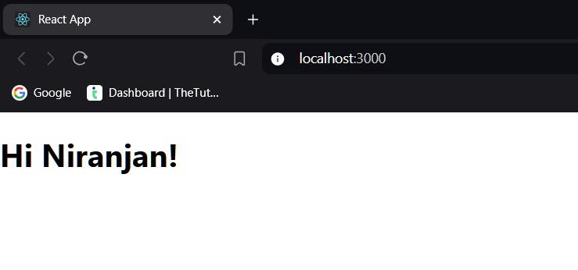

1. **Conditional Rendering using ternery operator**

// App.js

import React from 'react';

function App() {

const age = 20;

return (

<div>

<h1>{age > 18 ? "You can vote" : "You cannot vote"}</h1>

</div>

);

}

export default App;

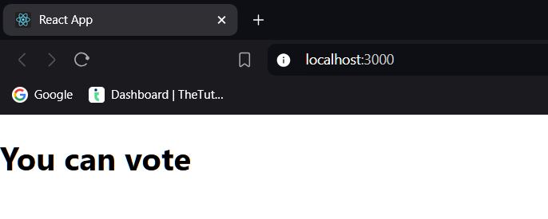

// App.js

import React from 'react';

function App() {

const age = 15;

return (

<div>

<h1>{age > 18 ? "You can vote" : "You cannot vote"}</h1>

</div>

);

}

export default App;

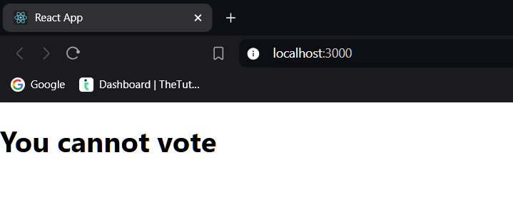

**Practical 5**

**UseState Hooks** :

import React, { useState } from 'react';

function USComponent() {

const myArray = useState(221107017)[0];

return (

<div>

<h1>{myArray}</h1>

</div>

);

}

export default USComponent;

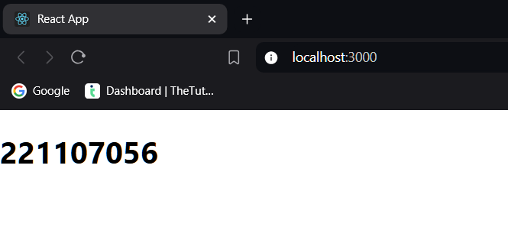

// USComponent.jsx

import React, { useState } from 'react';

function USComponent() {

const [myArray, setMyArray] = useState(["RCPIT"]);

return (

<div>

<h1>{myArray[0]}</h1>

<button onClick={() => setMyArray(["Autonomous"])}>Update</button>

</div>

);

}

export default USComponent;

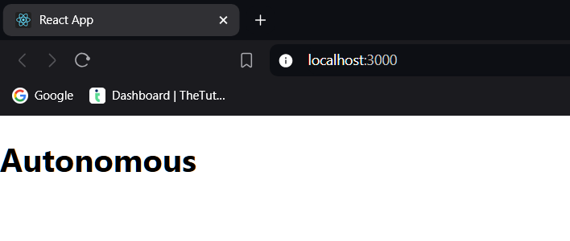

// USComponent.jsx

import React, { useState } from 'react';

function USComponent() {

const [name, setName] = useState("Niranjan");

const changeState = () => {

setName("Student");

};

return (

<div>

<h1>{name}</h1>

<button onClick={changeState}>Update</button>

</div>

);

}

export default USComponent;

u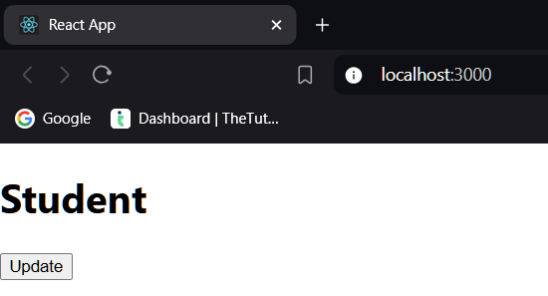

**UseContext Hook :**

//App.js

import React, { createContext } from 'react'

import Comp1 from './Comp1'

export const nameContext = createContext()

export default function App() {

return (

<div>

<nameContext.Provider value={"My Roll Number Is 55"}>

<Comp1 />

</nameContext.Provider>

</div>

)

}

//Comp1.jsx

import React from 'react'

import Comp2 from './Comp2'

export default function Comp1() {

return (

<div>Comp1 made by Niranjan

<Comp2/>

</div>

)

}

//Comp2.jsx

import React from 'react'

import Comp3 from './Comp3'

export default function Comp2() {

return (

<div>Comp2 made by Niranjan

<Comp3/>

</div>

)

}

//Comp3.jsx

import react, { useContext } from 'react'

import {nameContext} from './App'

export default function Comp3(){

const myName = useContext(nameContext)

return(

<div><p>Comp3 made By Niranjan</p>

{myName}

</div>

)

}

