This practice problem comes from Chapter 6. Arrays and Vectors – End-of-Chapter Exercises – Review Exercises - R6.20.

Understanding the problem: Finding out the most frequently occurring value in an array of numbers. As an example, we can think of these values as coins, with pennies, dimes, nickels, and quarters or other unknown denomination. Provide functions and arrays.

Step 1: Inputs and outputs,

* I would like to enter a set of coins, 10 coins for example – this will be our inputs:
  + - 1, 10, 5, 25 ,5 ,9 ,1 ,10, 1, 1
* My output will look like this:
  + This is the summary count of coins:
    - Pennies: 4
    - Nickels: 2
    - Dimes: 2
    - Quarters: 1
    - Other: 1
  + The most frequently occurring coins are: pennies with a count of 4

Step 2: Break problem into smaller tasks (these could be my functions actually),

* Store coins in an array
* Go through the array and count each coin denomination
* Display output showing summary results
* Compare counts of each coin denomination and find largest count
* Display output showing this count

Step 3: Describe each section in pseudocode,

* Create variable counter for each coin denomination
* Create an array, constant variable for 10 spaces
* Call a function that will count coin denominations:
  + FOR each index in the array
  + SWITCH CASE: count each coin denomination
* Call function to output summary
* Call function to compare each coin counter variable:
  + Set the first item in the array as the biggest number of coins
  + FOR each index in the array, compare with first one with the rest of the coin counts, if bigger count, then set it as the most occurring count
  + Display result accordingly with name of the coin denomination

Step 4: Test pseudo code by working on a few problems,

Another set: {2, 3, 1, 5, 10, 1, 25, 1, 1, 1}

Pennies: 5

Nickels: 1

Dimes: 1

Quarters: 1

Other: 2

Another set: {5, 5, 1, 5, 10, 5, 25, 1, 5, 1}

Pennies: 3

Nickels: 5

Dimes: 1

Quarters: 1

Other: 0

Another set: {25, 45, 51, 55, 10, 5, 125, 1, 5, 1}

Pennies: 2

Nickels: 2

Dimes: 1

Quarters: 1

Other: 4

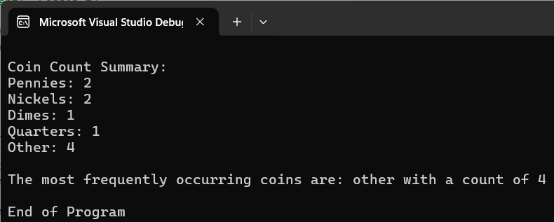

Another set: {10, 10, 50, 10, 10, 5, 50, 1, 5, 1}

Pennies: 2

Nickels: 2

Dimes: 4

Quarters: 0

Other: 2

