**Congratulations! You passed!**

Next Item

Correct

1 / 1 points

**1. Question 1**

Consider the problem of predicting how well a student does in her second year of college/university, given how well she did in her first year.

Specifically, let x be equal to the number of "A" grades (including A-. A and A+ grades) that a student receives in their first year of college (freshmen year). We would like to predict the value of y, which we define as the number of "A" grades they get in their second year (sophomore year).

Here each row is one training example. Recall that in linear regression, our hypothesis is h_\theta(x) = \theta_0 + \theta_1x*hθ*​(*x*)=*θ*0​+*θ*1​*x*, and we use m*m* to denote the number of training examples.

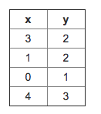

For the training set given above (note that this training set may also be referenced in other questions in this quiz), what is the value of m*m*? In the box below, please enter your answer (which should be a number between 0 and 10).

Correct

1 / 1 points

**2. Question 2**

For this question, assume that we are

using the training set from Q1. Recall our definition of the

cost function was J(\theta_0, \theta_1) = \frac{1}{2m}\sum_{i=1}^m{(h_\theta(x^{(i)}) - y^{(i)})^2}*J*(*θ*0​,*θ*1​)=2*m*1​∑*i*=1*m*​(*hθ*​(*x*(*i*))−*y*(*i*))2.

What is J(0, 1)*J*(0,1)? In the box below,

please enter your answer (Simplify fractions to decimals when entering answer, and '.' as the decimal delimiter e.g., 1.5).

Correct

1 / 1 points

**3. Question 3**

Suppose we set \theta_0 = -1, \theta_1 = 0.5*θ*0​=−1,*θ*1​=0.5. What is h_{\theta}(4)*hθ*​(4)?

Question 4

Correct

1 / 1 points

**4. Question 4**

In the given figure, the cost function J(\theta_0,\theta_1)*J*(*θ*0​,*θ*1​) has been plotted against \theta_0*θ*0​ and \theta_1*θ*1​, as shown in 'Plot 2'. The contour plot for the same cost function is given in 'Plot 1'. Based on the figure, choose the correct options (check all that apply).

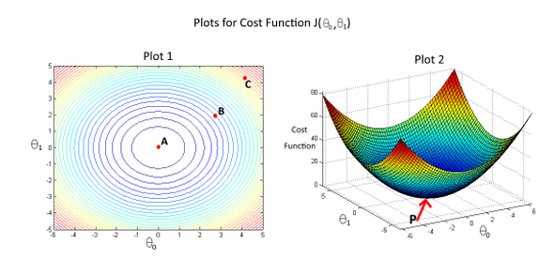

Question 5

Correct

1 / 1 points

**5. Question 5**

Suppose that for some linear regression problem (say, predicting housing prices as in the lecture), we have some training set, and for our training set we managed to find some \theta_0*θ*0​, \theta_1*θ*1​such that J(\theta_0, \theta_1)=0*J*(*θ*0​,*θ*1​)=0.

Which of the statements below must then be true? (Check all that apply.)