1. Go to search and Type – “Task Scheduler”

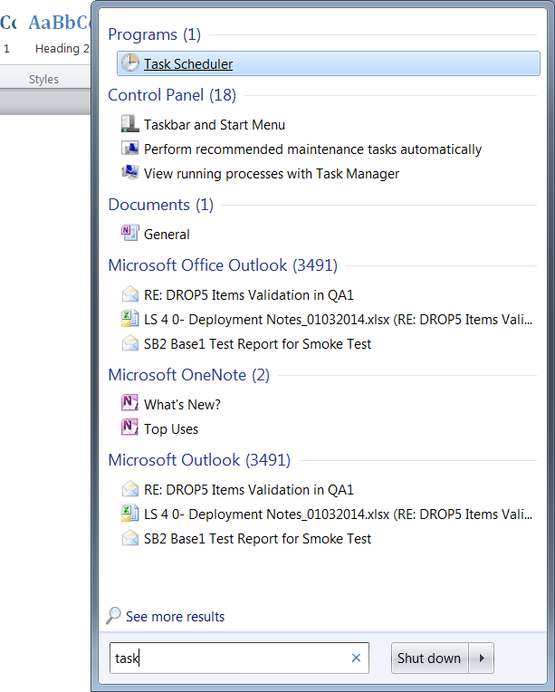

1. Click On “Task Scheduler”. You will see below window. Click on “Create Basic Task”

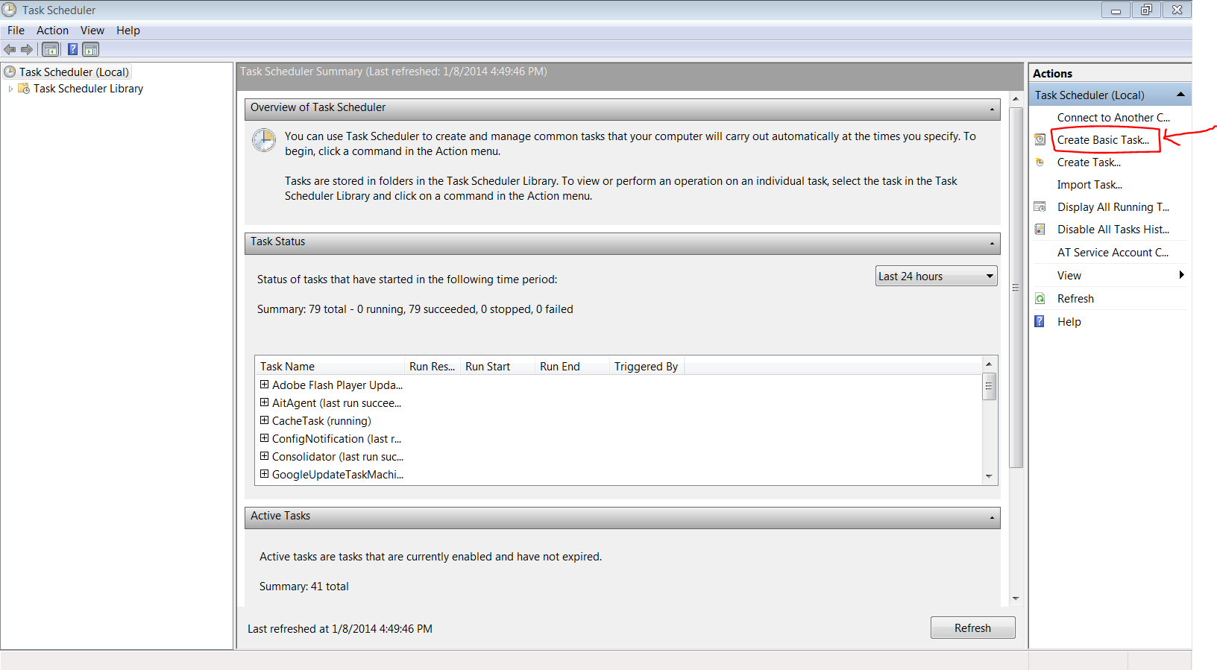

1. Provide “Name” for your Task and supply “Description”. Click Next.

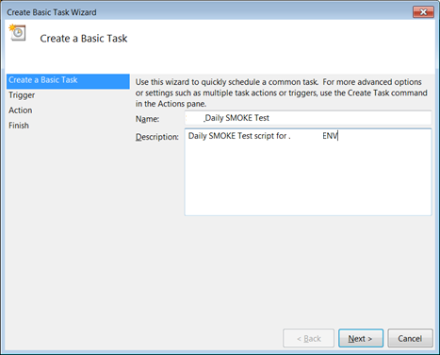

1. Select the “Frequency” for the task. Click Next.

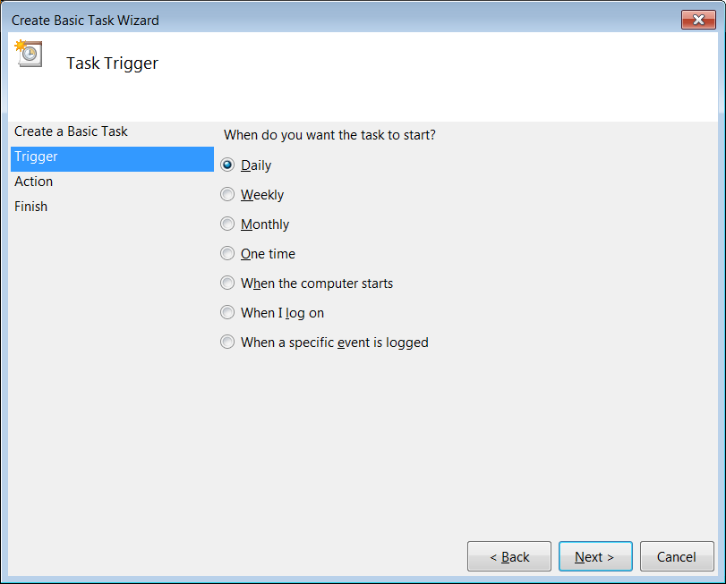

1. Provide Date, Time and Recurrence details. Click Next.

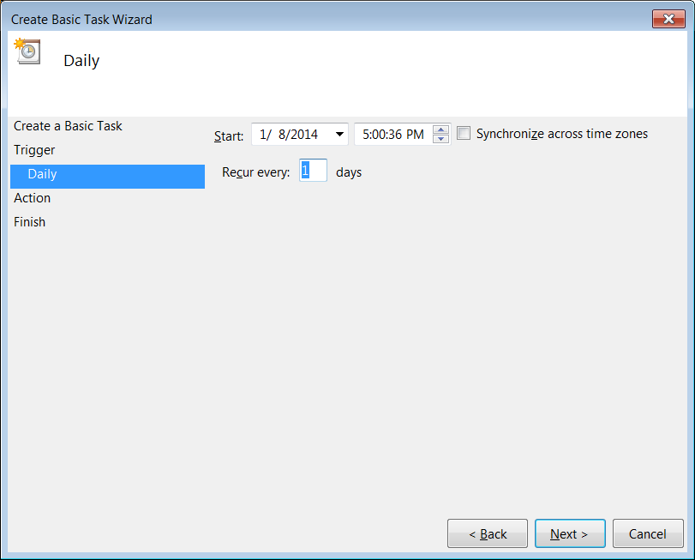

1. Select Action as “Start a Program”. Click Next.

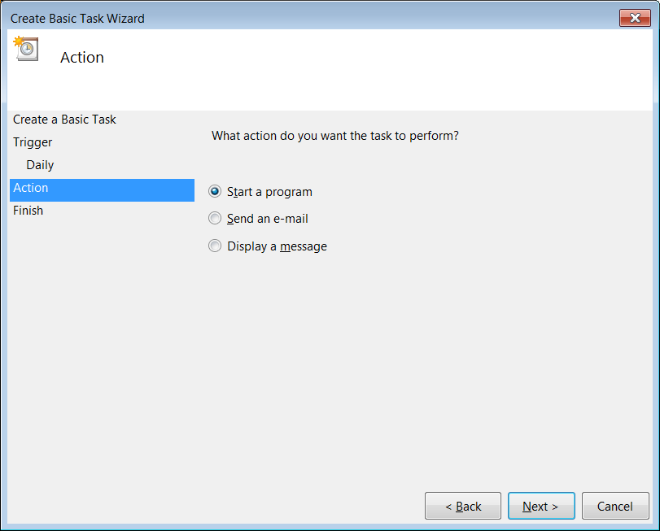

1. **Program/script:** Provide the Batch File Name. for *eg: Start.bat*

**Start in (optional):** Provide the path of the Batch File location. *Eg: C:\Users\welcome\TestNG Framework* ***and*****Click Next.**

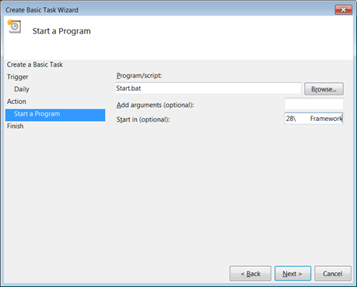

1. Select the “open the properties dialog for this task when I click Finish” check box. Click Finish.

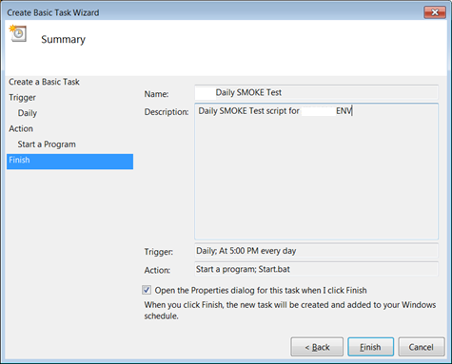

1. In the Properties Window, Under “**General” Tab.** make sure the settings are as shown below.

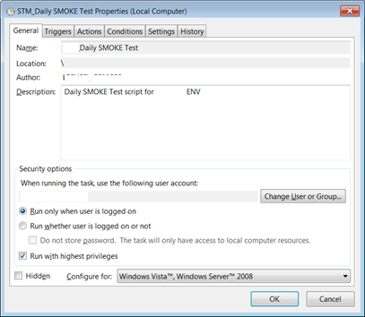

1. **Trigger Tab** – Check the Time and Recurrence details. Status should be **“Enabled”.**

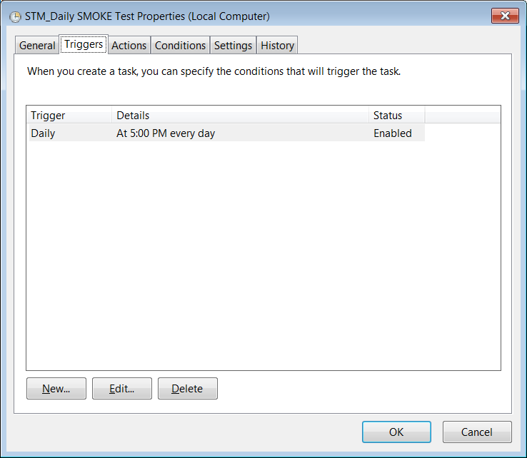

1. **Actions Tab** – should display Batch File name.

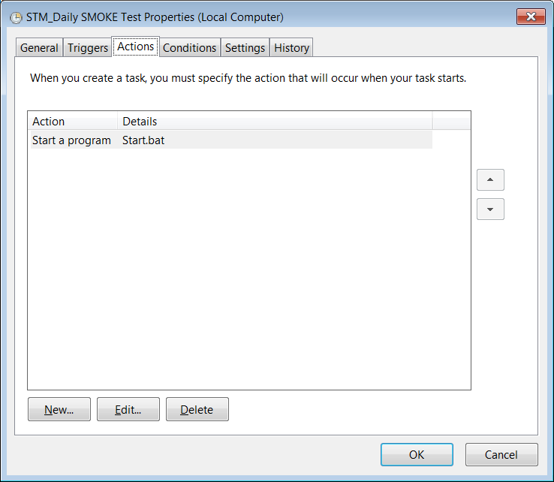

1. **Conditions** Tab – Make sure the settings are as shown below.

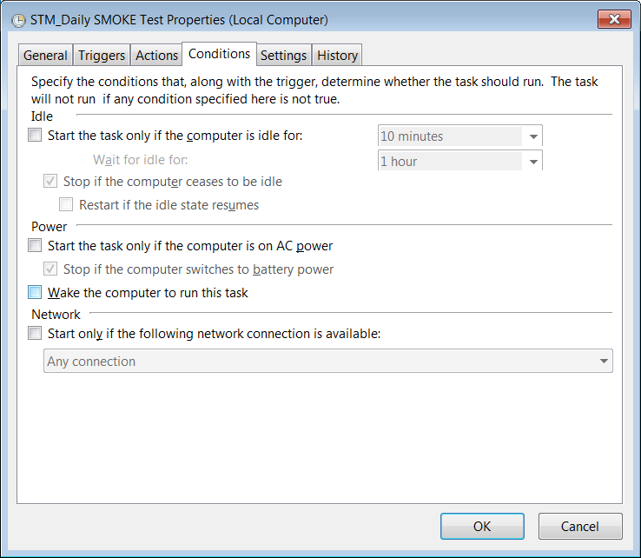

1. **Settings** Tab – Make sure the settings are as shown below. Click **OK**.

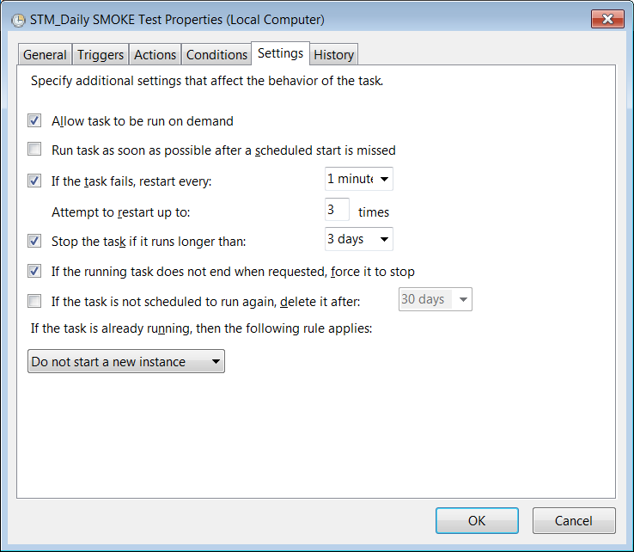

1. On the left side, Click on “Task Scheduler Library”. Task Name with **Status as Ready.**

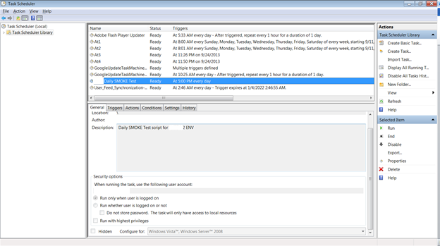

1. **Task is successfully added, and scheduled.**