|  |
| --- |
| Budget Prepay, Inc. |
| MVNO API System |
| User Guide 3.0 |

|  |
| --- |
| Steve Thomas  1/17/2014 |

Table of Contents

Revision History 2

Introduction 3

Support and Feedback 3

WSDL Interfaces 3

Verizon (3G only) 3

TopUp (Budget Prepay) 3

BeQuick (T-Mobile only) 3

Security 4

Management Console 5

Location 5

Reports 5

Review Requests 6

Definitions 8

# Revision History

|  |  |  |  |
| --- | --- | --- | --- |
| Release | Date | By | Description |
| 1.0 | 11/4/2013 | Steve Thomas | Device Inquiry - added  Device Activation - added  Device Activation Port - added  Order Inquiry - added  Management Console - added |
| 1.2 | 11/11/2013 | Steve Thomas | Update Bucket - added  Delete Bucket - added  Add Bucket – added  Search Bucket -added  Validate MDN Portability – added  Change ESN – added  Plan Code attribute on requests - added  Management Console User Edit bug - fixed  Many to many group/plan code relationship – added  Types description, please see WSDL - removed |
| 1.2 | 11/14/2013 | Steve Thomas | Input & Output parameter for each operation - added |
| 1.4 | 11/18/2013 | Steve Thomas | Remove Hotline - added  Activate Hotline Subscriber –added  Hotline Subscriber – added  WS-Security - added  WDSL Documentation, annotations – updated  WDSL element restrictions – updated  Generic Request reporting – added |
| 1.6.0 | 11/29/2013 | Steve Thomas | Additional Verizon operations  Ensure userId is being passed to Verizon, for compliance purposes see page 7 of CCT guide  Ensure the transactionId field is left blank  Disabled WS-Security due to complexity of Microsoft support, will attempt to re-enable in later releases |
| 1.6.1 | 12/01/2013 | Steve Thomas | Fix several bugs, write tests |
| 1.6.2 | 12/04/2013 | Steve Thomas | Fix several bugs, write tests |
| 1.6.3 | 12/06/2013 | Steve Thomas | Refactored VerizonEndpoint to reduce code redundancy, add better exception handling and client feedback, fixed changeESN operation |
| 1.8.0 | 12/08/2013 | Steve Thomas | Hardening Sprint, updated documentation, add C# and Java client samples |
| 2.0.0 | 1/5/2014 | Steve Thomas | Add Top Up operations, Enabled WS-Security |
| 3.0.0 | 1/17/2014 | Steve Thomas | Add BeQuick T-Mobile operations |

# Introduction

The Budget Prepay MVNO API System (MVNO) is an aggregator of internal and third party wireless provisioning services. It also attempts to apply Budget Prepay product branding features to the customer facing interfaces.

MVNO customer facing interfaces are built with open standards that aim to ensure ease of integration at the lowest possible labor cost. Integration developers are assumed to have exposure to open web services standard.

# Support and Feedback

Please use the contact information below to submit questions, bugs, or feature suggestions.

Email: [steve.thomas@softwarelikeyou.com](mailto:steve.thomas@softwarelikeyou.com)

Phone/Text: (713) 444-3489

# WSDL Interfaces

If an operation’s annotated description is vague or is not included, please send feedback (see Support and Feedback).

## Verizon (3G only)

<http://mvno-api01.budgetprepay.com/MVNO/Verizon.wsdl>

## TopUp (Budget Prepay)

<http://mvno-api01.budgetprepay.com/MVNO/Topup.wsdl>

## BeQuick (T-Mobile only)

<http://mvno-api01.budgetprepay.com/MVNO/Bequick.wsdl>

## Security

MVNO currently implements the WS-Security standard and in the near future HTTPS.

An example of a WS-Security header with plain text password is below. For specify implementation examples, please see <http://mvno-api01.budgetprepay.com/MVNO/Sampeles.zip>. Current samples are C# and Java, but other client technologies can be add by request (see Support and Feedback).

<soapenv:Header>

<wsse:Security

soapenv:mustUnderstand="1"

xmlns:wsse="http://docs.oasis-open.org/wss/2004/01/oasis-200401-wss-wssecurity-secext-1.0.xsd"

xmlns:wsu="http://docs.oasis-open.org/wss/2004/01/oasis-200401-wss-wssecurity-utility-1.0.xsd">

<wsu:Timestamp wsu:Id="TS-152">

<wsu:Created>2013-11-14T00:56:53.524Z</wsu:Created>

<wsu:Expires>2013-11-14T17:36:53.524Z</wsu:Expires>

</wsu:Timestamp>

<wsse:UsernameToken wsu:Id="UsernameToken-151">

<wsse:Username>steve.thomas</wsse:Username>

<wsse:Password Type="http://docs.oasis-open.org/wss/2004/01/oasis-200401-wss-username-token-profile-1.0#PasswordText">password</wsse:Password>

</wsse:UsernameToken>

</wsse:Security>

</soapenv:Header>

NOTE: SoapUI is a good testing tool – www.smartbear.com

# Management Console

The MVNO Management Console has a primary purpose of user and group management, but it can be helpful during request troubleshooting as well as, reporting on activity.

Current key features include:

* Manage Groups (Partners) – admin only
* Manage Users – admin only
* Reset of user passwords
* View raw XML of operations (filtered by user’s permissions)
* View and download requests (by group)
* Support graphs of operational activity based on groups

## Location

<http://mvno-api01.budgetprepay.com/MVNO/>

NOTE: User’s login into the Management Console with plain text password. Future releases will force HTTPS.

## Reports

Users of the Management Console my review/download Requests based on the user’s group attribute and date ranges.

[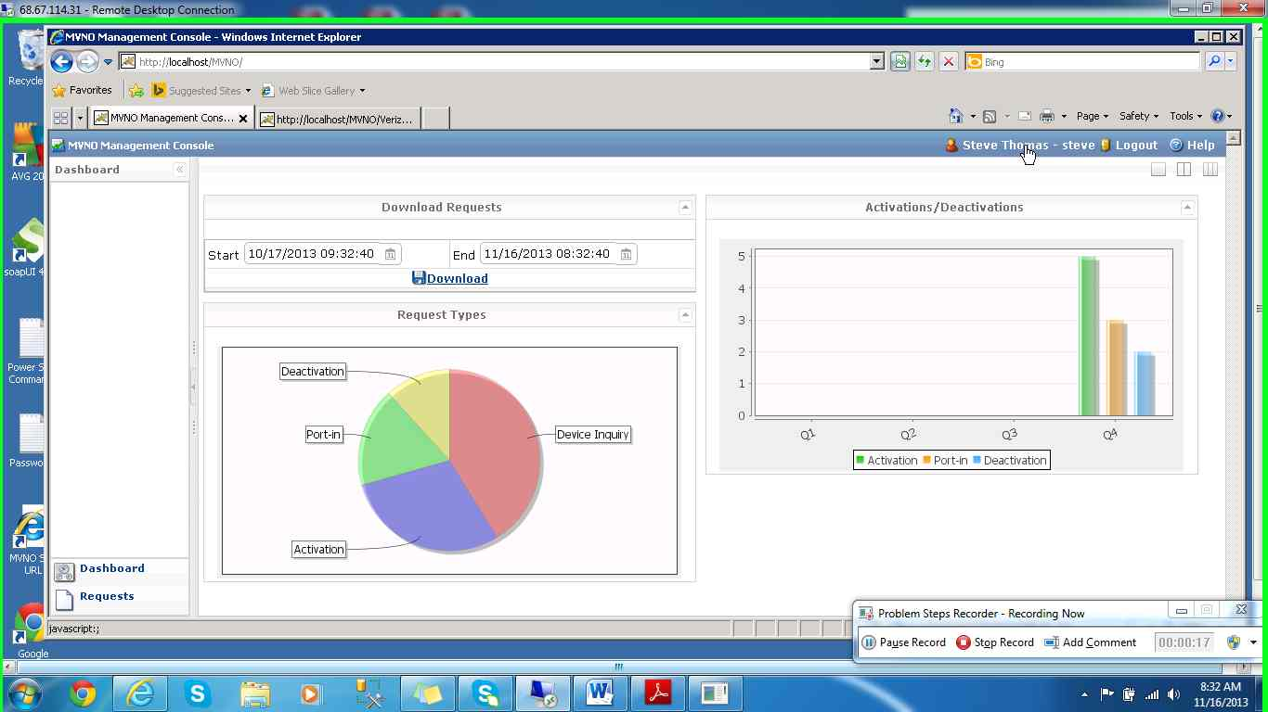](mhtml:file://C:%5CUsers%5Csteve.thomas%5CDesktop%5CMVNO%5CObtain%20Encoded%20Password%5CProblem_20131116_0833.mht!screenshot_0004.jpeg)

## Review Requests

[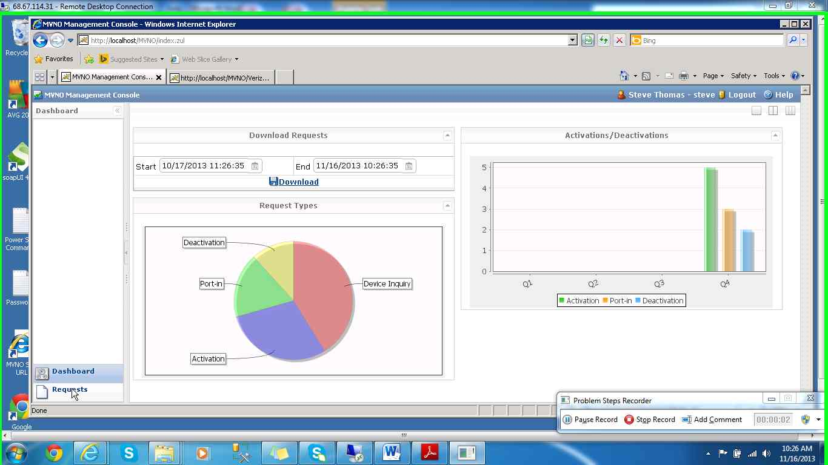](mhtml:file://C:%5CUsers%5Csteve.thomas%5CAppData%5CLocal%5CTemp%5CTemp1_ManagmentConsoleExample.zip%5CProblem_20131116_1026.mht!screenshot_0001.jpeg)

[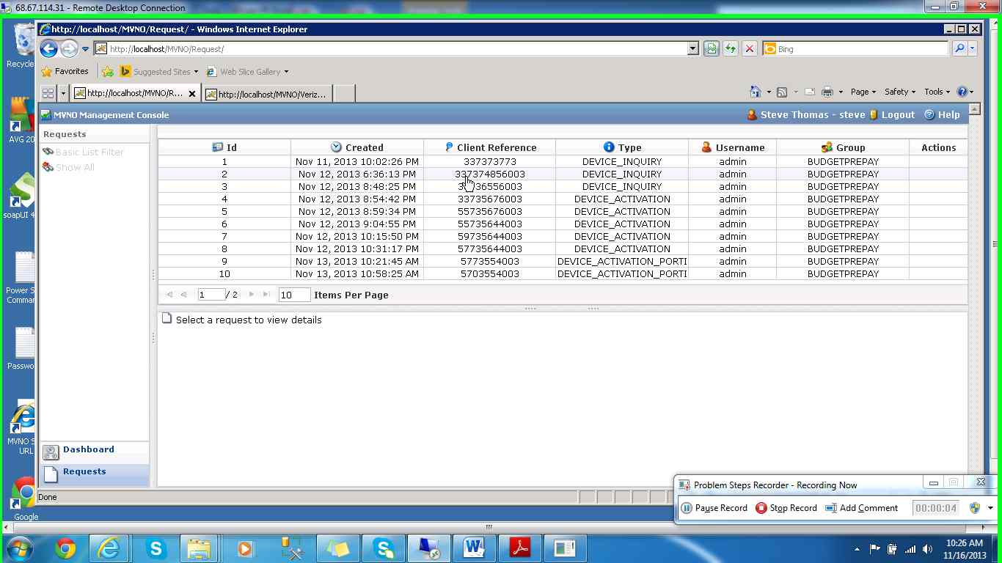](mhtml:file://C:%5CUsers%5Csteve.thomas%5CAppData%5CLocal%5CTemp%5CTemp1_ManagmentConsoleExample.zip%5CProblem_20131116_1026.mht!screenshot_0003.jpeg)

[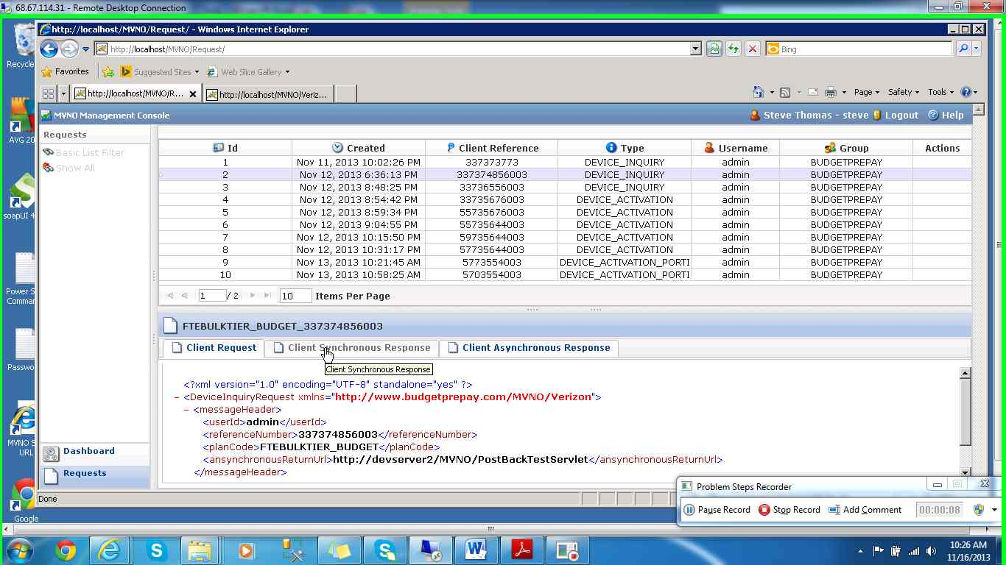](mhtml:file://C:%5CUsers%5Csteve.thomas%5CAppData%5CLocal%5CTemp%5CTemp1_ManagmentConsoleExample.zip%5CProblem_20131116_1026.mht!screenshot_0004.jpeg)

# Definitions

If a definition is vague or is not included here, please send feedback (see Support and Feedback).

|  |  |
| --- | --- |
| Term | Definition |
| UserId | Validate user account create with the MVNO Management Console, must be submit as part of the request within the MessageHeader |
| RefereneNumber | A unique number generated by the reseller with a max length of 50 characters, must be submit as part of the request within the MessageHeader |
| AnsynchronousReturnUrl | Reseller’s URL for asynchronous responses. Ex. http://companyname.com:8080/response. The total size of this field is 255 characters, , must be submit as part of the request within the MessageHeader |
| ReturnCode | Request Return code, example “00” |
| ReturnText | Return Text is the Return Message corresponding to the Return Code returned, example “SUCCESS” |
| AccountNo | Account Number to be used for the order |
| ZipCode | Zip Code in which the service/change requested |
| MDN | Mobile Directory Number to be activated. Ex. 4045551212 |
| ESN | The NPA and NXX Number for selecting an MDN from the pool of available MDNs. Ex. 404555 |
| MEID | Mobile Equipment Identifier containing 14 hexadecimal digits |
| FeatureCode | Billing system feature codes. Note: The reseller can add multiple features by adding more <feature> subsections into the transaction. |
| PlanCode | Price Plan Code based on the codes provided to the reseller. Ex. P004 |
| MPNPoolName | The name of a valid Mobile Private Network. MPNPoolName is optional for activation, unless the MPNSIP or MPNDIP feature is added. Also, if  The MPNPoolName is added one of these features must be present in the XML document. |
| MobileIPAddress | The mobileIPAddress element supports the Static IP or RestricteIPAddres functionalities. A Static IP or Restricted IP Address to be associated with the order. This IP Address must be 12 characters long. There can be no blank spaces or dots (‘.’) between digits. All characters must be digits. No alphabetic or control characters are accepted. Each segment may not exceed a value greater than 255.Each segment must consist of 3 digits. |
| SSN | SSN: 000000000 or 000-00-0000 (nine digits, dashes are optional) |
| TaxId | Company Tax ID: 0000000000 or 00-00000000 (ten digits, dashes are optional) |
| Make | Device manufacturer |
| Model | Device model |
| Mode | Device mode of information transmission |
| Iccid | ICCID i.e. Physical ID of the SIM card |
| BalanceType | Account Balance Type can be “primary”, “secondary”, or “both” |
| Sweep On | ‘true’ or ‘false’ |
| reTime | Recharge Date |
| balanceValue | Bucket Balance |
| sourceId | Bucket ID |
| Uom | Bucket Unit of Measure |
| bucketValue | Bucket Value |
| expTime | Expiration Date |
| sourceValue | description |
| canUpdate | ‘false’ to indicate whether a user with appropriate permissions can update the bucket. |
| canDelete | ‘true’ or ‘false’ to indicate whether a user with appropriate permissions can delete the bucket. |
| numBuckets | Number of buckets returned |
| primaryBalance | Account balance |
| endDate | Date bucket expires (must use minutes  or dollars by this date) |
| adjustmentType | INCR, DECR, or SETEXPIRATION |
| adjustmentValue | INCR or DECR: Integer amount by  which to modify bucketValue  SETEXPIRATION: MM/DD/YYYY date  to which to modify expiration value of  bucket |
| SubOrgID | A conditional element and is used with MPNPoolName, when more than one MPN is in use by a Reseller. |
| authorizationStatus (aStatus) | Authorization Status ‘Y’ if authorized; Otherwise ‘N’ (no quote marks) |
| Hotline Type | |  | | --- | | This tag can only have one of the following values: FRAUD, REGULAR, ROAMING | |
| Hotline Number | Hotline Phone Number provided by the reseller. This is the phone number that the MDN will be hotlined to. Ex. 7175975066 |