**1.**

**Given the following discrete random distribution function quantity X**

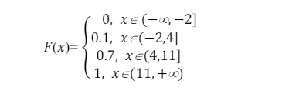

**Write the table of the law of distribution of X**

**Solution**

*The PMF, P(X=x), can be obtained by calculating the difference between the CDF values at the specified points.*

***Identify the intervals and corresponding F(x)F(x)F(x) values:***

*For x∈ (−∞, −2]: F(x)=0*

*For x∈ (−2,4]: F(x)=0.1*

*For x∈ (4,11]: F(x)=0.7*

*For x∈ (11, +∞): F(x)=1*

***Calculate the probabilities for each interval:***

*P(X≤−2) =F (−2) =0*

*P(X≤4) =F (4) −F (−2) =0.1−0=0.1*

*P(X≤11) =F (11) −F (4) =0.7−0.1=0.6*

*P(X>11) =F (∞) −F (11) =1−0.7=0.3*

***table of the law of distribution****:*

|  |  |
| --- | --- |
| ***x*** | ***P(X=x)*** |
| *x≤−2* | *0* |
| *−2<x≤4* | *0.1* |
| *4<x≤11* | *0.6* |
| *x>11* | *0.3* |