Title: DataGridView with Excel-Like auto-filter context menu on IList based lists
Author: Hartmut Schreiber
Email: softwareschreiber@gmail.com
Language: C# 4.0
Platform: Windows .NET, Linux Mono
Technology: WinForms, Linq.Expressions
Level: Advanced
Description: Excel like Filter and Sort without DataView.Filter
Section Desktop Development
SubSection Grid & Data Controls
License: Microsoft Public License (Ms-PL)
- Download demo project - XXX Kb
- Download source - XXX Kb
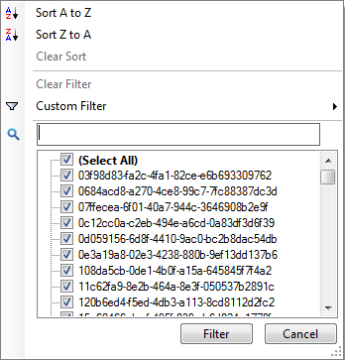 | 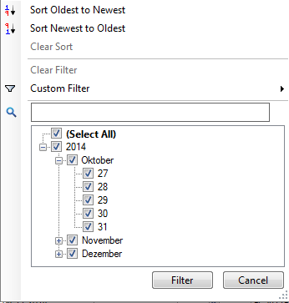

Introduction
Here is David Gironi’s feature description of his Advanced DataGridView:
- Ascending or Descending Sort order for any column, by code or run-time
- Filter any column using a Custom Filter, or selecting values from using an Excel-like Filter List view, using also an advanced feature for DateTime types
- Saving and Restoring preset for Filter and Sort
- Enabling or Disabling Filter and/or Sort features for any column,by code or run-time
- Search ToolBar to find values in columns
I enhanced the functionality with a Textbox for manual searches and filtering on IList based datasources.

Background
Some implementations of this feature like Microsofts “Building a Drop-Down Filter List for a DataGridView Column Header Cell” and Davide Gironi’s Advanced DataGridView are working only with DataTable based DataSources. But many data grid views are showing IList based data and cannot be filtered or sorted with this implementation.
Based on David Gironi’s ‘Advanced DataGridView’ I enhanced it with this capability.
Solution
I created two new generic classes (LambdaFilterBuilder<T> and SortLambdaBuilder<T>), that is using Linq.Expressions to filter and sort IList based data sources.

Using the code
The usage is very simple. There are two static helper methods for filter and sort events.
Sample:
/// <summary>
/// Handles the SortStringChanged event of the dataGridViewMaterials control.
/// </summary>
/// <param name="sender">The source of the event.</param>
/// <param name="e">The <see cref="System.EventArgs"/> instance containing the event data.</param>
void dataGridViewMaterials_SortStringChanged(object sender, EventArgs e)
{
Zuby.ADGV.AdvancedDataGridView dgv = (Zuby.ADGV.AdvancedDataGridView)sender;
Zuby.LambdaFilterBuilder<BO_PPBVPackungen>.SortChanged(dgv, _packungenList, this._bindingSourcePackungen, _doNotShowDeletedRows);
}
/// <summary>
/// Handles the FilterStringChanged event of the dataGridViewMaterials control.
/// </summary>
/// <param name="sender">The source of the event.</param>
/// <param name="e">The <see cref="System.EventArgs"/> instance containing the event data.</param>
void dataGridViewMaterials_FilterStringChanged(object sender, EventArgs e)
{
Zuby.ADGV.AdvancedDataGridView dgv = (Zuby.ADGV.AdvancedDataGridView)sender; Zuby.LambdaFilterBuilder<BO_PPBVPackungen>.FilterChanged(dgv, _packungenList, this._bindingSourcePackungen, _doNotShowDeletedRows);
}

[Geben Sie ein Zitat aus dem Dokument oder die Zusammenfassung eines interessanten Punkts ein. Sie können das Textfeld an einer beliebigen Stelle im Dokument positionieren. Verwenden Sie die Registerkarte 'Zeichentools', wenn Sie das Format des Textfelds 'Textzitat' ändern möchten.]

Remember to set the Language of your code snippet using the Language dropdown.
Use the "var" button to wrap Variable or class names in &lt;code&gt; tags like this.

Points of Interest
Did you learn anything interesting/fun/annoying while writing the code? Did you do anything particularly clever or wild or zany?

History
Keep a running update of any changes or improvements you've made here.

