**Java Maven Cucumber BDD setup and running process**

--------------------------------------------------

**Step-1: JAVA**

1. download and install Java-17 on your local machine
2. Java Environment Variables setup:

JAVA_HOME 🡪 C:\Program Files\Java\jdk-17.0.6

Path 🡪 C:\Program Files\Java\jdk-17.0.6\bin

**Step-2: MAVEN**

1. Download maven and unzip and copy the maven folder under C:\Program Files
2. Download link below:

<https://dlcdn.apache.org/maven/maven-3/3.9.6/binaries/apache-maven-3.9.6-bin.zip>

1. Maven Environment Variables setup:

MAVEN_HOME 🡪 C:\Program Files\apache-maven-3.9.6

Path 🡪 C:\Program Files\apache-maven-3.9.6\bin

**Step-3: GitHub**

1. Download and Install Git [https://git-scm.com/download/win]
2. clone repo from GitHub:

git clone <https://github.com/softwaretestlab/SwagLabsProject.git>

**Step-4: Use Intellij or Command Prompt to run the code**

1. Intellij Install [https://www.jetbrains.com/edu-products/download/download-thanks.html?platform=windows]

or

1. In cmd navigate to the location were this project is cloned to and type below command

* mvn clean install

Ex: C:\Users\softw\IdeaProjects\SwagLabsProject> mvn clean install

1. This command will run all the cucumber BDD's inside the project and a Cucumber JVM report gets generated under target folder
2. Open this folder and you will see the test results.

Ex: Location of BDD report

C:\Users\softw\IdeaProjects\SwagLabsProject\target\cucumber-JVM-reports\cucumber-html-reports

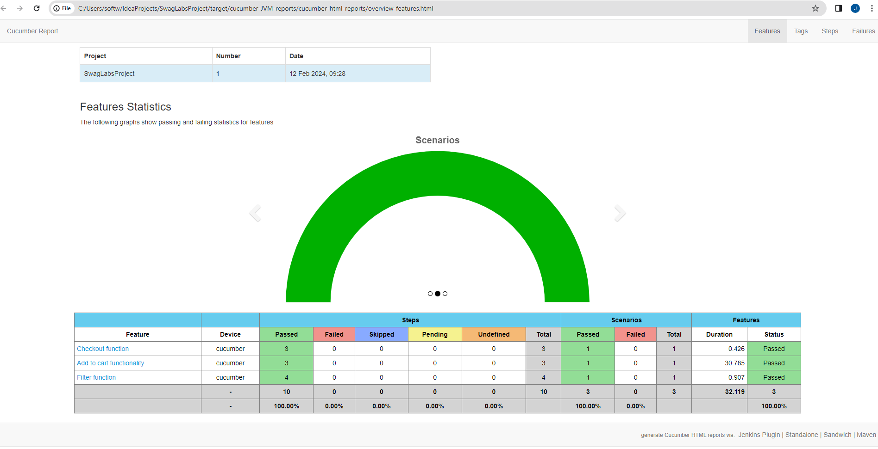

**Quick intro on Framework:**

1. src/main/java

Has reusable methods and properties file

1. src/test/java

FeatureFile🡪 Here BDD’s are written

StepDefination🡪Here BDD’s related step definitions are written

RunnerClass🡪Allows us to run the entire BDD’s or BDD’s related to tags