**Vulnversity**

**Task 1**

We completed the first task by starting the machine and then we received an Ip address .

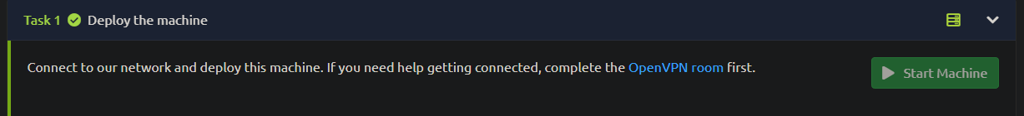

We opened the .ovpn file that we downloaded using openvpn command.

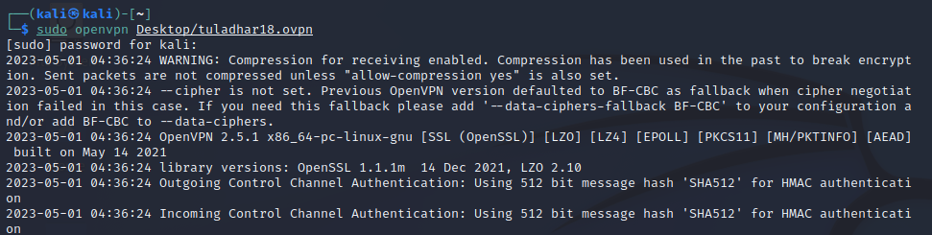

**Task 2**

We then used the nmap command followed by multiple parameters and the Ip address that we received to gain information about the machine and answering the questions .

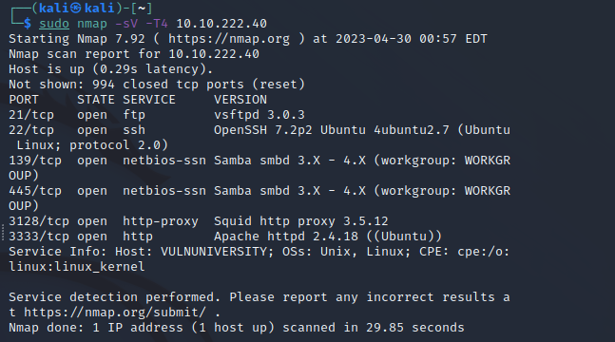



**Task 3**

In this step we have been asked to locate directories using Gobuster. We are also asked to provide a wordlist for Gobuster.

Gobuster is a tool used to brute-force directories and files, DNS subdomains, and virtual host names. The Gobuster command is used, specifying it to focus brute-forcing only directories followed by the flag **-u**, specifying the target URL and active http port of the machine followed by the path of the wordlist.

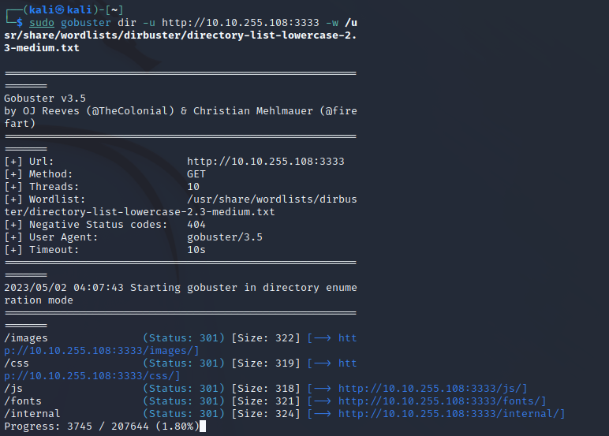

As we scanned the directories using Gobuster we came across a few directories. An interesting looking directory that we discovered was /internal. So we entered the IP of the machine and the directory /internal into a web browser and were greeted with an upload page.



**Task 4**

**We entered a reverse php shell**

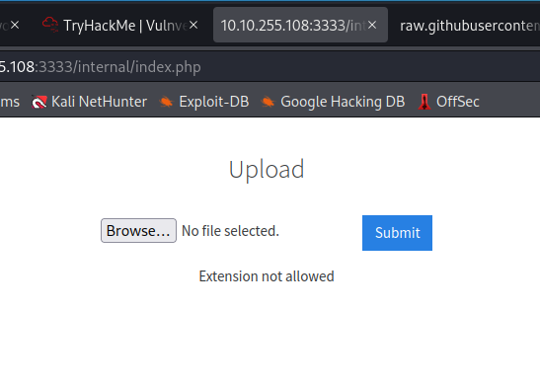

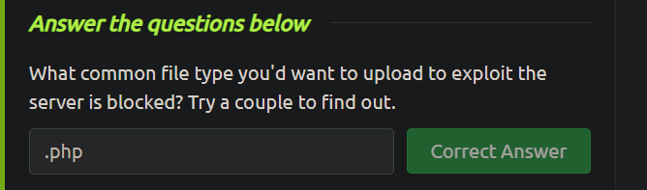

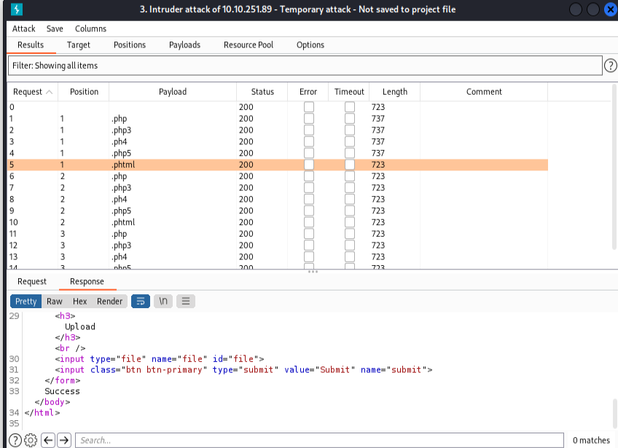

**Task 5**







