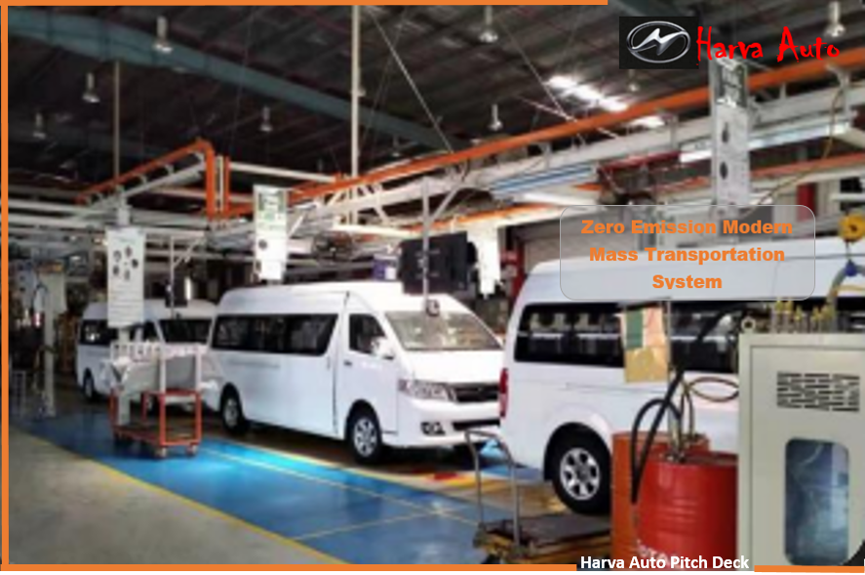

**Pitch Deck**

***e*- Mobility System** -

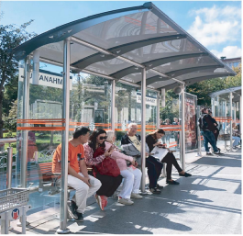

**CONTENTS**

**Introduction. 1**

**Features.2**

**Competitors. 3**

**Investment Opportunity. 4**

**Investment Terms. 5**

**Investor Privileges. 6**

**Share Value Forecast. 7**

**Potential Risks. 8**

**The Company. 9**

**Road Map. 10**

**INTRODUCTION**

Global warming - Caused by Power Generation, vehicle exhaust fumes, burning fossil fuels, cutting down forests and farming livestock are increasingly influencing the climate and the earth’s temperatures. This add enormous amounts of green house gases (GHG) which has led to climate change we are already noticing today.

The EU developed a long-term *Low greenhouse gas Emission Development Strategy* (LEDS) and the attendant Measurement, Reporting and Verification (MRV) framework for the period 2020-2050. The LEDS will inform absent NDC revisions and updates. This LEDS is in line with Zimbabwe’s vision of becoming an upper middle-income economy by 2030.

The transportation sector is responsible for over 29% of global Green House Gas (GHG) emissions, with road transportation accounting for three-quarters of this share.

Because of this, there have been some efforts from various governments world over and global automotive industry to reduce the GHG emissions from vehicles.

* **THE NEXT GENERATION -**

The Government of Zimbabwe (GOZ) needs to meet the country’s climate goals of cutting carbon emission by more than 30% by 2030 as pledged under the Paris agreement. This is why the GOZ has started to prepare for a future anchored on Green Energy. The introduction of e-Mobility to Zimbabwe can help the nation transition to a zero emission mobility system and at the same time contribute to economic development to reduce poverty.

Zimbabwe has an additional need for a decent transportation system in line with government policy towards an upper middle-income economy by year 2030. Electric mobility holds the key to long-term sustainable development.

Supporting the Electric Vehicle (**EV) Evolution** will contribute directly to achieving progress on Sustainable Development Goal (SDG) 13 on climate action, SDG 3 on good health and well-being, SDG 7 on affordable and clean energy, SDG 12 on responsible production and consumption and indirectly to achieving SDG 8 on sustained, inclusive, and sustainable economic growth, full and productive employment, and decent work for all.

We will produce and distribute on average 1 000 vehicles per year, total 5,000+ in the plan period of 5 years.

We aim to provide the Government of Zimbabwe with a comprehensive **Smart Mobility Plan** to reduce over 120 million litres of imported fossil fuel amounting to over US$200 million, reducing emission by over 140 million kgs, creating employment and inclusive growth within 5 years.

**-THE PROJECT-**

* **Harva Auto Works is seeking for Funds in equity/debt to support the initial project development.**
* **With this new investment, We will establish an EV assembly plant in Zimbabwe and launch the sales and delivery of its electric vehicles. The e-buses will come in 14 and 35-seater capacities, with a range of 250+ kilometres to replace the present Internal Combustion Engine (ICE) Vehicles – using equipment and parts sourced from Chinese leading e-Auto makers.**

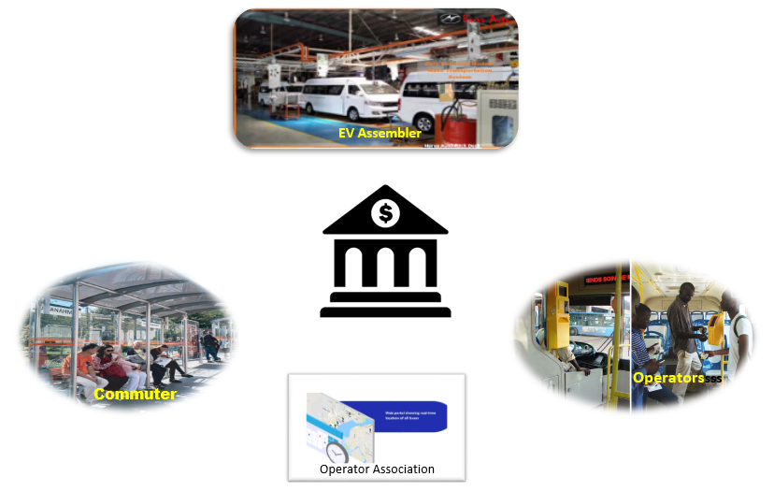

The strategic goal is to accelerate transition to clean-energy electric vehicles to reduce carbon emission and reduce the country’s fuel import bill, creating employment and reduce poverty. We will create reliable, affordable green products for the Southern Africa market.

The project includes assembling, deployment and maintenance of electric mini buses, e-taxi cabs, bus shelters and e-bus stations with charge pillars to provide EV charging where consumers shop, eat and work.

**- THE CONCEPT -**

**The main concept of HarvaAuto which distinguishes it from all other transportation systems is the financing model at the same time instilling confidence of use of electric vehicles by consumers.**

The Project’s innovative financing model makes these electric vehicles more accessible, allowing operators to pay for the vehicles, the battery and charging through a pay-as-you-drive plan to promote eco-friendly mobility in the country, reducing carbon emissions and noise pollution.

We will build, distribute and manage Smart transportation systems to manage the bus routes and fares, ticketing and operators, charging infrastructure, e-charge management and funds transfer.

Each of the e-mini buses carry more than 67 000 passengers per year @US$1 per passenger, enabling operators to provide smart travel with ease in the country. We will produce and distribute more than 5000 units and install more than 400 bus shelters within 5 years.

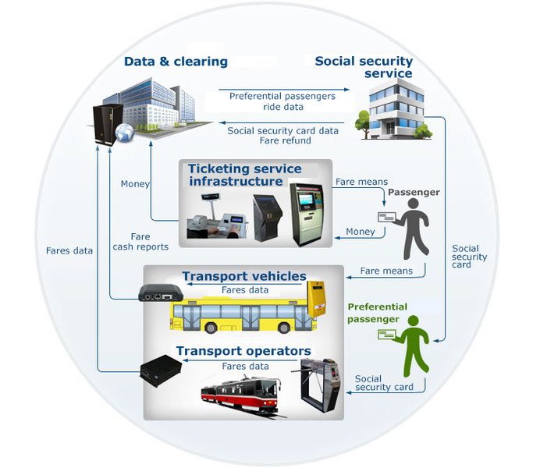

* **FEATURES -**

##### **The Harva electric Mini-Bus H5C stands out as the leader in its category, offering features that surpass its competitors in the region:**

**Unique Features of HARVA H5C EV**

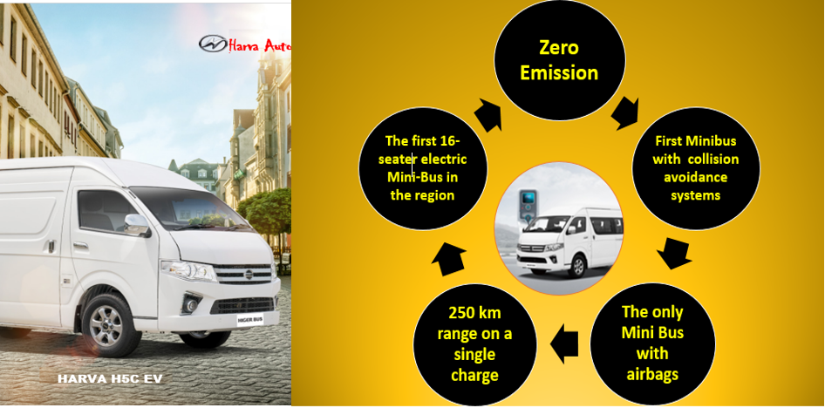

**This is more than a great mass transportation solution, but self-supporting - Eco-friendly system that promote transition to zero emission mobility and low noise pollution, creating employment while providing multiple revenue streams**

**- COMPETITORS -**

There is no specific company that can be named as a direct competitor, save for the traditional ICE buses and other illegal operators facing extinction for many reasons.

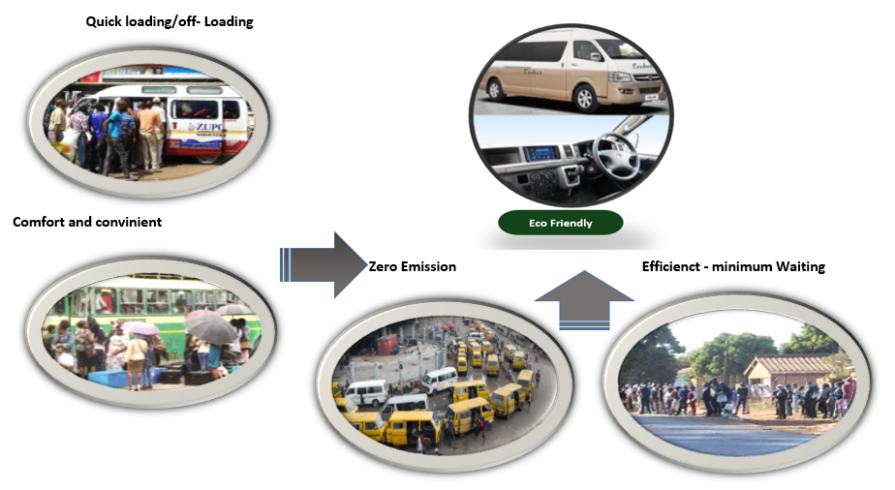

* **Advanced**. The e-mobility is a new smart solution for modern zero emission, low cost, compact, fast, mass transportation system with unique features.
* **Efficient**, **e**-mobility consist of large number of connected EVs, smart charging stations and information systems at the intersection of electricity and transportation sectors.
* ***Tried & Tested*. E-mobility** in itself is not new but have been limited and focused to markets in developed countries.

,

**- INVESTMENT OPPORTUNITY -**

Twelve (12) million common shares are reserved for investors which constitute 20% of the company total shares securitised by the initial fleet.

The funds will be used to build an electric vehicle assembly line and supporting infrastructure with route management systems within 3 years.

The more than 5 000 electric buses and taxis to be assembled will carry passengers across the country’s 10 provinces along several routes. With each of the e-mini buses carrying more 67 000+ passengers per year.

Over 400 bus shelters and over 200 **e**-charge stations will be installed within 5 years.

The Shares have the potential to soar very quickly and the promoter intends to payback all initial investors in this private offering, their investment by end of 3 years, while they keep their shares.

Projections show that share prices can reach more than four times the current offering price within 3 years.



**-INVESTMENT TERMS & INVESTOR PRIVILEGES-**

|  |  |
| --- | --- |
| **Offered Shares** | 12 million shares allocated to investor/s which constitute 20% of the company total shares. |
| **Number of Investors** | The total number of investors for the first round is limited |
| **Minimum Investment** | Sold in batches of 120,000 shares, securitised. |
| **Share Price** | US$1,00 per share |
| **Payment Terms** | 50% upon signing the agreement, 50% within 3 months. |
| **Return on Investment** | By the end of 3 years, we will payback all investors in this offering, their investment while they keep their shares. |

**Security:** The Harva H5C EV Mini-Buses will be held as security for the debt/equity and ownership will be transferred to operators after 3 years.

* **- INVESTOR PRIVILEGES -**

**Instalments**



The investor/s can pay for their secured investment in instalments

**Return of Investment**

We will pay back the investment amount in full after 36

Months, while they keep their shares.

**Voting Right**

The investor will have voting right

**Shares Trading**

In the second half of the third year, the company will launch

shares for private trading on the company’s platform to give

the shareholders the opportunity to sell or buy shares with an

initial target value of $2.5 per share.

* **SHARE VALUE FORECAST -**

**- POTENTIAL RISKS….**

Every business, no matter how large or small, has potential risks. For **HarvaAuto**, the analysis hereon shows the major potential risks and their impact and probability occurrence and how to respond to them

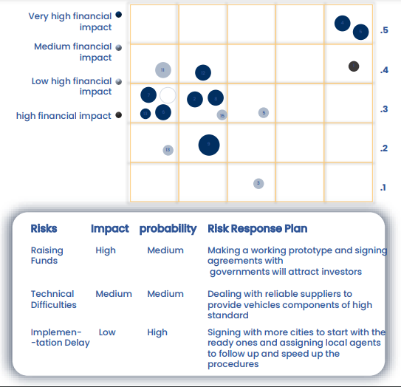

**Risk Response Plan:**

**-THE COMPANY….**

Masdell Capital (Pvt) Ltd trading as:

 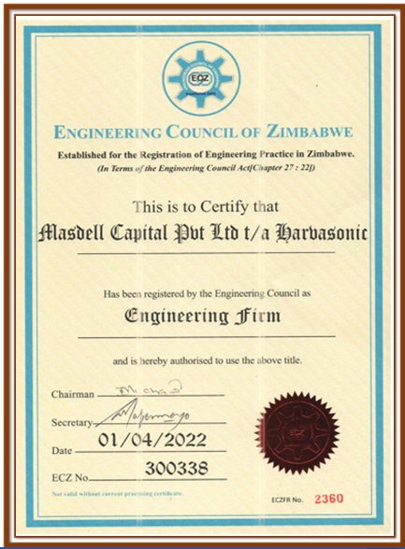

**Harva AutoWorks**

**No. 3142 Dan’graven Street, Kelston Park.**

**New Marlborough. Harare.**

**Name:**

Masdell Capital (Pvt) Ltd ***trading as: -*** **Harva AutoWorks**.

**Formation Jurisdiction:**

Harare – Zimbabwe

**The headquarters:**

Harare - Zimbabwe

**Foundation Date:**

January 2017

**Total number of shares:**

110 million shares

**Founders:**

A group of engineers and entrepreneurs who are members of:

* **The Green Society of Zimbabwe** – a Climate Advocate
* **Zimbabwe Institution of Engineers** – a multi-disciplinary institution covering all aspects of engineering in Zimbabwe.
* **Engineering Council of Zimbabwe** – a professional engineering body
* **THE ROAD MAP -**

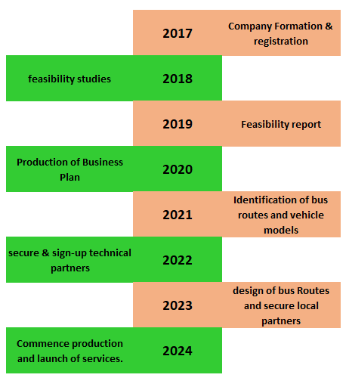

[*harvasonic@gmail.com*](mailto:harvasonic@gmail.com)*,* [*masdelinvestments@gmail.com*](mailto:masdelinvestments@gmail.com)

The design and development of **HarvaAuto** began more than six years

ago with collaboration between a number of stakeholders. The Plant is a wholly owned trading arm of Masdell Capital Private Limited Company, registered according to the laws of Zimbabwe.

In the pre -foundation stage, a market research was conducted which

include interviewing people and organisations in the target market and conducting questionnaires to prove the feasibility before embarking on the establishment of the project.

Identification of routes and bus shelter sites followed identification of suitable vehicles and initial design of the assembly plant. Government approvals and registrations.

Research and development is an ongoing process, we have a budget

To develop new models and products to maintain the company's leadership in e-mobility. The inclusion of local authorities present additional value.

Delivery of first lot of EVs will be within 6 Months of Financial Closure.

**Masdell Capital (Pvt) Ltd.**

No. 3142 Dan’graven Street

Kelston Park, Harare

Tel 263 773300493, 263 772 711 217

Email [Masdelinvestments@gmail.com](mailto:Masdelinvestments@gmail.com)

harvasonic@gmail.com