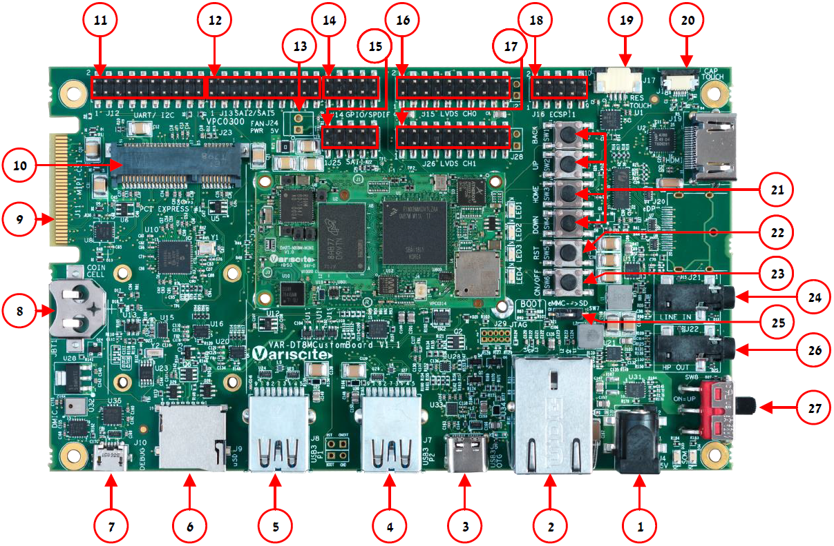

|  |  |
| --- | --- |
| Features:   1. 5V PWR IN (J4) 2. Gigabit Ethernet (J5) 3. USB 2.0 OTG (J6) 4. USB 2.0 Host P2(J7) 5. USB 2.0 Host P1(J8) 6. SD-MMC (J9) 7. USB Debug (J10) 8. RTC BAT. Slot (JBT1) 9. Single MIPI-CSI (J11) 10. Mini PCIe #1 (J23) 11. UART, I2C (J12) 12. SAI2, SAI5, PDM (J13) 13. FAN 5V (J24) 14. GPIO, SPDIF (J14) 15. SAI1 (J25) 16. LVDS CH0 (J15) 17. LVDS CH1 (J26) 18. ECSPI, Host wake (J16) 19. Resistive Touch (J17) 20. Capacitive Touch (J18) 21. User Buttons (SW1-TOP: SW4-BOT) 22. Reset Button (SW5) 23. ON/OFF Button (SW6) 24. Line In (J21) 25. Boot Select Switch (SW7) 26. Headphones (J22) 27. Power ON (SW8) | Evaluation kit initial Setup   1. Carefully remove the 7” LCD and   VAR-DT8MCustomBoard from the package.   1. Connect the 7” LCD Display and Touch cables to the Evaluation Kit connectors J15, J18 respectively.   *Note*:  *Display cable – connect the cable with the red wire on pin 1.*  *Touch cable – connect the cable with the metal contacts facing down.*     1. Plug the USB type A to micro B cable between the USB debug connector (J10) and a PC USB port. |

Setting the host PC for debug

1. Download any PC terminal software (e.g. [Putty](http://www.putty.org/)).
2. Set the PC terminal software parameters as follows:

- Baud Rate: 115200

- Data bits: 8

- Stop bits: 1

- Parity: None

- Flow Control: None

Booting from eMMC

1. For internal boot:   
   Set the Boot select switch (SW7) to eMMC position to boot from the DART-MX8M-MINI internal storage.
2. Plug the wall adapter into the 5V power jack (J4) and to a 120VAC~240VAC power source.
3. Set Power ON switch to ON state.
4. Boot messages should be printed within the PC terminal window.

Booting from a micro SD card

The microSD card is supplied within the package. Updated SD card images can also be downloaded from the Variscite FTP server.

See more details in the recovery SD card section in the Variscite Wiki pages.

1. Set Power ON (SW4) to off state.
2. Set Boot select switch (SW7) to SD side in order to boot from the SD card.
3. Push microSD card into the microSD card slot (J9) of the VAR-DT8MCustomBoard.
4. Set Power ON switch to ON state.
5. Boot messages should be printed within the PC terminal window.

(Re-)Installing the file system to eMMC

Please refer to the recovery SD card section in the Variscite Wiki pages.

Links

* Wiki page: <http://variwiki.com/index.php?title=DART-MX8M-MINI>
* DART-MX8M-MINI Evaluation kits: <https://www.variscite.com/products/evaluation-kits/dart-mx8m-mini-evaluation-kits/>
* DART-MX8M-MINI System on Module:  
  [https://www.variscite.com/products/system-on-module-som/cortex-a53-krait/dart-mx8m-mini-nxp-i-mx8m-mini/](https://www.variscite.com/products/system-on-module-som/cortex-a53-krait/dart-mx8m-nxp-imx-8m/%20)
* VAR-DT8MCustomBoard: <https://www.variscite.com/products/single-board-computers/var-dt8mcustomboard/>
* Customer portal:  
  <https://varisciteportal.axosoft.com/login>

**Thank you for purchasing Variscite’s product.**

**For additional assistance please contact:** [**sales@variscite.com**](mailto:sales@variscite.com)